(Large Print)

Springfield Presbyterian Church (USA)
7300 Spout Hill Road, Sykesville, MD 21784 410-795-6152

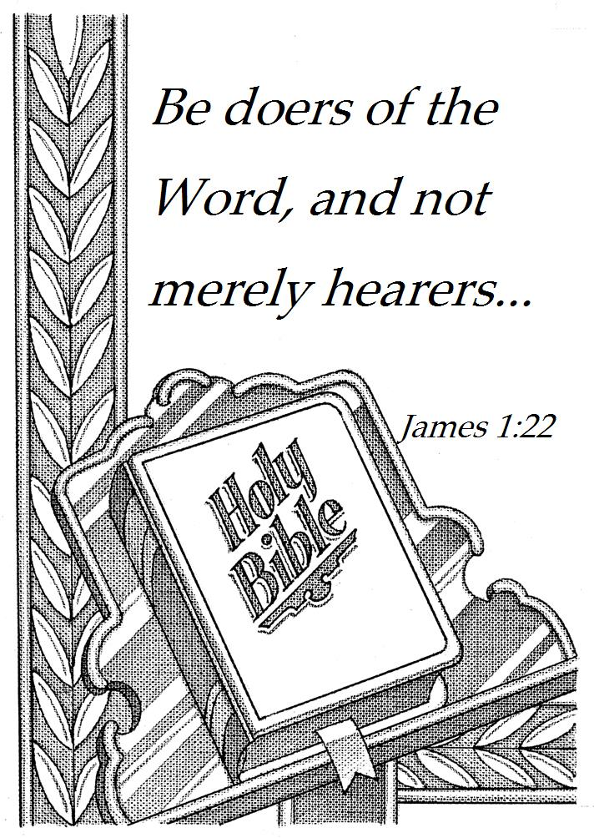

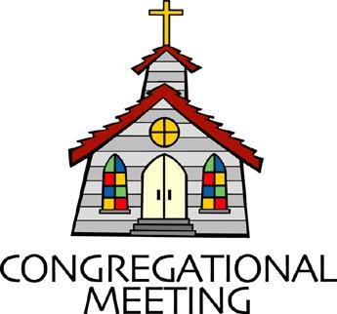
September 2, 2018 - 9:30 am

WELCOME VISITORS! We're glad you are here! Cards at the ends of each pew are for you to fill out and drop in the Offering Plate. Please let us know you are visiting, and join us for refreshments and fellowship following the service. The Sanctuary has an induction loop system to assist the hearing impaired. The system will also work on the telephone setting of hearing aids. A head set is available upon request.

Springfield Presbyterian Church is rooted in the gospel of Jesus Christ, led by the Holy Spirit, and called to loving relationships through vibrant worship and service. Valuing all people, we are committed to developing disciples and fostering stewardship.

PREPARATION FOR THE WORD
(* those who are able are invited to stand)

Please prepare for worship by listening to the music of the Prelude.

PRELUDE

GATHERING OF THE PEOPLE

The Lord be with you! And also with you! (Greeting)

LIGHTING THE CHRIST CANDLE
Leader: Whenever we light this candle we proclaim:
People: Christ is the Light of the world and the center of our lives.

CALL TO WORSHIP [Based upon Psalm 33]
Leader: Let the godly sing for joy to the Lord; it is fitting for the pure to praise Him.
People: Let us praise the Lord with melodies and make music for Him.
Leader: Sing a new song of praise to Him; play on the harp, and sing with joy.
People: For the word of the Lord holds true, and we can trust everything He does.
Leader: He loves whatever is just and good; the unfailing love of the Lord fills the earth.
People: We put our hope in the Lord. He is our help and our shield.
Leader: In God our hearts rejoice, for we trust God’s holy name.
People: Let your unfailing love surround us, Lord, for our hope is in you alone.
ALL: Let us worship our faithful God!

* HYMN For the Beauty of the Earth

For the beauty of the earth, for the glory of the skies,
For the love which from our birth, over and around us lies.

Refrain: Lord of all, to Thee we raise, this our hymn of grateful praise.

For the wonder of each hour, ff the day and of the night,
Hill and vale, and tree and flower, sun and moon, and stars of light. (Refrain)

For the joy of ear and eye, for the heart and mind’s delight,
For the mystic harmony, linking sense to sound and sight. (Refrain)

For the joy of human love, brother, sister, parent, child,
Friends on earth and friends above, for all gentle thoughts and mild. (Refrain)

For Thy Church, that evermore, lifteth holy hands above,
Offering up on every shore, her pure sacrifice of love. (Refrain)

PRAYER OF CONFESSION
Generous God, when we look in the mirror, we struggle to comprehend what we see. We are people who hear your Word, but do not always act upon your Word. We keep Your Word in our heart, but we find it difficult to express in our lives, whether that’s in school, at the workplace, or in our relationships. The call is high, O God, and we long to fulfil your call, but we often fall short. Forgive us and help us, God, to be a whole people, who do and act according to your Word. Renew us and revive us, encourage us once again and may our reflection continue to be refined by your work in our lives. Amen.

SILENT PRAYERS OF CONFESSION

RESPONSE The Lone, Wild Bird
O search me, God, my heart reveal, renew my life, my spirit heal;
For I am yours, I rest in you, Great Spirit, come, rest in me, too.

WORDS OF ASSURANCE
Leader: Anyone who is in Christ is a new creation. The old life has gone, a new life has begun.
People: We are a forgiven people! Let us praise God and be at peace. Amen.

* MUSICAL RESPONSE OF PRAISE From All That Dwell Below the Skies
From all that dwell below the skies, let the Creator’s praise arise: Alleluia! Alleluia!
Let the Redeemer’s name be sung, through every land, in every tongue.
Alleluia! Alleluia! Alleluia! Alleluia! Alleluia!

* THE PEACE The peace of Christ be with you! And also with you!
(You may greet those around you.)

* RESPONSE Here I Am, Lord
Here I am, Lord, Is it I, Lord? I have heard you calling in the night.
I will go, Lord, if you lead me. I will hold your people in my heart.

THE PROCLAMATION OF THE WORD

PRAYER OF ILLUMINATION
Leader: Let us pray, Lord, open our hearts and mind by the power of your Holy Spirit, that as the scriptures are read and your Word proclaimed, we may hear with joy what you say to us today. Amen.

FIRST SCRIPTURE LESSON Psalm 15
¹ O Lord, who may abide in your tent? Who may dwell on your holy hill? ² Those who walk blamelessly, and do what is right, and speak the

truth from their heart; ³ who do not slander with their tongue, and do no evil to their friends, nor take up a reproach against their neighbors;
⁴ in whose eyes the wicked are despised, but who honor those who fear the Lord; who stand by their oath even to their hurt; ⁵ who do not lend money at interest, and do not take a bribe against the innocent. Those who do these things shall never be moved.

SECOND SCRIPTURE LESSON James 1:17-27
¹⁷Every generous act of giving, with every perfect gift, is from above, coming down from the Father of lights, with whom there is no variation or shadow due to change. ¹⁸In fulfilment of his own purpose he gave us birth by the word of truth, so that we would become a kind of first fruits of his creatures. ¹⁹You must understand this, my beloved: let everyone be quick to listen, slow to speak, slow to anger; ²⁰for your anger does not produce God’s righteousness. ²¹Therefore rid yourselves of all sordidness and rank growth of wickedness, and welcome with meekness the implanted word that has the power to save your souls.
²²But be doers of the word, and not merely hearers who deceive themselves. ²³For if any are hearers of the word and not doers, they are like those who look at themselves in a mirror; ²⁴for they look at themselves and, on going away, immediately forget what they were like. ²⁵But those who look into the perfect law, the law of liberty, and persevere, being not hearers who forget but doers who act—they will be blessed in their doing. ²⁶If any think they are religious, and do not bridle their tongues but deceive their hearts, their religion is worthless. ²⁷Religion that is pure and undefiled before God, the Father, is this: to care for orphans and widows in their distress, and to keep oneself unstained by the world.

Leader: Hear what the Spirit is saying to the Church.
All: Thanks be to God.
TIME WITH YOUNG PEOPLE

SERMON The Man in the Mirror Rev. Becca Crate

THE RESPONSE TO THE WORD

* HYMN Let Us Talents and Tongues Employ
Let us talents and tongues employ, reaching out with a shout of joy:
Bread is broken, the wine is poured, Christ is spoken and seen and heard.

Refrain:
Jesus lives again, earth can breathe again,
Pass the Word around: loaves abound!

Christ is able to make us one. At the table He sets the tone,
Teaching people to live to bless, Love in word and in deed express. (Refrain)

Jesus calls us in, sends us out, bearing fruit in a world of doubt,
Gives us love to tell, bread to share: God (Immanuel) everywhere! (Refrain)

THE SACRAMENT OF HOLY COMMUNION

INVITATION

THE GREAT PRAYER OF THANKSGIVING
Leader: The Lord be with you.
People: And also with you.
Leader: Lift up your hearts.
People: We lift them up to the Lord.
Leader: Let us give thanks to the Lord our God.
People: It is right to give our thanks and praise.

[The Pastor continues… “…who forever sing to the glory of your name.”]

IN PRAISE OF GOD Tune #581
Holy, holy, holy, Lord, God of Power and might.
Heaven and earth are full of your glory, Hosanna in the highest!
Blessed is He who comes in the name of the Lord.
Hosanna in the highest, hosanna in the highest.

[The Pastor continues… “and all creation might be restored.”]

IN PRAISE OF CHRIST Tune #582
Dying, you destroyed our death; rising, you restored our life.
Lord Jesus, come in glory.

PASTORAL PRAYER AND THE LORD’S PRAYER
“For this I pray to God.” / “For this I give thanks to God.”
Congregational Response: “Hear our prayer, O God.”

WORDS OF INSTITUTION

SHARING OF THE MEAL

PRAYER OF DEDICATION (Unison)
Dear God, take us out to live as changed people because we have shared the living bread and cannot remain the same. Ask much of us, expect much from us, enable much by us, encourage many through us. So, Lord, may we live to your glory, both as inhabitants of the earth, and citizens of the commonwealth of Heaven. Through Christ, with Christ, in Christ, in the unity of the Holy Spirit, all glory and honor are yours, almighty God, now and forever. Amen.

PRESENTATION OF TITHES AND OFFERINGS
OFFERTORY
* SONG OF THANKS Take My Life
Take my silver and my gold, not a mite would I withhold;
Take my intellect and use, every power as Thou shalt choose,
Every power as Thou shalt choose.
* PRAYER OF DEDICATION

* HYMN Be Doers of the Word of God
Be doers of the word of God, not simply those who hear.
Be ones who look into God’s word, obey, and persevere.
Be quick to listen, slow to speak, and slow to anger, too.
Put wrath aside; instead, be meek, and let God work in you.

Religion that is undefiled, religion that is pure,
Will reach to help the orphaned child, and welcome all the poor.
If people come here poorly dressed, to judge them is a sin.
The rich aren’t better than the rest; God welcomes poor ones in.

O Christ, you save us by God’s grace, from having to obey.
Then freed to love, we can embrace, a life that seeks your way.
May we be doers of the word, may faith shine through our deeds;
And as we seek to trust in God, may ethics follow creeds.

* CHARGE AND BENEDICTION
Leader: When we look into the mirror, whom do we see?
People: Do we see people who listen and act on God’s Word?
Leader: Let us look into the mirror again, and examine who we are,
People: So that we might be hearers and doers,
Leader: And all may know the glory of God,
People: Through our words and actions.

* UNISON AMEN POSTLUDE

Sunday September 9 Lectionary
Proverbs 22:1-2, 8-9, 22-23; Psalm 125; James 2:1-10 (11-13) 14-17; Mark 7:24-37

Assisting in Worship: We appreciate those who serve:

Today 9/2 Next Week 9/9
Sunday Opener Ron Holmes Barbara Cornell
Greeters & Ushers Steve & Donna Ed & Sandy Newsome
Mazer
Lay Leader Sharon Pappas Tim Oates
Youth/Children’s Activity Shona Klein Shona Klein
Fellowship Barbara Cornell & Linda Caviglia
Shona Klein

Communion Servers Today: (Intinction)
1. Jim Wise 3. Bob Rogers
2. Ed Newsome 4. Barbara Cornell

Church Attendance: August 19 - 37 August 26 - 37

Church Cleaning: September 7, 8 or 9 - Martha & Davis Streaker

Happy Birthday! September 8 - Alexander Brant
September 9 - Rachel Spicer

Happy Anniversary! September 5 - Stephanie & John Bunting
September 7 - Max & Margaret Carroll
September 7 - Becky & Mike Spicer
September 9 - Larry & Heather Grimsley

Announcements

Memorial Service: A memorial service will be held for Rev. Dr. Helen Woodward on Saturday, September 8 at 10:00 am at Frederick Presbyterian Church, 115 West Second Street, Frederick, MD. All are welcome to attend to remember and celebrate Helen’s life.

Worship Service Time Change: Mark your calendars for September 9 when Worship Service moves to 10:30 am.

Sunday School: Sunday School for Pre-K - Youth begins on September 9. Be part of the excitement! Fun, games, surprises as we learn about Jesus.

C.I.A. (Community in Action): C.I.A. will meet on Monday, September 10 at 4:30 pm at the Manse. Bring your friends!

Youth Group: It is time for our first YOUTH GROUP event of the season! Our annual trip to Woodberry Crossing will be September 15-16. We will be leaving the Church at 8am on Saturday the 15th and returning on Sunday the 16th in the early afternoon. See Mr. Charlie or Ms. Deb for details.

Weekly Announcements: If you have an announcement to include with next week’s bulletin, please call the Office at 410-795-6152 or email to spc.office@verizon.net by Wednesday each week.

Prayers & Thanksgivings
~ Prayers of strength and comfort for Joy Barwick and her grandson, Dylan, while Dylan’s medical problems are addressed.
~ Prayers for Brenda McClung’s mom, Liz Old, who is in Copper Ridge Rehab.
~ Prayers of quick healing for Dr. Elwood LaBrosse, in Fairhaven Health Center.
~ “My sister, Shirley, passed away Tuesday evening, Aug 28th, just a month after her son, Joseph, died. I would like to thank my Church Family for all the concerns and prayers over these past couple of years for both of them and our whole family. Your prayers mean the world to me and also to my brothers, Gary and Jack. I think Gary actually considers himself a long-distance member of our church. He gets the Cross Roads and loves reading it and being a part of it all. So thank you one and all for always being there for me.” ~ Julie Ballard
~ Prayers for First of Westminster from our Ministry Group.

The Congregational Care team wants to know what YOU or someone you know needs...a visit...a call...a meal. Please contact Kay Freas or Connie Robinson.

Today:
Sunday September 2
9:30 am Worship
10:30 am Fellowship

This Week:
Wednesday September 5
6:30 pm Bell Choir Practice
7:45 pm Adult Choir Practice
Saturday September 8
10:00 am Memorial Service for Rev. Dr. Helen Woodward
Frederick Presbyterian Church
115 West Second Street, Frederick, MD
Looking Ahead:
Sunday September 9
10:30 am Worship Service and Sunday School
11:30 am Picnic
6:30 pm Youth Movie Night (Manse)
Monday September 10
4:30 pm C.I.A. Meeting (Manse)
7:00 pm Headhuggers
Tuesday September 11
10:30 am Prayer Group (Manse)
Wednesday September 12
6:30 pm Bell Choir Practice
7:45 pm Adult Choir Practice
Thursday September 13
9:30 am Presbytery Meeting (Cumberland, MD)
Saturday September 14
8:00 am Youth Depart for Youth Retreat (Woodberry Crossing)

Office Hours: Tuesday, Wednesday, Friday 9:00 am - 3:00 pm
Springfield Presbyterian Church

9:30 am Worship
10:30 am Fellowship
Website: www.springfield-church.org Church Office: 410-795-6152
Like us on Facebook: www.facebook.com/SpringfieldPresbyterianChurch
Pastor: Rev. Becca Crate
Email: springfieldpastor@gmail.com
Clerk of Session: Sharon Pappas
Minister of Music: Linda Caviglia
Accompanist: Aaron Thacker Organist: Jennifer Wise
Youth Group Coordinators: Charles & Deb Sperling
Sunday School Coordinator: Connie Robinson
Administrative Assistant: Donna Mazer
e-mail: spc.office@verizon.net

