(Large Print)

Springfield Presbyterian Church (USA)
7300 Spout Hill Road, Sykesville, MD 21784 410-795-6152

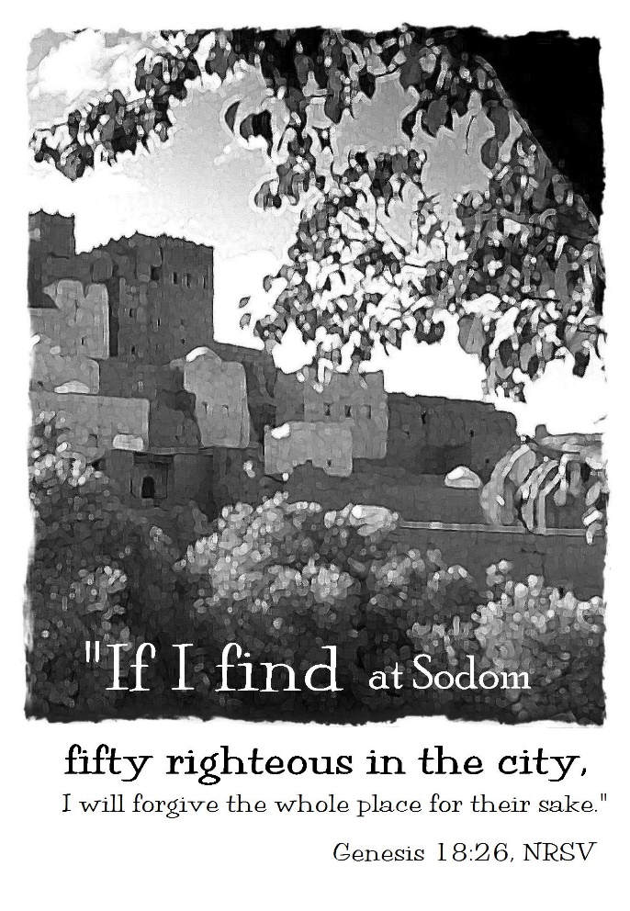

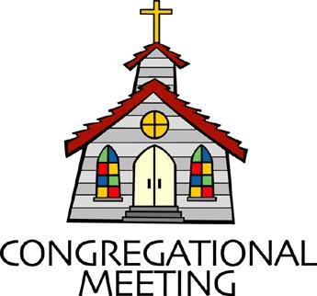
November 10, 2019 - 10:30 am

WELCOME VISITORS! We're glad you are here! Cards at the ends of each pew are for you to fill out and drop in the Offering Plate. Please let us know you are visiting, and join us for refreshments and fellowship following the service. The Sanctuary has an induction loop system to assist the hearing impaired. The system will also work on the telephone setting of hearing aids.

Springfield Presbyterian Church is rooted in the gospel of Jesus Christ, led by the Holy Spirit, and called to loving relationships through vibrant worship and service. Valuing all people, we are committed to developing disciples and fostering stewardship.
PREPARATION FOR THE WORD
(* those who are able are invited to stand)

PRELUDE

GATHERING OF THE PEOPLE

The Lord be with you! And also with you! (Greeting)

LIGHTING THE CHRIST CANDLE
Leader: Whenever we light this candle we proclaim:
People: Christ is the Light of the world and the center of our lives.

CALL TO WORSHIP [Psalm 91 Interpretation]
Leader: You who live in the shelter of the Most High, who abide in the shadow of the Almighty, will say to the Lord,
People: “Our refuge and our fortress; our God, in whom we trust.”
Leader: He will deliver you from the snare of the fowler, from deadly pestilence; He will cover you with His pinions, and under His wings you shall find a refuge; His faithfulness is a shield.
People: We will not fear the terror of the night, or the arrow that flies by day, or the pestilence that stalks in the darkness, or the destruction that wastes at noonday.
Leader: A thousand may fall at your side, ten thousand at your right hand, but it will not come near you. You will only look with your eyes and see the punishment of the wicked.
People: Because we have made the Lord our refuge, the Most High our dwelling place, no evil shall befall us, none shall come near our tent.
Leader: He will command His angels concerning you to guard you in all your ways. On their hands they will bear you up, so that you will not dash your foot against a stone.

People: We will tread on the lion, the young lion and the serpent will trample under foot.
Leader: Those who love God, I will deliver; I will protect those who know my name.
People: When we call upon God, God answers. God is with us in trouble. We will be rescued and honored and be satisfied with long life and salvation.
ALL: Let us praise our loving and merciful God!

* HYMN Christ Be Beside Me

Christ be beside me; Christ be before me; Christ be behind me, King of my heart. Christ be within me; Christ be below me; Christ be above me, never to part.

Christ on my right hand, Christ on my left hand, Christ all around me, shield in the strife. Christ in my sleeping, Christ in my sitting, Christ in my rising, Light of my life.

Christ be in all hearts thinking about me; Christ be on all tongues telling of me. Christ be the vision in eyes that see me; in ears that hear me Christ ever be.

PRAYER OF CONFESSION
Generous God, we are a people who want our own way, our own desires, and our wants and needs to be met. We are sometimes selfish, selfish in our lack of understanding that other’s needs need to come before our own. We try to bargain, we try to make deals, but we recognize that it is our own human way of coping with the situations we encounter. We ask that you forgive your people: our doubts, our anger, our bartering. Encourage us, restore us, and renew us to be the people we are called to be. Amen.

SILENT PRAYERS OF CONFESSION

RESPONSE Breathe on Me, Breath of God
Breathe on me, breath of God, until my heart is pure,
Until with thee I will one will, to do and to endure.

WORDS OF ASSURANCE
Leader: Our righteousness is found in Christ alone, a gift of God by faith. Beloved people of God, believe the good news: through the grace of Jesus Christ we are forgiven!
People: Praise be to God! Alleluia! Amen!

* MUSICAL RESPONSE OF PRAISE O My Soul, Bless Your Redeemer
O my soul, bless your Redeemer; all within me bless God’s name;
Bless the Savior, and forget not all God’s mercies to proclaim.

* THE PEACE The peace of Christ be with you! And also with you!
(You may greet those around you.)

* RESPONSE Here I Am, Lord
Here I am, Lord, Is it I, Lord? I have heard you calling in the night.
I will go, Lord, if you lead me. I will hold your people in my heart.

THE PROCLAMATION OF THE WORD

PRAYER OF ILLUMINATION
Leader: Generous God, pour out your Holy Spirit, O God, and prepare our hearts to accept your word. Silence in us any voice but your own, that, hearing, we may also obey your will; through Jesus Christ our Lord. Amen.

FIRST SCRIPTURE LESSON Genesis 18:20-33
²⁰Then the Lord said, ‘How great is the outcry against Sodom and Gomorrah and how very grave their sin! ²¹I must go down and see whether they have done altogether according to the outcry that has come to me; and if not, I will know.’ ²²So the men turned from there, and went towards Sodom, while Abraham remained standing before the Lord. ²³Then Abraham came near and said, ‘Will you indeed sweep away the righteous with the wicked? ²⁴Suppose there are fifty righteous within the city; will you then sweep away the place and not forgive it for the fifty righteous who are in it? ²⁵Far be it from you to do such a thing, to slay the righteous with the wicked, so that the righteous fare as the wicked! Far be that from you! Shall not the Judge of all the earth do what is just?’ ²⁶And the Lord said, ‘If I find at Sodom fifty righteous in the city, I will forgive the whole place for their sake.’ ²⁷Abraham answered, ‘Let me take it upon myself to speak to the Lord, I who am but dust and ashes. ²⁸Suppose five of the fifty righteous are lacking? Will you destroy the whole city for lack of five?’ And he said, ‘I will not destroy it if I find forty-five there.’ ²⁹Again he spoke to him, ‘Suppose forty are found there.’ He answered, ‘For the sake of forty I will not do it.’ ³⁰Then he said, ‘Oh do not let the Lord be angry if I speak. Suppose thirty are found there.’ He answered, ‘I will not do it, if I find thirty there.’ ³¹He said, ‘Let me take it upon myself to speak to the Lord. Suppose twenty are found there.’ He answered, ‘For the sake of twenty I will not destroy it.’ ³²Then he said, ‘Oh do not let the Lord be angry if I speak just once more. Suppose ten are found there.’ He answered, ‘For the sake of ten I will not destroy it.’ ³³And the Lord went his way, when he had finished speaking to Abraham; and Abraham returned to his place.

SECOND SCRIPTURE LESSON Exodus 32:9-14
⁹The Lord said to Moses, ‘I have seen this people, how stiff-necked they are. ¹⁰Now let me alone, so that my wrath may burn hot against them and I may consume them; and of you I will make a great nation.’
¹¹But Moses implored the Lord his God, and said, ‘O Lord, why does your wrath burn hot against your people, whom you brought out of the land of Egypt with great power and with a mighty hand? ¹²Why should the Egyptians say, “It was with evil intent that he brought them out to kill them in the mountains, and to consume them from the face of the earth”? Turn from your fierce wrath; change your mind and do not bring disaster on your people. ¹³Remember Abraham, Isaac, and Israel, your servants, how you swore to them by your own self, saying to them, “I will multiply your descendants like the stars of heaven, and all this land that I have promised I will give to your descendants, and they shall inherit it for ever.” ’ ¹⁴And the Lord changed his mind about the disaster that he planned to bring on his people.

Leader: Hear what the Spirit is saying to the Church.
All: Thanks be to God.

TIME WITH YOUNG PEOPLE

SERMON Holy Bartering Rev. Becca Crate

THE RESPONSE TO THE WORD

* HYMN Will You Come and Follow Me (The Summons)

Will you come and follow me if I but call your name?
Will you go where you don’t know and never be the same?
Will you let my love be shown, will you let my name be known,
Will you let my life be grown in you and you in me?

Will you leave yourself behind if I but call your name?
Will you care for cruel and kind and never be the same?
Will you risk the hostile stare should your life attract or scare?
Will you let me answer prayer in you and you in me?

Will you let the blinded see if I but call your name?
Will you set the prisoners free and never be the same?
Will you kiss the leper clean, and do such as this unseen,
And admit to what I mean in you and you in me?

Will you love the “you” you hide if I but call your name?
Will you quell the fear inside and never be the same?
Will you use the faith you’ve found to reshape the world around,
Through my sight and touch and sound in you and you in me?

Lord, your summons echoes true when you but call my name.
Let me turn and follow you and never be the same.
In your company I’ll go where your love and footsteps show.
Thus I’ll move and live and grow in you and you in me.

PASTORAL PRAYER AND THE LORD’S PRAYER
“For this I pray to God.” / “For this I give thanks to God.”
Congregational Response: “Hear our prayer, O God.”

PRESENTATION OF TITHES AND OFFERINGS
OFFERTORY
* SONG OF THANKS We Give Thee but Thine Own
May we thy bounties thus as stewards true receive,
And gladly, as thou blessest us, to thee our first-fruits give.
* PRAYER OF DEDICATION

* HYMN Lord, Speak to Me That I May Speak

Lord, speak to me that I may speak in living echoes of your tone.
As you have sought, so let me seek your erring children, lost and lone.

O lead me, Lord, that I may lead the wandering and the wavering feet.
O feed me, Lord, that I may feed your hungering ones with manna sweet.

O teach me, Lord, that I may teach the precious truths which you impart.
And wing my words that they may reach the hidden depths of many a heart.

O fill me with your fullness, Lord, until my very heart o'erflow
In kindling thought and glowing word, your love to tell, your praise to show.

O use me, Lord, use even me, just as you will, and when, and where
Until your blessed face I see, your rest, your joy, your glory share.

* CHARGE AND BENEDICTION
Leader: We are a called people,
People: So we listen to the Spirit
Leader: We listen so she may lead us to new opportunities,
People: New places beyond our imagination.
Leader: As people ready to face the Spirit’s calling,
People: We live freely, following, and embracing new opportunities to serve God.

* UNISON AMEN

POSTLUDE

Sunday November 17 Lectionary
Isaiah 65:17-25; Isaiah 12; 2 Thessalonians 3:6-13; Luke 21:5-19

Church Attendance: October 27 – 32 November 3 - 48

Church Cleaning: November 15, 16 or 17 – Sharon Pappas &
Sandy Newsome

Happy Anniversary! November 17 – Shona & Albert Klein

Assisting in Worship: We appreciate those who serve:

Today 11/10 Next Week 11/17
Sunday Opener Bob Rogers Beth Oates
Greeters & Ushers Steve & Donna Mazer Connie Robinson &
Martha Streaker
Lay Leader Linda Black Barbara Cornell
Sunday School Connie Robinson Connie Robinson
Fellowship Linda Caviglia Diana & Bob Steppling

Announcements

Called Meeting of the Congregation is TODAY immediately following Worship for the purpose of electing the 2020 Nominating Committee. The job of this Committee is to present a slate of nominees to be elected in April as Elders in the Class of 2022. Slate to be elected: Jennifer Wise, Steve Mazer, Carl Anderson, and Bob Rogers. Thanks to Chair Beth Oates and her team of Connie Robinson, Jen, Carl, Bob and Steve (they have volunteered to serve again in this capacity). The other purpose of the meeting is to approve the Terms of Call for Pastor Becca for 2020. Copies of those terms will be available for you to see before voting to approve.
Stewardship: Many of you have turned in your pledge card for 2020, and we thank you! If you haven’t submitted yours yet, you may put it in the offering plate or send it to the Church Office at your earliest convenience. This will help us to prepare our budget for 2020.

Christmas Flowers: It’s time to order your Christmas flowers! If you would like to place flowers in the Sanctuary for Christmas, there are order forms in the Narthex or contact the Church Office. All flower orders are due by November 18.

Youth/Children's Choir: I am hoping to have some of the young people in the congregation sing a few pieces through the year. The next time I have something planned is for the first week in December. I would love to have a group of the youth sing our introit for that morning We Look for the Star by Hal Hopson. This is a unison piece that we should be able to learn with just a little rehearsal. Brittany Rachin, a member of our congregation and choir, is also a music teacher in the school system and is interested in helping out with this endeavor. Please let me know if you are interested so we can work out a couple of times to practice before that first week in December. (Linda Caviglia - 410-746-1221 or linda@cavig5.net)

Children/Youth Activities: If your child/youth is participating in any activities this Fall, please let Connie Robinson know as we want to be part of the activity.

Blessing Bags are in the Narthex. Please feel free to pick up a few. Handing one out to someone in need gives you a very real way to meet their immediate needs by providing them with some basic supplies.

Weekly Announcements: If you have an announcement to include with next week’s bulletin, please call the Office at 410-795-6152 or email to spc.office@verizon.net by Wednesday each week.

Prayers & Thanksgivings

~ Prayers of healing for Rev. Jamie Dale who underwent bypass surgery.
~ Prayers for Catonsville Presbyterian Church from our Ministry Group.

The Congregational Care team wants to know what YOU or someone you know needs...a visit...a call...a meal. Please contact Diana Steppling or Connie Robinson. If you are in need of pastoral care, please contact Pastor Becca at 410-795-6152 or springfieldpastor@gmail.com.

Today:
Sunday November 10
10:30 am Worship
11:30 am Congregational Meeting
12:00 noon Fellowship

This Week:
Monday November 11
7:00 pm Head Huggers (Manse)
Tuesday November 12
10:30 am Prayer Group (Manse)
Wednesday November 13
6:30 pm Bell Choir Practice
7:45 pm Adult Choir Practice
Thursday November 14
7:00 pm Session Meeting (Manse)
Friday November 15
7:00 pm Family Game Night

Looking Ahead:
Sunday November 17
9:00 am Red Sea Parting Practice
10:30 am Worship
11:30 am Fellowship
Monday November 18
4:30 pm C.I.A. Meeting (Manse)
Wednesday November 20
6:30 pm Bell Choir Practice
7:45 pm Adult Choir Practice

Office Hours: Tuesday, Wednesday, Friday 9:00 am - 3:00 pm

Springfield Presbyterian Church

10:30 am Worship & Sunday School
11:30 am Fellowship
Website: www.springfield-church.org Church Office: 410-795-6152
Like us on Facebook: www.facebook.com/SpringfieldPresbyterianChurch
Pastor: Rev. Becca Crate
Email: springfieldpastor@gmail.com
Clerk of Session: Sharon Pappas
Minister of Music: Linda Caviglia
Accompanist: Aaron Thacker Organist: Jennifer Wise
Youth Group Coordinators: Charles & Deb Sperling
Sunday School Coordinator: Connie Robinson
Administrative Assistant: Donna Mazer
e-mail: spc.office@verizon.net

