Springfield Presbyterian Church (USA)
7300 Spout Hill Road, Sykesville, Maryland 21784

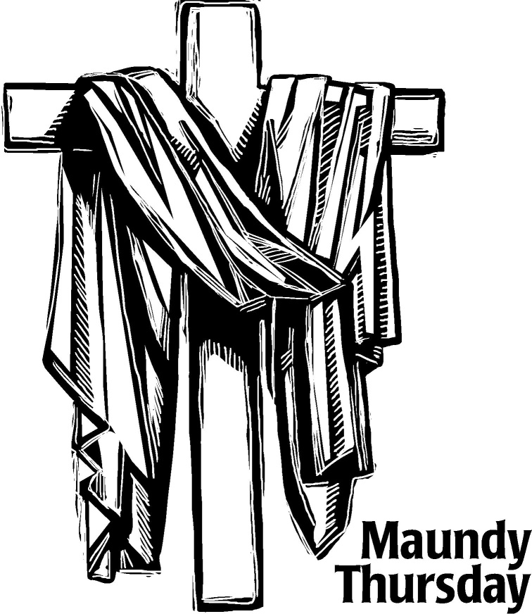

April 18, 2019 - 7:30 PM Worship Service

WELCOME VISITORS!
We're glad you are here! Cards at the ends of each pew are for you to fill out and drop in the Offering Plate. Please let us know you are visiting, and join us for refreshments and fellowship following the service. The Sanctuary has an induction loop system to assist the hearing impaired. The system will also work on the telephone setting of hearing aids. A head set is available upon request.

Springfield Presbyterian Church is rooted in the gospel of Jesus Christ, led by the Holy Spirit, and called to loving relationships through vibrant worship and service. Valuing all people, we are committed to developing disciples and fostering stewardship.

PREPARATION FOR THE WORD

When you enter the Sanctuary tonight, please prepare for the service in silence.

(* those who are able are invited to stand)

PRAYER OF PREPARATION
Beloved people of God: This is the day when Christ, our Passover Lamb, surrendered himself to those who would kill him, setting us free from sin and death forever. This is the day when Christ, our Teacher and Lord, knelt down to wash the disciples’ feet, showing us how to love and serve one another. This is the day when Christ, the bread of heaven, shared a holy meal with his followers, offering a feast of abundant life and grace for all.

CALL TO WORSHIP [Psalm 116]
Leader: We love you, Lord. You hear us. You listen to our prayers.
People: You have always heard us whenever we’ve called to you.
Leader: Though death tries to bind us and the gates of hell open before us,
People: We will call on the Lord’s name for deliverance.
Leader: You are full of grace and righteousness.
People: Lord, you are full of compassion!
Leader: You have saved us and preserved us, God.
People: We rest in your love and care.
Leader: How can we repay you, Lord, for the gifts you’ve showered upon us?
People: We offer our thanksgiving to you before all your people!
Leader: O praise the Lord!
People: Praise be to God! Amen.

* HYMN: An Upper Room Did Our Lord Prepare #202

PRAYER OF CONFESSION (Unison)
Eternal God, whose covenant with us is never broken, we confess that we fail to fulfill your will. Though you have bound yourself to us, we will not bind ourselves to you. In Jesus Christ you serve us freely, but we refuse your love and withhold ourselves from others. We do not love you fully or love one another as you command. In your mercy, forgive and cleanse us. Lead us once again to your table and unite us to Christ, who is the bread of life and the vine from which we grow in grace. Amen.

SILENT PRAYERS OF CONFESSION

MUSICAL RESPONSE GTG #471
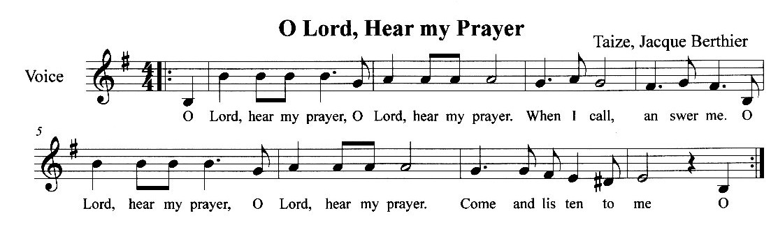

WORDS OF ASSURANCE
Leader: The mercy of the Lord is from everlasting to everlasting. I declare to you, in the name of Jesus Christ, you are forgiven.
People: May the God of mercy, who forgives us all our sins, strengthen us in all goodness, and by the power of the Holy Spirit keep us in eternal life. Amen.

SCRIPTURE LESSON 1 Corinthians 11:23-26 NT page 163

* THE PEACE The peace of Christ be with you! And also with you!
(You may greet those around you.)

REFLECTION Do This In Remembrance of Me Rev. Becca Crate

HOLY COMMUNION

INVITATION

THE GREAT PRAYER OF THANKSGIVING
The Lord be with you. And also with you.
Lift up your hearts. We lift them up to the Lord.
Let us give thanks to God. It is right to give our thanks and praise.
[The Pastor continues… “…who forever sing the glory of your name.”]

IN PRAISE OF GOD
Holy, holy, holy, Lord, God of power and might
Heaven and earth are full of your glory,
Hosanna in the highest!
Blessed is He who comes in the name of the Lord.
Hosanna in the highest, hosanna in the highest.
[The Pastor continues… “…proclaim the One crucified and risen.”]

IN PRAISE OF CHRIST Tune #553
Christ has died; Christ is risen; Christ will come again.
Christ has died; Christ is risen; Christ will come again.
PASTORAL PRAYER AND THE LORD’S PRAYER

WORDS OF INSTITUTION

SHARING OF THE MEAL

PRAYER OF DEDICATION (Unison)
God of grace, your Son Jesus Christ left us this holy meal of bread and wine in which we share His body and blood. May we who have celebrated this sign of His great love show in our lives the fruits of His redemption; through Jesus Christ our Lord, who lives and reigns with you and the Holy Spirit, one God, now and forever. Amen.

THE SERVICE OF TENEBRAE

THE STRIPPING OF THE CHURCH

RESPONSE GTG #204
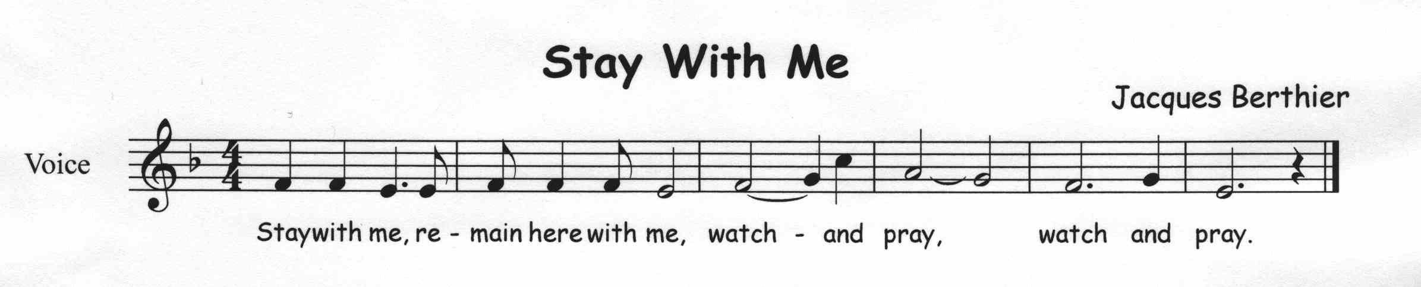

THE PASSION OF THE LORD

The Arrest and Denial John 18:1-28a Hymn #220 Go to Dark Gethsemane

The Trial John 18:28b- 40a Hymn #218 Ah, Holy Jesus (verses 1 & 2)

The Cry for Death John 19:1-18 Hymn #221 O Sacred Head, Now Wounded

The Crucifixion John 19:19-30 Anthem A Purple Robe, A Crown of Thorn
By Larson/Gabriel

The Burial John 19:31-42 Hymn #228 Were You There (verses 4 & 5)

The Word Was God John 3:16-17 & 1:1-5

RESPONSE GTG #227
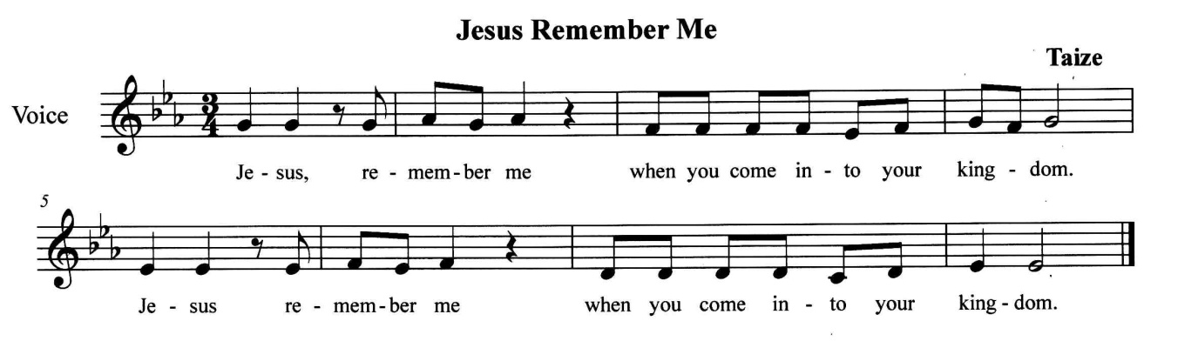

HOLY SILENCE AND TENEBRAE (Darkness)

THE TOLLING OF THE BELL

DEPARTURE (Silence)

The lighting of the chancel will mark the end of the service. You may remain in the Sanctuary for a time of personal prayer and reflection. When you depart, please do so as quietly as possible, respecting the private devotions of those around you.

Maundy Thursday has been from early times a day of particular solemnity for Christians. It serves to commemorate the institution of the Sacrament of the Lord’s Supper. The title Maundy is from the Latin phrase “mandatum novum do vobis” of John 13:34, “A new commandment I give to you, that you love one another; just as I have loved you, love”; and of 1 Corinthians 11.24, “Do this, in remembrance of me.”

Tenebrae means “darkness” or “shadows” in Latin. The term has traditionally been used in reference to services of lessons dramatizing the last days of our Lord. The twelve smaller candles represent the twelve disciples. The larger candle is the Christ candle. As the service progresses, the candles are extinguished, representing the disciples’ betrayal and denial of Jesus and his impending death.

