(Large Print)

Springfield Presbyterian Church (USA)
7300 Spout Hill Road, Sykesville, MD 21784 410-795-6152

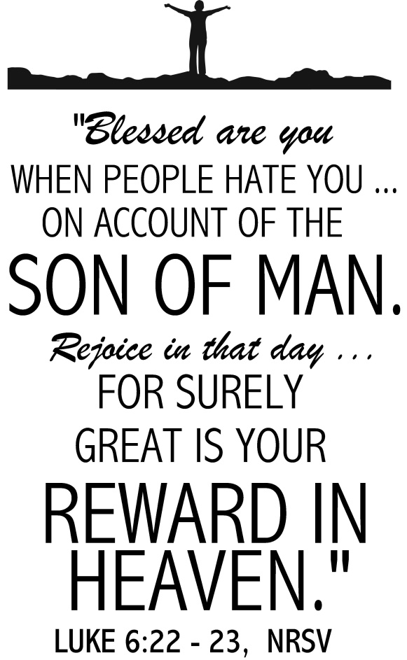

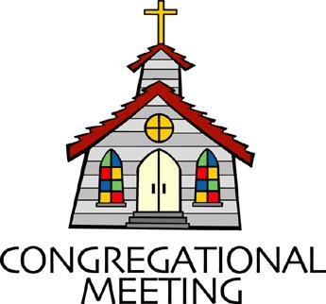
February 17, 2019 - 10:30 am

WELCOME VISITORS! We're glad you are here! Cards at the ends of each pew are for you to fill out and drop in the Offering Plate. Please let us know you are visiting, and join us for refreshments and fellowship following the service. The Sanctuary has an induction loop system to assist the hearing impaired. The system will also work on the telephone setting of hearing aids.

Springfield Presbyterian Church is rooted in the gospel of Jesus Christ, led by the Holy Spirit, and called to loving relationships through vibrant worship and service. Valuing all people, we are committed to developing disciples and fostering stewardship.
PREPARATION FOR THE WORD
(* those who are able are invited to stand)

Please prepare for worship by listening to the music of the Prelude.

PRELUDE

GATHERING OF THE PEOPLE

The Lord be with you! And also with you! (Greeting)

LIGHTING THE CHRIST CANDLE
Leader: Whenever we light this candle we proclaim:
People: Christ is the Light of the world and the center of our lives.

CALL TO WORSHIP [Variation of Psalm 138]
Leader: We give you thanks, O Lord, with our whole heart;
People: We bow down toward your holy temple.
Leader: We give thanks to your name for your steadfast love and your faithfulness;
People: You have exalted your name and your word above everything.
Leader: On the day we called, you answered us,
People: You increased the strength of our souls.
Leader: All the kings of the earth shall praise you,
People: For they have heard the words of your mouth.
Leader: They shall sing of the ways of the Lord,
People: The glory of the Lord is great.
Leader: For though the Lord is high, He regards the lowly;
People: The haughty He perceives from far away.
Leader: Though we walk in the midst of trouble,
People: You preserve us against the wrath of our enemies;
Leader: You stretch out your hand, and your hand delivers us.

People: The Lord will fulfill His purpose for us;
Leader: Your steadfast love, O Lord, endures forever.
People: Do not forsake the work of your hands.
ALL: Let us praise the God of blessing and glory! Let us worship God!

* HYMN Arise, Your Light Is Come!
Arise, your light is come! The Spirit’s call obey;
Show forth the glory of your God, which shines on you today.

Arise, your light is come! Fling wide the prison door;
Proclaim the captives’ liberty, good tidings to the poor.

Arise, your light is come! All you in sorrow born,
Bind up the broken-hearted ones and comfort those who mourn.

Arise, your light is come! The mountains burst in song!
Rise up like eagles on the wing; God’s power will make us strong.

PRAYER OF CONFESSION
Generous God, we are an inpatient people. We want our blessing now, we do not wish to wait, we do not want to put ourselves last so that others may thrive. It is not because we are bad people, it is our human instinct, yet you call us to live by a different way. You walk alongside the poor, the hungry, the ones who weep and you ask us, whether or not we are those people, to walk alongside those whose blessing seems far off. You ask us to be disciples that encourage and inspire, yet we often get wrapped up in our own dreams and goals. Part of us is afraid – who are these people, your people, who live with less. We ask for your forgiveness, O God. Help us to journey alongside the hurting with patience, to be encouragers, and to walk away from the fear that grasps us. Help

us to be your disciples, your people, who serve you in bold and brave ways. Amen.

SILENT PRAYERS OF CONFESSION

RESPONSE Restore in Us, O God
Restore in us, O God, the splendor of your love;
Renew your image in our hearts, and all our sins remove.

WORDS OF ASSURANCE
Leader: The mercy of the Lord is from everlasting to everlasting!
People: May the God of mercy, who forgives us all our sins, strengthen us in all goodness and by the power of the Holy Spirit renew us. Amen!

* MUSICAL RESPONSE OF PRAISE Joyful, Joyful, We Adore Thee
Joyful, joyful, we adore thee, God of glory, Lord of love!
Hearts unfold like flowers before thee, opening to the sun above.
Melt the clouds of sin and sadness; drive the dark of doubt away.
Giver of immortal gladness, fill us with the light of day.

* THE PEACE The peace of Christ be with you! And also with you!
(You may greet those around you.)

* RESPONSE Here I Am, Lord
Here I am, Lord, Is it I, Lord? I have heard you calling in the night.
I will go, Lord, if you lead me. I will hold your people in my heart.

THE PROCLAMATION OF THE WORD

PRAYER OF ILLUMINATION
Almighty God, in you are hidden all the treasures of wisdom and knowledge. Open our eyes that we may see the wonders of your Word; and give us grace that we may clearly understand and freely choose the way of your wisdom; through Christ our Lord. Amen.

FIRST SCRIPTURE LESSON Psalm 1
¹ Happy are those who do not follow the advice of the wicked, or take the path that sinners tread, or sit in the seat of scoffers; ² but their delight is in the law of the Lord, and on his law they meditate day and night. ³ They are like trees planted by streams of water, which yield their fruit in its season, and their leaves do not wither. In all that they do, they prosper. ⁴ The wicked are not so, but are like chaff that the wind drives away. ⁵ Therefore the wicked will not stand in the judgement, nor sinners in the congregation of the righteous; ⁶ for the Lord watches over the way of the righteous, but the way of the wicked will perish.

SECOND SCRIPTURE LESSON Luke 6:17-26
¹⁷He came down with them and stood on a level place, with a great crowd of his disciples and a great multitude of people from all Judea, Jerusalem, and the coast of Tyre and Sidon. ¹⁸They had come to hear him and to be healed of their diseases; and those who were troubled with unclean spirits were cured. ¹⁹And all in the crowd were trying to touch him, for power came out from him and healed all of them.
²⁰Then he looked up at his disciples and said: ‘Blessed are you who are poor, for yours is the kingdom of God. ²¹ ‘Blessed are you who are hungry now, for you will be filled. ‘Blessed are you who weep now, for you will laugh. ²² ‘Blessed are you when people hate you, and when they exclude you, revile you, and defame you on account of the Son of Man. ²³Rejoice on that day and leap for joy, for surely your reward is great in heaven; for that is what their ancestors did to the prophets.
²⁴ ‘But woe to you who are rich, for you have received your consolation.
²⁵ ‘Woe to you who are full now, for you will be hungry. ‘Woe to you who are laughing now, for you will mourn and weep. ²⁶ ‘Woe to you when all speak well of you, for that is what their ancestors did to the false prophets.

Leader: Hear what the Spirit is saying to the Church.
All: Thanks be to God.

TIME WITH YOUNG PEOPLE

SERMON Redemptive Blessings Rev. Becca Crate

THE RESPONSE TO THE WORD

* HYMN Blest Are They
Blest are they, the poor in spirit; theirs is the kingdom of God.
Blest are they, full of sorrow; they shall be consoled.

Refrain:
Rejoice and be glad! Blessed are you; holy are you!
Rejoice and be glad! Yours is the kingdom of God!

Blest are they, the lowly ones; they shall inherit the earth.
Blest are they, who hunger and thirst, they shall have their fill. [Refrain]

Blest are they who show mercy; mercy shall be theirs.
Blest are they, the pure of heart; they shall see God. [Refrain]

Blest are they who seek peace; they are the children of God.
Blest are they who suffer in faith; the glory of God is theirs. [Refrain]
Blest are you who suffer hate, all because of me.
Rejoice and be glad; yours is the kingdom; shine for all to see. [Refrain]

PASTORAL PRAYER AND THE LORD’S PRAYER
“For this I pray to God.” / “For this I give thanks to God.”
Congregational Response: “Hear our prayer, O God.”

PRESENTATION OF TITHES AND OFFERINGS
OFFERTORY The River by Jordan Feliz
* SONG OF THANKS Take Thou Our Minds, Dear Lord
Take thou ourselves, O Lord, heart, mind and will;
Through our surrendered souls thy plans fulfill.
We yield ourselves to thee: time, talents, all;
We hear, and henceforth heed, thy sovereign call.
* PRAYER OF DEDICATION

* HYMN Come, Thou Fount of Every Blessing
Come, thou Fount of every blessing; tune my heart to sing thy grace;
Streams of mercy, never ceasing, call for songs of loudest praise.
Teach me some melodious sonnet, sung by flaming tongues above;
Praise the mount! I’m fixed upon it, mount of God’s unchanging love!

Here I raise my Ebenezer; hither by thy help I’m come;
And I hope, by thy good pleasure, safely to arrive at home.
Jesus sought me when a stranger, wandering from the fold of God;
He, to rescue me from danger, interposed his precious blood.

O to grace how great a debtor, daily I’m constrained to be!
Let that grace now, like a fetter, bind my wandering heart to thee.
Prone to wander, Lord, I feel it, prone to leave the God I love;
Here’s my heart; O take and seal it; seal it for thy courts above.

* CHARGE AND BENEDICTION
Leader: Blessed are you,
People: Who walk with the weary.
Leader: Blessed are you,
People: Who love without judgment.
Leader: Blessed are you,
People: For we are the Kingdom of God. Amen.

* UNISON AMEN

POSTLUDE

Assisting in Worship: We appreciate those who serve:

Today 2/17 Next Week 2/24
Sunday Opener Barbara Cornell Jennifer Wise
Greeters & Ushers Don Vasbinder & Steve & Donna Mazer
Charlie Sperling
Lay Leader Diana Steppling Kathy Russ
Sunday School Connie Robinson Connie Robinson
Fellowship Sandy Newsome Barbara Cornell

Church Attendance: February 3 - 45 February 10 - 45
Concert - 94!

Church Cleaning: Feb. 22, 23 or 24 - Sandy & Ed Newsome

Happy Birthday! February 18 - Dorothy Schafer
February 24 - Jim Wise

Sunday February 24 Lectionary
Genesis 45:3-11, 15; Psalm 37:1-11, 39-40; 1 Corinthians 15:35-38,
42-50; Luke 6:27-38
Announcements

Flowers: The altar flowers are given to the glory of God in loving memory of Margaret “Peggy” Robbins on the one year anniversary of her joining the saints triumphant and in thanksgiving for her and Don Smith’s involvement with the saints at Springfield Presbyterian Church.

Food Drive: Please use the envelopes in the pews for the food drive through February 24 to stock the Sykesville Middle School Food Pantry.

Concert Committee: It is time again to get a few of us together to decide on what groups we'd like to invite for our next Concert Series year. We will meet 2 or 3 times in the next couple of months and plan to have our lineup for the 2019-2020 year finished by the end of April. We'd love to have people on the committee who are interested in the concerts and music in general... please consider joining us! If you are interested, please let Linda Caviglia know. (410-746-1221 or cavig5@comcast.net)

C.I.A. (Community In Action) will meet TOMORROW from 4:30-6 pm at the Manse. Pizza and drinks provided. Friends are welcome and encouraged to attend! C.I.A is a group open to all religious and non-religious people as a means of providing the community with acts of kindness. We will be doing different activities throughout the school year to help people in our community who are in need. Come and be part of giving back to our community.

Bible Study: Sarah Lantz will lead a Bible Study from Namesake: When God Rewrites Your Story by Jessica LaGrone. We will meet on three Tuesday evenings at 7:00 pm at Panera in Eldersburg - February 19, March 5, and March 19. Please join us!

Shrove Sunday Pancakes!!! No, you’re reading that right - Shrove Sunday, not Tuesday! On Sunday, March 3, we will celebrate Shrove Sunday with a pancake lunch/brunch in the Fellowship Room. We need volunteers to bring in griddles, pancake mix, syrup, etc., so please indicate what you’ll bring on the sign-up sheet downstairs.

Some interesting facts:
Quinquasegima is the 50-day period before Easter, which begins on Shrove Sunday - the Sunday before Ash Wednesday.
To shrive: to confess, ask for forgiveness, receive absolution; shrove is the past tense of shrive.
Historical note: The Shrove period originated in the Middle Ages and started on the Sunday before Ash Wednesday. It was a three-day celebration that culminated in a feast on Tuesday evening. During Lent, consumption of foods such as milk, eggs, meat, and fats was restricted. In order to use up those foods, the English began the tradition of making pancakes in order to use up as much milk, eggs, and fat as possible so they wouldn't spoil. In France, consuming primarily fats and fatty foods on this day is what led it to be known as "Fat Tuesday" or Mardi Gras.

Newsletter Deadline: The deadline for submitting information for the March newsletter is February 20. Please submit your info to spc.office@verizon.net.

Weekly Announcements: If you have an announcement to include with next week’s bulletin, please call the Office at 410-795-6152 or email to spc.office@verizon.net by Wednesday each week.

Prayers & Thanksgivings

~ Prayers of comfort for the family of Robert Frothingham, who passed away on February 10.
~ Prayers of comfort for Bob Rogers and family on the loss of his sister-in-law, Rebecca Rogers, and his aunt who passed away on February 6.
~ Prayers for Christ Memorial Presbyterian from our Ministry Group.

The Congregational Care team wants to know what YOU or someone you know needs...a visit...a call...a meal. Please contact Diana Steppling or Connie Robinson.

Today:
Sunday February 17
9:00 am Red Sea Parting Practice
10:30 am Worship & Sunday School
11:30 am Fellowship

This Week:
Monday February 18
9:30 am Feed My Sheep (Wesley Freedom)
4:30 pm C.I.A. Meeting (Manse)
Wednesday February 20
6:30 pm Bell Choir Practice
7:45 pm Adult Choir Practice

Looking Ahead:
Sunday February 24
10:30 am Worship & Sunday School
11:30 am Fellowship
11:30 am Youth Depart for Food Pantry Shopping
Tuesday February 26
10:30 am Prayer Group (Manse)
Wednesday February 27
6:30 pm Bell Choir Practice
7:45 pm Adult Choir Practice

Office Hours: Tuesday, Wednesday, Friday 9:00 am - 3:00 pm
Springfield Presbyterian Church

10:30 am Worship & Sunday School
11:30 am Fellowship
Website: www.springfield-church.org Church Office: 410-795-6152
Like us on Facebook: www.facebook.com/SpringfieldPresbyterianChurch
Pastor: Rev. Becca Crate
Email: springfieldpastor@gmail.com
Clerk of Session: Sharon Pappas
Minister of Music: Linda Caviglia
Accompanist: Aaron Thacker Organist: Jennifer Wise
Youth Group Coordinators: Charles & Deb Sperling
Sunday School Coordinator: Connie Robinson
Administrative Assistant: Donna Mazer
e-mail: spc.office@verizon.net

