Springfield Presbyterian Church (USA)
7300 Spout Hill Road, Sykesville, MD 21784 410-795-6152

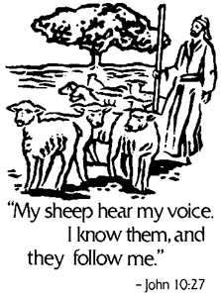
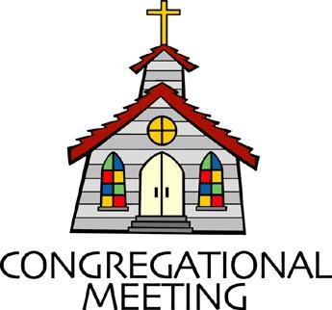
May 12, 2019 - 10:30 am

WELCOME VISITORS! We're glad you are here! Cards at the ends of each pew are for you to fill out and drop in the Offering Plate. Please let us know you are visiting, and join us for refreshments and fellowship following the service. The Sanctuary has an induction loop system to assist the hearing impaired. The system will also work on the telephone setting of hearing aids.

Springfield Presbyterian Church is rooted in the gospel of Jesus Christ, led by the Holy Spirit, and called to loving relationships through vibrant worship and service. Valuing all people, we are committed to developing disciples and fostering stewardship.
PREPARATION FOR THE WORD
(* those who are able are invited to stand)

PRELUDE

GATHERING OF THE PEOPLE

The Lord be with you! And also with you! (Greeting)

LIGHTING THE CHRIST CANDLE
Leader: Whenever we light this candle we proclaim:
People: Christ is the Light of the world and the center of our lives.

CALL TO WORSHIP [Psalm 100]
Leader: Shout for joy to the Lord!
People: Shout for joy, all the earth!
Leader: Let us worship the Lord with gladness!
People: Let us come before God with joyful songs!
Leader: Let us know that the Lord is God.
People: It is God who made us, we belong to Him;
Leader: We are God’s people, the sheep of the pasture.
People: Let us enter the gates with thanksgiving
Leader: Let us enter the courts with praise;
People: Let us give thanks and praise God’s name!
Leader: The Lord is good and God’s love endures forever.
People: God’s faithfulness continues through all generations.
ALL: Let us praise our faithful God!

* HYMN My Shepherd Will Supply My Need
My shepherd will supply my need; Jehovah is his name.
In pastures fresh he makes me feed, beside the living stream.
He brings my wandering spirit back when I forsake his ways,
and leads me, for his mercy's sake, in paths of truth and grace.
When I walk through the shades of death your presence is my stay;
one word of your supporting breath drives all my fears away.
Your hand, in sight of all my foes, does still my table spread;
my cup with blessings overflows; your oil anoints my head.
The sure provisions of my God attend me all my days;
O may your house be my abode, and all my work be praise.
There would I find a settled rest, while others go and come;
no more a stranger, or a guest, but like a child at home.
PRAYER OF CONFESSION
Generous God, again and again, you call us to be your sheep. You walk with us, before us, behind us, around us, tending to us. Yet, we are rebellious in our ways. We go astray, we look for other shepherds, hoping to sweeten the deal. We want our ways and we struggle to acknowledge that if a sheep doesn’t look like us or act like us – how can we all be yours? Yet you call us to unity, to love, and to you. Forgive us for the ways in which we stray and continue in your loving mercy to call us back, again and again, to your tender care. Amen.

SILENT PRAYERS OF CONFESSION

RESPONSE Restore in Us, O God
Restore in us, O God, the splendor of your love;
Renew your image in our hearts, and all our sins remove.

WORDS OF ASSURANCE
Leader: Our God is one of mercy, acceptance, and calls us back into the fold, shame and guilt free.
People: People of the flock: you are forgiven! Praise God forevermore! Amen.
* MUSICAL RESPONSE OF PRAISE Alleluia, Alleluia! Give Thanks
Alleluia, alleluia! Give thanks to the risen Lord.
Alleluia, alleluia! Give praise to His name.

* THE PEACE The peace of Christ be with you! And also with you!
(You may greet those around you.)

* RESPONSE Here I Am, Lord
Here I am, Lord, Is it I, Lord? I have heard you calling in the night.
I will go, Lord, if you lead me. I will hold your people in my heart.

THE PROCLAMATION OF THE WORD

PRAYER OF ILLUMINATION
Dear God, guide our hearts, minds, and souls to meditate on your Word and to listen with intentionality into what your Word calls us to this day and onwards. Amen.

FIRST SCRIPTURE LESSON Psalm 23
¹ The Lord is my shepherd, I shall not want. ² He makes me lie down in green pastures; he leads me beside still waters; ³ he restores my soul. He leads me in right paths for his name’s sake. ⁴ Even though I walk through the darkest valley, I fear no evil; for you are with me; your rod and your staff— they comfort me.
⁵ You prepare a table before me in the presence of my enemies; you anoint my head with oil; my cup overflows. ⁶ Surely goodness and mercy shall follow me
all the days of my life, and I shall dwell in the house of the Lord my whole life long.
SECOND SCRIPTURE LESSON John 10:22-30
22 At that time the festival of the Dedication took place in Jerusalem. It was winter, ²³and Jesus was walking in the temple, in the portico of Solomon. ²⁴So the Jews gathered around him and said to him, ‘How long will you keep us in suspense? If you are the Messiah, tell us plainly.’ ²⁵Jesus answered, ‘I have told you, and you do not believe. The works that I do in my Father’s name testify to me; ²⁶but you do not believe, because you do not belong to my sheep. ²⁷My sheep hear my voice. I know them, and they follow me. ²⁸I give them eternal life, and they will never perish. No one will snatch them out of my hand. ²⁹What my Father has given me is greater than all else, and no one can snatch it out of the Father’s hand. ³⁰The Father and I are one.’

Leader: Hear what the Spirit is saying to the Church.
All: Thanks be to God.

TIME WITH YOUNG PEOPLE

SERMON A Part of the Shepherd’s Flock Rev. Becca Crate

THE RESPONSE TO THE WORD

* HYMN
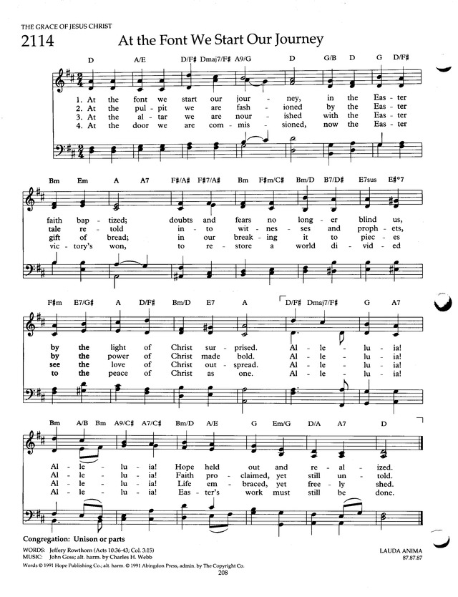
THE SACRAMENT OF BAPTISM

Harrison Joseph Rachin, son of Daniel J. & Brittany S. Rachin
Officiants:
Rev. Becca Crate, pastor, Springfield Presbyterian Church
Rev. Malcolm Stranathan, pastor, Westminster United Methodist Church

Presentation

Leader: There is one body and one Spirit, just as you were called to the one hope of your calling.
People: One Lord, one faith, one baptism, one God and Father of all, who is above all and through all and in all.

Questions

Do you desire that Harrison be baptised?
Parents: We do.

Relying on God’s grace, do you promise to live the Christian faith, and teach that faith to your child?
Parents: We do.

(To the sponsors/godparents if there are any)
Will you, by your prayers and witness, help Harrison to grow into the full stature of Christ?
Sponsor: I/We will.

(To the congregation)
Do you, as members of the church of Jesus Christ, promise to guide and nurture Harrison by word and deed, with love and prayer?
People: We will

Will you encourage him to know and follow Christ and to be faithful members of his church?
People: We will.

Profession of Faith

Trusting in the gracious mercy of God, do you turn from the ways of sin and renounce evil and its power in the world?
Parents: We do.

Who is your Lord and Savior?
Parents: Jesus Christ is my Lord and Savior

Will you be Christ’s faithful disciple, obeying his word and showing his love?
Parents: We will, with God’s help.

And now, as a whole church, let us confess our faith together by reciting the Apostle’s Creed together.

*Apostle’s Creed

I believe in God the Father almighty, Maker of heaven and earth. And in Jesus Christ, his only begotten Son, our Lord; who was conceived by the Holy Spirit,
born of the virgin Mary; suffered under Pontius Pilate; was crucified, dead, and buried; he descended into hell; the third day he rose again from the dead;
he ascended into heaven, and is seated at the right hand of God the Father almighty; from there he shall come to judge the living and the dead.
I believe in the Holy Spirit. I believe a holy catholic church, the communion of saints; the forgiveness of sins; the resurrection of the body; and the life everlasting. Amen.

Blessing the Waters

The Lord be with you
People: And also with you
Let us give thanks to the Lord our God
People: It is right to give our thanks and praise

Baptism

With joy and thanksgiving, we welcome Harrison into the body of Christ!
People: Alleluia! Amen!

Baptismal Candle

The peace of Christ be with you.
People: And also with you.
Welcome
PRESENTATION OF TITHES AND OFFERINGS
OFFERTORY Speak, O Lord Keith Getty & Stuart Townend
* SONG OF THANKS God, We Honor You
God, we honor you. God, we trust in you. God, we worship and adore you. Take what we bring, offered to you. Teach us to show your abundant blessings. Alleluia, alleluia, alleluia, amen.
* PRAYER OF DEDICATION

* HYMN
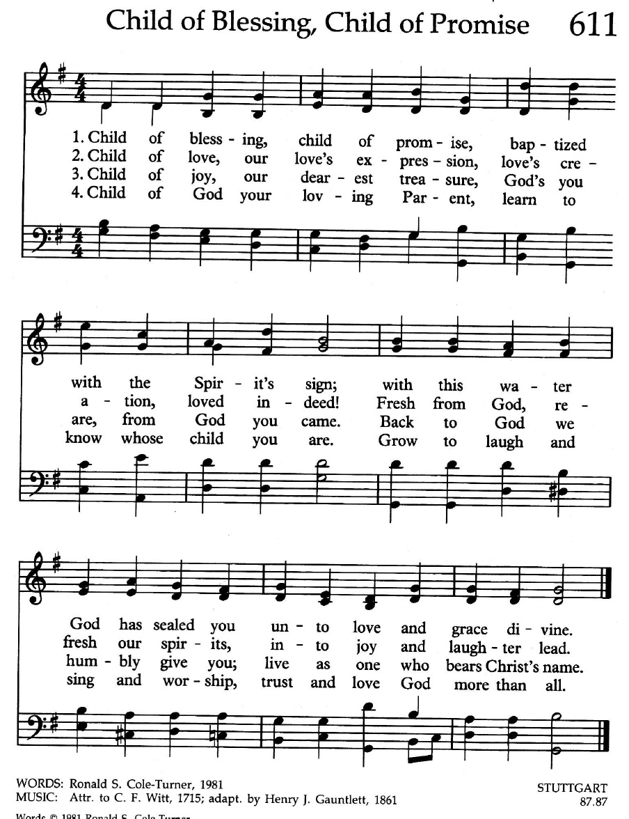

* CHARGE AND BENEDICTION

Leader: Through God’s generous love
People: We are His people.
Leader: Through God’s generous love,
People: He cleanses us with water and feeds us at the table.
Leader: Through God’s generous love,
People: We pour out our generosity on others, seeking to live a life of love, service, and mercy.
* UNISON AMEN

POSTLUDE

Sunday May 19 Lectionary
Acts 11:1-18; Psalm 148; Revelation 21:1-6; John 13:31-35

Assisting in Worship: We appreciate those who serve:

Today 5/12 Next Week 5/19
Sunday Opener Barbara Cornell Beth Oates
Greeters & Ushers Don Vasbinder & Martha Streaker &
Charlie Sperling Bob Rogers
Lay Leader Diana Steppling Bob Steppling
Sunday School Connie Robinson Connie Robinson
Fellowship Barbara Nickell Deb Sperling

Church Cleaning: May 17, 18 or 19 – The Oates Family

Church Attendance: April 28 – 42 May 5 - 39

Happy Birthday! May 18 – Georgia Hodges

Announcements

A Special Welcome: Today, we celebrate the baptism of Harrison J. Rachin. Harrison, the son of Danny and Brittany Rachin was born September 17, 2018 at Howard County General. We extend a warm welcome to Harrison’s large and loving family and friends, many who are with us this morning: grandparents Nicky Young-Rachin, Joe Rachin (in Arizona), Jacki Stranathan and Rev. Malcolm Stranathan; great grandparents Jack and Jane Anderson; aunts and uncles Beth Stranathan, Wesley Stranathan, and Mike Rachin (in Arizona); godparents (and god sister!) Adam and Sara Swecker and Sophie.

Summer Worship Hours: We are asking the congregation to vote on whether or not we should move Worship to 9:30 for the summer or keep it at 10:30 am. If you haven’t already done so, please pick up a ballot with your choice of time and drop it in the offering plate. Please vote only once.

Spring Plant Sale: Between May 1 and May 21, buy your spring plants at Buppert’s and they will donate 15% of your purchase price back to Springfield! Pick up a flyer in the Narthex and share it with your family and friends!

C.I.A. (Community In Action) will meet on Monday, May 20 from 4:30 - 6 pm at the Manse. Pizza and drinks provided. Friends are welcome and encouraged to attend! C.I.A is a group open to all religious and non-religious people as a means of providing the community with acts of kindness. We will be doing different activities throughout the school year to help people in our community who are in need. Come and be a part of giving back to our community!

Prayers & Thanksgivings

~ Prayers for Kathy Russ, recovering from surgery
~ Prayers for Catonsville Presbyterian from our Ministry Group.

The Congregational Care team wants to know what YOU or someone you know needs....a visit...a call....a meal. Please contact Diana Steppling or Connie Robinson.

Today:
Sunday May 12
10:30 am Worship & Sunday School
11:30 am Fellowship

This Week:
Monday May 13
7:00 pm Headhuggers (Manse)
Tuesday May 14
10:30 am Prayer Group (Manse)
7:00 pm Pack ESCAPE Lunches (Manse)
Wednesday May 15
6:30 pm Bell Choir Practice
7:45 pm Adult Choir Practice
Friday May 17
7:00 pm Game Night

Looking Ahead:
Sunday May 19
10:30 am Worship & Sunday School
Handbells Play
11:30 am Fellowship
Monday May 20
9:30 am Feed My Sheep (WFUMC)
4:30 pm C.I.A. Meeting (Manse)
Wednesday May 22
No Choir Practice

Office Hours: Tuesday, Wednesday, Friday 9:00 am - 3:00 pm

Springfield Presbyterian Church

10:30 am Worship & Sunday School
11:30 am Fellowship
Website: www.springfield-church.org Church Office: 410-795-6152
Like us on Facebook: www.facebook.com/SpringfieldPresbyterianChurch
Pastor: Rev. Becca Crate
Email: springfieldpastor@gmail.com
Clerk of Session: Sharon Pappas
Minister of Music: Linda Caviglia
Accompanist: Aaron Thacker Organist: Jennifer Wise
Youth Group Coordinators: Charles & Deb Sperling
Sunday School Coordinator: Connie Robinson
Administrative Assistant: Donna Mazer
e-mail: spc.office@verizon.net

