Springfield Presbyterian Church (USA)
7300 Spout Hill Road, Sykesville, MD 21784 410-795-6152
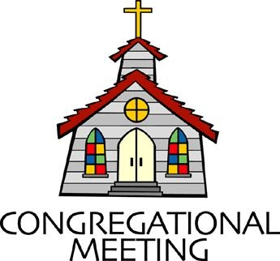

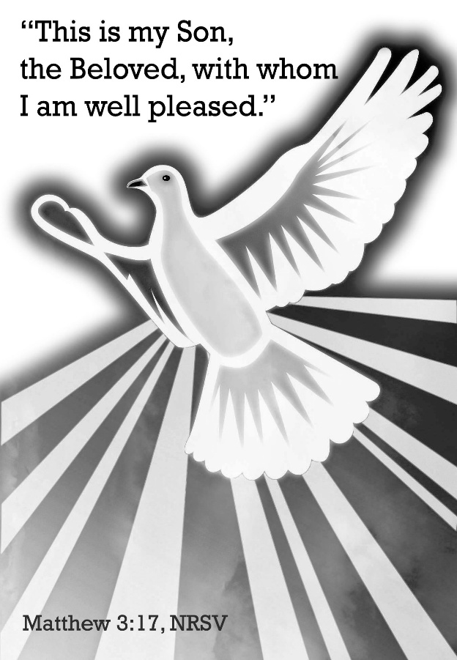

January 11, 2026 - 10:30 am

WELCOME VISITORS!

We're glad you are here! Cards at the ends of each pew are for you to fill out and drop in the Offering Plate. Please let us know you are visiting and join us for refreshments and fellowship following the service. The Sanctuary has an induction loop system to assist the hearing impaired. The system will also work on the telephone setting of hearing aids.

Springfield Presbyterian Church is rooted in the gospel of Jesus Christ, led by the Holy Spirit, and called to loving relationships through vibrant worship and service. Valuing all people, we are committed to developing disciples and fostering stewardship.

PREPARATION FOR THE WORD
(* those who are able are invited to stand)

PRELUDE

GATHERING OF THE PEOPLE

The Lord be with you! And also with you! (Greetings and Announcements)

LIGHTING THE CHRIST CANDLE
Leader: Whenever we light this candle we proclaim:
People: Christ is the Light of the world and the center of our lives.

CALL TO WORSHIP
Leader: The New Year is underway.
People: The star is still guiding us.
Leader: This is a season of beginnings: time to encounter with freshness and anticipation the God who calls us by name, who guides and leads.
All: God takes us by the hand and keeps us. In life and in death, we belong to God!

* HYMN Spirit Divine, Attend Our Prayers GTG #407

Spirit divine, attend our prayers, and make this house your home.
Descend with all your gracious powers. O come, great Spirit, come!

Come as the light. To us reveal our emptiness and woe.
And lead us in those paths of life where all the righteous go.

Come as the fire and purge our hearts like sacrificial flame.
Let our whole soul an offering be to our Redeemer's name.

Come as the dove and spread your wings, the wings of peaceful love.
And let the church on earth become blest as the church above.

Spirit divine, attend our prayers. Make a lost world your home.
Descend with all your gracious powers. O come, great Spirit, come!

CALL TO CONFESSION
Leader: Thanks be to God, the Word who speaks life into being, the Wind stirring the waters, the One who makes all things new, who calls us by name, whose love endures forever. In faith and confidence, let us confess our sin, and seek God’s mercy and grace.

PRAYER OF CONFESSION
God of grace, you claim us as beloved children and call us to follow you, but we do not always live out this calling. We stifle the gifts you give us. We sidestep opportunities to offer kindness. We fail to share your love for all. We pretend we can do nothing to further justice in our world. We shy away from taking risks for the sake of the gospel. Forgive us; give us grace. Pour out the power of your Spirit and renew us in our calling: to show the wonder of your love in Jesus Christ our Lord.

SILENT PRAYERS OF CONFESSION

RESPONSE Just as I Am, without One Plea GTG #442 (v. 3)
Just as I am, thou wilt receive, wilt welcome, pardon, cleanse, relieve;
Because thy promise I believe, O Lamb of God, I come; I come!

WORDS OF ASSURANCE
Leader: This good news has been passed from generation to generation, by prophets and priests and sages and seekers, from age to age… passed down to us: God claims us, names us, calls us, fills us with grace in every time, for our lifetime. Believe this good news and give thanks.
All: May the Spirit give us strength to live for others and bless us with the gift of peace.

* MUSICAL RESPONSE OF PRAISE We Praise You, O God GTG #612 (v. 3)
With voices united our praises we offer and gladly our songs of thanksgiving we raise.
With you, Lord, beside us, your strong arm will guide us. To you, our great Redeemer, forever be praise!

* THE PEACE The peace of Christ be with you! And also with you!
(You may greet those around you.)

* RESPONSE Here I Am, Lord GTG #69
Here I am, Lord. Is it I, Lord? I have heard you calling in the night.
I will go, Lord, if you lead me. I will hold your people in my heart.

THE PROCLAMATION OF THE WORD

PRAYER FOR ILLUMINATION
Saving God, source of our calling, your Word is radiant and beautiful. Pour out that Word upon us so that we may hear your voice claiming us as your own. And then by that grace, may we live faithfully as your beloved people, walking the way of Jesus Christ our Lord. Amen.

FIRST SCRIPTURE LESSON Isaiah 42:1-9 OT page 630
¹ Here is my servant, whom I uphold, my chosen, in whom my soul delights; I have put my spirit upon him; he will bring forth justice to the nations. ² He will not cry or lift up his voice, or make it heard in the street; ³ a bruised reed he will not break, and a dimly burning wick he will not quench; he will faithfully bring forth justice. ⁴ He will not grow faint or be crushed until he has established justice in the earth; and the coastlands wait for his teaching. ⁵ Thus says God, the Lord, who created the heavens and stretched them out, who spread out the earth and what comes from it, who gives breath to the people upon it and spirit to those who walk in it: ⁶ I am the Lord, I have called you in righteousness, I have taken you by the hand and kept you; I have given you as a covenant to the people, a light to the nations, ⁷ to open the eyes that are blind, to bring out the prisoners from the dungeon, from the prison those who sit in darkness. ⁸ I am the Lord, that is my name; my glory I give to no other, nor my praise to idols.
⁹ See, the former things have come to pass, and new things I now declare; before they spring forth, I tell you of them.

SECOND SCRIPTURE LESSON Matthew 3:13-17 NT page 3
¹³Then Jesus came from Galilee to John at the Jordan, to be baptized by him.
¹⁴ John would have prevented him, saying, "I need to be baptized by you, and do you come to me?" ¹⁵ But Jesus answered him, "Let it be so now; for it is proper for us in this way to fulfill all righteousness." Then he consented. ¹⁶ And when Jesus had been baptized, just as he came up from the water, suddenly the heavens were opened to him and he saw the Spirit of God descending like a dove and alighting on him. ¹⁷ And a voice from heaven said, "This is my Son, the Beloved, with whom I am well pleased."

Leader: Hear what the Spirit is saying to the Church.
All: Thanks be to God.

SERMON It Starts at the Water By Rev. Sue Lowcock Harris

THE RESPONSE TO THE WORD

* HYMN Down by the Jordan
(to the tune of "Praise Ye the Lord, the Almighty" GTG #35)

Down by the Jordan, a prophet named John was baptizing,
Preaching a message the people found bold and surprising:
"God will forgive! Show that you'll change how you live!
Surely God's new day is rising!"

There by the river, the crowd came with great expectation:
"Are you God's Chosen One, sent here to rescue our nation?"
"No!" John replied. "He who is mightier than I
Judges and offers salvation."

Jesus, you went to be baptized along with the others,
Taking your place among sinners, God's lost sons and daughters.
Then with great love, God's Spirit came as a dove!
Your work began in those waters.

Here in the Church, we are baptized and filled with God's Spirit.
Freed and forgiven, we're welcomed with joy! Can you hear it?
This is God's sign! This is how God says, "You're mine!"
Let's take the good news and share it!

Biblical References: Matthew 3:1-17; Mark 1:1-11; Luke 3:1-22; John 1:6-8, 14-34 Tune: Erneuerten Gesangbuch, Stralsund, 1665 ("Praise Ye the Lord, the Almighty") (MIDI) Text: Copyright © 2000 by Carolyn Winfrey Gillette. All rights reserved.

COMMUNION OF THE PEOPLE
INVITATION

THE GREAT PRAYER OF THANKSGIVING
Leader: The Lord be with you.
People: And also with you.
Leader: Lift up your hearts.
People: We lift them up to the Lord.
Leader: Let us give thanks to the Lord our God.
People: It is right to give our thanks and praise.
[The Pastor continues… “Therefore with all creation we sing your praise.”]

IN PRAISE OF GOD Tune #552
Holy, holy, holy, Lord, God of Power and might.
Heaven and earth are full of your glory, Hosanna in the highest!
Blessed is He who comes in the name of the Lord.
Hosanna in the highest, hosanna in the highest.
[The Pastor continues… “Great is the mystery of faith.”]

IN PRAISE OF CHRIST Tune #553
Christ has died; Christ is risen; Christ will come again.
Christ has died; Christ is risen; Christ will come again.
[The Pastor continues… “almighty God, now and forever.”]

PASTORAL PRAYER AND THE LORD’S PRAYER

WORDS OF INSTITUTION

SHARING OF THE MEAL

PRAYER OF DEDICATION
Leader: God, our Provision, we rejoice that you satisfy our needs. By your presence in this meal, you have fed us and strengthened us, as a mother nourishes her baby. In this waiting season, fill us with hopeful expectation that we may see the signs of your kingdom all around us and rejoice in your coming salvation and glory.
All: Amen.

PRESENTATION OF TITHES AND OFFERINGS
OFFERTORY Come to the Banquet By: Joseph M. Martin
* SONG OF THANKS For the Life That You Have Given GTG #717
For the life that you have given, for the love in Christ made known,
With these fruits of time and labor, with these gifts that are your own:
Here we offer, Lord, our praises; heart and mind and strength we bring;
Give us grace to love and serve you, living what we pray and sing.
* PRAYER OF DEDICATION

* HYMN In Christ There Is No Ease or West GTG #318

In Christ there is no east or west, in him no south or north,
But one great fellowship of love throughout the whole wide earth.

In Christ shall true hearts everywhere their high communion find;
His service is the golden cord close-binding humankind.

Join hands, disciples of the faith, whate’er your face may be.
All children of the living God are surely kin to me.

In Christ now meet both east and west; in him meet south and north.
All Christly souls are one in him throughout the whole wide earth.

* CHARGE AND BENEDICTION
Leader: We are the beloved community of God.
All: In water, God claims us. In calling, God leads us.
Leader: Claimed and called, we go to proclaim:
All: Christ is the light of the world and the center of our lives.

* UNISON AMEN GTG #601

POSTLUDE

Sunday January 18, 2026 Lectionary
Isaiah 49:1-7; Psalm 40:1-11; 1 Corinthians 1:1-9; John 1:29-42

Assisting in Worship: We appreciate those who serve:

Today 1/11 Next Week 1/18
Sunday Opener: Barbara Cornell Beth Oates
Ushers/Greeters: Steve & Donna Mazer Elizabeth Meirowitz
Cynthia Smith
Lay Leader: Max Carroll Tony Caviglia
Pulpit Supply: Rev. Sue Lowcock Harris Rev. Andrea Taylor
Communion Servers: 1. Bob Steppling
2. Barbara Nickell
3. Sharon Pappas
4. Elizabeth Meirowitz
5. Alex McClung
Fellowship Hosts: Linda Caviglia Andrea Kwako
Offering Count: Andrea Kwako Andrea Kwako

Happy Birthday! January 15 – Elizabeth Meirowitz

Announcements

Welcome! We welcome Rev. Sue Lowcock Harris to our pulpit today! Sue is a retired member of Baltimore Presbytery, currently serving as the Moderator of the Presbytery. She was ordained in 1983 and has served congregations, middle governing bodies, and university campuses in diverse roles as co-pastor, interim pastor, chaplain, project coordinator, and faculty, in urban, rural and suburban settings. From 2005 – 2023 she served as one of the Co-Pastors of the First Presbyterian Church of Howard County, with her husband, Morton Harris. Since retirement, she has served as a Bridge Pastor at Second Presbyterian Church and at Hunting Ridge Presbyterian Church where she continues to support the Session as their Moderator.

Welcome Back, Aaron! We are very happy to welcome our accompanist Aaron back after some time off. We are so glad to have you back!

Thank You! I would like to express my appreciation to you all for the Christmas gift! I was not expecting anything, but am grateful for your expression of thanks. I was happy to step in and help with the choir while Aaron was out on medical leave, and I am very appreciative for all the support from the choir and congregation during the last few months. A very happy new year to all and many thanks! ~ Linda Caviglia

Thank You! Many, many thanks to the congregation for your most generous Christmas gift! I am honored to work with all of you! ~ Donna Mazer

Per Capita: We have benefited greatly from funds contributed by all the churches in our presbytery. This fund keeps the lights on, salaries paid, and funds the work of all the commissions, like Baltimore-Dakota, or the Commission on Ministry that is helping us navigate through this season. Presbytery's share is $32.24; Synod's share is $1.50; and General Assembly's share is $11.26. If you are able to contribute the $45 due for 2026, it can be added to your pledge, or use a separate check with Per capita on the memo line, or cash in an envelope. We are grateful for your contribution.

Zoom Link for Worship Services: The Zoom link for church services is on the SPC website, not on the Facebook page. The Bulletin is also available on the website as well.

Congregational Care: If you know of someone who would benefit from a card or a phone call, please text or call Connie Gibbons at 410-935-3467.

Electronic Giving: Below is a QR code you can scan to make your contribution a new way! The page you get will ask for your name, email and phone

number. You can choose from a dropdown menu for selecting where the donation should go: General Fund, Capital Fund, Concert, Memorial. There is a fee for using a credit card, and you will be given the option to pay that fee along with your donation, but you don’t have to include it if you don’t want to.

Today:
Sunday January 11
10:30 am Worship
11:30 am Fellowship

This Week:
Tuesday January 13
3:30 pm Worship Committee Meeting (Zoom)
Wednesday January 14
6:15 – 7:15 pm Bell Choir Practice
7:30 – 8:45 pm Adult Choir Practice

Next Week:
Sunday January 18
10:30 am Worship
11:30 am Fellowship
12:00 noon Nominating Committee Meeting (Library)
Tuesday January 20
7:00 pm CoCaMO Meeting (Manse)
Wednesday January 21
6:15 – 7:15 pm Bell Choir Practice
7:30 – 8:45 pm Adult Choir Practice
Saturday January 24
7:00 pm Family Game Night (Fellowship Room)

Office Hours: Tuesday, Wednesday, Friday, 10 am – 3 pm

Springfield Presbyterian Church
10:30 am Worship (and Sunday School 1st & 3rd Sundays)
11:30 am Fellowship
Website: www.springfield-church.org Church Office: 410-795-6152
Like us on Facebook: www.facebook.com/SpringfieldPresbyterianChurch
Pastor: Vacant
Email: spc.office@verizon.net
Clerk of Session: Sharon Pappas
Minister of Music/Accompanist: Aaron Thacker
Bell Choir Director: Vacant
Youth Group Coordinator: Dylan Vasbinder
Administrative Assistant: Donna Mazer Email: spc.office@verizon.net

