(Large Print)

Springfield Presbyterian Church (USA)
7300 Spout Hill Road, Sykesville, MD 21784 410-795-6152

November 6, 2022 - 10:30 am

WELCOME VISITORS!
We're glad you are here! Cards at the ends of each pew are for you to fill out and drop in the Offering Plate. Please let us know you are visiting, and join us for refreshments and fellowship following the service. The Sanctuary has an induction loop system to assist the hearing impaired. The system will also work on the telephone setting of hearing aids.

Springfield Presbyterian Church is rooted in the gospel of Jesus Christ, led by the Holy Spirit, and called to loving relationships through vibrant worship and service. Valuing all people, we are committed to developing disciples and fostering stewardship.

PREPARATION FOR THE WORD
(* those who are able are invited to stand)

PRELUDE

GATHERING OF THE PEOPLE

The Lord be with you! And also with you! (Greeting)

MINUTE FOR MISSION Baltimore-Dakota Learning Camps

LIGHTING THE CHRIST CANDLE
Leader: Whenever we light this candle we proclaim:
People: Christ is the Light of the world and the center of our lives.

CALL TO WORSHIP
Leader: This is the place and this is the time,
People: Here and now the power of your Spirit breaks into this space.
Leader: To change our minds, to change our attitudes,
People: To change our ways, to change our lives.
Leader: To help us see the whole of life with your eyes,
People: And hear your Word anew.
Leader: To help us embrace your glory,
People: To breathe in the freshness of your Holy Spirit,
Leader: To help us reach out and touch the face of Jesus,
People: To feel your healing touch and taste your mercy,
Leader: To discover you in the unexpected,
People: To worship you with our whole selves. Come, Holy Spirit, come, as we join our hearts, minds, and voices to worship you.

* HYMN God of Grace and God of Glory GTG #307

God of grace and God of glory, on thy people pour thy power;
Crown thine ancient church's story; bring its bud to glorious flower.
Grant us wisdom, grant us courage, for the facing of this hour,
For the facing of this hour.

Lo! the hosts of evil round us scorn thy Christ, assail his ways!
From the fears that long have bound us free our hearts to faith and praise.
Grant us wisdom, grant us courage, for the living of these days,
For the living of these days.

Cure thy children's warring madness; bend our pride to thy control;
Shame our wanton, selfish gladness, rich in things and poor in soul.
Grant us wisdom, grant us courage, lest we miss thy kingdom's goal,
Lest we miss thy kingdom's goal.

Save us from weak resignation to the evils we deplore.
Let the gift of thy salvation be our glory evermore.
Grant us wisdom, grant us courage, serving thee whom we adore,
Serving thee whom we adore.

CALL TO CONFESSION
Leader: The psalmist models a transparent faith with these words: “Search me, O God, and know my thoughts. See if there is any wicked way in me, and lead me in the way everlasting.” (Ps. 139:23-24) We express our longing for God’s leading by our own transparent confession.

PRAYER OF CONFESSION
Generous Lord, in your mercy, hear our prayer. We confess that it is still all too easy for us to sacrifice our convictions for convenience, your standards for status, your principles for promotion, your absolutes for our ambition, our souls for shallow and unsatisfying success. How easily we are seduced by power, prestige, pleasure, or possessions – seduced into violating our integrity or harming our fellowship with you. From earth’s fullest bliss we turn to you again, unfulfilled. Forgive us our half-hearted devotion and our double-minded spirit. In the name Jesus Christ, Amen.

SILENT PRAYERS OF CONFESSION

RESPONSE Remember Not, O God Tune #430
O Lord, our Savior, help, and glorify your name;
Deliver us from all our sins and take away our shame.

WORDS OF ASSURANCE
Leader: May the God of mercy, who forgives all our sins, strengthen us in all goodness, and by the power of the Holy Spirit, keep us in eternal life.
People: We are forgiven! Thanks be to God! Alleluia and amen!

* MUSICAL RESPONSE OF PRAISE We Are Forgiven Tune #447
We are forgiven. We are forgiven. Thanks be to God. Thanks be to God.
We are forgiven. We are forgiven. Thanks be to God. Thanks be to God.

* THE PEACE The peace of Christ be with you! And also with you!
(You may greet those around you.)

* RESPONSE Here I Am, Lord
Here I am, Lord, Is it I, Lord? I have heard you calling in the night.
I will go, Lord, if you lead me. I will hold your people in my heart.

* HYMN Lord, When I Came into This Life GTG #691
Lord, when I came into this life you called me by my name;
Today I come, commit myself, responding to your claim.

Within the circle of the faith, as member of your cast,
I take my place with all the saints of future, present, past.

In all the tensions of my life, between my faith and doubt,
Let your great Spirit give me hope, sustain me, lead me out.

So help me in my unbelief and let my life be true:
Feet firmly planted on the earth, my sights set high on you.

THE PROCLAMATION OF THE WORD

PRAYER OF ILLUMINATION
Living God, help us to hear your Word with open hearts so that we may truly understand; and in understanding, that we may believe; and, in believing, that we may follow in all faithfulness and obedience, seeking your honor and glory in all we do. Through Christ, our Lord. Amen.

FIRST SCRIPTURE LESSON Matthew 25:14-29
¹⁴‘For it is as if a man, going on a journey, summoned his slaves and entrusted his property to them; ¹⁵to one he gave five talents, to another two, to another one, to each according to his ability. Then he went away. ¹⁶The one who had received the five talents went off at once and traded with them, and made five more talents. ¹⁷In the same way, the one who had the two talents made two more talents. ¹⁸But the one who had received the one talent went off and dug a hole in the ground and hid his master’s money. ¹⁹After a long time the master of those slaves came and settled accounts with them. ²⁰Then the one who had received the five talents came forward, bringing five more talents, saying, “Master, you handed over to me five talents; see, I have made five more talents.” ²¹His master said to him, “Well done, good and trustworthy slave; you have been trustworthy in a few things, I will put you in charge of many things; enter into the joy of your master.” ²²And the one with the two talents also came forward, saying, “Master, you handed over to me two talents; see, I have made two more talents.” ²³His master said to him, “Well done, good and trustworthy slave; you have been trustworthy in a few things, I will put you in charge of many things; enter into the joy of your master.” ²⁴Then the one who had received the one talent also came forward, saying, “Master, I knew that you were a harsh man, reaping where you did not sow, and gathering where you did not scatter seed; ²⁵so I was afraid, and I went and hid your talent in the ground. Here you have what is yours.” ²⁶But his master replied, “You wicked and lazy slave! You knew, did you, that I reap where I did not sow, and gather where I did not scatter? ²⁷Then you ought to have invested my money with the bankers, and on my return I would have received what was my own with interest. ²⁸So take the talent from him, and give it to the one with the ten talents. ²⁹For to all those who have, more will be given, and they will have an abundance; but from those who have nothing, even what they have will be taken away.

SECOND SCRIPTURE LESSON Luke 16:1-13
Then Jesus said to the disciples, ‘There was a rich man who had a manager, and charges were brought to him that this man was squandering his property. ²So he summoned him and said to him, “What is this that I hear about you? Give me an account of your management, because you cannot be my manager any longer.” ³Then the manager said to himself, “What will I do, now that my master is taking the position away from me? I am not strong enough to dig, and I am ashamed to beg. ⁴I have decided what to do so that, when I am dismissed as manager, people may welcome me into their homes.” ⁵So, summoning his master’s debtors one by one, he asked the first, “How much do you owe my master?” ⁶He answered, “A hundred jugs of olive oil.” He said to him, “Take your bill, sit down quickly, and make it fifty.” ⁷Then he asked another, “And how much do you owe?” He replied, “A hundred containers of wheat.” He said to him, “Take your bill and make it eighty.” ⁸And his master commended the dishonest manager because he had acted shrewdly; for the children of this age are more shrewd in dealing with their own generation than are the children of light. ⁹And I tell you, make friends for yourselves by means of dishonest wealth so that when it is gone, they may welcome you into the eternal homes.
10 ‘Whoever is faithful in a very little is faithful also in much; and whoever is dishonest in a very little is dishonest also in much. ¹¹If then you have not been faithful with the dishonest wealth, who will entrust to you the true riches? ¹²And if you have not been faithful with what belongs to another, who will give you what is your own? ¹³No slave can serve two masters; for a slave will either hate the one and love the other, or be devoted to the one and despise the other. You cannot serve God and wealth.’

Leader: Hear what the Spirit is saying to the Church.
All: Thanks be to God.

SERMON A Stewardship Message Elder Bob Steppling

THE RESPONSE TO THE WORD

ANTHEM We Come Together Here
(SEE LAST PAGE OF BULLETIN)

THE COMMUNION OF THE PEOPLE

INVITATION

THE GREAT PRAYER OF THANKSGIVING
Leader: The Lord be with you.
People: And also with you.
Leader: Lift up your hearts.
People: We lift them up to the Lord.
Leader: Let us give thanks to the Lord our God.
People: It is right to give our thanks and praise.
[The Pastor continues… “…who forever sing to the glory of your name.”]

IN PRAISE OF GOD Tune #552
Holy, holy, holy, Lord, God of Power and might.
Heaven and earth are full of your glory, Hosanna in the highest!
Blessed is He who comes in the name of the Lord.
Hosanna in the highest, hosanna in the highest.
[The Pastor continues… “…proclaim the one crucified and risen.”]

IN PRAISE OF CHRIST Tune #553
Christ has died; Christ is risen; Christ will come again.
Christ has died; Christ is risen; Christ will come again.

PASTORAL PRAYER AND THE LORD’S PRAYER

WORDS OF INSTITUTION

SHARING OF THE MEAL

PRAYER OF DEDICATION (Unison)
Dear God, take us out to live as changed people because we have shared the living bread and cannot remain the same. Ask much of us, expect much from us, enable much by us, encourage many through us. So, Lord, may we live to your glory, both as inhabitants of the earth, and citizens of the commonwealth of Heaven. Through Christ, with Christ, in Christ, in the unity of the Holy Spirit, all glory and honor are yours, almighty God, now and forever. Amen.
OFFERTORY
* SONG OF THANKS We Give Thee but Thine Own Tune #708
May we thy bounties thus as stewards true receive,
And gladly, as thou blessest us, to thee our first-fruits give.
* PRAYER OF DEDICATION

* HYMN Take My Life GTG #697

Take my life and let it be consecrated, Lord, to thee;
Take my moments and my days; let them flow in ceaseless praise;
Let them flow in ceaseless praise.

Take my hands and let them move at the impulse of thy love;
Take my feet and let them be swift and beautiful for thee,
Swift and beautiful for thee.

Take my voice and let me sing always, only, for my King;
Take my lips and let them be filled with messages from thee,
Filled with messages from thee.

Take my silver and my gold; not a mite would I withhold;
Take my intellect and use every power as thou shalt choose,
Every power as thou shalt choose.

* CHARGE AND BENEDICTION
Leader: Go into the world: dance, laugh, sing, and create.
People: We go with the assurance of God’s blessing.
Leader: Go into the world: risk, explore, discover, and love.
People: We go with the assurance of God’s blessing.
Leader: Go into the world: believe, hope, struggle, and remember.
People: We go with the assurance of God’s blessing.

* UNISON AMEN

POSTLUDE

Sunday, November 13, 2022 Lectionary
Malachi 4:1-2a; Psalm 98; Thessalonians 3:6-13; Luke 21:5-19
Assisting in Worship: We appreciate those who serve:

Today 11/6 Next Week 11/13
Sunday Opener Ron Holmes Bob Rogers
Ushers/Greeters Elizabeth Meirowitz Sharon Pappas
Beth Oates Cynthia Smith
Lay Leader Diana Steppling Linda Black
Communion Servers Diana Steppling
Kathy Russ

Happy Anniversary! November 9 – Steve & Donna Mazer

Announcements

Giving Thanks Potluck: TODAY Springfield will celebrate our annual “Giving Thanks Potluck Lunch” after worship. We invite you to bring yourselves and your family. TODAY is also Stewardship Sunday, another opportunity to give thanks through giving.

Called Congregational Meeting: Our called congregational meeting is immediately following worship on Sunday, November 13. We will vote on Pastor Becca's Terms of Call for 2023. We will also elect new members to the nominating committee for work next year putting together a slate of three elders for election in April. Copies of the Terms of Call will be available that Sunday and Zoomers will also be able to see the document.

Christmas Flowers: Yes, it is time to place your orders for Christmas flowers! The order form is included here for your use. Please send in your order and check to the office by November 20.

Mask Update: Since COVID-19 is still with us, the Session has decided that masking and social distancing is encouraged but is optional. Though it is not a mandate, we seek to love one another by keeping each other as safe as possible. Thank you for your help in this endeavor.

Christian Education: Our Time and Talents survey shows folks are interested in an adult bible study program, and Alex McClung is interested in leading a study group. We imagine meeting 2x/month before church, but content, format, and timing are all TBD. Please contact Alex with your suggestions, interests, and best times: akmcclungiii@gmail.com.

Pastor-Parish Committee: The Pastor-Parish Committee invites you to share your concerns, suggestions, and gratitude. We have a form in the Narthex and a lock-box that we will open weekly and we ask that you share your name and be specific. We look forward to reading your comments so that we can continue to grow into the body of Christ.

Springfield Membership: Are you interested in finding out more about our faith community and becoming a member? We would love to answer any questions you have. Please contact Pastor Becca at springfieldpastor@gmail.com for more information.

Congregational Care / Mission & Outreach (CoCaMO): Do you know of a member or friend of our church family who is ill, needs prayers, would like call, a visit or a card, or might benefit from meal train? If so, please contact the Church Office (410-795-6152), Cathy Marsh (410-549-6916) or Diana Steppling (862-266-2242).

Prayers & Thanksgivings
~ Prayers of healing for Pastor Becca’s mother who had a fall.
~ Continued prayers for Sue Holmes’ mom, Betty Martlew.
Today:
Sunday November 6 – Stewardship Sunday
10:30 am Worship
11:30 am Potluck Lunch

This Week:
Monday November 7
7:00 pm HeadHuggers (Manse)
Tuesday November 8
7:00 pm CoCaMO Meeting (Manse)
Wednesday November 9
6:15 – 7:15 pm Bell Choir Practice
7:30 – 8:45 pm Adult Choir Practice
Thursday November 10
7:00 pm Session Meeting (Manse)

Looking Ahead:
Sunday November 13
10:30 am Worship
11:30 am Called Congregational Meeting
12:00 noon Fellowship
Wednesday November 16
6:15 – 7:15 pm Bell Choir Practice
7:30 – 8:45 pm Adult Choir Practice

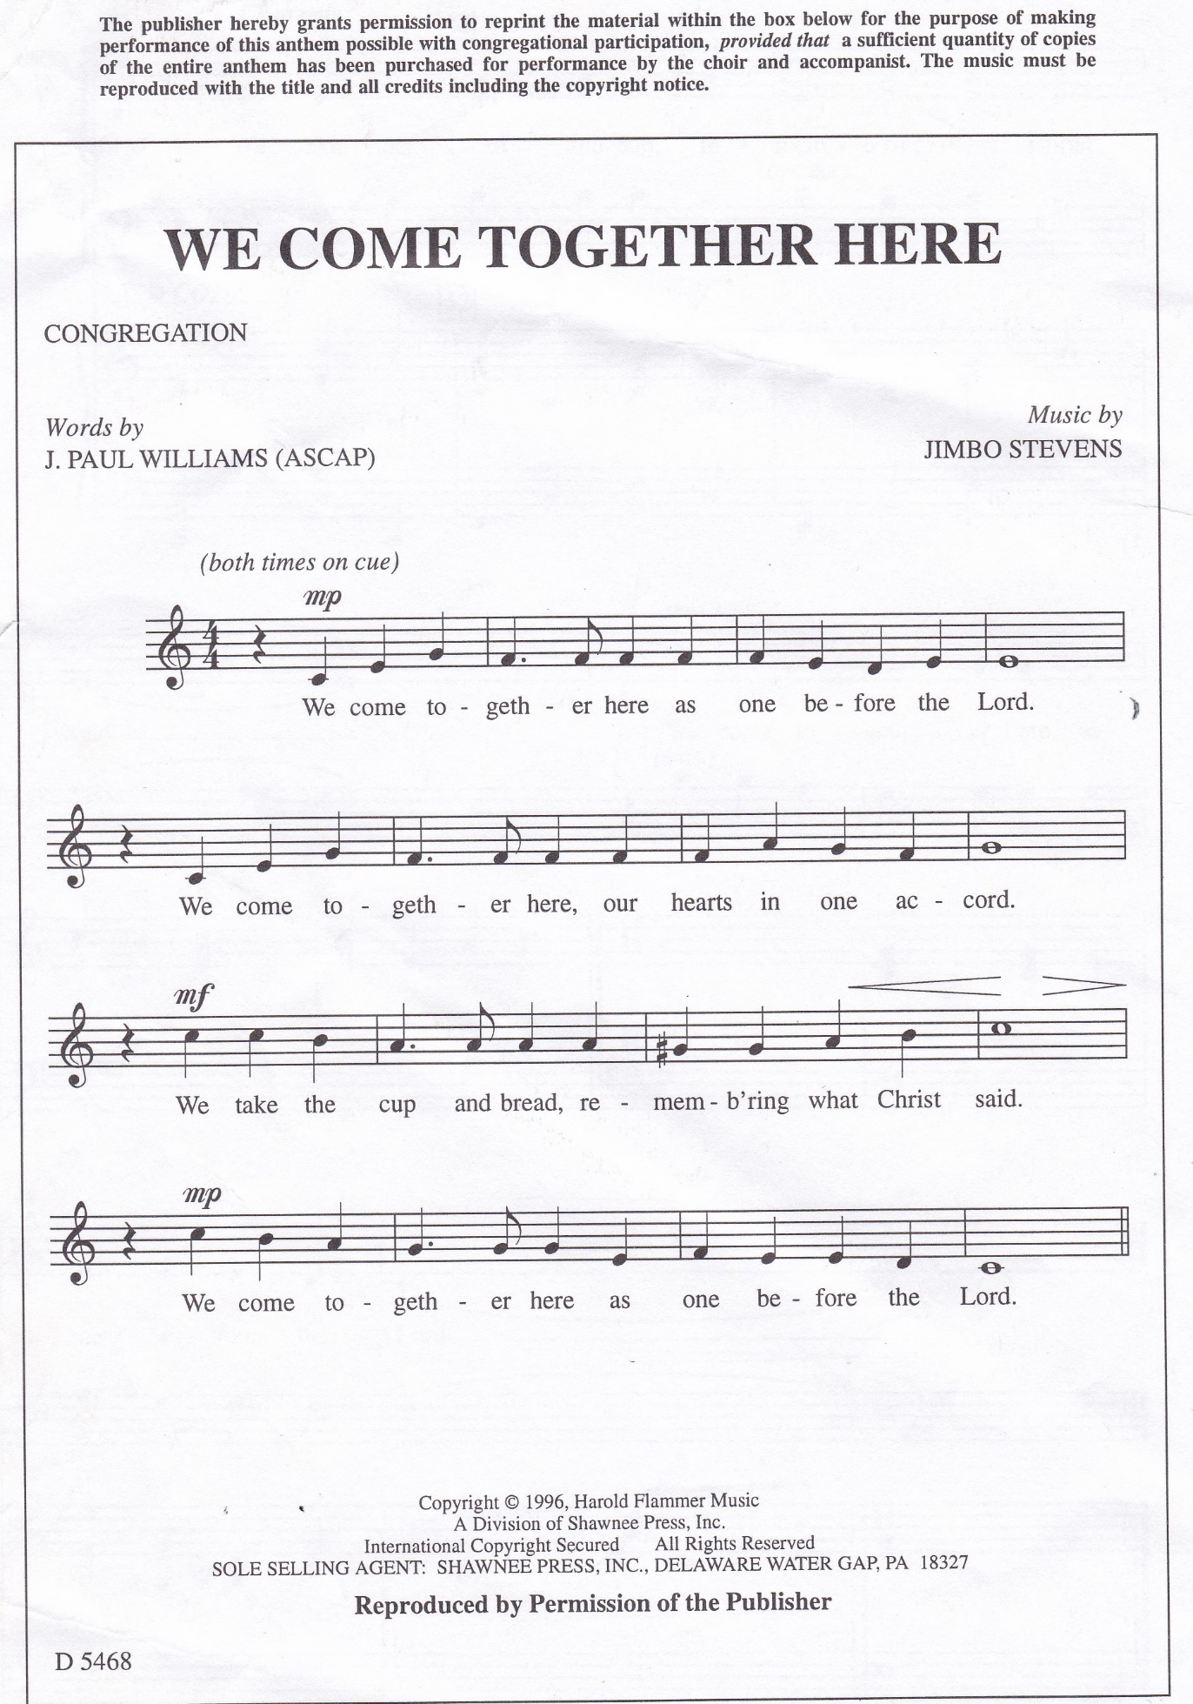

Springfield Presbyterian Church

10:30 am Worship
11:30 am Fellowship
Website: www.springfield-church.org Church Office: 410-795-6152
Like us on Facebook: www.facebook.com/SpringfieldPresbyterianChurch
Pastor: Rev. Becca Price
Email: springfieldpastor@gmail.com
Clerk of Session: Sharon Pappas
Minister of Music: Linda Caviglia
Accompanist/Organist: Aaron Thacker
Youth Group Coordinator: Dylan Vasbinder
Administrative Assistant: Donna Mazer e-mail: spc.office@verizon.net

