(Large Print)

Springfield Presbyterian Church (USA)
7300 Spout Hill Road, Sykesville, MD 21784 410-795-6152
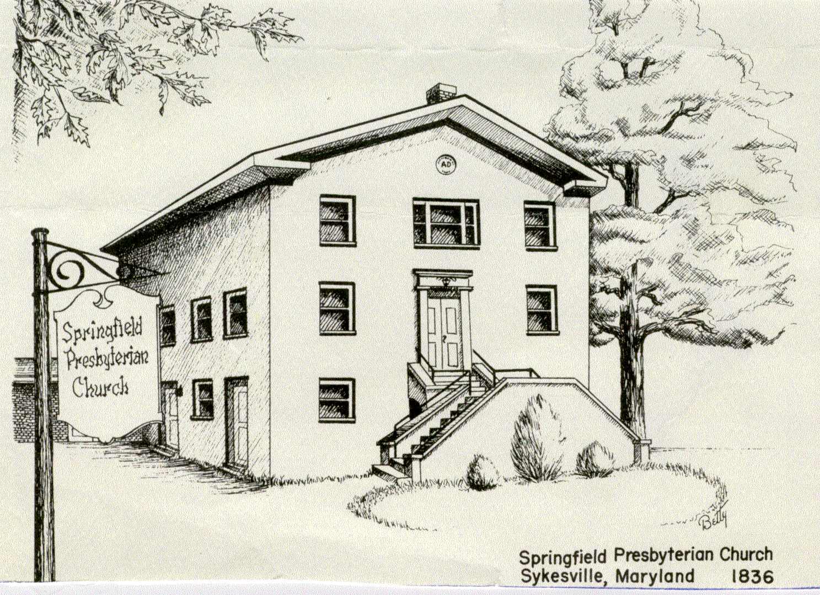

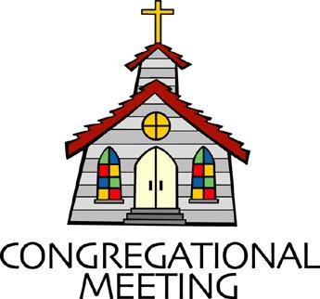
March 19, 2023 - 10:30 am

March 26, 2023
WELCOME VISITORS!
We're glad you are here! Cards at the ends of each pew are for you to fill out and drop in the Offering Plate. Please let us know you are visiting, and join us for refreshments and fellowship following the service. The Sanctuary has an induction loop system to assist the hearing impaired. The system will also work on the telephone setting of hearing aids.

Springfield Presbyterian Church is rooted in the gospel of Jesus Christ, led by the Holy Spirit, and called to loving relationships through vibrant worship and service. Valuing all people, we are committed to developing disciples and fostering stewardship.
PREPARATION FOR THE WORD
(* those who are able are invited to stand)

PRELUDE

GATHERING OF THE PEOPLE

The Lord be with you! And also with you!

(Greetings and Announcements)

LIGHTING THE CHRIST CANDLE
Leader: Whenever we light this candle we proclaim:
People: Christ is the Light of the world and the center of our lives.

CALL TO WORSHIP
Leader: Have you ever felt washed up, brittle, worn-down to the bone?
People: Have you ever felt grief lay heavy on your back?
Leader: Have you ever felt like hope was out of reach?
People: Have you ever wondered, can these bones live?
Leader: If you have, then you are in the right place, for this is God’s house. Hope lives here.
People: So, we come together. Let us rest our weary bones.
All: Let us worship God.
*HYMN Be Still, My Soul #819
1. Be still, my soul: the Lord is on thy side. Bear patiently the cross of grief or pain. Leave to thy God to order and provide, who through all changes faithful will remain. Be still, my soul: thy best, thy heavenly friend through thorny ways leads to a joyful end.
2. Be still, my soul: thy God doth undertake to guide the future surely as the past. Thy hope, thy confidence let nothing shake; all now mysterious shall be bright at last. Be still, my soul: the waves and winds still know his voice who ruled them while he dwelt below.
3. Be still, my soul: the hour is hastening on when we shall be forever with the Lord; when disappointment, grief, and fear are gone, sorrow forgot, love’s purest joys restored. Be still, my soul: when change and tears are past all safe and blessed we shall meet at last.

CALL TO CONFESSION
Friends, there is nothing that we have to keep hidden from God—not our anger, our grief, or the ways in which we have fallen short. In confession, we speak honestly and are met with grace. So let us not hold back. Let us bring our full selves to this prayer, knowing that God is already running to meet us. Let us pray.
PRAYER OF CONFESSION
Jesus of Nazareth, We confess: we forget that you know this feeling. We forget that you, too, have wept. We forget that you, too, have lost. We forget that you, too, have gathered at the tomb, have grieved for a friend, have felt the sting of humanity. Forgive us for all the times we create distance, imagining that you could never feel what we feel. Forgive us for allowing the valley of dry bones to be a sea of space between us. Pour yourself into the cracks in our hearts. Bring these bones back to life. Bring us closer to you. With gratitude, we pray. Amen.
SILENT PRAYERS OF CONFESSION
RESPONSE O Lord, Hear My Prayer Tune #471 (sing twice)
O Lord, hear my prayer. O Lord, hear my prayer. When I call, answer me.
O Lord, hear my prayer. O Lord, hear my prayer. Come and listen to me.

WORDS OF ASSURANCE
Leader: Friends, you could spend your whole life ignoring God, pushing God away, or trying to solve the world’s problems on your own, and God would still love you all the same. Even in all our shortcomings, we are always called God’s beloved. So hear, believe, and speak this good news:
People: We are saved by grace through faith. We belong to God. We are forgiven. We are not alone. Amen.

* MUSICAL RESPONSE OF PRAISE Come, Thou Almighty King
To thee, great One in Three, eternal praises be, hence evermore!
Thy sovereign majesty may we in glory see, and to eternity love and adore.

* THE PEACE The peace of Christ be with you! And also with you!
(You may greet those around you.)

* RESPONSE Here I Am, Lord
Here I am, Lord, Is it I, Lord? I have heard you calling in the night.
I will go, Lord, if you lead me. I will hold your people in my heart.

THE PROCLAMATION OF THE WORD

PRAYER OF ILLUMINATION
Creator God,
Why is bad news so loud? In the midst of gun violence, hunger, melting ice caps, and anxiety, it often feels like suffering has a microphone. How do we hear you? How do we find You? How do we know that these bones can live? Today we bring our raw selves into this space asking that once more you would rush through this room like a mighty wind. Remind us that these bones can live. Speak to us in your still, small, and powerful voice, and let it be loud enough to speak to the sorrow of the day. We know that good news rests in you, and we know that you are here. So help us listen, not to the bad news of the day alone, but to the hope that you breathe into every word. With open hearts we pray, Amen.

FIRST SCRIPTURE LESSON Ezekiel 37: 1-14 OT page 759
The hand of the Lord came upon me, and he brought me out by the spirit of the Lord and set me down in the middle of a valley; it was full of bones. He led me all around them; there were very many lying in the valley, and they were very dry. He said to me, “Mortal, can these bones live?” I answered, “O Lord God, you know.” Then he said to me, “Prophesy to these bones, and say to them: O dry bones, hear the word of the Lord. Thus says the Lord God to these bones: I will cause breath to enter you, and you shall live. I will lay sinews on you, and will cause flesh to come upon you, and cover you with skin, and put breath in you, and you shall live; and you shall know that I am the Lord.”

So I prophesied as I had been commanded; and as I prophesied, suddenly there was a noise, a rattling and the bones came together, bone to its bone, I looked, and there were sinews on them, and flesh had come upon them, and skin had covered them; but there was no breath in them. Then he said to me, “Prophesy to the breath, prophesy, mortal, and say to the breath: Thus says the Lord God: Come from the four winds, O breath, and breathe upon these slain, that they may live.” I prophesied as he commanded me, and the breath came into them, and they lived, and stood on their feet, a vast multitude.

Then he said to me, “Mortal, these bones are the whole house of Israel. They say, ‘Our bones are dried up, and our hope is lost; we are cut off completely.’ Therefore prophesy, and say to them, Thus says the Lord God: I am going to open your graves, and bring you up from your graves, O my people; and I will bring you back to the land of Israel. And you shall know that I am the Lord, when I open your graves, and bring you up from your graves, O my people. I will put my spirit within you, and you shall live, and I will place you on your own soil; then you shall know that I, the Lord, have spoken and will act, says the Lord.”

SECOND SCRIPTURE LESSON John 11: 1-45 NT page 98
Now a certain man was ill, Lazarus of Bethany, the village of Mary and her sister Martha. Mary was the one who anointed the Lord with perfume and wiped his feet with her hair; her brother Lazarus was ill. So the sisters sent a message to Jesus, “Lord, he whom you love is ill.” But when Jesus heard it, he said, “This illness does not lead to death; rather it is for God’s glory, so that the Son of God may be glorified through it.” Accordingly, though Jesus loved Martha and her sister and Lazarus, after having heard that Lazarus was ill, he stayed two days longer in the place where he was.

Then after this he said to the disciples, “Let us go to Judea again.” The disciples said to him, “Rabbi, the Jews were just now trying to stone you, and are you going there again?” Jesus answered, “Are there not twelve hours of daylight? Those who walk during the day do not stumble, because they see the light of this world. But those who walk at night stumble because the light is not in them.” After saying this, he told them. “Our friend Lazarus has fallen asleep, but I am going there to awaken him.” The disciples said to him, “Lord, if he has fallen asleep, he will be all right.” Jesus, however, had been speaking about his death, but they thought that he was referring merely to sleep. Then Jesus told them plainly, “Lazarus is dead. For your sake I am glad I was not there, so that you may believe. But let us go to him.” Thomas, who was called the Twin, said to his fellow disciples, “Let us also go, that we may die with him.”

When Jesus arrived, he found that Lazarus had already been in the tomb four days. Now Bethany was near Jerusalem, some two miles away, and many of the Jews had come to Martha and Mary to console them about their brother. When Martha heard that Jesus was coming, she went and met him, while Mary stayed at home. Martha said to Jesus, “Lord, if you had been here, my bother would not have died. But even now I know that God will give you whatever you ask of him.” Jesus said to her, “Your brother will rise again.” Martha said to him, “I know that he will rise again in the resurrection on the last day.” Jesus said to her, “I am the resurrection and the life. Those who believe in me, even though they die, will live, and everyone who lives and believes in me will never die. Do you believe this?” She said to him, “Yes, Lord, I believe that you are the Messiah, the Son of God, the one coming into the world.”

When she had said this, she went back and called her sister Mary, and told her privately, “The Teacher is here and is calling for you.” And when she heard it, she got up quickly and went to him. Now Jesus had not yet come to the village, but was still at the place where Martha had met him. The Jews who were with her in the house consoling her, saw Mary get up quickly and go out. They followed her because they thought that she was going to the tomb to weep there. When Mary came where Jesus was and saw him, she knelt at his feet and said to him, “Lord, if you had been here, my brother would not have died.” When Jesus saw her weeping, and the Jews who came with her also weeping, he was greatly disturbed in spirit and deeply moved. He said, “Where have you laid him?” They said to him, “Lord, come and see.” Jesus began to weep. So the Jews said, “See how he loved him!” But some of them said, “Could not he who opened the eyes of the blind man have kept this man from dying?”

Then Jesus, again greatly disturbed, came to the tomb. It was a cave, and a stone was lying against it. Jesus said, “Take away the stone.” Martha, the sister of the dead man, said to him, “Lord, already there is a stench because he has been dead four days.” Jesus said to her, “Did I not tell you that if you believed, you would see the glory of God?” So they took away the stone. And Jesus looked upward and said, “Father, I thank you for having heard me. I knew that you always hear me, but I have said this for the sake of the crowd standing here, so that they may believe that you sent me.” When he had said this, he cried with a loud voice, “Lazarus, come out!” The dead man came out, his hands and feet bound with strips of cloth, and his face wrapped in a cloth. Jesus said to them, “Unbind him, and let him go.” Many of the Jews therefore, who had come with Mary and had seen what Jesus did, believed in him.

SERMON Can These Dry Bones Live? Rev. Becca Price

THE RESPONSE TO THE WORD

*HYMN Can These Bones Live? (To the tune of Praise, My Soul, the King of Heaven) #620
1. When the past is dead and buried. Lifeless in the barren ground. What good can emerge from ashes? Where can any life be found? Breathe in deep the rushing Spirit. Life is growing all around.
2. When our hearts are bowed in sorrow. And the grief is newly wrought. Crying “If you’d only been here.” Weeping for what we have lost. Resurrect our hearts and spirits. Living God who we exalt.
3. When our spirits feel so broken, wrapped in linens and entombed. Without hope and without feeling, As the storm clouds round us loom. Hear the words of life from Jesus. “Come out, be unbound” and bloom.

PASTORAL PRAYER AND OUR LORD’S PRAYER

OFFERTORY
* SONG OF THANKS Lord of All Good Tune #711
Lord of all good, our gifts we bring to you; use them your holy purpose to fulfill,
Tokens of love and pledges brought anew, that our whole life is offered to your will.
* PRAYER OF DEDICATION

* HYMN Our Hope, Our Life #847

1. Our hope, our life are in the Lord, the God we honor and confess. Why crave renown or opulence? They fade, those things we now possess.
2. Some flaunt their gold; some trust its power, but what they cherish will decay; and still the ransom for a soul remains a price too great to pay.
3. Through wealth or learning may be ours, or fame that spreads throughout the land, the shackles of mortality prevent so much that we have planned.
4. Beyond this age of shame and sham we glimpse a better destiny: the Lord will lift us free from death to dwell in praise eternally.

* CHARGE AND BENEDICTION
Leader: As you leave this place, may God bless you with seeking.
People: We will seek out the hungry, the weary, the good in every person we pass.
Leader: Go to seek out the hopeful, the faithful, the God in each of us.
People: We shall seek and wonder.
Leader: And so, may we find what we are looking for. In the name of our loving God, who is always seeking us, let us go in peace. Amen.

* UNISON AMEN
POSTLUDE
Assisting in Worship: We appreciate those who serve:

Today 3/26 Next Week 4/2
Ushers/Greeters: Connie Gibbons Brenda McClung
Sharon Pappas Volunteer Needed
Lay Leader: Diana Steppling Alex McClung
Church Opener: Beth Oates Ron Holmes

Happy Birthday! April 3 – Barbara Cornell
April 3 – India Oates
April 7 – Wes McClung
April 12 – Lisa Rogers
April 13 – Kelsey Robinson
April 15 – Belle Vasbinder
April 19 – Debbie Sperling
April 23 – Morgan Mazer

Sunday April 2, 2023 Lectionary
Matt. 21:1-11 and Ps. 118:1-2, 19-29; Isa. 50:4-9a and Ps. 31:9-16; Phil. 2:5-11; Matt. 26:14-27:66 or Matt. 27:11-54

Announcements

RGF Meeting: Today

One Great Hour of Sharing: Our church is a Four for Four church, meaning it receives all four of the special offerings of PC(USA). The first, One Great Hour of Sharing, is received during Lent. With this offering we support rebuilding hope through Presbyterian Disaster Assistance; the growing food insecurity with the Presbyterian Hunger Program; and we partner in progress through the Self-Development of People. Donations go equally to all three programs. As we watch the news, we know the importance of all three of these needs. You may use the separate envelope included in your bulletin, or include a donation with your pledge with a note for OGHS. Or, if you have strong preferences for one of the three programs, you may note on your check how you want it divided. Your gifts will help so many. Thank you.

Comfort Bags: Do you know of anyone who is in need of a little comfort? New comfort bags are now available in the Narthex. Feel free to scoop one up and pass it along to someone in need. “No act of kindness, no matter how small, is ever wasted.” ~ Aesop

Springfield Membership: Are you interested in finding out more about our faith community and becoming a member? We would love to answer any questions you have. Please contact Pastor Becca at springfieldpastor@gmail.com for more information.

Congregational Care / Mission & Outreach (CoCaMO): Do you know of a member or friend of our church family who is ill, needs prayers, would like call, a visit or a card, or might benefit from meal train? If so, please contact the Church Office (410-795-6152), Cathy Marsh (410-549-6916) or Diana Steppling (862-266-2242).

Today:
Sunday March 26
10:30 am Worship
11:30 am Fellowship
This Week:
Wednesday March 29
6:15 – 7:15 pm Bell Choir Practice
7:30 – 8:45 pm Adult Choir Practice

Looking Ahead:
Sunday April 2
10:30 am Worship
11:30 am Fellowship
Monday April 3
7:00 p.m. Headhuggers
Wednesday April 5
6:15 – 7:15 Bell Choir Practice
7:30 – 8:45 Adult Choir Practice
Thursday April 6
7:00 Maundy Thursday Service

Office Hours: Tuesday, Wednesday and Friday, 10:00 am - 3:00 pm
Springfield Presbyterian Church

10:30 am Worship
11:30 am Fellowship
Website: www.springfield-church.org Church Office: 410-795-6152
Like us on Facebook: www.facebook.com/SpringfieldPresbyterianChurch
Pastor: Rev. Becca Price
Email: springfieldpastor@gmail.com
Clerk of Session: Sharon Pappas
Minister of Music: Linda Caviglia
Accompanist/Organist: Aaron Thacker
Youth Group Coordinator: Dylan Vasbinder
Administrative Assistant: Donna Mazer e-mail: spc.office@verizon.net

