(Large Print)

Springfield Presbyterian Church (USA)
7300 Spout Hill Road, Sykesville, MD 21784 410-795-6152

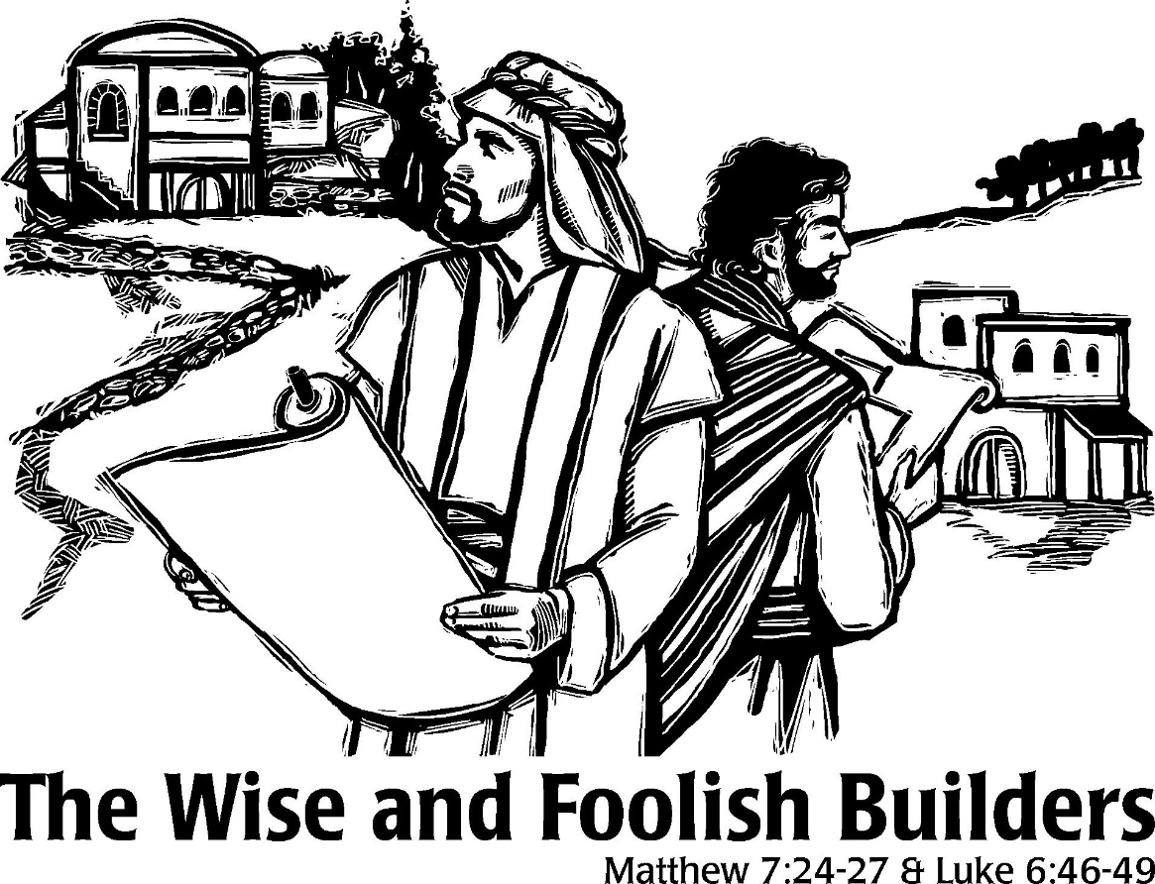

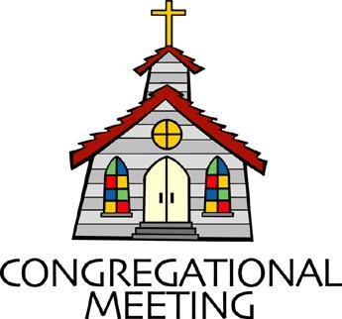
June 23, 2019 - 10:30 am

WELCOME VISITORS! We're glad you are here! Cards at the ends of each pew are for you to fill out and drop in the Offering Plate. Please let us know you are visiting, and join us for refreshments and fellowship following the service. The Sanctuary has an induction loop system to assist the hearing impaired. The system will also work on the telephone setting of hearing aids.

Springfield Presbyterian Church is rooted in the gospel of Jesus Christ, led by the Holy Spirit, and called to loving relationships through vibrant worship and service. Valuing all people, we are committed to developing disciples and fostering stewardship.

PREPARATION FOR THE WORD
(* those who are able are invited to stand)

PRELUDE

GATHERING OF THE PEOPLE

The Lord be with you! And also with you! (Greeting)

LIGHTING THE CHRIST CANDLE
Leader: Whenever we light this candle we proclaim:
People: Christ is the Light of the world and the center of our lives.

CALL TO WORSHIP [Psalm 92:1-4, 12-15]
Leader: It is good to praise the Lord,
People: It is good to make music to your name, O Most High.
Leader: It is good to proclaim your love in the morning,
People: It is good to proclaim your faithfulness at night.
Leader: We make music of the ten-stringed lyre and the melody of the harp.
People: For you make us glad by your deeds, Lord.
Leader: We sing for joy at what your hands have done.
People: The righteous will flourish like a palm tree and grow like a cedar of Lebanon.
Leader: They are planted in the house of the Lord,
People: They will flourish in the courts of our God.
Leader: They will still bear fruit in old age,
People: They will stay fresh and green.
Leader: They will proclaim: “The Lord is upright, he is our Rock!”
People: Let us praise our faithful God!

* HYMN Spirit Divine, Attend Our Prayers

Spirit divine, attend our prayers, and make this house your home.
Descend with all your gracious powers. O come, great Spirit, come!

Come as the light. To us reveal our emptiness and woe.
And lead us in those paths of life where all the righteous go.

Come as the fire and purge our hearts like sacrificial flame.
Let our whole soul an offering be to our Redeemer's name.

Come as the dove and spread your wings, the wings of peaceful love.
And let the church on earth become blest as the church above.

Spirit divine, attend our prayers. Make a lost world your home.
Descend with all your gracious powers. O come, great Spirit, come!

PRAYER OF CONFESSION (Unison)
Generous God, we prop our souls up on unworthy things: from material goods, to quick fixes, to false hopes. We hope for the best, but do not stand in good faith. We fail to rely on you, to hold you as cornerstone, as the axis of our lives. Help us to reorient ourselves and trust in you, knowing that through the power of your Holy Spirit, you will build in us more than we could ever accomplish. Guide us, lead us, and restore us to your people, held and loved, by the firm foundation of your mercy and grace. Amen.

SILENT PRAYERS OF CONFESSION

RESPONSE Remember Not, O God
O Lord, our Savior, help, and glorify your name;
Deliver us from all our sins and take away our shame.

WORDS OF ASSURANCE
Leader: Anyone who is in Christ is a new creation. The old life has gone; a new life has begun.
People: In Christ, we know that we are forgiven! Thanks be to God! Alleluia! Amen!

* MUSICAL RESPONSE OF PRAISE Great Is Thy Faithfulness
Great is thy faithfulness! Great is thy faithfulness! Morning by morning new mercies I see. All I have needed thy hand hath provided. Great is thy faithfulness Lord unto me.

* THE PEACE The peace of Christ be with you! And also with you!
(You may greet those around you.)

* RESPONSE Here I Am, Lord
Here I am, Lord, Is it I, Lord? I have heard you calling in the night.
I will go, Lord, if you lead me. I will hold your people in my heart.

THE PROCLAMATION OF THE WORD

PRAYER OF ILLUMINATION
Leader: Loving God, fountain of every blessing, open us to your life-giving word, and fill us with your Holy Spirit so that living water may flow through our hearts – a spring of hope for a thirsty world; through Jesus Christ our Lord. Amen.

FIRST SCRIPTURE LESSON Isaiah 55:10-13
¹⁰ For as the rain and the snow come down from heaven, and do not return there until they have watered the earth, making it bring forth and sprout, giving seed to the sower and bread to the eater, ¹¹ so shall my word be that goes out from my mouth; it shall not return to me empty, but it shall accomplish that which I purpose, and succeed in the thing for which I sent it. ¹² For you shall go out in joy, and be led back in peace; the mountains and the hills before you shall burst into song, and all the trees of the field shall clap their hands. ¹³ Instead of the thorn shall come up the cypress; instead of the brier shall come up the myrtle; and it shall be to the Lord for a memorial, for an everlasting sign that shall not be cut off.

SECOND SCRIPTURE LESSON Luke 6:39-49
³⁹He also told them a parable: ‘Can a blind person guide a blind person? Will not both fall into a pit? ⁴⁰A disciple is not above the teacher, but everyone who is fully qualified will be like the teacher. ⁴¹Why do you see the speck in your neighbor’s eye, but do not notice the log in your own eye? ⁴²Or how can you say to your neighbor, “Friend, let me take out the speck in your eye”, when you yourself do not see the log in your own eye? You hypocrite, first take the log out of your own eye, and then you will see clearly to take the speck out of your neighbor’s eye. ⁴³‘No good tree bears bad fruit, nor again does a bad tree bear good fruit; ⁴⁴for each tree is known by its own fruit. Figs are not gathered from thorns, nor are grapes picked from a bramble bush. ⁴⁵The good person out of the good treasure of the heart produces good, and the evil person out of evil treasure produces evil; for it is out of the abundance of the heart that the mouth speaks.
⁴⁶ ‘Why do you call me “Lord, Lord”, and do not do what I tell you? ⁴⁷I will show you what someone is like who comes to me, hears my words, and acts on them. ⁴⁸That one is like a man building a house, who dug deeply and laid the foundation on rock; when a flood arose, the river burst against that house but could not shake it, because it had been well built. ⁴⁹But the one who hears and does not act is like a man who built a house on the ground without a foundation. When the river burst against it, immediately it fell, and great was the ruin of that house.’

Leader: Hear what the Spirit is saying to the Church.
All: Thanks be to God.

TIME WITH YOUNG PEOPLE

SERMON Built Upon the Cornerstone Rev. Becca Crate

THE RESPONSE TO THE WORD

* HYMN My Hope Is Built on Nothing Less

My hope is built on nothing less than Jesus' blood and righteousness;
I dare not trust the sweetest frame, but wholly lean on Jesus' name.

Refrain:
On Christ, the solid Rock, I stand;
All other ground is sinking sand; all other ground is sinking sand.

When darkness seems to hide his face, I rest on his unchanging grace;
In every high and stormy gale, my anchor holds within the veil. [Refrain]

His oath, his covenant, his blood support me in the whelming flood;
When all around my soul gives way, he then is all my hope and stay. [Refrain]

When he shall come with trumpet sound, O may I then in him be found, dressed in his righteousness alone, faultless to stand before the throne. [Refrain]

PASTORAL PRAYER AND THE LORD’S PRAYER
“For this I pray to God.” / “For this I give thanks to God.”
Congregational Response: “Hear our prayer, O God.”

PRESENTATION OF TITHES AND OFFERINGS
OFFERTORY

* SONG OF THANKS As Those of Old Their Firstfruits Brought
In gratitude and humble trust we bring our best today,
To serve your cause and share your love with all along life’s way.
O God who gave yourself to us in Jesus Christ your Son,
Help us to give ourselves each day until life’s work is done.
* PRAYER OF DEDICATION

* HYMN Christ Is Made the Sure Foundation

Christ is made the sure foundation, Christ the head and cornerstone,
Chosen of the Lord and precious, binding all the church in one;
Holy Zion's help forever, and our confidence alone.

To this temple, where we call you, come, O Lord of hosts, and stay;
Come, with all your loving-kindness; hear your people as we pray,
And your fullest benediction shed within these walls today.

Here bestow on all your servants what they seek from you to gain;
What they gain from you, forever with the blessed to retain;
And hereafter in your glory evermore with you to reign.

Laud and honor to the Father, laud and honor to the Son,
Laud and honor to the Spirit, ever three and ever one:
One in might and one in glory while unending ages run!

* CHARGE AND BENEDICTION
Leader: We hear your Word,
People: And so we act upon it.
Leader: To build a firm foundation of faith,
People: And profess that faith in love.
Leader: So that all may be blessed,
People: And we will strive to be a blessing to this world. Amen.

* UNISON AMEN POSTLUDE
Sunday June 30 Lectionary
2 Kings 2:1-2, 6-14; Psalm 77:1-2, 11-20; Galatians 5:1, 13-25;
Luke 9:51-62

Assisting in Worship: We appreciate those who serve:

Today 6/23 Next Week 6/30
Sunday Opener Beth Oates Jennifer Wise
Greeters & Ushers Ed & Sandy Steve & Donna
Newsome Mazer
Lay Leader Kathy Russ Bob Steppling
Children’s Activity Connie Robinson Connie Robinson
Fellowship Sandy Newsome Diana Steppling

Church Attendance: June 9 – 53 June 16 - 31

Church Cleaning: June 28, 29 or 30 – Lisa & Bob Rogers

Happy Birthday! June 24 – Leah Halvorson
June 28 – Margaret Carroll
June 30 – Diana Steppling

Happy Anniversary! June 27 – Barbara & Peter Cornell
June 29 – Linda & Larry Black
June 30 – Martha & Davis Streaker

Announcements

C.I.A. Camp: Starts TONIGHT with dinner served to ESCAPE families from 4:30 to 6 pm and a bluegrass concert at 6:30 pm. We still need lots of volunteers to help with setup, snacks, etc. each night. There will be sign-up sheets during Fellowship. Please see Charlie Sperling or Connie Robinson with any questions.

Big Tent: Volunteers are needed for Big Tent on August 1 – 3 in Baltimore. Big Tent is PCUSA’s 3-day conference featuring bible studies, learning opportunities, worship, workshops, and speakers from around the country. To learn more and sign up to help, go to http://oga.pcusa.org/section/big-tent-2019/volunteer-opportunities/ or email Sonce Reese at sonce.reese@pcusa.org.

Interested in trying out bell ringing? Linda Caviglia is planning to have introductory bell sessions on 3 Sundays over the summer - July 21, August 4, and August 18, time to be announced. There is a signup sheet on the bulletin board in the Narthex if you are interested (Fall 2019 going into 4th grade and up).

Summer Music for Worship: If you'd like to share some of your musical talents (all levels of accomplishment) over the summer while the choir and bell choir take a rest, we'd love to have you participate. There is a sign-up sheet in the Narthex for each Sunday over the summer. Please talk with Linda Caviglia about your thoughts/plans if you need Aaron to accompany you, or would like some other "backup" music.

Blessing Bags are in the Narthex. Please feel free to pick up a few. Handing one out to someone in need gives you a very real way to meet their immediate needs by providing them with some basic supplies.

Weekly Announcements: If you have an announcement to include with next week’s bulletin, please call the Office at 410-795-6152 or email to spc.office@verizon.net by Wednesday each week.

Prayers & Thanksgivings

~ Prayers of thanksgiving and joy for Ron and Sue Holmes’ new granddaughter, Violet Elizabeth, who was born on 6/16.
~ Prayers of comfort for Ron and Sue Holmes’ son-in-law Garrett, whose father passed away on 6/16.
~ Continued prayers of healing for Max Carroll and prayers of comfort and strength for Margaret Carroll.
~ Continued prayers of healing for Shona Klein who had surgery.
~ Prayers for Korean United Presbyterian Church from our Ministry Group.

The Congregational Care team wants to know what YOU or someone you know needs...a visit...a call...a meal. Please contact Diana Steppling or Connie Robinson.

Today:
Sunday June 23
10:30 am Worship
11:30 am Fellowship
4:30 pm Dinner for ESCAPE
6:30 pm C.I.A. Camp Kickoff
Bluegrass Concert (Church lawn)

This Week:
Monday June 24
6:30 pm C.I.A. Camp – First Responders Appreciation Night
Tuesday June 25
6:30 pm C.I.A. Camp – Heifer Awareness & Petting Zoo
Wednesday June 26
6:30 pm C.I.A. Camp – Caring Carroll & Moon Bounce
Thursday June 27
6:30 pm C.I.A. Camp – Family Cookout

Looking Ahead:
Sunday June 30 – Noisy Offering
10:30 am Worship
11:30 am Fellowship
Tuesday July 2
7:00 pm Mission Committee Meeting (Manse)

Office Hours: Tuesday, Wednesday, Friday 9:00 am - 3:00 pm

Springfield Presbyterian Church

10:30 am Worship
11:30 am Fellowship
Website: www.springfield-church.org Church Office: 410-795-6152
Like us on Facebook: www.facebook.com/SpringfieldPresbyterianChurch
Pastor: Rev. Becca Crate
Email: springfieldpastor@gmail.com
Clerk of Session: Sharon Pappas
Minister of Music: Linda Caviglia
Accompanist: Aaron Thacker Organist: Jennifer Wise
Youth Group Coordinators: Charles & Deb Sperling
Sunday School Coordinator: Connie Robinson
Administrative Assistant: Donna Mazer
e-mail: spc.office@verizon.net

