(Large Print)

Springfield Presbyterian Church (USA)
7300 Spout Hill Road, Sykesville, MD 21784 410-795-6152

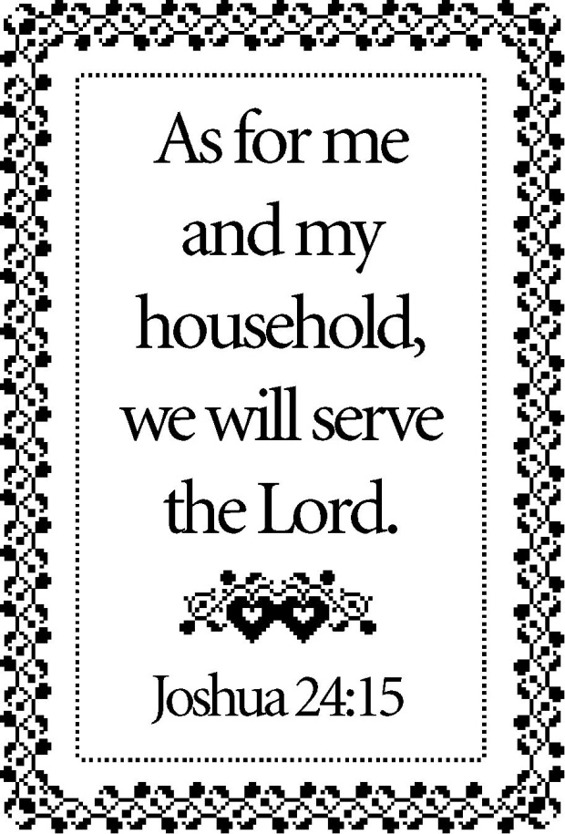

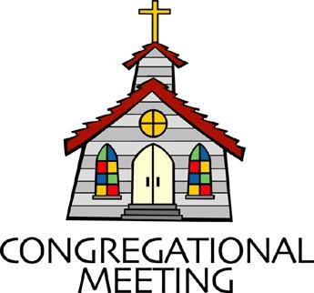
August 26, 2018 - 9:30 am

WELCOME VISITORS! We're glad you are here! Cards at the ends of each pew are for you to fill out and drop in the Offering Plate. Please let us know you are visiting, and join us for refreshments and fellowship following the service. The Sanctuary has an induction loop system to assist the hearing impaired. The system will also work on the telephone setting of hearing aids. A head set is available upon request.

Springfield Presbyterian Church is rooted in the gospel of Jesus Christ, led by the Holy Spirit, and called to loving relationships through vibrant worship and service. Valuing all people, we are committed to developing disciples and fostering stewardship.
PREPARATION FOR THE WORD
(* those who are able are invited to stand)

Please prepare for worship by listening to the music of the Prelude.

PRELUDE

GATHERING OF THE PEOPLE

The Lord be with you! And also with you! (Greeting)

LIGHTING THE CHRIST CANDLE
Leader: Whenever we light this candle we proclaim:
People: Christ is the Light of the world and the center of our lives.

CALL TO WORSHIP [Based upon Psalm 84 NRSV]
Leader: How lovely is your dwelling place, O Lord of hosts!
People: Our souls long, indeed it faints for the courts of the Lord.
Leader: Our heart and our flesh sing for joy to the living God.
People: Even the sparrow finds a home, and the swallow a nest for herself, where she may lay her young, at your altars, O Lord of hosts, our King and our God.
Leader: Happy are those who live in your house, ever singing your praise.
People: Happy are those whose strength is in you, in whose heart are the highways to Zion.
Leader: As they go through the valley of Baca they make it a place of springs; the early rain also covers it with pools.
People: They go from strength to strength; the God of gods will be seen in Zion.
Leader: O Lord, God of hosts, hear our prayer, give ear, O God of Jacob!
People: Behold our shield, O God; look on the face of your anointed. For a day in your courts is better than a thousand elsewhere.
Leader: We would rather be doorkeepers in the house of our God than live in the tents of wickedness.
People: For the Lord God is a sun and shield; He bestows favor and honor.
Leader: No good thing does the Lord withhold from those who walk uprightly.
People: O Lord of hosts, happy is everyone who trusts in you. Let us praise our God!

* HYMN Love Divine, All Loves Excelling
Love divine, all loves excelling, joy of heaven to earth come down,
Fix in us Thy humble dwelling, all Thy faithful mercies crown!
Jesus, Thou art all compassion, pure, unbounded love Thou art;
Visit us with Thy salvation, enter every trembling heart.

Breathe, O breathe Thy loving Spirit, into every troubled breast!
Let us all in Thee inherit, let us find the promised rest;
Take away the love of sinning; Alpha and Omega be;
End of faith, as its beginning, set our hearts at liberty.

Come, Almighty to deliver, let us all Thy life receive;
Suddenly return, and never, nevermore Thy temples leave.
Thee we would be always blessing, serve Thee as Thy hosts above,
Pray, and praise Thee without ceasing, glory in Thy perfect love.

Finish, then, Thy new creation; pure and spotless let us be;
Let us see Thy great salvation, perfectly restored in Thee;
Changed from glory into glory, till in heaven we take our place,
Till we cast our crowns before Thee, lost in wonder, love, and praise.

PRAYER OF CONFESSION
Generous God, you ask us, ‘who do we serve?’ Are our hearts aligned with you, and your mission, and your will in this world?
We say we serve you, and we do our best, but we face the reality that temptations get in the way. We do not always choose to remember your covenant, those promises with us and to us that have been rooted in our deep history as a people. We become tangled up in the ways of the world, serving those things that will make us more powerful, more esteemed, and more independent. Help us, again, O God, to seek humility, to say once again that we serve you and you alone, and help us to remember the covenant that you renew with us from our ancestors to this very moment. Forgive us, O God, we ask, for the ways in which we have turned away from the covenant and redeem us once again to be your people. Amen.

SILENT PRAYERS OF CONFESSION

RESPONSE Kyrie
Lord, have mercy upon us. Christ, have mercy upon us. Lord, have mercy upon us.

WORDS OF ASSURANCE
Leader: The covenant of our God is from everlasting to everlasting, from our ancestors to this very moment. Our faithful God forgives us, as His mercy is unending.
People: Praise God, the covenant maker, and the one we serve, for God’s infinite love. Amen.

* MUSICAL RESPONSE OF PRAISE How Great Thou Art
Then sings my soul, my Savior God, to Thee, how great Thou art, how great Thou art. Then sings my soul, my Savior God, to Thee, how great Thou art, how great Thou art!

* THE PEACE The peace of Christ be with you! And also with you!
(You may greet those around you.)

* RESPONSE Here I Am, Lord
Here I am, Lord, Is it I, Lord? I have heard you calling in the night.
I will go, Lord, if you lead me. I will hold your people in my heart.

THE PROCLAMATION OF THE WORD

FIRST SCRIPTURE LESSON Psalm 34:15-22
¹⁵ The eyes of the Lord are on the righteous, and his ears are open to their cry. ¹⁶ The face of the Lord is against evildoers, to cut off the remembrance of them from the earth. ¹⁷ When the righteous cry for help, the Lord hears, and rescues them from all their troubles. ¹⁸ The Lord is near to the broken-hearted, and saves the crushed in spirit. ¹⁹Many are the afflictions of the righteous, but the Lord rescues them from them all. ²⁰ He keeps all their bones; not one of them will be broken. ²¹ Evil brings death to the wicked, and those who hate the righteous will be condemned. ²² The Lord redeems the life of his servants; none of those who take refuge in him will be condemned.

SECOND SCRIPTURE LESSON Joshua 24:1-2a, 14-18
Then Joshua gathered all the tribes of Israel to Shechem, and summoned the elders, the heads, the judges, and the officers of Israel; and they presented themselves before God. ²And Joshua said to all the people… ¹⁴ ‘Now therefore revere the Lord, and serve him in sincerity and in faithfulness; put away the gods that your ancestors served beyond the River and in Egypt, and serve the Lord. ¹⁵Now if you are unwilling to serve the Lord, choose this day whom you will serve, whether the gods your ancestors served in the region beyond the River or the gods of the Amorites in whose land you are living; but as for me and my household, we will serve the Lord.’ ¹⁶Then the people answered, ‘Far be it from us that we should forsake the Lord to serve other gods; ¹⁷for it is the Lord our God who brought us and our ancestors up from the land of Egypt, out of the house of slavery, and who did those great signs in our sight. He protected us along all the way that we went, and among all the peoples through whom we passed; ¹⁸and the Lord drove out before us all the peoples, the Amorites who lived in the land. Therefore we also will serve the Lord, for he is our God.’

Leader: Hear what the Spirit is saying to the Church.
All: Thanks be to God.

TIME WITH YOUNG PEOPLE

SERMON Who Will You Serve? Rev. Becca Crate

THE RESPONSE TO THE WORD

UNISON REAFFIRMATION OF FAITH
In life and in death we belong to God. Through the grace of our Lord Jesus Christ, the love of God, and the communion of the Holy Spirit,
we trust in the one triune God, the Holy One of Israel, whom alone we worship and serve.

We trust in Jesus Christ, fully human, fully God. Jesus proclaimed the reign of God: preaching good news to the poor and release to the captives, teaching by word and deed and blessing the children,
healing the sick and binding up the brokenhearted, eating with outcasts, forgiving sinners, and calling all to repent and believe the gospel. Unjustly condemned for blasphemy and sedition, Jesus was crucified, suffering the depths of human pain and giving his life for the sins of the world. God raised this Jesus from the dead, vindicating his sinless life, breaking the power of sin and evil, delivering us from death to life eternal.

We trust in God, whom Jesus called Abba, Father. In sovereign love God created the world good and makes everyone equally in God’s image
male and female, of every race and people, to live as one community.
But we rebel against God; we hide from our Creator. Ignoring God’s commandments, we violate the image of God in others and ourselves,
accept lies as truth, exploit neighbor and nature, and threaten death to the planet entrusted to our care. We deserve God’s condemnation.
Yet God acts with justice and mercy to redeem creation. In everlasting love, the God of Abraham and Sarah chose a covenant people to bless all families of the earth. Hearing their cry, God delivered the children of Israel from the house of bondage. Loving us still, God makes us heirs
with Christ of the covenant. Like a mother who will not forsake her nursing child, like a father who runs to welcome the prodigal home,
God is faithful still.

We trust in God the Holy Spirit, everywhere the giver and renewer of life. The Spirit justifies us by grace through faith, sets us free to accept ourselves and to love God and neighbor, and binds us together with all believers in the one body of Christ, the Church. The same Spirit who inspired the prophets and apostles rules our faith and life in Christ through Scripture, engages us through the Word proclaimed, claims us in the waters of baptism, feeds us with the bread of life and the cup of salvation, and calls women and men to all ministries of the church. In a broken and fearful world the Spirit gives us courage to pray without ceasing, to witness among all peoples to Christ as Lord and Savior,
to unmask idolatries in Church and culture, to hear the voices of peoples long silenced, and to work with others for justice, freedom, and peace. In gratitude to God, empowered by the Spirit, we strive to serve Christ in our daily tasks and to live holy and joyful lives, even as we

watch for God’s new heaven and new earth, praying, “Come, Lord Jesus!”

With believers in every time and place, we rejoice that nothing in life or in death can separate us from the love of God in Christ Jesus our Lord.
Glory be to the Father, and to the Son, and to the Holy Spirit. Amen.

* HYMN Great Is Thy Faithfulness
Great is Thy faithfulness, O God my Father,
There is no shadow of turning with Thee;
Thou changest not, Thy compassions they fail not;
As Thou hast been Thou forever will be.

Refrain:
Great is Thy faithfulness! Great is Thy faithfulness!
Morning by morning new mercies I see;
All I have needed Thy hand hath provided;
Great is Thy faithfulness, Lord, unto me!

Summer and winter and springtime and harvest,
Sun, moon, and stars in their courses above
Join with all nature in manifold witness
To Thy great faithfulness, mercy and love. (Refrain)

Pardon for sin and a peace that endureth,
Thine own dear presence to cheer and to guide;
Strength for today and bright hope for tomorrow,
Blessings all mine, with ten thousand beside! (Refrain)

PASTORAL PRAYER AND THE LORD’S PRAYER
“For this I pray to God.” / “For this I give thanks to God.”
Congregational Response: “Hear our prayer, O God.”

PRESENTATION OF TITHES AND OFFERINGS
OFFERTORY
* SONG OF THANKS Doxology
Praise God from whom all blessings flow;
Praise Him, all creatures here below;
Praise Him above, ye heavenly host;
Praise Father, Son and Holy Ghost. Amen.
* PRAYER OF DEDICATION

* HYMN Lord, Whose Love Through Humble Service
Lord, whose love through humble service, bore the weight of human need,
Who upon the cross, forsaken, offered mercy’s perfect deed,
We, your servants, bring the worship, not of voice alone, but heart,
Consecrating to your purpose, every gift that you impart.

Still your children wander homeless; still the hungry cry for bread,
Still the captives long for freedom; still in grief we mourn our dead.
As, O Lord, your deep compassion, healed the sick and freed the soul,
Use the love your Spirit kindles, still to save and make us whole.

As we worship, grant us vision, till your love’s revealing light,
In its height and depth and greatness, dawns upon our quickened sight,
Making known the needs and burdens, your compassion bids us hear, stirring us to tireless striving, your abundant life to share.

Called from worship to your service, forth in your dear name we go,
To the child, the youth, the aged, love in living deeds to show;
Hope and health, goodwill and comfort, counsel, aid and peace we give,
That your servants, Lord, in freedom, may your mercy know and live.

* CHARGE AND BENEDICTION
Leader: Who do you serve?
People: We serve God.
Leader: From generation to generation,
People: Our faithful God renews His covenant with His people.
Leader: And in service to our faithful and covenant making God,
People: We will live lives of service, discerning and following God’s will.

* UNISON AMEN

POSTLUDE

Assisting in Worship: We appreciate those who serve:

Today 8/26 Next Week 9/2
Sunday Opener Sandy Newsome Ron Holmes
Greeters & Ushers Kathy Russ & Steve & Donna
Barbara Nickell Mazer
Lay Leader Barbara Cornell Sharon Pappas
Youth/Children’s Activity Shona Klein Shona Klein
Fellowship Ed & Sandy Newsome Barbara Cornell &
Shona Klein

Church Attendance: August 12 - 30 August 19 - 37
Concert - 34

Church Cleaning: September 7, 8 or 9 - Martha & Davis Streaker

Sunday September 2 Lectionary
Song of Solomon 2:8-13; Psalm 45:1-2, 6-9; James 1:17-27;
Mark 7:1-8, 14-15, 21-23
Happy Birthday! August 27 - Aaron Wise
August 28 - Bob Rogers
August 28 - Katie Grimsley
August 31 - Bridget Doyle

Happy Anniversary! September 1 - Charlie & Deb Sperling

Announcements

Memorial Service: A memorial service will be held for Rev. Dr. Helen Woodward on Saturday, September 8 at 10:00 am at Frederick Presbyterian Church, 115 West Second Street, Frederick, MD. All are welcome to attend to remember and celebrate Helen’s life.

Youth Group: It is time for our first YOUTH GROUP event of the season! Our annual trip to Woodberry Crossing will be September 15-16. We will be leaving the Church at 8am on Saturday the 15th and returning on Sunday the 16th in the early afternoon. See Mr. Charlie or Ms. Deb for details.

Weekly Announcements: If you have an announcement to include with next week’s bulletin, please call the Office at 410-795-6152 or email to spc.office@verizon.net by Wednesday each week.

Prayers & Thanksgivings
~ Prayers of thanksgiving for Ron Holmes’ mom who will be turning 103 on Tuesday!
~ Prayers of quick healing for Dr. Elwood LaBrosse, in Fairhaven Health Center.
~ Prayers for First of Howard County from our Ministry Group.

The Congregational Care team wants to know what YOU or someone you know needs...a visit...a call...a meal. Please contact Kay Freas or Connie Robinson.
Today:
Sunday August 26
9:30 am Worship Service
10:30 am Fellowship
11:00 am Session Meeting (Manse)
11:00 am RGEF Meeting (Classroom)

This Week:
Tuesday August 28
10:00 am Prayer Group (Manse)
Wednesday August 29
6:30 pm Adult Choir Practice

Looking Ahead:
Sunday September 2
9:30 am Worship
10:30 am Fellowship
Wednesday September 5
6:30 pm Bell Choir Practice
7:45 pm Adult Choir Practice
Saturday September 8
10:00 am Memorial Service for Rev. Dr. Helen Woodward
Frederick Presbyterian Church
115 West Second Street, Frederick, MD
Sunday September 9
10:30 am Worship Service and Sunday School
11:30 am Picnic
6:30 pm Youth Movie Night (Manse)

Office Hours: Tuesday, Wednesday, Friday 9:00 am - 3:00 pm
Springfield Presbyterian Church

9:30 am Worship
10:30 am Fellowship
Website: www.springfield-church.org Church Office: 410-795-6152
Like us on Facebook: www.facebook.com/SpringfieldPresbyterianChurch
Pastor: Rev. Becca Crate
Email: springfieldpastor@gmail.com
Clerk of Session: Sharon Pappas
Minister of Music: Linda Caviglia
Accompanist: Aaron Thacker Organist: Jennifer Wise
Youth Group Coordinators: Charles & Deb Sperling
Sunday School Coordinator: Connie Robinson
Administrative Assistant: Donna Mazer
e-mail: spc.office@verizon.net

