(Large Print)

Springfield Presbyterian Church (USA)
7300 Spout Hill Road, Sykesville, MD 21784 410-795-6152

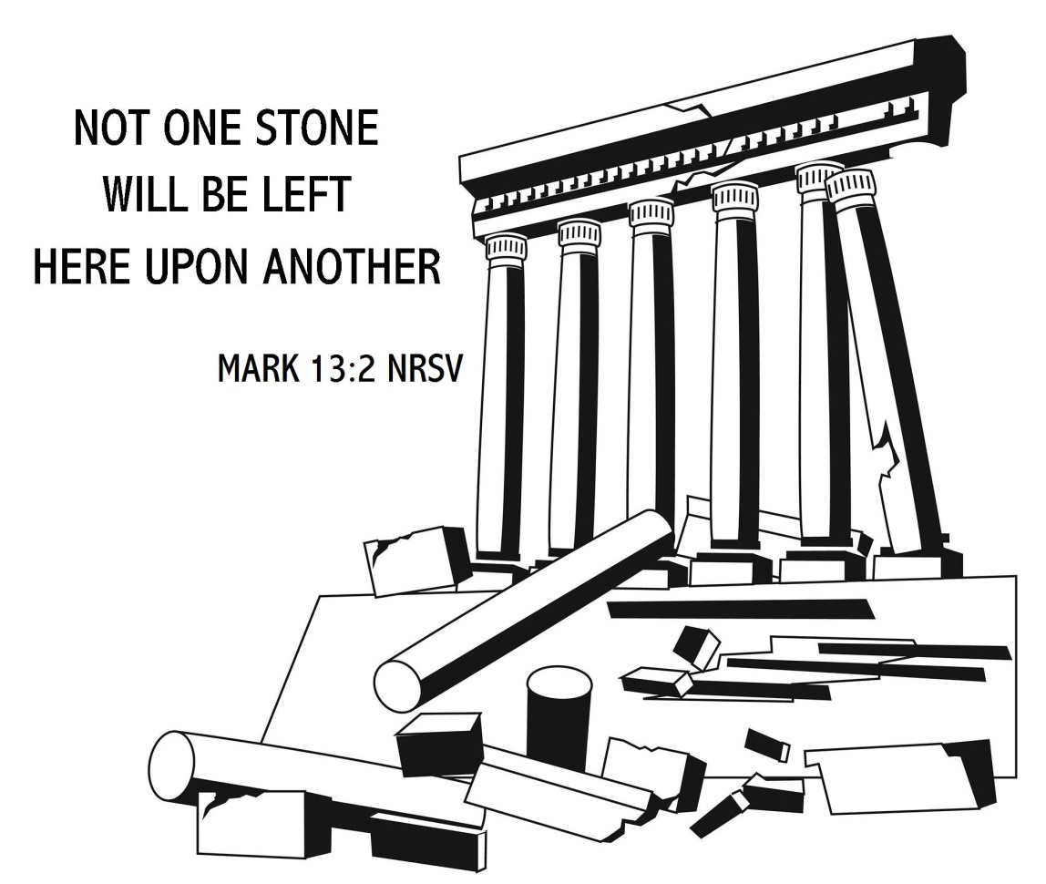

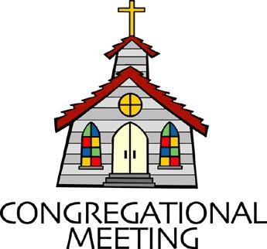
November 18, 2018 - 10:30 am

WELCOME VISITORS! We're glad you are here! Cards at the ends of each pew are for you to fill out and drop in the Offering Plate. Please let us know you are visiting, and join us for refreshments and fellowship following the service. The Sanctuary has an induction loop system to assist the hearing impaired. The system will also work on the telephone setting of hearing aids. A head set is available upon request.

Springfield Presbyterian Church is rooted in the gospel of Jesus Christ, led by the Holy Spirit, and called to loving relationships through vibrant worship and service. Valuing all people, we are committed to developing disciples and fostering stewardship.
PREPARATION FOR THE WORD
(* those who are able are invited to stand)

Please prepare for worship by listening to the music of the Prelude.

PRELUDE

GATHERING OF THE PEOPLE

The Lord be with you! And also with you! (Greeting)

LIGHTING THE CHRIST CANDLE
Leader: Whenever we light this candle we proclaim:
People: Christ is the Light of the world and the center of our lives.

INTROIT He Has Made Me Glad By Leona Von Brethorst

CALL TO WORSHIP [Excerpts from Isaiah 43]
Leader: But now thus says the Lord, He who created you, O Jacob, He who formed you, O Israel:
People: Do not fear, for God has redeemed you; I have called you by name, you are mine.
Leader: When you pass through the waters, I will be with you; and through the rivers, they shall not overwhelm you.
People: When you walk through fire you shall not be burned, and the flame shall not consume you.
Leader: For I am the Lord your God, the Holy One of Israel, your Savior.
People: Thus says the Lord, who makes a way in the sea, a path in the mighty waters, who brings out chariot and horse, army and warrior;
Leader: They lie down, they cannot rise, they are extinguished, quenched like a wick:
People: Do not remember the former things, or consider the things of old.

Leader: I am about to do a new thing; now it springs forth, do you not perceive it?
People: I will make a way in the wilderness and rivers in the desert.
ALL: Let us praise our God! Amen.

* HYMN Morning Has Broken

Morning has broken, like the first morning,
Blackbird has spoken, like the first bird.
Praise for the singing! Praise for the morning!
Praise for them springing, fresh from the Word.

Sweet the rain’s new fall, sunlit from heaven,
Like the first dew-fall, on the first grass.
Praise for the sweetness of the wet garden,
Sprung in completeness, where God’s feet pass.

Mine is the sunlight, mine is the morning,
Born of the one light Eden saw play!
Praise with elation, praise every morning,
God’s recreation of the new day!

PRAYER OF CONFESSION
Generous God, in our humanity, we are weighed down by the troubles of the times and the troubles of this world. Instead of relying on your grace and trusting in your promises, we carry doubt that love will usher in all the nations. We forget your call, to seek justice, to love mercy, and to walk humbly with you. Renew our hearts again, O God, and push all of those things that bring us fear. Help us to keep our eyes focused upon your promise and live accordingly. Forgive us for our doubt, and raise us up in a new and engaged faithfulness. Amen.

SILENT PRAYERS OF CONFESSION

RESPONSE Breathe on Me, Breath of God
Breathe on me, breath of God, until my heart is pure,
Until with thee I will one will, to do and to endure.

WORDS OF ASSURANCE
Leader: Hear the good news! Who is in a position to condemn? Only Christ, and Christ died for us, Christ rose for us, Christ reigns in power for us, and Christ prays for us.
People: We believe in the good news of the Gospel! In Jesus Christ we are forgiven! Amen!

* MUSICAL RESPONSE OF PRAISE O My Soul, Bless Your Redeemer
Bless your Maker, all you creatures, ever under God’s control.
All throughout God’s vast dominion; bless the Lord of all, my soul!

* THE PEACE The peace of Christ be with you! And also with you!
(You may greet those around you.)

* RESPONSE Here I Am, Lord
Here I am, Lord, Is it I, Lord? I have heard you calling in the night.
I will go, Lord, if you lead me. I will hold your people in my heart.

THE PROCLAMATION OF THE WORD

PRAYER OF ILLUMINATION
Guide us, O God, by your Word, and Holy Spirit, that in your light we may see light, in your truth find freedom, and in your will discover peace; through Christ our Lord. Amen.

FIRST SCRIPTURE LESSON Psalm 16
¹ Protect me, O God, for in you I take refuge. ² I say to the Lord, ‘You are my Lord; I have no good apart from you.’ ³ As for the holy ones in the land, they are the noble, in whom is all my delight. ⁴ Those who choose another god multiply their sorrows; their drink-offerings of blood I will not pour out or take their names upon my lips. ⁵ The Lord is my chosen portion and my cup; you hold my lot. ⁶ The boundary lines have fallen for me in pleasant places; I have a goodly heritage. ⁷ I bless the Lord who gives me counsel; in the night also my heart instructs me.
⁸ I keep the Lord always before me; because he is at my right hand, I shall not be moved. ⁹ Therefore my heart is glad, and my soul rejoices; my body also rests secure. ¹⁰ For you do not give me up to Sheol, or let your faithful one see the Pit. ¹¹ You show me the path of life. In your presence there is fullness of joy; in your right hand are pleasures for evermore.

SECOND SCRIPTURE LESSON Mark 13:1-8
As he came out of the temple, one of his disciples said to him, ‘Look, Teacher, what large stones and what large buildings!’ ²Then Jesus asked him, ‘Do you see these great buildings? Not one stone will be left here upon another; all will be thrown down.’ ³When he was sitting on the Mount of Olives opposite the temple, Peter, James, John, and Andrew asked him privately, ⁴‘Tell us, when will this be, and what will be the sign that all these things are about to be accomplished?’ ⁵Then Jesus began to say to them, ‘Beware that no one leads you astray. ⁶Many will come in my name and say, “I am he!” and they will lead many astray. ⁷When you hear of wars and rumors of wars, do not be alarmed; this must take place, but the end is still to come. ⁸For nation will rise against nation, and kingdom against kingdom; there will be earthquakes in various places; there will be famines. This is but the beginning of the birth pangs.
Leader: Hear what the Spirit is saying to the Church.
All: Thanks be to God.

TIME WITH YOUNG PEOPLE

SERMON The Birth Pangs Rev. Becca Crate

THE RESPONSE TO THE WORD

* HYMN How Great Thou Art

O Lord my God! When I in awesome wonder, consider all the worlds Thy hands have made,
I see the stars, I hear the rolling thunder, Thy power throughout the universe displayed;

Refrain:
Then sings my soul, my Savior God, to Thee,
How great Thou art, how great Thou art!
Then sings my soul, my Savior God, to Thee,
How great Thou art, how great Thou art!

When through the woods and forest glades I wander, and hear the birds sing sweetly in the trees;
When I look down from lofty mountain grandeur, and hear the brook and feel the gentle breeze; [Refrain]

And when I think that God, His Son not sparing, sent Him to die, I scarce can take it in;
That on the cross, my burden gladly bearing, He bled and died to take away my sin; [Refrain]

When Christ shall come with shout of acclamation, and take me home, what joy shall fill my heart!
Then I shall bow in humble adoration, and there proclaim, my God, how great Thou art! [Refrain]
PASTORAL PRAYER AND THE LORD’S PRAYER
“For this I pray to God.” / “For this I give thanks to God.”
Congregational Response: “Hear our prayer, O God.”

PRESENTATION OF TITHES AND OFFERINGS
OFFERTORY Thank You By Ben Fielding and Reuben Morgan
* SONG OF THANKS We Give Thee but Thine Own
We give Thee but Thine own, whate’er the gift may be;
All that we have is Thine alone, a trust, O Lord, from Thee.
* PRAYER OF DEDICATION

* HYMN Take My Life

Take my life, and let it be, consecrated, Lord, to Thee.
Take my moments and my days; let them flow in ceaseless praise,
Let them flow in ceaseless praise.

Take my hands, and let them move, t the impulse of Thy love.
Take my feet, and let them be, swift and beautiful for Thee,
Swift and beautiful for Thee.

Take my voice, and let me sing, always, only, for my King.
Take my lips, and let them be, filled with messages from Thee,
Filled with messages from Thee.

Take my silver and my gold; not a mite would I withhold;
Take my intellect, and use, every power as Thou shalt choose,
Every power as Thou shalt choose.

Take my will, and make it Thine; it shall be no longer mine.
Take my heart, it is Thine own; it shall be Thy royal throne,
It shall be Thy royal throne.

Take my love, my Lord, I pour, at Thy feet its treasure store.
Take myself, and I will be, ever, only, all for Thee,
Ever, only, all for Thee.

* CHARGE AND BENEDICTION
Leader: When we hear of troubles,
People: We put our trust in the Lord.
Leader: When nations rise up against nations,
People: We will stand firm upon the promises of our God.
Leader: When the earth quakes and fires consume,
People: We will work alongside one another, ushering in a new day.

* UNISON AMEN

POSTLUDE [All are invited to stay and listen, but feel free to leave after the Unison Amen if you prefer.]

Assisting in Worship: We appreciate those who serve:

Today 11/18 Next Week 11/25
Sunday Opener Sandy Newsome Jennifer Wise
Greeters & Ushers Connie Robinson & Donna Mazer &
Martha Streaker Bob Rogers
Lay Leader Barbara Cornell Kathy Russ
Sunday School Connie Robinson Connie Robinson
Fellowship Jim & Mary Rhodes Need Volunteer

Sunday November 25 Lectionary
2 Samuel 23:1-7; Psalm 132:1-12 (13-18); Revelation 1:4b-8;
John 18:33-37
Church Attendance: November 4 - 31 November 11 - 43

Church Cleaning: Nov. 30, Dec. 1 or 2 - Lisa & Bob Rogers

Happy Birthday! November 20 - Cathy White
November 25 - Barbara Nickell

Announcements

Called Meeting of the Congregation will be held TODAY immediately following Worship service. The meeting is called for the purpose of approving Terms of Call for Rev. Crate. Copies of the proposed Terms of Call will be available at the meeting.

Christmas Flowers: The deadline to place your order for Christmas flowers is TODAY! If you would like to place flowers in the Sanctuary for Christmas, please complete the red form, attach your check and return it to the Office or offering plate.

Newsletter Deadline: The deadline for submitting info for the December newsletter is TODAY. Please forward your info to spc.office@verizon.net.

C.I.A. (Community In Action): C.I.A. is a group open to all religious and non-religious people as a means of providing the community with acts of kindness. We will be doing different activities throughout the school year to help people in our community who are in need. Our next meeting will be TOMORROW from 4:30 to 6:00 pm at the Manse. Pizza and drinks provided! We will be putting together bags for the homeless.

Congratulations to Elsa Oates who was voted the Most Improved Rookie by her peers at the Marching Band Banquet. She came in 5th out of 16 in the Nationals! Way to go Elsa!!!
Holy Cow’ Conversations Assessment: In the next three weeks, we will be asking you to fill out an assessment on line (there are also pen and paper questionnaires available) to get a better sense of where the Spirit is leading us. We are looking forward to hearing your voice and kicking off the new year with the assessment in hand. It’s exciting to see where the Spirit will take us!

Needed: New volunteers for Ushers/Greeters for the following dates: March 10, 2019, April 28, 2019, May 19, 2019, August 4, 2019, Oct. 6, 2019, Dec. 24, 2019 (8 pm service). If you are able to serve any of these dates, please contact Kathy Russ at 410-795-2587 before the end of November. Many thanks!

Weekly Announcements: If you have an announcement to include with next week’s bulletin, please call the Office at 410-795-6152 or email to spc.office@verizon.net by Wednesday each week.

Prayers & Thanksgivings

~ Continued prayers of comfort and strength for Kay Freas for health issues.
~ Prayers for Christ Memorial Presbyterian from our Ministry Group.

The Congregational Care team wants to know what YOU or someone you know needs...a visit...a call...a meal. Please contact Diana Steppling or Connie Robinson.

Today:
Sunday November 18
9:00 am Red Sea Parting Practice
10:30 am Worship & Sunday School
11:30 am Congregational Meeting (Sanctuary)
7:30 pm Ecumenical Thanksgiving Worship Service
(Gaither United Methodist Church)

This Week:
Monday November 19
9:30 am Feed My Sheep (Wesley Freedom)
4:30 pm C.I.A. Meeting (Manse)
Wednesday November 21
No Choir or Bell Practice

Looking Ahead:
Sunday November 25
10:30 am Worship & Sunday School
11:30 am Fellowship
Youth Group Caroling

Office Hours: Tuesday, Wednesday, Friday 9:00 am - 3:00 pm
Springfield Presbyterian Church

10:30 am Worship & Sunday School
11:30 am Fellowship
Website: www.springfield-church.org Church Office: 410-795-6152
Like us on Facebook: www.facebook.com/SpringfieldPresbyterianChurch
Pastor: Rev. Becca Crate
Email: springfieldpastor@gmail.com
Clerk of Session: Sharon Pappas
Minister of Music: Linda Caviglia
Accompanist: Aaron Thacker Organist: Jennifer Wise
Youth Group Coordinators: Charles & Deb Sperling
Sunday School Coordinator: Connie Robinson
Administrative Assistant: Donna Mazer
e-mail: spc.office@verizon.net

