,Springfield Presbyterian Church (USA)
7300 Spout Hill Road, Sykesville, MD 21784 410-795-6152
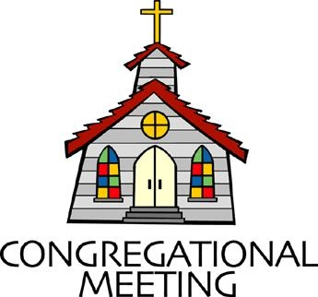

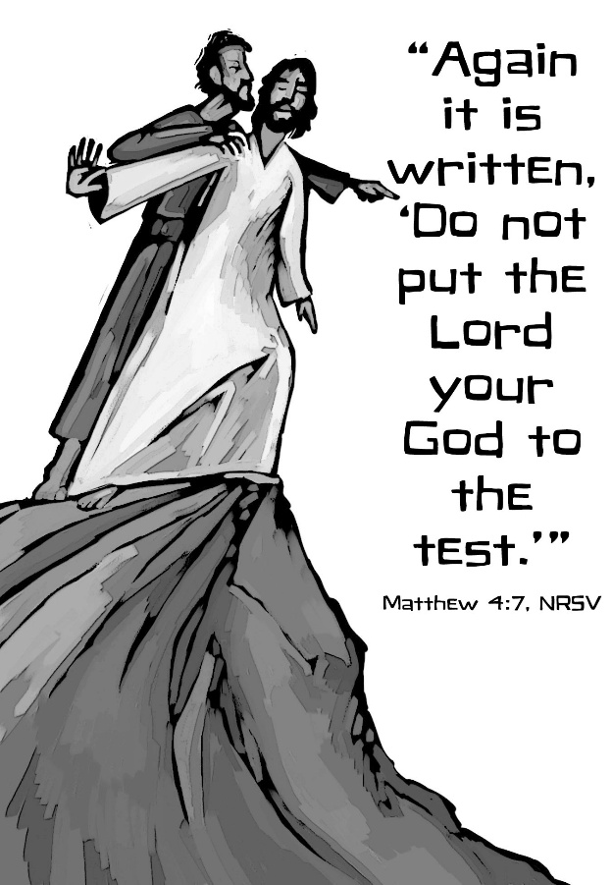

February 22, 2026 - 10:30 am

WELCOME VISITORS!

We're glad you are here! Cards at the ends of each pew are for you to fill out and drop in the Offering Plate. Please let us know you are visiting and join us for refreshments and fellowship following the service. The Sanctuary has an induction loop system to assist the hearing impaired. The system will also work on the telephone setting of hearing aids.

Springfield Presbyterian Church is rooted in the gospel of Jesus Christ, led by the Holy Spirit, and called to loving relationships through vibrant worship and service. Valuing all people, we are committed to developing disciples and fostering stewardship.
PREPARATION FOR THE WORD
(* those who are able are invited to stand)
PRELUDE

GATHERING OF THE PEOPLE

The Lord be with you! And also with you! (Greetings and Announcements)

LIGHTING THE CHRIST CANDLE
Leader: Whenever we light this candle we proclaim:
People: Christ is the Light of the world and the center of our lives.

CALL TO WORSHIP
Leader: The Lord is merciful and gracious,
People: Slow to anger and abounding in love.
Leader: God’s promise is for all generations;
People: God’s covenant is with every living thing.

* HYMN O Worship the King, All Glorious Above! GTG #41

O worship the King, all glorious above!
O gratefully sing God's power and God’s love:
our shield and defender, the Ancient of Days,
pavilioned in splendor and girded with praise.

O tell of God's might; O sing of God's grace,
whose robe is the light, whose canopy space,
whose chariots of wrath the deep thunderclouds form;
and bright is God's path on the wings of the storm.

The earth with its store of wonders untold,
Almighty, your power has founded of old;
established it fast by a changeless decree,
and round it has cast, like a mantle, the sea.

Your bountiful care what tongue can recite?
It breathes in the air; it shines in the light;
it streams from the hills; it descends to the plain,
and sweetly distills in the dew and the rain.

Frail children of dust, and feeble as frail,
in you do we trust, nor find you to fail;
your mercies, how tender, how firm to the end,
our Maker, Defender, Redeemer, and Friend.

CALL TO CONFESSION
Leader: Are you thirsty for grace? Are you hungry for mercy? God is calling; come to the waters. Trusting in God’s grace, let us confess our sin.

PRAYER OF CONFESSION
God of mercy, you sent Jesus Christ to seek and save the lost. We confess that we have strayed from you and turned aside from your way. We are misled by pride, for we see ourselves pure when we are stained, and great when we are small. We have failed in love, neglected justice, and ignored your truth. Have mercy, O God, and forgive our sin. Return us to paths of righteousness through Jesus Christ, our Savior.

SILENT PRAYERS OF CONFESSION

RESPONSE O Lord, Hear My Prayer GTG #471 (sing 3 times)
O Lord, hear my prayer. O Lord, hear my prayer. When I call, answer me.
O Lord, hear my prayer. O Lord, hear my prayer. Come and listen to me.

WORDS OF ASSURANCE
Leader: Listen, so that you may live: the steadfast love of the Lord never fails.
All: In Jesus Christ, we are forgiven! Thanks be to God.

* MUSICAL RESPONSE OF PRAISE Praise Ye the Lord, the Almighty
GTG #35 (v. 3)
Praise ye the Lord! O let all that is in me adore him!
All that hath life and breath, come now with praises before him!
Let the amen sound from his people again; gladly for aye we adore him.

* THE PEACE The peace of Christ be with you! And also with you!
(You may greet those around you.)

* RESPONSE Here I Am, Lord GTG #69
Here I am, Lord. Is it I, Lord? I have heard you calling in the night.
I will go, Lord, if you lead me. I will hold your people in my heart.

THE PROCLAMATION OF THE WORD

PRAYER FOR ILLUMINATION
Gracious God, our way in the wilderness, guide us, by your Word, through these forty days, and minister to us with your Holy Spirit, so that we may be reformed, restored, and renewed; through Jesus Christ our Lord. Amen.

FIRST SCRIPTURE LESSON Psalm 32:1-11 OT page 479
¹ Happy are those whose transgression is forgiven, whose sin is covered.
² Happy are those to whom the Lord imputes no iniquity and in whose spirit there is no deceit. ³ While I kept silent, my body wasted away through my groaning all day long. ⁴ For day and night your hand was heavy upon me; my strength was dried up as by the heat of summer. ⁵ Then I acknowledged my sin to you, and I did not hide my iniquity; I said, “I will confess my transgressions to the Lord,” and you forgave the guilt of my sin. ⁶ Therefore let all who are faithful
offer prayer to you; at a time of distress, the rush of mighty waters shall not reach them. ⁷ You are a hiding place for me; you preserve me from trouble; you surround me with glad cries of deliverance. ⁸ I will instruct you and teach you the way you should go; I will counsel you with my eye upon you. ⁹ Do not be like a horse or a mule, without understanding, whose temper must be curbed with bit and bridle, else it will not stay near you. ¹⁰ Many are the torments of the wicked, but steadfast love surrounds those who trust in the Lord. ¹¹ Be glad in the Lord and rejoice, O righteous, and shout for joy, all you upright in heart.

SECOND SCRIPTURE LESSON Matthew 4:1-11 NT page 3
¹ Then Jesus was led up by the Spirit into the wilderness to be tested by the devil. ² He fasted forty days and forty nights, and afterward he was famished.
³ The tempter came and said to him, “If you are the Son of God, command these stones to become loaves of bread.” ⁴ But he answered, “It is written, ‘One does not live by bread alone, but by every word that comes from the mouth of God.’
⁵ Then the devil took him to the holy city and placed him on the pinnacle of the temple, ⁶ saying to him, “If you are the Son of God, throw yourself down, for it is written, ‘He will command his angels concerning you,’ and ‘On their hands they will bear you up, so that you will not dash your foot against a stone.’ ” ⁷ Jesus said to him, “Again it is written, ‘Do not put the Lord your God to the test.’ ”
⁸ Again, the devil took him to a very high mountain and showed him all the kingdoms of the world and their glory, ⁹ and he said to him, “All these I will give you, if you will fall down and worship me.” ¹⁰ Then Jesus said to him, “Away with you, Satan! for it is written, ‘Worship the Lord your God, and serve only him.’ ”
¹¹ Then the devil left him, and suddenly angels came and waited on him.

Leader: Hear what the Spirit is saying to the Church.
All: Thanks be to God.

SERMON Temptation in the Wilderness By Rev. Angela Tyler-Williams

THE RESPONSE TO THE WORD

* HYMN Lord, Who throughout These Forty Days GTG #166

Lord, who throughout these forty days for us did fast and pray,
Teach us with you to mourn our sins and close by you to stay.

As you with Satan did contend and did the victory win,
O give us strength to persevere, in you to conquer sin.

And through these days of penitence, and through this Passiontide,
Yes, evermore, in life and death, O Lord, with us abide.

Abide with us, till when this life of suffering shall be past,
An Easter of unending joy we may attain at last.

PASTORAL PRAYER AND THE LORD’S PRAYER

PRESENTATION OF TITHES AND OFFERINGS
OFFERTORY
* SONG OF THANKS Lord of All Good GTG #711 (v. 1)
Lord of all good, our gifts we bring to you;
Use them your holy purpose to fulfill,
Tokens of love and pledges brought anew,
That our whole life is offered to your will.
* PRAYER OF DEDICATION

* HYMN Be Still, My Soul GTG #819

Be still, my soul: the Lord is on thy side.
Bear patiently the cross of grief or pain.
Leave to thy God to order and provide,
who through all changes faithful will remain.
Be still, my soul: thy best, thy heavenly Friend
through thorny ways leads to a joyful end.

Be still, my soul: thy God doth undertake
to guide the future surely as the past.
Thy hope, thy confidence let nothing shake;
all now mysterious shall be bright at last.
Be still, my soul: the waves and winds still know
his voice who ruled them while he dwelt below.

Be still, my soul: the hour is hastening on
when we shall be forever with the Lord;
when disappointment, grief, and fear are gone,
sorrow forgot, love’s purest joys restored.
Be still, my soul: when change and tears are past
all safe and blessed we shall meet at last.

* CHARGE AND BENEDICTION
Leader: May the Lord guide you always, satisfying your hunger and thirst in this dry and weary land.
People: Amen.
Leader: We urge you, on behalf of Christ: Be reconciled to God.
All: Thanks be to God.

* UNISON AMEN GTG #601

POSTLUDE

Sunday March 1, 2026 Lectionary
Genesis 12:1-4a; Psalm 121; Romans 4:1-5, 13-17; Matthew 17:1-9
Assisting in Worship: We appreciate those who serve:

Today 2/22 Next Week 3/1
Sunday Opener: Carl Anderson Linda Caviglia
Ushers/Greeters: Leah Halvorson Steve and Donna Mazer
Cynthia Smith
Lay Leader: Sharon Pappas Bob Steppling
Pulpit Supply: Rev. Angela Tyler-Williams Rev. Shannon Weston
Fellowship Hosts: Rebekah Schermer Linda Caviglia

Happy Birthday! February 26 – Elsa Oates
February 27 – Cathy Marsh

Announcements

Welcome! We welcome Rev. Angela Tyler-Williams to our pulpit today! Angela (She/Her) serves as an at-large minister member of National Capital Presbytery. From 2020-2026, Angela co-founded and led SACReD - the Spiritual Alliance of Communities for Reproductive Dignity. She finds life in experiencing music, listening to podcasts, exploring creation, and engaging in theological discussions that go off the beaten path. Angela lives with her wife Rev. Adelyn, and their cats, Mouse and Stella, in Washington, DC.

Annual Congregational Meeting: TODAY, after church, in person and online. We will receive the 2026 budget, committee reports, and elect members of the congregation (Belle Vasbinder, Julie Ballard, Barbara Nickell, and Christy Yeager) to join Beth Oates and Steve Mazer chosen by Session for the nominating committee to elect elders. Copies of the budget and committee reports will be shared after church in person and online.

Concert: Mark your calendars for the next concert featuring The Eric Byrd Trio on Sunday March 1 at 3:00 pm. The Eric Byrd Trio has been a part of our concert series several times in the past years and has always been a joy to host. If you have enjoyed a concert by them before, you know you don’t want to miss it and if you haven’t, be sure you come to enjoy the Trio’s amazing music and talent, followed by excellent food afterwards.

Search Team: At the January Session meeting, a new Search Team was elected to move forward to find us a new pastor. Committee on Ministry member, Guy Moody, met with Session to explain our options. Session chose to follow a new path, Transitional Pastor, designed to move quicker and offer more creative possibilities for the way things might work now. The purpose is to ensure that we have essential pastoral leadership and to guide us in determining our mission and style of leadership to achieve that goal.

The Search Team met twice and learned in more detail how this Transitional Pastor position will work for us. It will allow us to call a Bridge Pastor for up to six months while we design interview questions and advertise. The Search Team will review applications and interview candidates for the Transitional Pastor position. Once a candidate is identified, Session will contract with the selected pastor for 1-2 years with options to renew.

At the last meeting, the Search Team finalized a job description that is now being sent to Committee on Ministry (COM). With their continued guidance, the team will move forward with each step. The pool of candidates is not large and if you know anyone who might be interested, let us know. They need to be an ordained minister PC(USA) or from a denomination with whom PC(USA) is in full communion.

If you have any questions, please contact Bob Steppling at bobsteppling@gmail.com

Search Team: Chair Bob Steppling, Tony Caviglia, Sue Holmes, Steve Mazer, Belle Vasbinder, with Sharon Pappas

Zoom Link for Worship Services: The Zoom link for church services is on the SPC website, not on the Facebook page. The Bulletin is also available on the website as well.

Congregational Care: If you know of someone who would benefit from a card or a phone call, please text or call Connie Gibbons at 410-935-3467.

Electronic Giving: Below is a QR code you can scan to make your contribution a new way! The page you get will ask for your name, email and phone

number. You can choose from a dropdown menu for selecting where the donation should go: General Fund, Capital Fund, Concert, Memorial. There is a fee for using a credit card, and you will be given the option to pay that fee along with your donation, but you don’t have to include it if you don’t want to.

Today:
Sunday February 22
10:30 am Worship
11:30 am Congregational Meeting (Sanctuary)
12:00 noon Fellowship

This Week:
Wednesday February 25
6:15 – 7:15 pm Bell Choir Practice
7:30 – 8:45 pm Adult Choir Practice
Saturday February 28
7:00 pm Family Game Night (Fellowship Room)

Next Week:
Sunday March 1
10:30 am Worship
11:30 am Fellowship
3:00 pm Concert (Sanctuary)
Monday March 2
7:00 pm HeadHuggers (Manse)
Tuesday March 3
7:00 pm ESCAPE Lunch Packing (Manse)
Wednesday March 4
6:15 – 7:15 pm Bell Choir Practice
7:30 – 8:45 pm Adult Choir Practice

Office Hours: Tuesday, Wednesday, Friday, 10 am – 3 pm

Springfield Presbyterian Church
10:30 am Worship (and Sunday School 1st & 3rd Sundays)
11:30 am Fellowship
Website: www.springfield-church.org Church Office: 410-795-6152
Like us on Facebook: www.facebook.com/SpringfieldPresbyterianChurch
Pastor: Vacant
Email: spc.office@verizon.net
Clerk of Session: Sharon Pappas
Minister of Music/Accompanist: Vacant
Bell Choir Director: Vacant
Youth Group Coordinator: Dylan Vasbinder
Administrative Assistant: Donna Mazer Email: spc.office@verizon.net

