(Large Print)

Springfield Presbyterian Church (USA)
7300 Spout Hill Road, Sykesville, MD 21784 410-795-6152
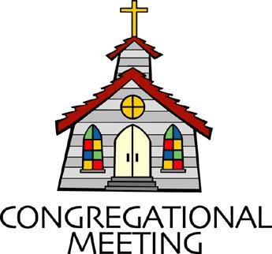
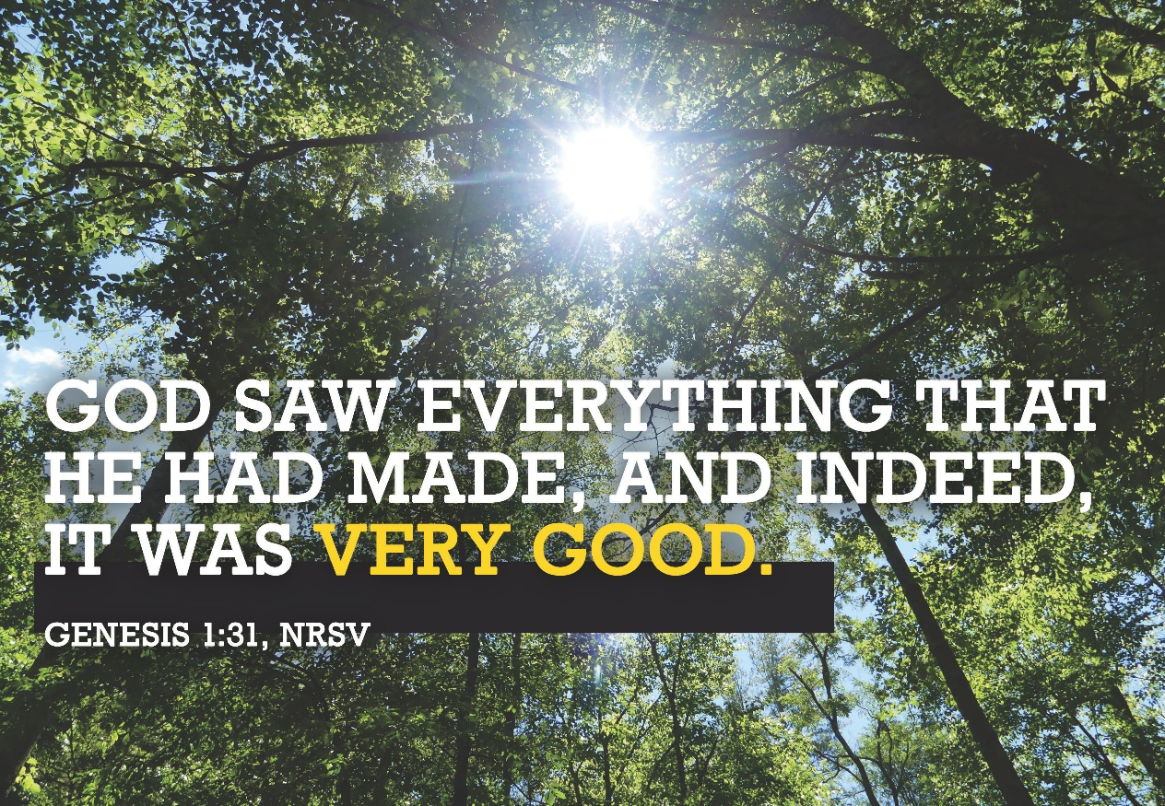

April 23, 2023 - 10:30 am

WELCOME VISITORS!

We're glad you are here! Cards at the ends of each pew are for you to fill out and drop in the Offering Plate. Please let us know you are visiting and join us for refreshments and fellowship following the service. The Sanctuary has an induction loop system to assist the hearing impaired. The system will also work on the telephone setting of hearing aids.

Springfield Presbyterian Church is rooted in the gospel of Jesus Christ, led by the Holy Spirit, and called to loving relationships through vibrant worship and service. Valuing all people, we are committed to developing disciples and fostering stewardship.

PREPARATION FOR THE WORD
(* those who are able are invited to stand)

PRELUDE In the Garden Arr. Cynthia Dobrinski

GATHERING OF THE PEOPLE

The Lord be with you! And also with you!

(Greetings and Announcements)

LIGHTING THE CHRIST CANDLE
Leader: Whenever we light this candle we proclaim:
People: Christ is the Light of the world and the center of our lives.

CALL TO WORSHIP [Psalm 8 excerpts]
Leader: O Lord, our Sovereign, how majestic is your name in all the earth!
People: You have set your glory above the heavens.
Leader: When we look at your heavens, the work of your fingers, the moon and the stars that you have established;
People: What are humans that you are mindful of them, mortals that you care for them.
Leader: You have given dominion over the works of your hands; you have put all things under our feet.
People: All sheep and oxen, and also the beasts of the field.
Leader: The birds of the air, and the fish of the sea, and whatever passes along the paths of the seas.
People: O Lord, our Sovereign, how majestic is your name in all the Earth!
ALL: Let us worship our Creator God!

*HYMN How Great Thou Art
O Lord my God! When I in awesome wonder, consider all the worlds thy hands have made,
I see the stars, I hear the rolling thunder, thy power throughout the universe displayed:

Refrain:
Then sings my soul, my Savior God, to thee,
How great thou art! How great thou art!
Then sings my soul, my Savior God, to thee:
How great thou art! How great thou art!

When through the woods and forest glades I wander and hear the birds sing sweetly in the trees,
When I look down from lofty mountain grandeur and hear the brook and feel the gentle breeze: [Refrain]

And when I think that God, his Son not sparing, sent him to die, I scarce can take it in,
That on the cross, my burden gladly bearing, he bled and died to take away my sin: [Refrain]

When Christ shall come with shout of acclamation and take me home, what joy shall fill my heart!
Then I shall bow in humble adoration, and there proclaim, “My God, how great thou art!” [Refrain]

CALL TO CONFESSION
As your pastor, I did a bit of research this past week. As I’ve been drinking from my plastic water bottles up here at the pulpit, I had an embarrassing realization when I found out, from a reputable source, that only 5% of plastic in the USA is recycled and the rest is thrown into the landfill. As I think about my generation and the generations to come, I realize that I am compliant in my comfort, and I need to do better. I wonder if you’ve had some of these realizations, so let us come together and pray, admitting to God our faults and seek to care for our Creator’s world boldly:

PRAYER OF CONFESSION
Generous and Loving God, as we look around our world, we admit that we often choose the easy way. We have become complacent with convenience, rather than doing the hard work of seeking ways to sustain your Creation. We have lost sight of Eden, of the blooming of flowers and the growth of plants and vegetables. We can do better – we need to do better, not only for us, but for the generations that follow. You have entrusted us with your Creation. Please forgive us for our inaction and restore us to be in harmony again with the new life you bring daily. Amen.

SILENT PRAYERS OF CONFESSION

RESPONSE Restore in Us, O God (verse 1) Tune #434
Restore in us, O God, the splendor of your love;
Renew your image in our hearts, and all our sins remove.

WORDS OF ASSURANCE
Leader: When we come before God and admit our fault and failure, God is quick to hear our sin and forgive us. Let us speak the truth together:
ALL: We are forgiven, we are redeemed, by the power and grace of Jesus Christ alone, our Risen Lord.

* MUSICAL RESPONSE OF PRAISE Alleluia, Alleluia! Give Thanks Alleluia, alleluia! Give thanks to the risen Lord.
Alleluia, alleluia! Give praise to His name.

* THE PEACE The peace of Christ be with you! And also with you!
(You may greet those around you.)

* RESPONSE Here I Am, Lord
Here I am, Lord, Is it I, Lord? I have heard you calling in the night.
I will go, Lord, if you lead me. I will hold your people in my heart.

THE PROCLAMATION OF THE WORD

PRAYER OF ILLUMINATION
Creator God, as we hear your Word, help us to hear the places where you invite us to co-create with you. You have entrusted us to care for this world, so as we listen, open our minds, hearts, and souls. Guide us from prayer and thoughtfulness to action so that your creation may be restored. Amen.

FIRST SCRIPTURE LESSON Genesis 1:1-23
¹In the beginning when God created the heavens and the earth, ²the earth was a formless void and darkness covered the face of the deep, while a wind from God swept over the face of the waters. ³Then God said, ‘Let there be light’; and there was light. ⁴And God saw that the light was good; and God separated the light from the darkness. ⁵God called the light Day, and the darkness he called Night. And there was evening and there was morning, the first day. ⁶And God said, ‘Let there be a dome in the midst of the waters, and let it separate the waters from the waters.’ ⁷So God made the dome and separated the waters that were under the dome from the waters that were above the dome. And it was so. ⁸God called the dome Sky. And there was evening and there was morning, the second day. ⁹And God said, ‘Let the waters under the sky be gathered together into one place, and let the dry land appear.’ And it was so. ¹⁰God called the dry land Earth, and the waters that were gathered together he called Seas. And God saw that it was good. ¹¹Then God said, ‘Let the earth put forth vegetation: plants yielding seed, and fruit trees of every kind on earth that bear fruit with the seed in it.’ And it was so. ¹²The earth brought forth vegetation: plants yielding seed of every kind, and trees of every kind bearing fruit with the seed in it. And God saw that it was good. ¹³And there was evening and there was morning, the third day. ¹⁴And God said, ‘Let there be lights in the dome of the sky to separate the day from the night; and let them be for signs and for seasons and for days and years, ¹⁵and let them be lights in the dome of the sky to give light upon the earth.’ And it was so. ¹⁶God made the two great lights—the greater light to rule the day and the lesser light to rule the night—and the stars. ¹⁷God set them in the dome of the sky to give light upon the earth, ¹⁸to rule over the day and over the night, and to separate the light from the darkness. And God saw that it was good. ¹⁹And there was evening and there was morning, the fourth day. ²⁰And God said, ‘Let the waters bring forth swarms of living creatures, and let birds fly above the earth across the dome of the sky.’ ²¹So God created the great sea monsters and every living creature that moves, of every kind, with which the waters swarm, and every winged bird of every kind. And God saw that it was good. ²²God blessed them, saying, ‘Be fruitful and multiply and fill the waters in the seas, and let birds multiply on the earth.’ ²³And there was evening and there was morning, the fifth day.

SECOND SCRIPTURE LESSON Genesis 1:24-31
²⁴And God said, ‘Let the earth bring forth living creatures of every kind: cattle and creeping things and wild animals of the earth of every kind.’ And it was so. ²⁵God made the wild animals of the earth of every kind, and the cattle of every kind, and everything that creeps upon the ground of every kind. And God saw that it was good. ²⁶Then God said, ‘Let us make humankind in our image, according to our likeness; and let them have dominion over the fish of the sea, and over the birds of

the air, and over the cattle, and over all the wild animals of the earth, and over every creeping thing that creeps upon the earth.’ ²⁷ So God created humankind in his image, in the image of God he created them;
male and female he created them. ²⁸God blessed them, and God said to them, ‘Be fruitful and multiply, and fill the earth and subdue it; and have dominion over the fish of the sea and over the birds of the air and over every living thing that moves upon the earth.’ ²⁹God said, ‘See, I have given you every plant yielding seed that is upon the face of all the earth, and every tree with seed in its fruit; you shall have them for food. ³⁰And to every beast of the earth, and to every bird of the air, and to everything that creeps on the earth, everything that has the breath of life, I have given every green plant for food.’ And it was so. ³¹God saw everything that he had made, and indeed, it was very good. And there was evening and there was morning, the sixth day.

SERMON Co-Creating with God Rev. Becca Price

THE RESPONSE TO THE WORD

*HYMN The Earth is the Lord’s
(to the tune of "Immortal, Invisible, God Only Wise" GTG #12)

"The earth is the Lord's and the fullness thereof."
Creation reminds us, O God, of your love.
By grace we are learning, as year leads to year,
We're called to be stewards, your caretakers here.

Your rainforests nurture the world that we share.
Your wetlands give animals shelter and care.
Your coral reefs cradle the life of the sea.
You've shown us, in love, what your good world can be.

Too often, O God, we abuse your good earth.
We fail to remember its beauty and worth.
We take from creation much more than we need,
We threaten your world through indifference and greed.

May we be good stewards of all that you give,
Protecting creation wherever we live.
May we be a church that renews and restores
And lovingly cares for this earth that is yours.

Biblical References: Genesis 1, 2; Psalms 8, 24
Tune: Traditional Welsh hymn, in John Robert's Caniadau y Cyssegr (Songs of the Sanctuary), 1839 ("Immortal, Invisible, God Only Wise") (MIDI)
Text: Copyright © 2001 by Carolyn Winfrey Gillette. All rights reserved.

PASTORAL PRAYER AND THE LORD’S PRAYER

PRESENTATION OF TITHES AND OFFERINGS
OFFERTORY Pie Jesu (from “Requiem” by Andrew Lloyd Webber)
* SONG OF THANKS We Give Thee but Thine Own (v. 1) #708
We give thee but thine own, what-e’er the gift may be;
All that we have is thine alone, a trust, O Lord from thee.
* PRAYER OF DEDICATION

* HYMN Touch the Earth Lightly

Touch the earth lightly, use the earth gently,
Nourish the life of the world in our care:
Gift of great wonder, ours to surrender,
Trust for the children tomorrow will bear.

We who endanger, who create hunger,
Agents of death for all creatures that live,
We who would foster clouds of disaster,
God of our planet, forestall and forgive!

Let there be greening, birth from the burning,
Water that blesses and air that is sweet,
Health in God’s garden, hope in God’s children,
Regeneration that peace will complete.

God of all living, God of all loving,
God of the seedling, the snow, and the sun,
Teach us, deflect us, Christ reconnect us,
Using us gently and making us one.

* CHARGE AND BENEDICTION
Leader: We honor and praise God for the gift of life and the call to be good stewards of the earth, our home.
People: So we go from this place, renewed and restored.
Leader: As we consider the fragility and interconnectedness of all creation,
People: We will be wise in the use of our resources.
Leader: As we seek to be active participants in your Creation,
People: We will preserve the beauty and goodness of the earth for ourselves and all the generations to come.
ALL: Alleluia and Amen.

* UNISON AMEN

POSTLUDE For the Beauty of the Earth Arr. J.D. Frizzell

Sunday April 30, 2023 Lectionary
Acts 2:42-47; Psalm 23; 1 Peter 2:19-25; John 10:1-10
Assisting in Worship: We appreciate those who serve:
Today 4/23 Next Week 4/30
Sunday Opener: Barbara Nickell Linda Caviglia
Ushers/Greeters: Cynthia Smith Steve & Donna
Sharon Pappas Mazer
Lay Leader: Barbara Cornell Christy Yeager

Happy Birthday! April 23 – Morgan Mazer

Announcements

Spring Plant Sale: Our friends at Buppert's /Doran's Chance Farm are very generous in our community, donating produce to "Community Table" and other causes. For many years they have donated back to Springfield 10% of the purchases we make using a special flyer that you can pick up at church. This will run from May 1 to 21, so plan your gardening and go see their beautiful choices!

ESCAPE Lunches: It is our turn to contribute bag lunches to ESCAPE the first Wednesday in May! We will gather at the Manse Tuesday evening May 2 at 7 pm to assemble the lunches. There is a sign-up sheet in the church kitchen if you can donate some of the makings. Join us! We're usually finished in an hour. Check with Sharon Pappas if you have any questions.

Springfield Membership: Are you interested in finding out more about our faith community and becoming a member? We would love to answer any questions you have. Please contact Pastor Becca at springfieldpastor@gmail.com for more information.

Congregational Care / Mission & Outreach (CoCaMO): Do you know of a member or friend of our church family who is ill, needs prayers, would like call, a visit or a card, or might benefit from meal train? If so, please contact the Church Office (410-795-6152), Cathy Marsh (410-549-6916) or Diana Steppling (862-266-2242).

Pastor-Parish Committee: The Pastor-Parish Committee invites you to share your concerns, suggestions, and gratitude. We have a form in the Narthex and a lock-box that we will open weekly and we ask that you share your name and be specific. We look forward to reading your comments so that we can continue to grow into the body of Christ.

Blessing Bags and Comfort Bags are in the Narthex. Please feel free to pick up a few. Handing one out to someone in need gives you a very real way to meet their immediate needs by providing them with some basic supplies and a little bit of comfort.

Office Hours: Tuesday, Wednesday and Friday, 10:00 am - 3:00 pm
Springfield Presbyterian Church

10:30 am Worship
11:30 am Fellowship
Website: www.springfield-church.org Church Office: 410-795-6152
Like us on Facebook: www.facebook.com/SpringfieldPresbyterianChurch
Pastor: Rev. Becca Price
Email: springfieldpastor@gmail.com
Clerk of Session: Sharon Pappas
Minister of Music: Linda Caviglia
Accompanist/Organist: Aaron Thacker
Youth Group Coordinator: Dylan Vasbinder
Administrative Assistant: Donna Mazer e-mail: spc.office@verizon.net

Today:
Sunday April 23
10:30 am Worship
11:30 am Fellowship

This Week:
Wednesday April 26
6:15 – 7:15 pm Bell Choir Practice
7:30 – 8:45 pm Adult Choir Practice
Friday April 28
7:00 pm Family Game Night (Fellowship Room)

Looking Ahead:
Sunday April 30
10:30 am Worship
11:30 am Fellowship
Monday May 1
7:00 pm HeadHuggers (Manse)
Tuesday May 2
7:00 pm ESCAPE Lunch Packing (Manse)
Wednesday May 3
6:15 – 7:15 pm Bell Choir Practice
7:30 – 8:45 pm Adult Choir Practice
Saturday May 6
9:00 – 11:00 am Church Clean-Up

