(Large Print)

Springfield Presbyterian Church (USA)
7300 Spout Hill Road, Sykesville, MD 21784 410-795-6152

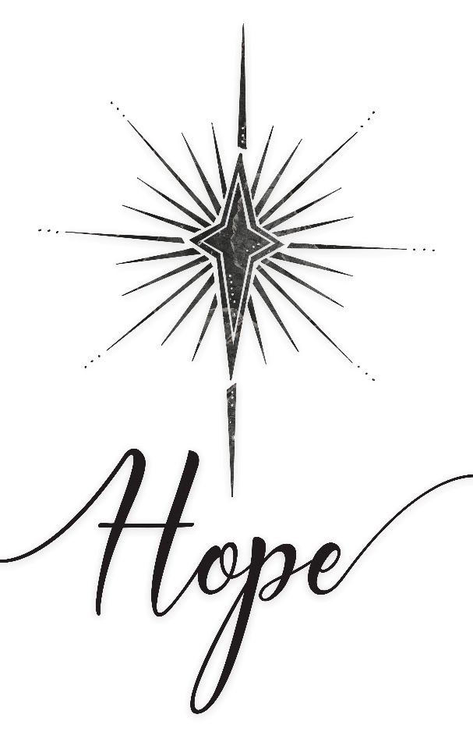

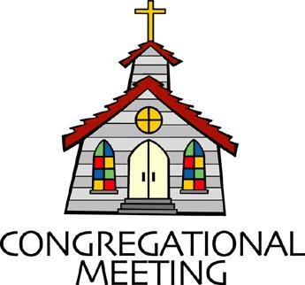
November 27, 2022 - 10:30 am

WELCOME VISITORS!
We're glad you are here! Cards at the ends of each pew are for you to fill out and drop in the Offering Plate. Please let us know you are visiting, and join us for refreshments and fellowship following the service. The Sanctuary has an induction loop system to assist the hearing impaired. The system will also work on the telephone setting of hearing aids.

Springfield Presbyterian Church is rooted in the gospel of Jesus Christ, led by the Holy Spirit, and called to loving relationships through vibrant worship and service. Valuing all people, we are committed to developing disciples and fostering stewardship.

PREPARATION FOR THE WORD
(* those who are able are invited to stand)

PRELUDE

GATHERING OF THE PEOPLE

The Lord be with you! And also with you! (Greeting)

LIGHTING THE CHRIST CANDLE
Leader: Whenever we light this candle we proclaim:
People: Christ is the Light of the world and the center of our lives.

A MINUTE FOR EDUCATION Elder Alex McClung

ADVENT CANDLE LIGHTING

CALL TO WORSHIP
Leader: From generation to generation,
People: There are so many names to describe all the ways we are different.
Leader: From GenZ, to the Millennials, Generation X, Baby Boomers, the Silent Generation, and the G.I. Generation,
People: We are a people to come to this place with different experiences, traditions, and memories.
Leader: Yet the beauty is that no one is left out.
People: This church is a church for all people.
Leader: So as we begin this Advent journey together, let us covenant to remember,
People: That we all belong here, and above all, we all belong to God.
ALL: Let us worship our God who spans the generations! Amen!

* HYMN Come, Thou Long-Expected Jesus GTG #82

Come, thou long-expected Jesus, born to set thy people free;
from our fears and sins release us; let us find our rest in thee.
Israel’s strength and consolation, hope of all the earth thou art;
dear desire of every nation, joy of every longing heart.

Born thy people to deliver, born a child and yet a king,
born to reign in us forever, now thy gracious kingdom bring.
By thine own eternal Spirit rule in all our hearts alone;
by thine all-sufficient merit raise us to thy glorious throne.

CALL TO CONFESSION
Leader: In God’s house, everyone is welcome – those who seem like they have it all together, and those who feel like their world is falling apart. No matter who we are, there’s room for us here. With that confidence, we turn to God in prayer, speaking the truth of our lives. Let us pray together:

PRAYER OF CONFESSION
Leader: God of today and God of tomorrow, you say, “Bring your full self. There’s room for you here.”
People: But we say, “Our lives are too messy.”
Leader: You say, “Bring your hopes and your dreams. There’s room for you here.”
People: But we say, “It’s too risky to hope.”
Leader: You say, “Bring your grief and your prayers. There’s room for you here.”
People: But we say, “Some things are easier to forget.”
Leader: God of today and God of tomorrow, we know in our hearts that there’s room for us here.
People: Forgive us for withholding our full selves from you. Forgive us for giving only our Sunday best.
Leader: Help us remember, today and tomorrow,
People: There’s room for every story. Amen.

SILENT PRAYERS OF CONFESSION

RESPONSE On Jordan’s Bank the Baptist’s Cry Tune #96
Then cleansed be every life from sin; make straight away for God within,
And let us all our hearts prepare for Christ to come and enter there.

WORDS OF ASSURANCE
Leader: Family of faith, we who feel scattered are held together. We who have lost our way are forgiven and found. And we who are lonely are brought into the fold and are told, “There’s room for you here.”
People: From generation to generation, this is the good news of the gospel. In Jesus Christ we are held, forgiven, found, and welcomed. Thanks be to God! Amen.

* MUSICAL RESPONSE OF PRAISE Refrain from Angels We Have Heard on High Gloria in excelsis Deo!

* THE PEACE The peace of Christ be with you! And also with you!
(You may greet those around you.)

* RESPONSE Here I Am, Lord
Here I am, Lord, Is it I, Lord? I have heard you calling in the night.
I will go, Lord, if you lead me. I will hold your people in my heart.

THE PROCLAMATION OF THE WORD

PRAYER OF ILLUMINATION
God of the Ages, in Scripture we hear stories of people like us – ordinary people, people who longed to know you, people who longed to follow you, people who made mistakes, people who tried to grow – old, young, native, immigrant, new to the faith, lifelong believer. In Scripture we hear stories of people like us, so just as you walked with them, help us to hear and remember all the ways that you walk with us. We are listening. We are grateful. We are yours. Amen.

FIRST SCRIPTURE LESSON Isaiah 2:1-5
The word that Isaiah son of Amoz saw concerning Judah and Jerusalem.
² In days to come the mountain of the Lord’s house shall be established as the highest of the mountains, and shall be raised above the hills;
all the nations shall stream to it. ³ Many peoples shall come and say,
‘Come, let us go up to the mountain of the Lord, to the house of the God of Jacob; that he may teach us his ways and that we may walk in his paths.’ For out of Zion shall go forth instruction, and the word of the Lord from Jerusalem. ⁴ He shall judge between the nations, and shall arbitrate for many peoples; they shall beat their swords into ploughshares, and their spears into pruning-hooks; nation shall not lift up sword against nation, neither shall they learn war any more.
⁵ O house of Jacob, come, let us walk in the light of the Lord!

SECOND SCRIPTURE LESSON Matthew 1:1-17
An account of the genealogy of Jesus the Messiah, the son of David, the son of Abraham. ²Abraham was the father of Isaac, and Isaac the father of Jacob, and Jacob the father of Judah and his brothers, ³and Judah the father of Perez and Zerah by Tamar, and Perez the father of Hezron, and Hezron the father of Aram, ⁴and Aram the father of Aminadab, and Aminadab the father of Nahshon, and Nahshon the father of Salmon, ⁵and Salmon the father of Boaz by Rahab, and Boaz the father of Obed by Ruth, and Obed the father of Jesse, ⁶and Jesse the father of King David. And David was the father of Solomon by the wife of Uriah, ⁷and Solomon the father of Rehoboam, and Rehoboam the father of Abijah, and Abijah the father of Asaph, ⁸and Asaph the father of Jehoshaphat, and Jehoshaphat the father of Joram, and Joram the father of Uzziah, ⁹and Uzziah the father of Jotham, and Jotham the father of Ahaz, and Ahaz the father of Hezekiah, ¹⁰and Hezekiah the father of Manasseh, and Manasseh the father of Amos, and Amos the father of Josiah, ¹¹and Josiah the father of Jechoniah and his brothers, at the time of the deportation to Babylon. ¹²And after the deportation to Babylon: Jechoniah was the father of Salathiel, and Salathiel the father of Zerubbabel, ¹³and Zerubbabel the father of Abiud, and Abiud the father of Eliakim, and Eliakim the father of Azor, ¹⁴and Azor the father of Zadok, and Zadok the father of Achim, and Achim the father of Eliud, ¹⁵and Eliud the father of Eleazar, and Eleazar the father of Matthan, and Matthan the father of Jacob, ¹⁶and Jacob the father of Joseph the husband of Mary, of whom Jesus was born, who is called the Messiah. ¹⁷So all the generations from Abraham to David are fourteen generations; and from David to the deportation to Babylon, fourteen generations; and from the deportation to Babylon to the Messiah, fourteen generations.

Leader: Hear what the Spirit is saying to the Church.
All: Thanks be to God.

SERMON There’s Room for Every Story Rev. Becca Price

THE RESPONSE TO THE WORD

* HYMN Through the Ages (see last page of bulletin)

AFFIRMATION OF FAITH
We believe in a God, who promised to Abraham, who wrestled with Jacob, who walked with Ruth, who spoke with Moses, who grieved with Bathsheba, who danced with David, who dreamed with Joseph, and who hoped like Mary. We believe in a God who has been loving, inviting, transforming, and challenging us from generation to generation. And we believe that same God is here with us now, saying, “Come on in; there’s room for you here.” Amen.

PASTORAL PRAYER AND OUR LORD’S PRAYER

OFFERTORY
* SONG OF THANKS As with Gladness Men of Old Tune #150
As they offered gifts most rare at thy manger, rude and bare,
So may we with holy joy, pure and free from sin’s alloy,
All our costliest treasures bring, Christ, to thee, our heavenly king.
* PRAYER OF DEDICATION

* HYMN Watchman, Tell Us of the Night GTG #97

Watchman, tell us of the night, what its signs of promise are.
Traveler, what a wondrous sight: see that glory-beaming star.
Watchman, does its beauteous ray news of joy or hope foretell?
Traveler, yes; it brings the day, promised day of Israel.

Watchman, tell us of the night; higher yet that star ascends.
Traveler, blessedness and light, peace and truth its course portends.
Watchman, will its beams alone gild the spot that gave them birth?
Traveler, ages are its own; see, it bursts o’er all the earth.

Watchman, tell us of the night, for the morning seems to dawn.
Traveler, shadows take their flight; doubt and terror are withdrawn.
Watchman, you may go your way; hasten to your quiet home.
Traveler, we rejoice today, for Emmanuel has come!

* CHARGE AND BENEDICTION
Leader: As you leave this place, may you go knowing that from generation to generation, we have been claimed and loved.
People: From generation to generation, God has been by our side.
Leader: From generation to generation, we are not alone.
People: The God of yesterday and the God of tomorrow knows you by name, loves you, and calls you forth, saying, “Go be the person you are called to be, love wildly, do justice, and come back soon.”
Leader: May it be so. Amen.

* UNISON AMEN

POSTLUDE

Assisting in Worship: We appreciate those who serve:

Today 11/27 Next Week 12/4
Sunday Opener Beth Oates Ron Holmes
Ushers/Greeters Alex McClung Sharon Pappas
Need Volunteer Bob Rogers
Lay Leader Mark Kearney Tim Oates

Happy Birthday! December 3 – Angle Carbaugh
December 4 – Ryley Brown

Happy Anniversary! November 28 – Connie Gibbons & Cathy Marsh
November 29 – Amy & Omar Izaguirre

Sunday, December 4, 2022 Lectionary
Isaiah 11:1-10; Psalm 72:1-7,18-19; Romans 15:4-13; Matthew 3:1-12

Announcements

Mask Update: Since COVID-19 is still with us, the Session has decided that masking and social distancing is encouraged but is optional. Though it is not a mandate, we seek to love one another by keeping each other as safe as possible. Thank you for your help in this endeavor.

Christian Education: Our Time and Talents survey shows folks are interested in an adult bible study program, and Alex McClung is interested in leading a study group. We imagine meeting 2x/month before church, but content, format, and timing are all TBD. Please contact Alex with your suggestions, interests, and best times: akmcclungiii@gmail.com.

Pastor-Parish Committee: The Pastor-Parish Committee invites you to share your concerns, suggestions, and gratitude. We have a form in the Narthex and a lock-box that we will open weekly and we ask that you share your name and be specific. We look forward to reading your comments so that we can continue to grow into the body of Christ.

Springfield Membership: Are you interested in finding out more about our faith community and becoming a member? We would love to answer any questions you have. Please contact Pastor Becca at springfieldpastor@gmail.com for more information.

Congregational Care / Mission & Outreach (CoCaMO): Do you know of a member or friend of our church family who is ill, needs prayers, would like call, a visit or a card, or might benefit from meal train? If so, please contact the Church Office (410-795-6152), Cathy Marsh (410-549-6916) or Diana Steppling (862-266-2242).

Prayers & Thanksgivings
~ Prayers for Craig Robinson, fully recovered from MRSA.
~ Prayers of healing for Pastor Becca’s mother who had a fall.
~ Continued prayers for Sue Holmes’ mom, Betty Martlew.

Today:
Sunday November 27 – 1st Sunday of Advent
10:30 am Worship
11:30 am Fellowship

This Week:
Wednesday November 30
6:15 – 7:15 pm Bell Choir Practice
7:30 – 8:45 pm Adult Choir Practice
Saturday December 3
5:30 – 8:30 pm Laser Tag

Looking Ahead:
Sunday December 4 – 2nd Sunday of Advent
10:30 am Worship
11:30 am Fellowship
Monday December 5
7:00 pm HeadHuggers (Manse)
Tuesday December 6
7:00 pm CoCaMO Meeting (via Zoom)
Wednesday December 7
6:15 – 7:15 pm Bell Choir Practice
7:30 – 8:45 pm Adult Choir Practice
Thursday December 8
7:00 pm Session Meeting (Manse)

Office Hours: Tuesday, Wednesday and Friday, 10:00 am - 3:00 pm
Springfield Presbyterian Church

10:30 am Worship
11:30 am Fellowship
Website: www.springfield-church.org Church Office: 410-795-6152
Like us on Facebook: www.facebook.com/SpringfieldPresbyterianChurch
Pastor: Rev. Becca Price
Email: springfieldpastor@gmail.com
Clerk of Session: Sharon Pappas
Minister of Music: Linda Caviglia
Accompanist/Organist: Aaron Thacker
Youth Group Coordinator: Dylan Vasbinder
Administrative Assistant: Donna Mazer e-mail: spc.office@verizon.net

