(Large Print)

Springfield Presbyterian Church (USA)
7300 Spout Hill Road, Sykesville, MD 21784 410-795-6152

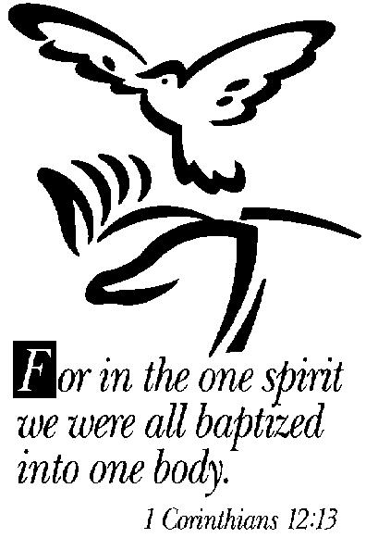

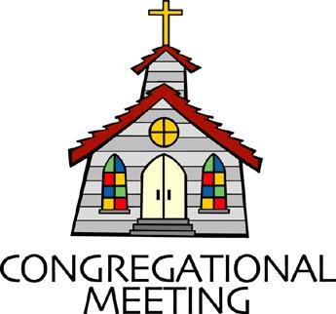
January 27, 2019 - 10:30 am

WELCOME VISITORS! We're glad you are here! Cards at the ends of each pew are for you to fill out and drop in the Offering Plate. Please let us know you are visiting, and join us for refreshments and fellowship following the service. The Sanctuary has an induction loop system to assist the hearing impaired. The system will also work on the telephone setting of hearing aids. A head set is available upon request.

Springfield Presbyterian Church is rooted in the gospel of Jesus Christ, led by the Holy Spirit, and called to loving relationships through vibrant worship and service. Valuing all people, we are committed to developing disciples and fostering stewardship.

PREPARATION FOR THE WORD
(* those who are able are invited to stand)

Please prepare for worship by listening to the music of the Prelude.

PRELUDE

GATHERING OF THE PEOPLE

The Lord be with you! And also with you! (Greeting)

LIGHTING THE CHRIST CANDLE
Leader: Whenever we light this candle we proclaim:
People: Christ is the Light of the world and the center of our lives.

CALL TO WORSHIP [Excerpts of Psalm 96]
Leader: O sing to the Lord a new song; sing to the Lord, all the earth.
People: Sing to the Lord, bless His name; tell of His salvation from day to day.
Leader: Declare His glory among the nations, His marvelous works among all the peoples.
People: For great is the lord, and greatly to be praised; He is to be revered above all gods.
Leader: For all the gods of the peoples are idols, but the Lord made the heavens.
People: Honor and majesty are before Him; strength and beauty are in His sanctuary.
Leader: Ascribe to the Lord, O families of the peoples, ascribe to the Lord glory and strength.
People: Ascribe to the Lord the glory due His name; bring an offering, and come into His courts.
Leader: Worship the Lord in holy splendor; tremble before Him, all the earth.

People: Say among the nations, “The Lord is king! The world is firmly established; it shall never be moved. He will judge the peoples with equity.”
Leader: Let the heavens be glad, and let the earth rejoice; let the sea roar, and all that fills it;
People: Let the field exult, and everything in it. Then shall all the trees of the forest sing for joy.
ALL: The Lord is coming! He will judge the world with righteousness and the people with His truth. Let us worship our God!

* HYMN Here in This Place (Gather Us In)

Here in the place the new light is streaming; now is the darkness vanished away; see in this space our fears and our dreamings brought here to you in the light of this day.
Gather us in, the lost and forsaken; gather us in, the blind and the lame; call to us now, and we shall awaken; we shall arise at the sound of our name.

We are the young, our lives are a mystery. We are the old who yearn for your face. We have been sung throughout all of history, called to be light in the whole human race.
Gather us in, the rich and the haughty; gather us in, the proud and the strong; give us a heart, so meek and so lowly; give us the courage to enter the song.

Here we will take the wine and the water; here we will take the bread of new birth. Here you shall call your sons and your daughters, call us anew to be salt for the earth.

Give us to drink the wine of compassion; give us to eat the bread that is you; nourish us well, and teach us to fashion live that are holy and hearts that are true.

Not in the dark of buildings confining, not in some heaven, light years away: here in this place the new light is shining; now is the kingdom, and now is the day.
Gather us in and hold us forever; gather us in and make us your own; gather us in, all peoples together, fire of love in our flesh and our bone.

PRAYER OF CONFESSION
Generous God, you call us to proclaim the gospel, but we remain silent in the presence of evil. You call us to be reconciled to you and one another, but we are content to live in separation. You call us to seek the good of all, but we fail to resist the powers of oppression. You call us to fight pretensions and injustice, but we sit idly by, endangering the lives of people far and near. Forgive us, O Lord. Reconcile us to you by the power of your Spirit and give us the courage and strength to be reconciled to others; through Jesus Christ, our Savior. Amen.

SILENT PRAYERS OF CONFESSION

RESPONSE Spirit of the Living God
Spirit of the living God, fall afresh on me.
Spirit of the living God, fall afresh on me.
Melt me; mold me; fill me; use me.
Spirit of the living God, fall afresh on me.

WORDS OF ASSURANCE
Leader: Our righteousness is found in Christ alone, a gift of God by faith.

People: As beloved people of God, we believe the good news: through Jesus Christ we are forgiven! Praise be to God! Amen.

* MUSICAL RESPONSE OF PRAISE O Day of Rest and Gladness
O day of rest and gladness, O day of joy and light;
O balm for care and sadness, most beautiful, most bright;
On you, the high and lowly, through ages joined in tune,
Sing “Holy, holy, holy” to the great God triune.

* THE PEACE The peace of Christ be with you! And also with you!
(You may greet those around you.)

* RESPONSE Here I Am, Lord
Here I am, Lord, Is it I, Lord? I have heard you calling in the night.
I will go, Lord, if you lead me. I will hold your people in my heart.

THE PROCLAMATION OF THE WORD

PRAYER OF ILLUMINATION
Generous God, pour out your Holy Spirit and prepare our hearts to accept your word. Silence in us any voice but your own, that, hearing, we may also obey your will; through Jesus Christ our Lord. Amen.

FIRST SCRIPTURE LESSON Psalm 19:8-14
⁸ The precepts of the Lord are right, rejoicing the heart; the commandment of the Lord is clear, enlightening the eyes; ⁹ the fear of the Lord is pure, enduring for ever; the ordinances of the Lord are true and righteous altogether. ¹⁰ More to be desired are they than gold, even much fine gold; sweeter also than honey, and drippings of the honeycomb. ¹¹ Moreover by them is your servant warned; in keeping them there is great reward. ¹² But who can detect their errors? Clear me

from hidden faults. ¹³ Keep back your servant also from the insolent; do not let them have dominion over me. Then I shall be blameless, and innocent of great transgression. ¹⁴ Let the words of my mouth and the meditation of my heart be acceptable to you, O Lord, my rock and my redeemer.

SECOND SCRIPTURE LESSON 1 Corinthians 12:12-31
¹²For just as the body is one and has many members, and all the members of the body, though many, are one body, so it is with Christ. ¹³For in the one Spirit we were all baptized into one body—Jews or Greeks, slaves or free—and we were all made to drink of one Spirit.
¹⁴Indeed, the body does not consist of one member but of many. ¹⁵If the foot were to say, ‘Because I am not a hand, I do not belong to the body’, that would not make it any less a part of the body. ¹⁶And if the ear were to say, ‘Because I am not an eye, I do not belong to the body’, that would not make it any less a part of the body. ¹⁷If the whole body were an eye, where would the hearing be? If the whole body were hearing, where would the sense of smell be? ¹⁸But as it is, God arranged the members in the body, each one of them, as he chose. ¹⁹If all were a single member, where would the body be? ²⁰As it is, there are many members, yet one body. ²¹The eye cannot say to the hand, ‘I have no need of you’, nor again the head to the feet, ‘I have no need of you.’ ²²On the contrary, the members of the body that seem to be weaker are indispensable, ²³and those members of the body that we think less honorable we clothe with greater honor, and our less respectable members are treated with greater respect; ²⁴whereas our more respectable members do not need this. But God has so arranged the body, giving the greater honor to the inferior member, ²⁵that there may be no dissension within the body, but the members may have the same care for one another. ²⁶If one member suffers, all suffer together with it;

if one member is honored, all rejoice together with it. ²⁷Now you are the body of Christ and individually members of it. ²⁸And God has appointed in the church first apostles, second prophets, third teachers; then deeds of power, then gifts of healing, forms of assistance, forms of leadership, various kinds of tongues. ²⁹Are all apostles? Are all prophets? Are all teachers? Do all work miracles? ³⁰Do all possess gifts of healing? Do all speak in tongues? Do all interpret? ³¹But strive for the greater gifts. And I will show you a still more excellent way.

Leader: Hear what the Spirit is saying to the Church.
All: Thanks be to God.

TIME WITH YOUNG PEOPLE

SERMON We Belong to the Body Rev. Becca Crate

THE RESPONSE TO THE WORD

* HYMN For Everyone Born

For everyone born, a place at the table,
for everyone born, clean water and bread,
a shelter, a space, a safe place for growing,
for everyone born, a star overhead,

Refrain:
And God will delight when we are creators of justice and joy, Compassion and peace: yes, God will delight when we are creators
Of justice, justice and joy!

For woman and man, a place at the table,
revising the roles, deciding the share,
with wisdom and grace, dividing the power,
for woman and man, a system that's fair, [Refrain]

For young and for old, a place at the table,
a voice to be heard, a part in the song,
the hands of a child in hands that are wrinkled,
for young and for old, the right to belong, [Refrain]

For just and unjust, a place at the table,
abuser, abused, with need to forgive,
in anger, in hurt, a mindset of mercy,
for just and unjust, a new way to live, [Refrain]

For everyone born, a place at the table,
to live without fear, and simply to be,
to work, to speak out, to witness and worship,
for everyone born, the right to be free, [Refrain]

PASTORAL PRAYER AND THE LORD’S PRAYER
“For this I pray to God.” / “For this I give thanks to God.”
Congregational Response: “Hear our prayer, O God.”

PRESENTATION OF TITHES AND OFFERINGS
OFFERTORY God is Here! arr. Helen Kemp

(see next page)
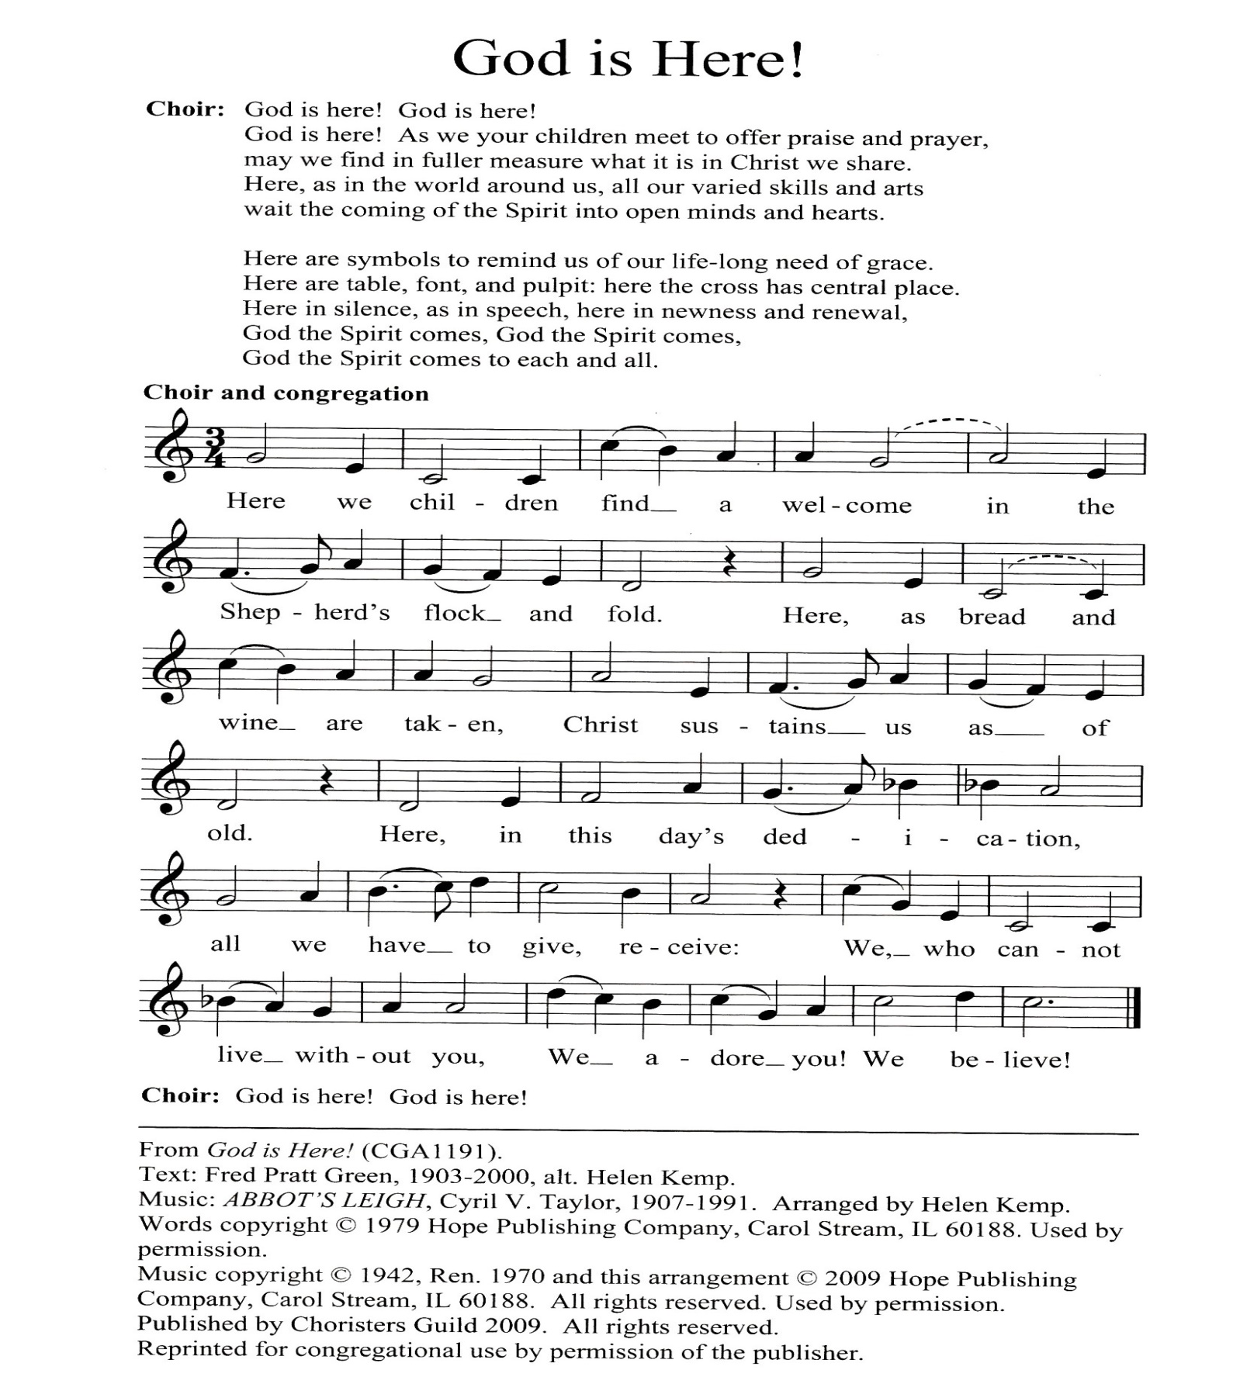

* SONG OF THANKS We Praise You, O God
We praise you, O God, our Redeemer, Creator;
In grateful devotion our tribute we bring.
We lay it before you; we kneel and adore you;
We bless your holy name; glad praises we sing.
* PRAYER OF DEDICATION
* HYMN Called as Partners in Christ’s Service

Called as partners in Christ’s service, called to ministries of grace,
We respond with deep commitment, fresh new lines of faith to trace.
May we learn the art of sharing, side by side and friend with friend,
Equal partners in our caring, to fulfill God’s chosen end.

Christ’s example, Christ’s inspiring, Christ’s clear call to work and worth,
Let us follow, never faltering, reconciling folk on earth.
Men and women, richer, poorer, all God’s people, young and old,
Blending human skills together, gracious gifts from God unfold.

Thus new patterns for Christ’s mission, in a small or global sense,
Help us bear each other’s burdens, breaking down each wall or fence.
Words of comfort, words of vision, words of challenge, said with care,
Bring new power and strength for action, make us colleagues, free and fair.

So God grant us for tomorrow, ways to order human life.
That surround each person’s sorrow, with a calm that conquers strife.
Make us partners in our living, our compassion to increase,
Messengers of faith, thus giving hope and confidence and peace.

* CHARGE AND BENEDICTION
Leader: We belong to the body,
People: Each of us sharing our gifts.
Leader: We belong to the body,
People: The gifts of Christ are to be shared.
Leader: We belong to the body,
People: And so we use our gifts to serve Christ in our world.

* UNISON AMEN POSTLUDE

Sunday February 3 Lectionary
Jeremiah 1:4-10; Psalm 71:1-6; 1 Corinthians 13:1-13; Luke 4:21-30

Assisting in Worship: We appreciate those who serve:

Today 1/27 Next Week 2/3
Sunday Opener Jennifer Wise Bob Rogers
Greeters & Ushers Sharon Pappas & Amy Vasbinder &
Martha Streaker Jim Wise
Lay Leader Mark Kearney Tim Oates
Sunday School Connie Robinson Connie Robinson
Fellowship Linda Caviglia Souper Bowl Luncheon

Church Attendance: January 20 - 37

Church Cleaning: Feb. 8, 9 or 10 - Belle Vasbinder & Barbara Nickell

Happy Birthday! February 1 - Steve & Donna Mazer

Announcements

Sunday School will be held today after the Sermon.

Souper Bowl Sunday: Our Souper Bowl bread and soup luncheon will be on February 3 after Worship. If you would like to help out, please see Diana Steppling. There will be envelopes in the pews for the next few weeks to benefit Souper Bowl Sunday, proceeds to fund the youth shopping trip to stock Sykesville Middle School’s Food Pantry.

C.I.A. (Community In Action) will meet on Monday, February 4 from 4:30 - 6 pm at the Manse. Pizza and drinks provided. Friends are welcome and encouraged to attend! C.I.A is a group open to all religious and non-religious people as a means of providing the community with acts of kindness. We will be doing different activities throughout the school year to help people in our community who are in need. Come and be part of giving back to our community.

Congregational Meeting: Our annual Congregational Meeting will be on Sunday, February 10 immediately after Worship to receive the 2019 budget and the 2018 annual committee reports.

Prayers & Thanksgivings

~ Prayers for Bob Roger’s sister-in-law Rebecca Rogers, who is in hospice.
~ Prayers of comfort for Martha Streaker and her family on the loss of her sister, Grace Erb, on January 12, 2019.
~ Prayers for St. Andrew’s of Mt. Airy from our Ministry Group.

The Congregational Care team wants to know what YOU or someone you know needs...a visit...a call...a meal. Please contact Diana Steppling or Connie Robinson.

Today:
Sunday January 27
10:30 am Worship & Sunday School
11:30 am Fellowship
12:00 noon Calendar Planning Meeting (Library)
5:30 pm Youth Group Laser Tag at ShadowLand

This Week:
Wednesday January 30
6:30 pm Bell Choir Practice
7:45 pm Adult Choir Practice

Looking Ahead:
Sunday February 3
10:30 am Worship & Sunday School
11:30 am Souper Bowl Luncheon
Monday February 4
4:30 pm C.I.A. Meeting (Manse)
Wednesday February 6
6:30 pm Adult Choir Practice
7:45 pm Bell Choir Practice
Thursday February 7
7:00 pm Session Meeting (Manse)
Sunday February 10
10:30 am Worship & Sunday School
11:30 am Congregational Meeting
12:00 noon Nominating Committee Meeting (Library)
3:00 pm Concert (Sanctuary)
6:30 pm Youth Movie Night (Manse)

Office Hours: Tuesday, Wednesday, Friday 9:00 am - 3:00 pm
Springfield Presbyterian Church

10:30 am Worship & Sunday School
11:30 am Fellowship
Website: www.springfield-church.org Church Office: 410-795-6152
Like us on Facebook: www.facebook.com/SpringfieldPresbyterianChurch
Pastor: Rev. Becca Crate
Email: springfieldpastor@gmail.com
Clerk of Session: Sharon Pappas
Minister of Music: Linda Caviglia
Accompanist: Aaron Thacker Organist: Jennifer Wise
Youth Group Coordinators: Charles & Deb Sperling
Sunday School Coordinator: Connie Robinson
Administrative Assistant: Donna Mazer
e-mail: spc.office@verizon.net

