(Large Print)

Springfield Presbyterian Church (USA)
7300 Spout Hill Road, Sykesville, MD 21784 410-795-6152

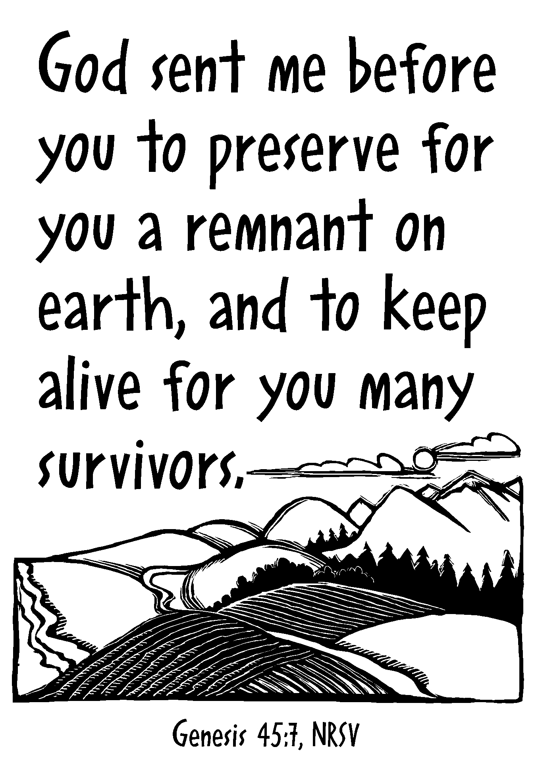

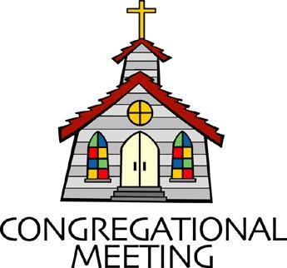
February 24, 2019 - 10:30 am

WELCOME VISITORS! We're glad you are here! Cards at the ends of each pew are for you to fill out and drop in the Offering Plate. Please let us know you are visiting, and join us for refreshments and fellowship following the service. The Sanctuary has an induction loop system to assist the hearing impaired. The system will also work on the telephone setting of hearing aids.

Springfield Presbyterian Church is rooted in the gospel of Jesus Christ, led by the Holy Spirit, and called to loving relationships through vibrant worship and service. Valuing all people, we are committed to developing disciples and fostering stewardship.
PREPARATION FOR THE WORD
(* those who are able are invited to stand)

Please prepare for worship by listening to the music of the Prelude.

PRELUDE

GATHERING OF THE PEOPLE

The Lord be with you! And also with you! (Greeting)

LIGHTING THE CHRIST CANDLE
Leader: Whenever we light this candle we proclaim:
People: Christ is the Light of the world and the center of our lives.

CALL TO WORSHIP [Based on Psalm 103]
Leader: Bless the Lord, O our souls, and all that is within us, bless His holy name.
People: Let us bless the Lord, let us not forget all His benefits –
Leader: It is He who forgives our iniquity, it is He who heals our diseases.
People: It is He who redeems our life, who graces us with steadfast love and mercy.
Leader: He satisfies us with good as long as we live so that we are renewed.
People: The Lord works for justice for all who are oppressed.
Leader: The Lord is merciful and gracious, slow to anger, and abounding in steadfast love.
People: He will not always accuse, nor will He keep His anger forever.
Leader: He does not deal with us according to our sins, nor repay us according to our iniquities.
People: For as high as the heavens are above the earth, so great is His steadfast love.
Leader: As far as the east is from the west, He removes our sin from us.
People: Bless the Lord, O the people, for love, grace, and mercy abide.
ALL: Let us worship our God!

* HYMN The Lord Will Provide

In some way or other the Lord will provide; it may not be my way,
It may not be thy way, and yet in His own way, the Lord will provide.

Refrain:
Then we’ll trust in the Lord, and He will provide;
Yes, we’ll trust in the Lord, and He will provide.

At some time or other the Lord will provide; it may not be my time,
It may not be thy time, and yet in His own time, the Lord will provide.
[Refrain]

March on, then, right and boldly, the sea shall divide; the pathway made glorious, with shoutings victorious, we’ll join in the chorus:
The Lord will provide. [Refrain]

PRAYER OF CONFESSION
Generous God, we have been like the brothers of Joseph: we are quick to dismiss people whose life does not align with ours. We have seen the good in others, and rather than blessing them and encouraging them, we have become jealous and envious. We push people away and do not expect reconciliation. Forgive us, O God, for the ways in which we have stunted the growth of others for our own ego. Forgive us, O God, for the times that we have treated others as if they were not your children. Forgive us, O God, for not being just and kind, to increase our own defenses. Renew us,

encourage us, and restore us once again to the people you call us to be in the world. Amen.

SILENT PRAYERS OF CONFESSION

RESPONSE Restore in Us, O God
Restore in us, O God, the splendor of your love;
Renew your image in our hearts, and all our sins remove.

WORDS OF ASSURANCE [From Christine Longhurst]
Leader: If God kept track of all our mistakes – the harmful things we say and do, the callous way we sometimes treat the people around us, the selfishness that puts our needs ahead of the needs of others – if God kept track, what chance would we have?
People: But with unfailing love, God offers us forgiveness – complete forgiveness that erases our sins completely, and allows us to begin again. Let us be at peace and know that we are forgiven! Praise be to God!

* MUSICAL RESPONSE OF PRAISE Joyful, Joyful, We Adore Thee
Joyful, joyful, we adore thee, God of glory, Lord of love!
Hearts unfold like flowers before thee, opening to the sun above.
Melt the clouds of sin and sadness; drive the dark of doubt away.
Giver of immortal gladness, fill us with the light of day.

* THE PEACE The peace of Christ be with you! And also with you!
(You may greet those around you.)

* RESPONSE Here I Am, Lord
Here I am, Lord, Is it I, Lord? I have heard you calling in the night.
I will go, Lord, if you lead me. I will hold your people in my heart.

THE PROCLAMATION OF THE WORD

PRAYER OF ILLUMINATION
Prepare our hearts, O God, to accept your Word. Silence in us any voices but your own, so that we may hear your Word and also do it; through Christ our Lord. Amen.

FIRST SCRIPTURE LESSON Psalm 37:1-11, 39-40
¹ Do not fret because of the wicked; do not be envious of wrongdoers,
² for they will soon fade like the grass, and wither like the green herb.
³ Trust in the Lord, and do good; so you will live in the land, and enjoy security. ⁴ Take delight in the Lord, and he will give you the desires of your heart. ⁵ Commit your way to the Lord; trust in him, and he will act.
⁶ He will make your vindication shine like the light, and the justice of your cause like the noonday. ⁷ Be still before the Lord, and wait patiently for him; do not fret over those who prosper in their way, over those who carry out evil devices. ⁸ Refrain from anger, and forsake wrath. Do not fret—it leads only to evil. ⁹ For the wicked shall be cut off, but those who wait for the Lord shall inherit the land. ¹⁰ Yet a little while, and the wicked will be no more; though you look diligently for their place, they will not be there. ¹¹ But the meek shall inherit the land, and delight in abundant prosperity. ³⁹ The salvation of the righteous is from the Lord; he is their refuge in the time of trouble. ⁴⁰ The Lord helps them and rescues them; he rescues them from the wicked, and saves them, because they take refuge in him.

SECOND SCRIPTURE LESSON Genesis 45:3-11, 15
³Joseph said to his brothers, ‘I am Joseph. Is my father still alive?’ But his brothers could not answer him, so dismayed were they at his presence. ⁴Then Joseph said to his brothers, ‘Come closer to me.’ And they came closer. He said, ‘I am your brother Joseph, whom you sold into Egypt. ⁵And now do not be distressed, or angry with yourselves, because you sold me here; for God sent me before you to preserve life. ⁶For the famine has been in the land these two years; and there are five more years in which there will be neither ploughing nor harvest. ⁷God sent me before you to preserve for you a remnant on earth, and to keep alive for you many survivors. ⁸So it was not you who sent me here, but God; he has made me a father to Pharaoh, and lord of all his house and ruler over all the land of Egypt. ⁹Hurry and go up to my father and say to him, “Thus says your son Joseph, God has made me lord of all Egypt; come down to me, do not delay. ¹⁰You shall settle in the land of Goshen, and you shall be near me, you and your children and your children’s children, as well as your flocks, your herds, and all that you have. ¹¹I will provide for you there—since there are five more years of famine to come—so that you and your household, and all that you have, will not come to poverty.” ¹⁵And he kissed all his brothers and wept upon them; and after that his brothers talked with him.

Leader: Hear what the Spirit is saying to the Church.
All: Thanks be to God.

TIME WITH YOUNG PEOPLE

SERMON From Slavery to Freedom Rev. Becca Crate
(After the Sermon, children are dismissed for Sunday School.)

THE RESPONSE TO THE WORD

* HYMN O God, in a Mysterious Way
O God, in a mysterious way, great wonders you perform.
You plant your footsteps in the sea and ride upon the storm.

Deep in unfathomable mines of never-failing skill,
You treasure up your bright designs and work your sovereign will.

O fearful saints, fresh courage take. The clouds you so much dread
Are big with mercy and shall break in blessings on your head.

Our unbelief is sure to err and scan your work in vain.
You are your own interpreter, and you will make it plain.

PASTORAL PRAYER AND THE LORD’S PRAYER
“For this I pray to God.” / “For this I give thanks to God.”
Congregational Response: “Hear our prayer, O God.”

PRESENTATION OF TITHES AND OFFERINGS
OFFERTORY Let There Be Peace arr. Liebergen/Shafferman
* SONG OF THANKS Take Thou Our Minds, Dear Lord
Take thou ourselves, O Lord, heart, mind and will;
Through our surrendered souls thy plans fulfill.
We yield ourselves to thee: time, talents, all;
We hear, and henceforth heed, thy sovereign call.
* PRAYER OF DEDICATION

* HYMN Our God, Our Help in Ages Past

Our God, our help in ages past, our hope for years to come,
Our shelter from the stormy blast, and our eternal home:

Beneath the shadow of thy throne, thy saints have dwelt secure;
Sufficient is thine arm alone, and our defense is sure.

Before the hills in order stood, or earth received its frame,
From everlasting thou art God, to endless years the same.

A thousand ages in thy sight are like an evening gone,
Short as the watch that ends the night before the rising sun.

Time, like an ever rolling stream, bears all our years away;
They fly forgotten, as a dream dies at the opening day.

Our God, our help in ages past, our hope for years to come,
Be thou our guard while life shall last, and our eternal home.
* CHARGE AND BENEDICTION
Leader: From slavery to freedom,
People: You set your people free.
Leader: From slavery to freedom,
People: You call us beyond ourselves and into your call.
Leader: From slavery to freedom,
People: So that we may act powerfully for your Kingdom. Amen.

* UNISON AMEN

POSTLUDE

Assisting in Worship: We appreciate those who serve:

Today 2/24 Next Week 3/3
Sunday Opener Jennifer Wise Ron Holmes
Greeters & Ushers Steve & Donna Ed & Sandy
Mazer Newsome
Lay Leader Kathy Russ Elizabeth Meirowitz
Sunday School Connie Robinson Connie Robinson
Fellowship Barbara Cornell Shrove Sunday

Church Attendance: February 10 - 45 February 17 - 38
Concert - 94!

Church Cleaning: March 8, 9 or 10 - Deb & Charlie Sperling

Happy Birthday! February 24 - Jim Wise
February 26 - Elsa Oates
March 2 - Linda Black

Sunday March 3 Lectionary
Exodus 34:29-35; Psalm 99; 2 Corinthians 3:12-4:2; Luke 9:28-36 (37-43)
Announcements

Food Drive: Last chance to donate to stock the Sykesville Middle School Food Pantry. Our youth will be leaving the Church at 11:30 am for lunch at Panera and on to Shopper’s in Westminster to purchase food, then heading to Sykesville Middle School to stock the shelves of their Food Pantry.

Shrove Sunday Pancakes!!! No, you’re reading that right - Shrove Sunday, not Tuesday! On Sunday, March 3, we will celebrate Shrove Sunday with a pancake lunch/brunch in the Fellowship Room. We need volunteers to bring in griddles, pancake mix, syrup, etc., so please indicate what you’ll bring on the sign-up sheet downstairs.

Some interesting facts:
Quinquasegima is the 50-day period before Easter, which begins on Shrove Sunday - the Sunday before Ash Wednesday.
To shrive: to confess, ask for forgiveness, receive absolution; shrove is the past tense of shrive.
Historical note: The Shrove period originated in the Middle Ages and started on the Sunday before Ash Wednesday. It was a three-day celebration that culminated in a feast on Tuesday evening. During Lent, consumption of foods such as milk, eggs, meat, and fats was restricted. In order to use up those foods, the English began the tradition of making pancakes in order to use up as much milk, eggs, and fat as possible so they wouldn't spoil. In France, consuming primarily fats and fatty foods on this day is what led it to be known as "Fat Tuesday" or Mardi Gras.

Easter Flowers: The deadline to order Easter flowers is March 10. Please place your completed order form and check in the offering plate or send it to the Church Office at 7314 Spout Hill Road, Sykesville, MD 21784. Additional order forms are available in the Narthex.
Concert Committee: It is time again to get a few of us together to decide on what groups we'd like to invite for our next Concert Series year. We will meet 2 or 3 times in the next couple of months and plan to have our lineup for the 2019-2020 year finished by the end of April. We'd love to have people on the committee who are interested in the concerts and music in general... please consider joining us! If you are interested, please let Linda Caviglia know. (410-746-1221 or cavig5@comcast.net)

Bible Study: Sarah Lantz will lead a Bible Study from Namesake: When God Rewrites Your Story by Jessica LaGrone. We will meet on two more Tuesday evenings at 7:00 pm at Panera in Eldersburg - March 5 and March 19. Please join us!

C.I.A. (Community In Action) will meet on Monday, March 4 from 4:30-6 pm at the Manse. Pizza and drinks provided. Friends are welcome and encouraged to attend! C.I.A is a group open to all religious and non-religious people as a means of providing the community with acts of kindness. We will be doing different activities throughout the school year to help people in our community who are in need. Come and be part of giving back to our community.

Blessing Bags are in the Narthex. Please feel free to pick up a few and pass them out to those in need.

Weekly Announcements: If you have an announcement to include with next week’s bulletin, please call the Office at 410-795-6152 or email to spc.office@verizon.net by Wednesday each week.

The Congregational Care team wants to know what YOU or someone you know needs...a visit...a call...a meal. Please contact Diana Steppling or Connie Robinson.

Prayers & Thanksgivings

~ Prayers of comfort for the family of Robert Frothingham, who passed away on February 10.
~ Prayers for First of Howard County from our Ministry Group.

Today:
Sunday February 24
10:30 am Worship & Sunday School
11:30 am Fellowship
11:30 am Youth Depart for Food Pantry Shopping

This Week:
Tuesday February 26
10:30 am Prayer Group (Manse)
Wednesday February 27
6:30 pm Bell Choir Practice
7:45 pm Adult Choir Practice

Looking Ahead:
Sunday March 3 - Shrove Sunday
10:30 am Worship & Sunday School
11:30 am Pancake Lunch/Brunch
Monday March 4
4:30 pm C.I.A. Meeting (Manse)
Wednesday March 6 - Ash Wednesday
7:00 pm Worship

Office Hours: Tuesday, Wednesday, Friday 9:00 am - 3:00 pm
Springfield Presbyterian Church

10:30 am Worship & Sunday School
11:30 am Fellowship
Website: www.springfield-church.org Church Office: 410-795-6152
Like us on Facebook: www.facebook.com/SpringfieldPresbyterianChurch
Pastor: Rev. Becca Crate
Email: springfieldpastor@gmail.com
Clerk of Session: Sharon Pappas
Minister of Music: Linda Caviglia
Accompanist: Aaron Thacker Organist: Jennifer Wise
Youth Group Coordinators: Charles & Deb Sperling
Sunday School Coordinator: Connie Robinson
Administrative Assistant: Donna Mazer
e-mail: spc.office@verizon.net

