Springfield Presbyterian Church (USA)
7300 Spout Hill Road, Sykesville, MD 21784 410-795-6152
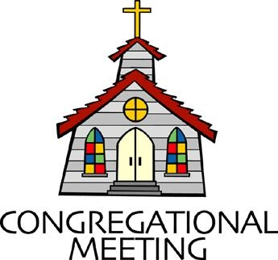

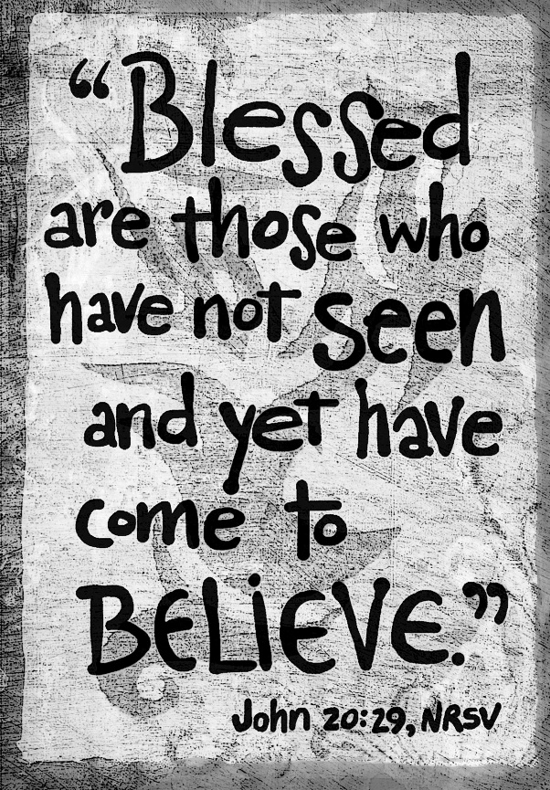

April 12, 2026 - 10:30 am

WELCOME VISITORS!

We're glad you are here! Cards at the ends of each pew are for you to fill out and drop in the Offering Plate. Please let us know you are visiting and join us for refreshments and fellowship following the service. The Sanctuary has an induction loop system to assist the hearing impaired. The system will also work on the telephone setting of hearing aids.

Springfield Presbyterian Church is rooted in the gospel of Jesus Christ, led by the Holy Spirit, and called to loving relationships through vibrant worship and service. Valuing all people, we are committed to developing disciples and fostering stewardship.
PREPARATION FOR THE WORD
(* those who are able are invited to stand)
PRELUDE

GATHERING OF THE PEOPLE

The Lord be with you! And also with you! (Greetings and Announcements)

LIGHTING THE CHRIST CANDLE
Leader: Whenever we light this candle we proclaim:
People: Christ is the Light of the world and the center of our lives.

CALL TO WORSHIP
Leader: The risen Lord is our chosen portion and our cup;
People: We live our lives in you;
Leader: The boundary lines have fallen for us in pleasant places;
People: Our lives are wonderful!
Leader: We bless the Lord, who gives us counsel;
People: In the dark nights, also, our hearts instruct us.
Leader: We keep the Lord always before us;
People: Because he is with us, we shall not be moved.
Leader: Therefore our hearts are glad, and our souls rejoice;
People: Our bodies can find safety and rest.
Leader: You show us the path of life. In your presence there is fullness of joy; in your right hand are pleasures forevermore.
People: Let us worship the risen Lord!

* HYMN Breathe on Me, Breath of God GTG #286

Breathe on me, Breath of God; fill me with life anew,
That I may love what thou dost love, and do what thou wouldst do.

Breathe on me, Breath of God, until my heart is pure,
Until with thee I will one will, to do and to endure.

Breathe on me, Breath of God, till I am wholly thine,
Until this earthly part of me glows with thy fire divine.

Breathe on me, Breath of God, so shall I never die,
But live with thee the perfect life of thine eternity.

CALL TO CONFESSION
Leader: Sometimes it seems that we have locked ourselves behind the doors of our foolish choices and lost the key. But God picks the locks, comes into our lives, and breathes peace and grace upon us. Knowing such grace, we may bring our lives to God, trusting in that merciful forgiveness offered to us. Join me as we pray together saying,

UNISON PRAYER FOR FORGIVENESS
It has only been a week, God of holiness, and yet we live as if Easter never took place. Like Pharoah clinging to those chariots, we grasp our fears determined never to let go. If we cannot see it, it cannot be true, and if we cannot manage it, we just close our hearts to reality. And so, we are unable to notice your mercy, your justice, your grace all around us, and settle for mere shadows instead of your light. Have mercy on us, God who raised Jesus to new life. Appear in all those closed places where we hide, stand with us in our fears, whisper grace into our hearts, peace into our souls, and call us by name so we know we are your beloved children, called from death into the new life shown in Jesus Christ, the Risen One. Amen.

SILENT PRAYERS OF CONFESSION

RESPONSE Restore in Us, O God GTG #434 (v. 1)
Restore in us, O God, the splendor of your love;
Renew your image in our hearts, and all our sins remove.

WORDS OF ASSURANCE
Heather: By God’s great mercy, we have been born anew into that living hope through the resurrection of Christ Jesus. Though we have not seen him, we love him as he loves us. Though we do not see him now, we believe – celebrating with joy which cannot be contained. In Jesus Christ, we are forgiven, restored, and made new. Thanks be to God! Amen.

* MUSICAL RESPONSE OF PRAISE Alleluia, Alleluia! Give Thanks
GTG #240 (refrain only)
Alleluia, alleluia! Give thanks to the risen Lord.
Alleluia, alleluia! Give praise to his name.

* THE PEACE The peace of Christ be with you! And also with you!
(You may greet those around you.)

* RESPONSE Here I Am, Lord GTG #69
Here I am, Lord. Is it I, Lord? I have heard you calling in the night.
I will go, Lord, if you lead me. I will hold your people in my heart.

THE PROCLAMATION OF THE WORD

TIME FOR ALL GOD’S CHILDREN

PRAYER OF ILLUMINATION
Leader: Guide us, O God, by your Word and Holy Spirit, that in your light we may see light, in your truth find freedom, and in your will discover your peace; through Jesus Christ our Lord. Amen.

FIRST SCRIPTURE LESSON 1 Peter 1:3-9 NT page 218
³Blessed be the God and Father of our Lord Jesus Christ! By his great mercy he has given us a new birth into a living hope through the resurrection of Jesus Christ from the dead, ⁴and into an inheritance that is imperishable, undefiled, and unfading, kept in heaven for you, ⁵who are being protected by the power of God through faith for a salvation ready to be revealed in the last time. ⁶In this you rejoice, even if now for a little while you have had to suffer various trials,
⁷so that the genuineness of your faith—being more precious than gold that, though perishable, is tested by fire—may be found to result in praise and glory and honor when Jesus Christ is revealed. ⁸Although you have not seen him, you love him; and even though you do not see him now, you believe in him and rejoice with an indescribable and glorious joy, ⁹for you are receiving the outcome of your faith, the salvation of your souls.

GOSPEL LESSON John 20:19-31 NT page 108
¹⁹When it was evening on that day, the first day of the week, and the doors of the house where the disciples had met were locked for fear of the Jews, Jesus came and stood among them and said, "Peace be with you." ²⁰After he said this, he showed them his hands and his side. Then the disciples rejoiced when they saw the Lord. ²¹Jesus said to them again, "Peace be with you. As the Father has sent me, so I send you." ²²When he had said this, he breathed on them and said to them, "Receive the Holy Spirit. ²³If you forgive the sins of any, they are forgiven them; if you retain the sins of any, they are retained." ²⁴But Thomas (who was called the Twin ), one of the twelve, was not with them when Jesus came. ²⁵So the other disciples told him, "We have seen the Lord." But he said to them, "Unless I see the mark of the nails in his hands, and put my finger in the mark of the nails and my hand in his side, I will not believe." ²⁶A week later his disciples were again in the house, and Thomas was with them. Although the doors were shut, Jesus came and stood among them and said, "Peace be with you." ²⁷Then he said to Thomas, "Put your finger here and see my hands. Reach out your hand and put it in my side. Do not doubt but believe." ²⁸Thomas answered him, "My Lord and my God!" ²⁹Jesus said to him, "Have you believed because you have seen me? Blessed are those who have not seen and yet have come to believe." ³⁰Now Jesus did many other signs in the presence of his disciples, which are not written in this book. ³¹But these are written so that you may come to believe that Jesus is the Messiah, the Son of God, and that through believing you may have life in his name.

Heather: This is the Word of the Lord. All: Thanks be to God.

SERMON Courageous Thomas By Heather Russell

THE RESPONSE TO THE WORD

* HYMN Crown Him with Many Crowns GTG #268

Crown him with many crowns, the Lamb upon his throne;
Hark, how the heavenly anthem drowns all music but its own!
Awake, my soul, and sing of him who died for thee,
And hail him as thy matchless King through all eternity.

Crown him the Lord of love; behold his hands and side,
Rich wounds, yet visible above, in beauty glorified:
No angel in the sky can fully bear that sight,
But downward bends his burning eye at mysteries so bright.

Crown him the Lord of peace, whose power a scepter sways
From pole to pole, that wars may cease, absorbed in prayer and praise.
His reign shall know no end; and round his pierced feet
Fair flowers of paradise extend their fragrance ever sweet.

Crown him the Lord of years, the potentate of time;
Creator of the rolling spheres, ineffably sublime.
All hail, Redeemer, hail! For thou hast died for me;
Thy praise shall never, never fail throughout eternity.

PRAYERS OF THE PEOPLE AND THE LORD’S PRAYER

PRESENTATION OF TITHES AND OFFERINGS
OFFERTORY We Walk By Faith
* SONG OF THANKS God, We Honor You GTG #709
God, we honor you. God, we trust in you. God, we worship and adore you.
Take what we bring, offered to you. Teach us to show your abundant blessings. Alleluia, alleluia, alleluia, amen.
* PRAYER OF DEDICATION

* HYMN Thine Is the Glory GTG #238

Thine is the glory, risen, conquering Son;
Endless is the victory thou o'er death hast won.
Angels in bright raiment rolled the stone away,
Kept the folded grave-clothes where thy body lay.

Refrain:
Thine is the glory, risen, conquering Son;
Endless is the victory thou o'er death hast won.

Lo! Jesus meets us, risen from the tomb;
Lovingly he greets us, scatters fear and gloom.
Let the church with gladness hymns of triumph sing,
For the Lord now liveth; death hath lost its sting. [Refrain]

No more we doubt thee, glorious Prince of life!
Life is naught without thee; aid us in our strife.
Make us more than conquerors through thy deathless love;
Bring us safe through Jordan to thy home above. [Refrain]

* CHARGE AND BENEDICTION
Heather: As you go out into the world, may the grace of the Lord Jesus Christ, the love of God, and the fellowship of the Holy Spirit be with you all, now and forevermore. Amen.

* UNISON AMEN GTG #601

POSTLUDE

Some liturgy adapted from Thom Shuman

Assisting in Worship: We appreciate those who serve:

Today 4/12 Next Week 4/19
Sunday Opener: Linda Caviglia Ron Holmes
Ushers/Greeters: Steve & Donna Mazer Elizabeth Meirowitz
Cynthia Smith
Lay Leader: Max Carroll Tony Caviglia
Offering Count: Andra Kwako & Linda C. Andrea Kwako & Beth O.
Fellowship Hosts: Linda Caviglia

Sunday April 19, 2026 Lectionary
Acts 2:14a, 36-41; Psalm 116:1-4, 12-19; 1 Peter 1:17-23; Luke 24:13-35

Happy Birthday! April 12 – Lisa Rogers
April 13 – Kelsey Robinson
April 15 – Belle Vasbinder
April 19 – Debbie Sperling

Announcements

A warm welcome to our new Ministry Associate Heather Russell!

Welcome! We welcome Junghoon Park as our substitute accompanist today!
Junghoon is a Korean American concert pianist and organist currently serving at Woods Memorial Presbyterian Church in Severna Park, Maryland, under Pastor JC Austin and Music Director David Merrill. He is a recipient of Howard County's Creative Arts grant as well as Maryland States Arts Council's performing artist grant.

He also says, “I would also be delighted to extend an invitation to your choir and congregation to participate in or attend our upcoming spring performance of Beethoven’s Choral Fantasy, featuring solo piano, orchestra, church choir, and community singers. It is free and open to all. We would be delighted to have your choir singers and music lovers singing along with us. Dress Rehearsal is June 5, 6:00 to 9:00 PM, and Concert is June 6, arrival at 5:30 PM, performance at 7:00 PM.”

Congregational Meeting: April 19 to elect our new slate of elders: Tony Caviglia, Diane Chaplik and Steve Mazer will be presented for election by our Nominating Committee Co-chaired by Beth Oates and Steve Mazer with Julie Ballard, Barb Nickell, Belle Vasbinder and Christy Yeager. If you would like to nominate someone else from the floor, you must speak with them first.
As Leah Halvorson, Ron Holmes, and Barbara Nickell rotate off this year, with great appreciation, we thank them for the time and thought they have freely given to the work of the church over the last several years.

The zoom link will be available for you to watch and vote.

Graduation Celebration: We will celebrate our high school and college graduates on May 17 during fellowship. Please let Diana Steppling or Connie Gibbons know if you have a child or grandchild graduating from high school or college this year.

Congregational Care: If you know of someone who would benefit from a card or a phone call, please text or call Connie Gibbons at 410-935-3467.

Electronic Giving: Below is a QR code you can scan to make your contribution a new way! The page you get will ask for your name, email and phone

number. You can choose from a dropdown menu for selecting where the donation should go: General Fund, Capital Fund, Concert, Memorial. There is a fee for using a credit card, and you will be given the option to pay that fee along with your donation, but you don’t have to include it if you don’t want to.

Today:
Sunday April 12
10:30 am Worship
11:30 am Fellowship

This Week:
Wednesday April 15
6:15 – 7:15 pm Bell Choir Practice
7:30 – 8:45 pm Adult Choir Practice
Thursday April 16
7:00 pm Session Meeting (Manse)

Next Week:
Sunday April 19
10:30 am Worship
11:30 am Congregational Meeting
12:00 noon Fellowship
Tuesday April 21
7:00 pm CoCaMO Meeting (Manse)
Wednesday April 22
6:15 – 7:15 pm Bell Choir Practice
7:30 – 8:45 pm Adult Choir Practice
Saturday April 25
7:00 pm Family Game Night

Office Hours: Tuesday, Wednesday, Friday, 10 am – 3 pm
Springfield Presbyterian Church
10:30 am Worship (and Sunday School 1st & 3rd Sundays)
11:30 am Fellowship
Website: www.springfield-church.org Church Office: 410-795-6152
Like us on Facebook: www.facebook.com/SpringfieldPresbyterianChurch
Ministry Associate: Heather Russell von Marko
Email: spc.office@verizon.net
Clerk of Session: Sharon Pappas
Minister of Music: Vacant
Accompanist: Michael Hall
Bell Choir Director: Vacant
Youth Group Coordinator: Dylan Vasbinder
Administrative Assistant: Donna Mazer Email: spc.office@verizon.net

