(Large Print)

Springfield Presbyterian Church (USA)
7300 Spout Hill Road, Sykesville, MD 21784 410-795-6152

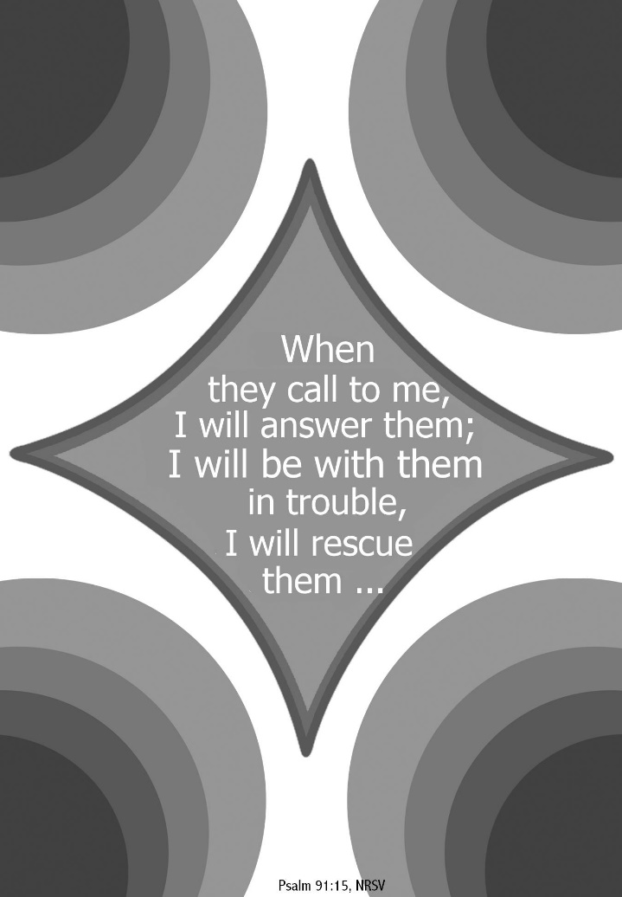

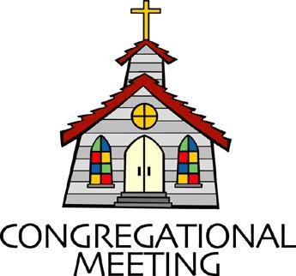
August 21, 2022 - 10:30 am

WELCOME VISITORS!
We're glad you are here! Cards at the ends of each pew are for you to fill out and drop in the Offering Plate. Please let us know you are visiting, and join us for refreshments and fellowship following the service. The Sanctuary has an induction loop system to assist the hearing impaired. The system will also work on the telephone setting of hearing aids.

Springfield Presbyterian Church is rooted in the gospel of Jesus Christ, led by the Holy Spirit, and called to loving relationships through vibrant worship and service. Valuing all people, we are committed to developing disciples and fostering stewardship.
PREPARATION FOR THE WORD
(* those who are able are invited to stand)

PRELUDE

GATHERING OF THE PEOPLE

The Lord be with you! And also with you! (Greeting)

LIGHTING THE CHRIST CANDLE
Leader: Whenever we light this candle we proclaim:
People: Christ is the Light of the world and the center of our lives.

CALL TO WORSHIP
Leader: The Psalms tell us, “Unless the Lord builds the house, those who build it labor in vain.”
People: When we look at our church, our house, the same is the true.
Leader: It is only through God’s guidance and the Spirit’s dwelling that a true community is built.
People: Today we recognize again that God is the head of the church.
Leader: Today, we seek to discover how we are a part of it.
People: We long to be part of the bigger story, the story of God’s church here – alive and awake, ready to serve.
Leader: Let us gather together, bearing all this in mind.
People: Let us join our hearts, our voices, and our spirits to praise our God, Jesus Christ. Amen.

* HYMN Praise, My Soul, the God of Heaven GTG #619
Praise, my soul, the God of heaven; glad of heart your carols raise;
Ransomed, healed, restored, forgiven, who, like me, should sing God’s praise?
Alleluia! Alleluia! Praise the Maker all your days!

Praise God for the grace and favor shown our forebears in distress;
God is still the same forever, slow to chide, and swift to bless.
Alleluia! Alleluia! Sing our Maker’s faithfulness!

Like a loving parent caring, God knows well our feeble frame,
Gladly all our burdens bearing, still to countless years the same.
Alleluia! Alleluia! All within me, praise God’s name!

Angels, teach us adoration; you behold God face to face.
Sun and moon and all creation, dwellers all in time and space.
Alleluia! Alleluia! Praise with us the God of grace!

CALL TO CONFESSION
Leader: In our hectic world, we keep our hands busy, often consumed by one task to the next. We forget to bow our heads, to offer our prayer and praise, and to recognize how and where you are calling us in our lives. We come today to our God, who is ready to accept our atonement and set us on the right path once again. Let us join in prayer.

PRAYER OF CONFESSION
Generous God, help us to take our minds and hearts outside of these four walls and see what you are doing in the world that you have created. We admit that we have been resistant in asking what your will is for our lives. We take pride in our work, and while that’s okay, we forget that you are the one who made us able to accomplish this good work. Forgive us for forgetting to continually discern where you are calling us next: in our families, in our work, in our church, in our communities, and in all the sectors of our lives. Amen.

SILENT PRAYERS OF CONFESSION

RESPONSE The Woman Hiding in the Crowd Tune #178
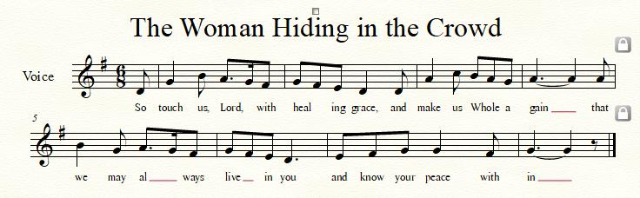

WORDS OF ASSURANCE
Leader: The saying is sure and worthy of full acceptance, that Jesus Christ came into the world to save sinners. He himself bore our sins in his body on the cross, that we might be dead to sin, and alive to all that is good.
People: Let us declare together that in the name of Jesus Christ, we are forgiven! Alleluia and amen!

* MUSICAL RESPONSE OF PRAISE O My Soul, Bless Your Redeemer
Bless your Maker, all you creatures, ever under God’s control,
All throughout God’s vast dominion; bless the Lord of all, my soul!

* THE PEACE The peace of Christ be with you! And also with you!
(You may greet those around you.)

* RESPONSE Here I Am, Lord
Here I am, Lord, Is it I, Lord? I have heard you calling in the night.
I will go, Lord, if you lead me. I will hold your people in my heart.

THE PROCLAMATION OF THE WORD

PRAYER OF ILLUMINATION
God of Mercy, you promised never to break your covenant with us. Amid all the changing words of our generation, speak your eternal word that does not change. Then may we respond to your gracious promises with faithful and obedient lives; through our Lord Jesus Christ. Amen.

FIRST SCRIPTURE LESSON Psalm 91:1-16
¹ You who live in the shelter of the Most High, who abide in the shadow of the Almighty, ² will say to the Lord, ‘My refuge and my fortress; my God, in whom I trust.’ ³ For he will deliver you from the snare of the fowler and from the deadly pestilence; ⁴ he will cover you with his pinions, and under his wings you will find refuge; his faithfulness is a shield and buckler. ⁵ You will not fear the terror of the night, or the arrow that flies by day, ⁶ or the pestilence that stalks in darkness, or the destruction that wastes at noonday. ⁷ A thousand may fall at your side, ten thousand at your right hand, but it will not come near you. ⁸ You will only look with your eyes and see the punishment of the wicked.
⁹ Because you have made the Lord your refuge, the Most High your dwelling-place, ¹⁰ no evil shall befall you, no scourge come near your tent. ¹¹ For he will command his angels concerning you to guard you in all your ways. ¹² On their hands they will bear you up, so that you will not dash your foot against a stone. ¹³ You will tread on the lion and the adder, the young lion and the serpent you will trample under foot.
¹⁴ Those who love me, I will deliver; I will protect those who know my name. ¹⁵ When they call to me, I will answer them; I will be with them in trouble, I will rescue them and honor them. ¹⁶ With long life I will satisfy them, and show them my salvation.

SECOND SCRIPTURE LESSON Ephesians 4:1-13, 25-32
I therefore, the prisoner in the Lord, beg you to lead a life worthy of the calling to which you have been called, ²with all humility and gentleness, with patience, bearing with one another in love, ³making every effort to maintain the unity of the Spirit in the bond of peace. ⁴There is one body and one Spirit, just as you were called to the one hope of your calling, ⁵one Lord, one faith, one baptism, ⁶one God and Father of all, who is above all and through all and in all. ⁷But each of us was given grace according to the measure of Christ’s gift. ⁸Therefore it is said,
‘When he ascended on high he made captivity itself a captive; he gave gifts to his people.’ ⁹(When it says, ‘He ascended’, what does it mean but that he had also descended into the lower parts of the earth? ¹⁰He who descended is the same one who ascended far above all the heavens, so that he might fill all things.) ¹¹The gifts he gave were that some would be apostles, some prophets, some evangelists, some pastors and teachers, ¹²to equip the saints for the work of ministry, for building up the body of Christ, ¹³until all of us come to the unity of the faith and of the knowledge of the Son of God, to maturity, to the measure of the full stature of Christ. ²⁵So then, putting away falsehood, let all of us speak the truth to our neighbors, for we are members of one another. ²⁶Be angry but do not sin; do not let the sun go down on your anger, ²⁷and do not make room for the devil. ²⁸Thieves must give up stealing; rather let them labor and work honestly with their own hands, so as to have something to share with the needy. ²⁹Let no evil talk come out of your mouths, but only what is useful for building up, as there is need, so that your words may give grace to those who hear. ³⁰And do not grieve the Holy Spirit of God, with which you were marked with a seal for the day of redemption. ³¹Put away from you all bitterness and wrath and anger and wrangling and slander, together with all malice, ³²and be kind to one another, tender-hearted, forgiving one another, as God in Christ has forgiven you.

Leader: Hear what the Spirit is saying to the Church.
All: Thanks be to God.

SERMON Envisioning a Church for Today Rev. Becca Crate-Price

THE RESPONSE TO THE WORD

* HYMN Your Faithfulness, O Lord, Is Sure GTG #42

Your faithfulness, O Lord, is sure in all your words, your gracious deeds;
You gently lift all burdened souls and well provide for all our needs.

The eyes of all are fixed on you; by you their wants are all supplied;
Your open hand is bountiful and every soul is satisfied.

Lord, you are just in all your ways, and kind in everything you do;
Forever near you stand to hear and help all those who call on you.

My mouth shall speak your praise, O Lord; my soul shall bless your holy name;
Let all things living join the song of praise, from age to age the same.

AFFIRMATION OF FAITH The Apostles’ Creed
I believe in God, the Father almighty, Maker of heaven and earth,
and in Jesus Christ, his only Son, our Lord; who was conceived by the Holy Ghost, born of the Virgin Mary, suffered under Pontius Pilate, was crucified, dead, and buried; he descended into hell;
the third day he rose again from the dead; he ascended into heaven, and sitteth on the right hand of God the Father Almighty;
from thence he shall come to judge the quick and the dead.
I believe in the Holy Ghost; the holy catholic church; the communion of saints; the forgiveness of sins; the resurrection of the body; and the life everlasting. Amen.

PASTORAL PRAYER AND THE LORD’S PRAYER

OFFERTORY
SONG OF THANKS As Those of Old Their Firstfruits Brought #712
In gratitude and humble trust we bring our best today, to serve your cause and share your love with all along life’s way. O God who gave yourself to us in Jesus Christ your Son, help us to give ourselves each day until life’s work is done.
PRAYER OF DEDICATION

* HYMN God Be with You Till We Meet Again GTG #541

God be with you till we meet again; loving counsels guide, uphold you, with a shepherd’s care enfold you: God be with you till we meet again.

God be with you till we meet again; unseen wings protecting hide you, daily manna still provide you: God be with you till we meet again.

God be with you till we meet again; when life’s perils thick confound you, put unfailing arms around you: God be with you till we meet again.

God be with you till we meet again; keep love’s banner floating o’er you; smite death’s threatening wave before you:
God be with you till we meet again.

* CHARGE AND BENEDICTION
Leader: As we go from this place,
People: Let us invite God into our lives,
Leader: To direct us,
People: To comfort us,
Leader: To show us a path forward,
People: So that God may be praised and God’s work be done. Amen.

* UNISON AMEN

POSTLUDE

Sunday, August 28 2022 Lectionary
Proverbs 25:6-7; Psalm 112; Hebrews 13:1-8, 15-16; Luke 14:1, 7-14
Assisting in Worship: We appreciate those who serve:

Today 8/21 Next Week 8/28
Sunday Opener Bob Rogers Barbara Cornell
Ushers/Greeters Steve & Donna Tim & Beth
Mazer Oates
Lay Leader Christy Yeager Sharon Pappas

Happy Birthday! August 23 – Robert Doyle
August 27 – Connie Gibbons
August 28 – Bob Rogers

Announcements

SPC Adult Choir and Bell Choir: August is here and already going by quickly! I wanted to let everyone know what the plans are for choir and bell choir this year.

Choir practice will start on September 7th with a longer than normal rehearsal – starting at 6:30 and ending at 8:30. We will plan to sight read through much of the music planned for the fall and work on our first anthem to be sung on Sunday September 11th . During our 2 hours, we will take a 30 minute break for fellowship and refreshments. Hope you can all be there and will enjoy our time to start singing again!

The Presbytones Bell Choir will begin rehearsing on September 14th from 6:15 to 7:15 pm. Choir will follow from 7:30 to 8:45 pm.

Looking forward to seeing everyone! ~ Linda Caviglia

Summer Mission Project: It won’t be long before school starts again. Preparing for a new school year includes buying items on the STUDENT SUPPLY LIST. For some children and their families, this can be a challenge and in some instances buying needed supplies just isn’t possible. For that reason, during July and August, we will be collecting school supplies to help these children. The GIVING TREE is in the Narthex. If you would like to help with this project, you can take a tag from the tree and buy the item written on it or simply choose from the below items (taken from Sykesville Middle School STUDENT SUPPLY LIST). Please place your donated items in the designated basket in the Narthex. Thank you! ~ CoCaMO Committee

3-ring binders-1, 1 ½ or 2” Pencil pouch Glue sticks
Loose-leaf paper Pack of #2 pencils Pair of Ear Buds
Pack of 5-tab binder dividers Pocket folders Scissors
Blue, black or red pens Block or cap erasers Sticky notes
3X5 ruled index cards Dry erase markers Crayons
Folders with brads 10-pack colored pencils
Spiral notebook-200 pgs. Pencil sharpener
Multi-colored highlighters Composition book

Mask Update: Due to the uptick in COVID-19 cases, the Session has decided to strongly encourage masking and social distancing. Though it is not a mandate, we seek to love one another by keeping each other as safe as possible. Thank you for your help in this endeavor.

Sunday School is back! On the 1st and 3rd Sundays of the month, we will be offering Sunday School! See Pastor Becca for details…

Pastor-Parish Committee: The Pastor-Parish Committee invites you to share your concerns, suggestions, and gratitude. We have a form in the Narthex and a lock-box that we will open weekly and we ask that you share your name and be specific. We look forward to reading your comments so that we can continue to grow into the body of Christ.

Springfield Membership: Are you interested in finding out more about our faith community and becoming a member? We would love to answer any questions you have. Please contact Pastor Becca at springfieldpastor@gmail.com for more information.

Congregational Care / Mission & Outreach: Do you know of a member or friend of our church family who is ill, needs prayers, would like call, a visit or a card, or might benefit from meal train? If so, please contact the Church Office (410-795-6152), Cathy Marsh (410-549-6916) or Diana Steppling (862-266-2242).

Fellowship Help Needed: If you are interested in helping with Fellowship, please contact Barbara Cornell (240-308-0035). A sign-up sheet will also be available.

Today:
Sunday August 21
10:30 am Worship
11:30 am Fellowship

Looking Ahead:
Sunday August 28
10:30 am Worship
11:30 am Fellowship

Office Hours: Tuesday, Wednesday & Friday
Springfield Presbyterian Church

10:30 am Worship
11:30 am Fellowship
Website: www.springfield-church.org Church Office: 410-795-6152
Like us on Facebook: www.facebook.com/SpringfieldPresbyterianChurch
Pastor: Rev. Becca Crate-Price
Email: springfieldpastor@gmail.com
Clerk of Session: Sharon Pappas
Minister of Music: Linda Caviglia
Accompanist/Organist: Aaron Thacker
Youth Group Coordinator: Dylan Vasbinder
Administrative Assistant: Donna Mazer e-mail: spc.office@verizon.net

