(Large Print)

Springfield Presbyterian Church (USA)
7300 Spout Hill Road, Sykesville, MD 21784 410-795-6152

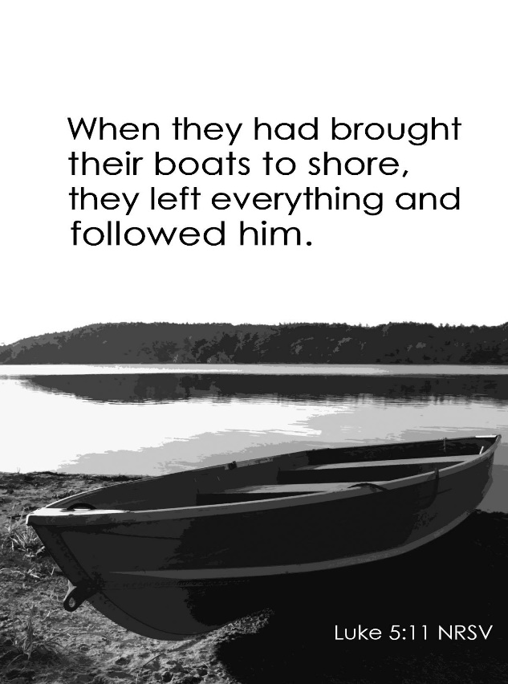

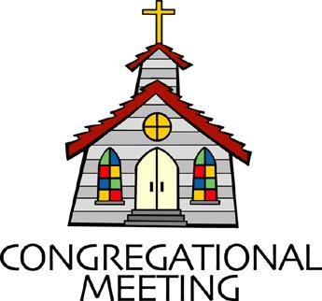
February 6, 2022 - 10:30 am

WELCOME VISITORS! We're glad you are here! Cards at the ends of each pew are for you to fill out and drop in the Offering Plate. Please let us know you are visiting, and join us for refreshments and fellowship following the service. The Sanctuary has an induction loop system to assist the hearing impaired. The system will also work on the telephone setting of hearing aids.

Springfield Presbyterian Church is rooted in the gospel of Jesus Christ, led by the Holy Spirit, and called to loving relationships through vibrant worship and service. Valuing all people, we are committed to developing disciples and fostering stewardship.
PREPARATION FOR THE WORD
(* those who are able are invited to stand)
PRELUDE

GATHERING OF THE PEOPLE

The Lord be with you! And also with you! (Greeting)

LIGHTING THE CHRIST CANDLE
Leader: Whenever we light this candle we proclaim:
People: Christ is the Light of the world and the center of our lives.

CALL TO WORSHIP [Psalm 138]
Leader: We give you thanks, O Lord, with our whole heart; before the gods we sing your praise;
People: We bow down toward your holy temple and give thanks to your name for your steadfast love and your faithfulness.
Leader: For you, O God, have exalted your name and your word above everything.
People: On the day we called, you answered us, you increased the strength of our souls.
Leader: All the kings of the earth shall praise you, O Lord, for they have heard the words of your mouth.
People: They shall sing of the ways of the Lord, for great is the glory of the Lord.
Leader: For though the Lord is high, He regards the lowly; but the haughty He perceives from far away.
People: Though we walk in the midst of trouble, you preserve us against the wrath of our enemies; you stretch out your hand, and your right hand delivers us.
Leader: The Lord will fulfill His purpose for us; your steadfast love, O Lord, endures forever. Do not forsake the work of your hands.
ALL: Let us worship our faithful God.
* HYMN You Walk along Our Shoreline #170

You walk along our shoreline where land meets unknown sea.
We hear your voice of power, “Now come and follow me.
And if you still will follow through storm and wave and shoal,
Then I will make you fishers but of the human soul.”

You call us, Christ, to gather the people of the earth.
We cannot fish for only those lives we think have worth.
We spread your net of gospel across the water’s face,
Our boat a common shelter for all found by your grace.

We cast our net, O Jesus; we cry the kingdom’s name;
We work for love and justice; we learn to hope through pain.
You call us, Lord, to gather God’s daughters and God’s sons,
To let your judgment heal us so that all may be one.

CALL TO CONFESSION
Leader: In relationship with you, we see that you point us to discipleship and to servanthood. In your Scriptures and in our lives, you have shown us examples of how to be the people you call us to be. Yet in our own humanity, conflicted by the world’s ways and our own desires, we have lost sight of your call. Let us come together to admit our sin and seek your forgiveness.

PRAYER OF CONFESSION
Generous God, we tentatively say, ‘Here I am, Lord’, hesitantly receiving your call to discipleship. Even when you show us in profound and simple ways how to act, we go astray. We forget your power, your might, and your mercy. We lose sight of your call in the midst of our everyday lives. Forgive us, we pray. Renew us and restore us, O God, to live into your call once again as faithful disciples. Amen.

SILENT PRAYERS OF CONFESSION

RESPONSE Come and Fill Our Hearts Tune #466
Come and fill our hearts with your peace. You alone, O Lord, are holy.
Come and fill our hearts with your peace. Alleluia!

WORDS OF ASSURANCE
Leader: Our God is a God of mercy, love, and grace, ready to welcome home the sinner and set us free once again to live anew.
People: Thanks be to God whose forgiveness is never ending. Alleluia and amen!

* MUSICAL RESPONSE OF PRAISE Now Thank We All Our God
All praise and thanks to God, who reigns in highest heaven,
To Father and to Son and Spirit now be given.
The one eternal God, whom heaven and earth adore,
The God who was, and is, and shall be ever more.

* THE PEACE The peace of Christ be with you! And also with you!
(You may greet those around you.)

* RESPONSE Here I Am, Lord
Here I am, Lord, Is it I, Lord? I have heard you calling in the night.
I will go, Lord, if you lead me. I will hold your people in my heart.

THE PROCLAMATION OF THE WORD

PRAYER OF ILLUMINATION
Generous God, help us to open ourselves to your Word today in a new way. Help us to see where your Word and our lives intersect. Help us then to live the Word out faithfully in the here and now. Amen.

FIRST SCRIPTURE LESSON Isaiah 6:1-8
In the year that King Uzziah died, I saw the Lord sitting on a throne, high and lofty; and the hem of his robe filled the temple. ²Seraphs were in attendance above him; each had six wings: with two they covered their faces, and with two they covered their feet, and with two they flew. ³And one called to another and said: ‘Holy, holy, holy is the Lord of hosts; the whole earth is full of his glory.’ ⁴The pivots on the thresholds shook at the voices of those who called, and the house filled with smoke. ⁵And I said: ‘Woe is me! I am lost, for I am a man of unclean lips, and I live among a people of unclean lips; yet my eyes have seen the King, the Lord of hosts!’ ⁶Then one of the seraphs flew to me, holding a live coal that had been taken from the altar with a pair of tongs. ⁷The seraph touched my mouth with it and said: ‘Now that this has touched your lips, your guilt has departed and your sin is blotted out.’ ⁸Then I heard the voice of the Lord saying, ‘Whom shall I send, and who will go for us?’ And I said, ‘Here am I; send me!’

SECOND SCRIPTURE LESSON Luke 5:1-11
Once while Jesus was standing beside the lake of Gennesaret, and the crowd was pressing in on him to hear the word of God, ²he saw two boats there at the shore of the lake; the fishermen had gone out of them and were washing their nets. ³He got into one of the boats, the one belonging to Simon, and asked him to put out a little way from the shore. Then he sat down and taught the crowds from the boat. ⁴When he had finished speaking, he said to Simon, ‘Put out into the deep water and let down your nets for a catch.’ ⁵Simon answered, ‘Master, we have worked all night long but have caught nothing. Yet if you say so, I will let down the nets.’ ⁶When they had done this, they caught so many fish that their nets were beginning to break. ⁷So they signaled to their partners in the other boat to come and help them. And they came and filled both boats, so that they began to sink. ⁸But when Simon

Peter saw it, he fell down at Jesus’ knees, saying, ‘Go away from me, Lord, for I am a sinful man!’ ⁹For he and all who were with him were amazed at the catch of fish that they had taken; ¹⁰and so also were James and John, sons of Zebedee, who were partners with Simon. Then Jesus said to Simon, ‘Do not be afraid; from now on you will be catching people.’ ¹¹When they had brought their boats to shore, they left everything and followed him.

Leader: Hear what the Spirit is saying to the Church.
All: Thanks be to God.

SERMON Casting the Nets Rev. Becca Crate-Price

THE RESPONSE TO THE WORD

* HYMN Will You Come and Follow Me #726

Will you come and follow me if I but call your name?
Will you go where you don’t know and never be the same?
Will you let my love be shown, will you let my name be known,
Will you let my life be grown in you and you in me?

Will you leave yourself behind if I but call your name?
Will you care for cruel and kind and never be the same?
Will you risk the hostile stare should your life attract or scare?
Will you let me answer prayer in you and you in me?

Will you let the blinded see if I but call your name?
Will you set the prisoners free and never be the same?
Will you kiss the leper clean, and do such as this unseen,
And admit to what I mean in you and you in me?

Will you love the “you” you hide if I but call your name?
Will you quell the fear inside and never be the same?
Will you use the faith you’ve found to reshape the world around,
Through my sight and touch and sound in you and you in me?

Lord, your summons echoes true when you but call my name.
Let me turn and follow you and never be the same.
In your company I’ll go where your love and footsteps show.
Thus I’ll move and live and grow in you and you in me.

COMMUNION OF THE PEOPLE

INVITATION

THE GREAT PRAYER OF THANKSGIVING
Leader: The Lord be with you.
People: And also with you.
Leader: Lift up your hearts.
People: We lift them up to the Lord.
Leader: Let us give thanks to the Lord our God.
People: It is right to give our thanks and praise.
[The Pastor continues… “…who forever sing to the glory of your name.”]

IN PRAISE OF GOD Tune #552
Holy, holy, holy, Lord, God of Power and might.
Heaven and earth are full of your glory, Hosanna in the highest!
Blessed is He who comes in the name of the Lord.
Hosanna in the highest, hosanna in the highest.
[The Pastor continues… “…proclaim the one crucified and risen.”]

IN PRAISE OF CHRIST Tune #553
Christ has died; Christ is risen; Christ will come again.
Christ has died; Christ is risen; Christ will come again.

PASTORAL PRAYER AND THE LORD’S PRAYER

WORDS OF INSTITUTION

SHARING OF THE MEAL

PRAYER OF DEDICATION (Unison)
Dear God, take us out to live as changed people because we have shared the living bread and cannot remain the same. Ask much of us, expect much from us, enable much by us, encourage many through us. So, Lord, may we live to your glory, both as inhabitants of the earth, and citizens of the commonwealth of Heaven. Through Christ, with Christ, in Christ, in the unity of the Holy Spirit, all glory and honor are yours, almighty God, now and forever. Amen.
ANTHEM In Remembrance

* HYMN Holy, Holy, Holy! Lord God Almighty! #1

Holy, holy, holy! Lord God Almighty!
Early in the morning our song shall rise to thee.
Holy, holy, holy! Merciful and mighty!
God in three persons, blessed Trinity!

Holy, holy, holy! All the saints adore thee,
Casting down their golden crowns around the glassy sea;
Cherubim and seraphim falling down before thee,
Who wert, and art, and evermore shalt be.

Holy, holy, holy! Though the darkness hide thee,
Though the eye of sinfulness thy glory may not see,
Only thou art holy; there is none beside thee,
Perfect in power, in love and purity.

Holy, holy, holy! Lord God Almighty!
All thy works shall praise thy name, in earth and sky and sea.
Holy, holy, holy! Merciful and mighty!
God in three persons, blessed Trinity!

* CHARGE AND BENEDICTION
Leader: May we be courageous,
People: And cast the nets into the water.
Leader: May we be daring,
People: Even when the future is unknown.
Leader: And may we go forth,
People: And spread the good news of the Gospel as disciples of the Word.

* UNISON AMEN

POSTLUDE

Assisting in Worship: We appreciate those who serve:

Today 2/6 Next Week 2/13
Sunday Opener Ron Holmes Ron Holmes
Greeter Sharon Pappas Bobby Barrett
Lay Leader Christy Yeager Linda Black

Sunday February 13, 2022 Lectionary
Jeremiah 17:5-10; Psalm 1; 1 Corinthians 15:12-20; Luke 6:17-26

Happy Birthday! February 12 – Megan Anderson
Announcements

Congregational Meeting: Sunday, February 13 is our annual Congregational Meeting immediately following Worship, both in person and virtually. At this meeting the congregation receives all the committee reports for work done in 2021. The new 2022 budget is also presented. Those documents will be ready in hard copy for you on the 13th and will be mailed as in the past. There is much to celebrate and we hope all will stay. No votes will be taken at this meeting.

Upcoming Concert: We are excited to welcome Candice Mowbray and Danny Webber to our concert on February 13 at 3:00 pm, a guitar duo performing on electric and acoustic instruments covering a range of musical styles. Due to our COVID protocols, all attendees will be required to wear a mask while indoors for the concert. Hope to see you there!

Per Capita: Per Capita is how we Presbyterian congregations care for each other and stay connected. It funds mission work, support and training for pastors and congregations, and administration expenses. Our portion this year is $38.13; $28 remains at Presbytery, $1.15 to Synod, and $8.98 to General Assembly. You will find this expense in our budget but you can help offset that and show your support by contributing that portion as faithful members. There is a wonderful article by J. Herbert Nelson, Stated Clerk for PC(USA) that can be found by going to baltimorepresbytery.org/percapita and then scroll to the bottom of the page to click on Stated Clerk: What per capita pays for, why it matters.

Easter Flowers: Believe it our not, it is time to order your Easter flowers! Attached is a flyer for your use. Orders need to be in to the Office no later than February 20.

Fellowship Reminder: Following the Worship service, we will gather downstairs for fellowship, but will not have food and will continue to wear our masks. We, as a Session, have made this decision out of an abundance of caution and the desire to keep our family of Christ safe and healthy.

Congregational Care / Mission & Outreach: Do you know of a member or friend of our church family who is ill, needs prayers, would like call, a visit or a card, or might benefit from meal train? If so, please contact the Church Office (410-795-6152), Cathy Marsh (410-549-6916) or Diana Steppling (862-266-2242).

Inclement Weather: If we feel the need to cancel Worship, there will be a message on the Church answering machine, as well as on Facebook. You may also receive an email with that information.

Today:
Sunday February 6
10:30 am Worship
11:30 am Fellowship

This Week:
Wednesday February 9
6:15 – 7:15 pm Bell Choir Practice
7:30 – 8:45 pm Adult Choir Practice

Looking Ahead:
Sunday February 13
10:30 am Worship
11:30 am Congregational Meeting
12:00 noon Fellowship
3:00 pm Concert
Wednesday February 16
6:15 – 7:15 pm Bell Choir Practice
7:30 – 8:45 pm Adult Choir Practice

Office Hours: Tuesday, Wednesday & Friday
Springfield Presbyterian Church

10:30 am Worship
11:30 am Fellowship
Website: www.springfield-church.org Church Office: 410-795-6152
Like us on Facebook: www.facebook.com/SpringfieldPresbyterianChurch
Pastor: Rev. Becca Crate-Price
Email: springfieldpastor@gmail.com
Clerk of Session: Sharon Pappas
Minister of Music: Linda Caviglia
Accompanist/Organist: Aaron Thacker
Youth Group Coordinator: Dylan Vasbinder
Administrative Assistant: Donna Mazer e-mail: spc.office@verizon.net

