Springfield Presbyterian Church (USA)
7300 Spout Hill Road, Sykesville, MD 21784 410-795-6152
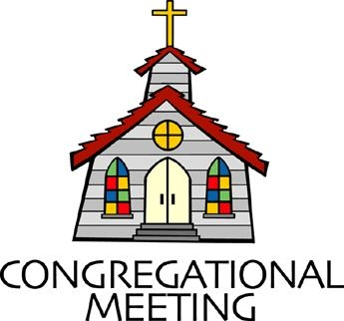

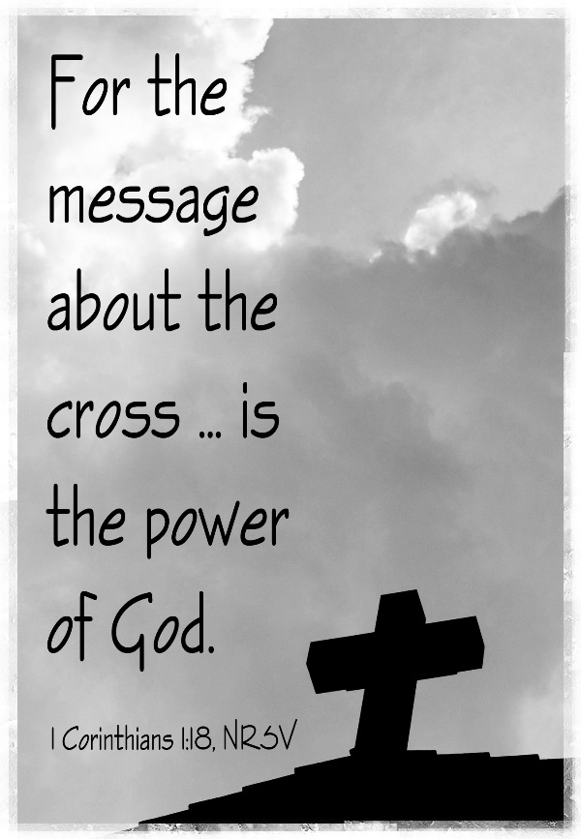

January 25, 2026 - 10:30 am

WELCOME VISITORS!

We're glad you are here! Cards at the ends of each pew are for you to fill out and drop in the Offering Plate. Please let us know you are visiting and join us for refreshments and fellowship following the service. The Sanctuary has an induction loop system to assist the hearing impaired. The system will also work on the telephone setting of hearing aids.

Springfield Presbyterian Church is rooted in the gospel of Jesus Christ, led by the Holy Spirit, and called to loving relationships through vibrant worship and service. Valuing all people, we are committed to developing disciples and fostering stewardship.
PREPARATION FOR THE WORD
(* those who are able are invited to stand)
PRELUDE

GATHERING OF THE PEOPLE

The Lord be with you! And also with you! (Greetings and Announcements)

LIGHTING THE CHRIST CANDLE
Leader: Whenever we light this candle we proclaim:
People: Christ is the Light of the world and the center of our lives.

CALL TO WORSHIP
Leader: God of grace, you have given us minds to know you, hearts to love you, and voices to sing your praise.
People: Fill us with your Spirit, that we may celebrate your glory and worship you in spirit and truth; through Jesus Christ our Lord. Amen.

* HYMN Lord, the Light of Your Love Is Shining GTG #192

Lord, the light of your love is shining, in the midst of the darkness, shining; Jesus, Light of the World, shine upon us; set us free by the truth you now bring us. Shine on me; shine on me.

Refrain:
Shine, Jesus, shine; fill this land with the Father’s glory.
Blaze, Spirit, blaze; set our hearts on fire.
Flow, river, flow; flood the nations with grace and mercy.
Send forth your word, Lord, and let there be light.

Lord, I come to your awesome presence, from the shadows into your radiance; by the blood I may enter your brightness.
Search me; try me; consume all my darkness. Shine on me; shine on me. [Refrain]

As we gaze on your kingly brightness, so our faces display your likeness; ever changing from glory to glory, mirrored here may our lives tell your story. Shine on me; shine on me. [Refrain]

CALL TO CONFESSION
Leader: As we just sang, we are invited to come “from the shadows” into God’s radiance. Let us then approach God boldly that we may find grace and help in our time of need.

PRAYER OF CONFESSION
Almighty God, you love us, but we have not loved you with our whole hearts. You call, but we have listened to other voices above yours. We have let our hearts and minds become distracted and divided. In your mercy, forgive our sins, and draw us back to you again.

SILENT PRAYERS OF CONFESSION

RESPONSE Just as I Am, without One Plea GTG #442 (v. 3)
Just as I am, thou wilt receive, wilt welcome, pardon, cleanse, relieve;
Because thy promise I believe, O Lamb of God, I come; I come!

WORDS OF ASSURANCE
Friends - the light of God’s love continues to shine on us and we are forgiven.

* MUSICAL RESPONSE OF PRAISE We Praise You, O God GTG #612 (v. 3)
With voices united our praises we offer and gladly our songs of thanksgiving we raise.
With you, Lord, beside us, your strong arm will guide us. To you, our great Redeemer, forever be praise!

* THE PEACE The peace of Christ be with you! And also with you!
(You may greet those around you.)

* RESPONSE Here I Am, Lord GTG #69
Here I am, Lord. Is it I, Lord? I have heard you calling in the night.
I will go, Lord, if you lead me. I will hold your people in my heart.

THE PROCLAMATION OF THE WORD

PRAYER OF ILLUMINATION
Guide us, O God, by your Word and Spirit, that in your light we may see light, in your truth find freedom, and in your will discover your peace, through Jesus Christ our Lord. Amen,

FIRST SCRIPTURE LESSON 1 Corinthians 1:10-18 NT page 155
Now I appeal to you, brothers and sisters, by the name of our Lord Jesus Christ, that all of you be in agreement and that there be no divisions among you but that you be knit together in the same mind and the same purpose. ¹¹ For it has been made clear to me by Chloe’s people that there are quarrels among you, my brothers and sisters. ¹² What I mean is that each of you says, “I belong to Paul,” or “I belong to Apollos,” or “I belong to Cephas,” or “I belong to Christ.” ¹³ Has Christ been divided? Was Paul crucified for you? Or were you baptized in the name of Paul? ¹⁴ I thank God that I baptized none of you except Crispus and Gaius, ¹⁵ so that no one can say that you were baptized in my name. ¹⁶ I did baptize also the household of Stephanas; beyond that, I do not know whether I baptized anyone else. ¹⁷ For Christ did not send me to baptize but to proclaim the gospel—and not with eloquent wisdom, so that the cross of Christ might not be emptied of its power.¹⁸ For the message about the cross is foolishness to those who are perishing, but to us who are being saved it is the power of God.

SECOND SCRIPTURE LESSON Matthew 4:12-23 NT page 3
¹² Now when Jesus heard that John had been arrested, he withdrew to Galilee. ¹³ He left Nazareth and made his home in Capernaum by the sea, in the territory of Zebulun and Naphtali, ¹⁴ so that what had been spoken through the prophet Isaiah might be fulfilled: ¹⁵ “Land of Zebulun, land of Naphtali, on the road by the sea, across the Jordan, Galilee of the gentiles— ¹⁶ the people who sat in darkness have seen a great light, and for those who sat in the region and shadow of death light has dawned.” ¹⁷ From that time Jesus began to proclaim, “Repent, for the kingdom of heaven has come near.” ¹⁸ As he walked by the Sea of Galilee, he saw two brothers, Simon, who is called Peter, and Andrew his brother, casting a net into the sea—for they were fishers. ¹⁹ And he said to them, “Follow me, and I will make you fishers of people.” ²⁰ Immediately they left their

nets and followed him. ²¹ As he went from there, he saw two other brothers, James son of Zebedee and his brother John, in the boat with their father Zebedee, mending their nets, and he called them. ²² Immediately they left the boat and their father and followed him.²³ Jesus went throughout all Galilee, teaching in their synagogues and proclaiming the good news of the kingdom and curing every disease and every sickness among the people.

Leader: Hear what the Spirit is saying to the Church.
All: Thanks be to God.

SERMON The Voice By Kathy Welsh Smith

THE RESPONSE TO THE WORD

* HYMN O Jesus, I Have Promised GTG #724

O Jesus, I have promised to serve thee to the end;
Be thou forever near me, my Master and my friend;
I shall not fear the battle if thou art by my side,
Nor wander from the pathway if thou wilt be my guide.

O let me feel thee near me! The world is ever near:
I see the sights that dazzle; the tempting sounds I hear.
My foes are ever near me, around me and within;
But, Jesus, draw thou nearer and shield my soul from sin.

O let me hear thee speaking in accents clear and still,
Above the storms of passion, the murmurs of self-will;
O speak to reassure me, to hasten or control;
O speak, and make me listen, thou guardian of my soul.

O Jesus, thou hast promised to all who follow thee
That where thou art in glory there shall thy servant be.
And, Jesus, I have promised to serve thee to the end;
O give me grace to follow, my Master and my friend.

PASTORAL PRAYER AND THE LORD’S PRAYER
PRESENTATION OF TITHES AND OFFERINGS
OFFERTORY
* SONG OF THANKS For the Life That You Have Given GTG #717
For the life that you have given, for the love in Christ made known,
With these fruits of time and labor, with these gifts that are your own:
Here we offer, Lord, our praises; heart and mind and strength we bring;
Give us grace to love and serve you, living what we pray and sing.
* PRAYER OF DEDICATION

* HYMN The Church’s One Foundation GTG #321

The church's one foundation is Jesus Christ her Lord.
She is his new creation by water and the word.
From heaven he came and sought her to be his holy bride.
With his own blood he bought her, and for her life he died.

Elect from every nation, yet one o'er all the earth,
Her charter of salvation: one Lord, one faith, one birth.
One holy name she blesses, partakes one holy food,
And to one hope she presses, with every grace endued.

Though with a scornful wonder this world sees her oppressed,
By schisms rent asunder, by heresies distressed,
Yet saints their watch are keeping; their cry goes up: "How long?"
And soon the night of weeping shall be the morn of song.

Mid toil and tribulation, and tumult of her war,
She waits the consummation of peace forevermore:
Till with the vision glorious her longing eyes are blest,
And the great church victorious shall be the church at rest.

Yet she on earth has union with God, the Three in One,
And mystic sweet communion with those whose rest is won:
O happy ones and holy! Lord, give us grace that we,
Like them, the meek and lowly, may live eternally.

* CHARGE AND BENEDICTION

* UNISON AMEN GTG #601

POSTLUDE

Assisting in Worship: We appreciate those who serve:

Today 1/25 Next Week 2/1
Sunday Opener: Linda Caviglia Mark Chaplik
Ushers/Greeters: Alex & Brenda McClung Don Vasbinder
Bob Rogers
Lay Leader: Ron Holmes Mark Kearney
Pulpit Supply: Kathy Welsh Smith Troy Bailey
Fellowship Hosts: Belle & Don Vasbinder
Offering Count:

Happy Birthday! February 1 – Steve & Donna Mazer

Sunday February 1, 2026 Lectionary
Micah 6:1-8; Psalm 15; 1 Corinthians 1:18-31; Matthew 5:1-12

Announcements

UPDATE: There will be NO WORSHIP SERVICE on Sunday 1/25 due to the predicted weather. Be safe!

Welcome! We welcome Kathy Welsh Smith to our pulpit again today! After a long career in collegiate campus ministry, Kathy made the leap to working in the church in 2017. She most recently served as the Director of Discipleship at Central Presbyterian. Kathy is now a Candidate for Minister of Word and Sacrament and a recent graduate of United Seminary, Twin Cities. She is married to Rob, who works at Loyola University, and together they are the parents of two adult children and the grandparents of the 3 (objectively!) cutest grandsons in the world.

Search Team: At the January Session meeting, a new Search Team was elected to move forward to find us a new pastor. Committee on Ministry member, Guy Moody, met with Session to explain our options. Session chose to follow a new path, Transitional Pastor, designed to move quicker and offer more creative possibilities for the way things might work now. The purpose is to ensure that we have essential pastoral leadership and to guide us in determining our mission and style of leadership to achieve that goal.

The Search Team met twice and learned in more detail how this Transitional Pastor position will work for us. It will allow us to call a Bridge Pastor for up to six months while we design interview questions and advertise. The Search Team will review applications and interview candidates for the Transitional Pastor position. Once a candidate is identified, Session will contract with the selected pastor for 1-2 years with options to renew.

At the last meeting, the Search Team finalized a job description that is now being sent to Committee on Ministry (COM). With their continued guidance, the team will move forward with each step. The pool of candidates is not large and if you know anyone who might be interested, let us know. They need to be an ordained minister PC(USA) or from a denomination with whom PC(USA) is in full communion.

If you have any questions, please contact Bob Steppling at bobsteppling@gmail.com

Search Team: Chair Bob Steppling, Tony Caviglia, Sue Holmes, Steve Mazer, Belle Vasbinder, with Sharon Pappas

Contribution Statements: Contribution statements for the year ending 12/31/25 are available for pickup in the Narthex.

Per Capita: We have benefited greatly from funds contributed by all the churches in our presbytery. This fund keeps the lights on, salaries paid, and funds the work of all the commissions, like Baltimore-Dakota, or the Commission on Ministry that is helping us navigate through this season. Presbytery's share is $32.24; Synod's share is $1.50; and General Assembly's share is $11.26. If you are able to contribute the $45 due for 2026, it can be added to your pledge, or use a separate check with Per capita on the memo line, or cash in an envelope. We are grateful for your contribution.

Easter Flowers: Easter comes early this year, so it’s time to start thinking about flower orders! Attached is the order form – orders are due by February 15!

Zoom Link for Worship Services: The Zoom link for church services is on the SPC website, not on the Facebook page. The Bulletin is also available on the website as well.

Congregational Care: If you know of someone who would benefit from a card or a phone call, please text or call Connie Gibbons at 410-935-3467.

Electronic Giving: Below is a QR code you can scan to make your contribution a new way! The page you get will ask for your name, email and phone

number. You can choose from a dropdown menu for selecting where the donation should go: General Fund, Capital Fund, Concert, Memorial. There is a fee for using a credit card, and you will be given the option to pay that fee along with your donation, but you don’t have to include it if you don’t want to.

Today:
Sunday January 25
10:30 am Worship
11:30 am Fellowship

This Week:
Wednesday January 28
6:15 – 7:15 pm Bell Choir Practice
7:30 – 8:45 pm Adult Choir Practice

Next Week:
Sunday February 1
10:30 am Worship
11:30 am Fellowship
Monday February 2
7:00 pm HeadHuggers (Manse)
Wednesday February 4
6:15 – 7:15 pm Bell Choir Practice
7:30 – 8:45 pm Adult Choir Practice

Office Hours: Tuesday, Wednesday, Friday, 10 am – 3 pm

Springfield Presbyterian Church
10:30 am Worship (and Sunday School 1st & 3rd Sundays)
11:30 am Fellowship
Website: www.springfield-church.org Church Office: 410-795-6152
Like us on Facebook: www.facebook.com/SpringfieldPresbyterianChurch
Pastor: Vacant
Email: spc.office@verizon.net
Clerk of Session: Sharon Pappas
Minister of Music/Accompanist: Aaron Thacker
Bell Choir Director: Vacant
Youth Group Coordinator: Dylan Vasbinder
Administrative Assistant: Donna Mazer Email: spc.office@verizon.net

2026 Easter Flowers
If you would like to order flowers for Easter, please complete
the order form below and drop it off at the office or mail this form and
your payment on or before February 15 to the Church Office at:
Springfield Presbyterian Church, 7314 Spout Hill Road, Sykesville, MD 21784
Please make your check payable to Springfield Presbyterian Church.
You may pick up your Easter flowers after worship service on April 5.
Dutch Asiatic (non-fragrant)
Lillies: | White | Yellow |  |  |  | #_______ |  | @15.95 = __________
(3 stems, multiple blooms)
Tulips: | Yellow | Red |  | Pink |  | #_______ |  | @12.50 = __________
6" pot | (please circle preferred color)
Hyacinths: | Purple | Pink |  | White |  | #_______ |  | @11.95 = __________
6" pot | (please circle preferred color)
(3 blooms)
In Memory of:_______________________________________________________________
In Honor of:_________________________________________________________________
In Appreciation for:_________________________________________________________
Name of Donor:_____________________________________________________________


 |  |  |  |  |  | I would like my
 |  |  |  |  |  | flower to go to
 |  |  |  |  |  | a shut-in:
 |  |  |  |  |  | YES |  | NO

