Springfield Presbyterian Church (USA)
7300 Spout Hill Road, Sykesville, MD 21784 410-795-6152

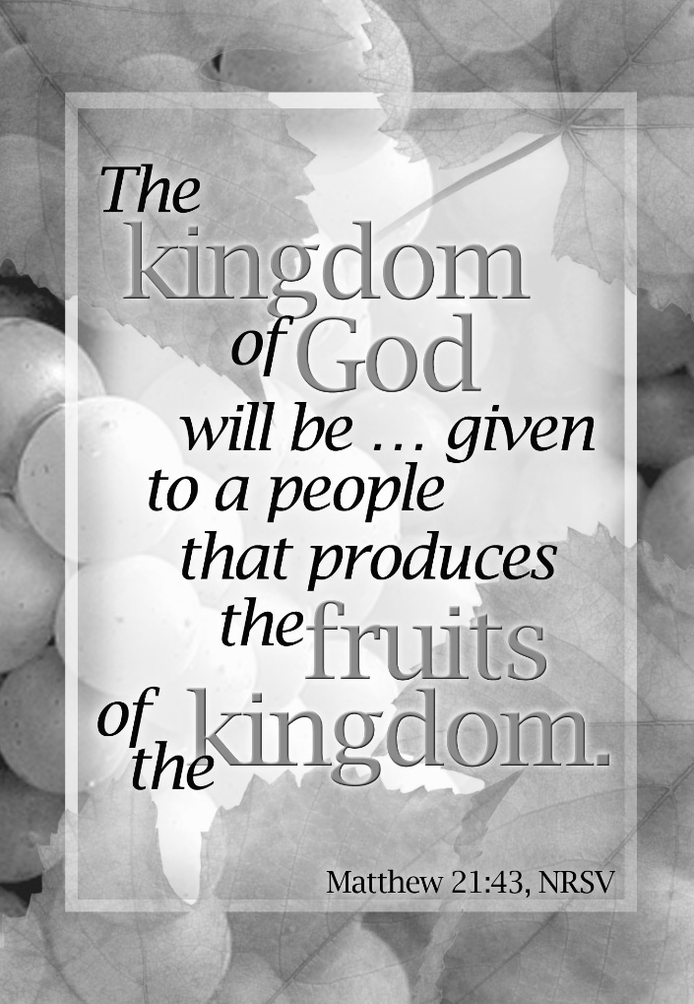

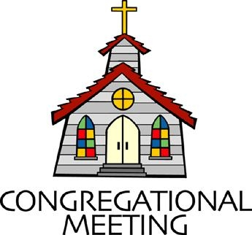
October 4, 2026 - 10:30 am

WELCOME VISITORS!

We're glad you are here! Cards at the ends of each pew are for you to fill out and drop in the Offering Plate. Please let us know you are visiting and join us for refreshments and fellowship following the service. The Sanctuary has an induction loop system to assist the hearing impaired. The system will also work on the telephone setting of hearing aids.

Springfield Presbyterian Church is rooted in the gospel of Jesus Christ, led by the Holy Spirit, and called to loving relationships through vibrant worship and service. Valuing all people, we are committed to developing disciples and fostering stewardship.
PREPARATION FOR THE WORD
(* those who are able are invited to stand)
PRELUDE

PASTOR’S WELCOME

GATHERING OF THE PEOPLE

The Lord be with you! And also with you! (Greetings and Announcements)

LIGHTING THE CHRIST CANDLE
Leader: Whenever we light this candle we proclaim:
People: Christ is the Light of the world and the center of our lives.

CALL TO WORSHIP
Leader: When you are hungry,
All: there is room at God’s table.
Leader: When you are tired,
All: there is room at God’s table.
Leader: Whether this place is familiar or new,
All: there is room at God’s table.
Leader: Whether you are close or very far away,
All: there is room at God’s table.
Leader: Come and worship the God who nourishes us.
All: There is room at God’s table!

* HYMN I Danced in the Morning GTG #157

I danced in the morning when the world was begun,
And I danced in the moon and the stars and the sun,
And I came down from heaven and I danced on the earth.
At Bethlehem I had my birth.

Refrain:
Dance, then, wherever you may be; I am the Lord of the Dance, said he,
And I'll lead you all, wherever you may be,
And I'll lead you all in the dance, said he.

I danced for the scribe and the Pharisee,
But they would not dance and they would not follow me.
I danced for the fishermen, for James and John.
They came with me and the dance went on. [Refrain]

I danced on the Sabbath and I cured the lame.
The holy people said it was a shame.
They whipped and they stripped and they hung me high,
And left me there on a cross to die. [Refrain]

I danced on a Friday when the sky turned black.
It's hard to dance with the devil on your back.
They buried my body and they thought I'd gone,
but I am the dance and I still go on. [Refrain]

They cut me down and I leapt up high.
I am the life that will never, never die.
I'll live in you if you'll live in me,
I am the Lord of the Dance, said he. [Refrain]

CALL TO CONFESSION
Leader: God has taught us to live in community with each other, caring for each other’s needs. We don’t always do this well. Sometimes we hesitate, afraid that we will offend someone. Sometimes we act, but we do it to feel good about ourselves more than to help someone else. Let us confess the ways we miss the mark, trusting in God’s mercy.

PRAYER OF CONFESSION
Loving God, we confess that we use our words to hurt instead of to heal. We take more than we need and don’t share what we have. We don’t care for ourselves or each other. Teach us again your ways of love. Help us to live as your faithful people. Hear us now as we silently share the things we’d rather not say out loud.

SILENT PRAYERS OF CONFESSION

RESPONSE Hear My Prayer, O God GTG #782 (v. 1)
Hear my prayer, O God, and listen to my plea;
Faithful, righteous One, give ear and answer me.
Judge me not, I pray; no merit dare I claim;
Knowing my own faults, I trust in your just Name.

WORDS OF ASSURANCE
Heather: Friends, there is no better news than this: God has heard us. God has forgiven us. God loves us. Go forth to love and forgive one another. Amen.

* MUSICAL RESPONSE OF PRAISE O, For a Thousand Tongues to Sing
GTG #610 (v.5)
To God all glory, praise and love be now and ever given,
By saints below and saints above, the church in earth and heaven.

* THE PEACE The peace of Christ be with you! And also with you!
(You may greet those around you.)

* RESPONSE Here I Am, Lord GTG #69
Here I am, Lord. Is it I, Lord? I have heard you calling in the night.
I will go, Lord, if you lead me. I will hold your people in my heart.

THE PROCLAMATION OF THE WORD

PRAYER OF ILLUMINATION
Leader: Guide us, O God, by your Word and Holy Spirit, that in your light we may see light, in your truth find freedom, and in your will discover your peace; through Jesus Christ our Lord. Amen.

FIRST READING: Micah 6:6-8 OT page 816
⁶"With what shall I come before the Lord, and bow myself before God on high? Shall I come before him with burnt offerings, with calves a year old? ⁷Will the Lord be pleased with thousands of rams, with ten thousands of rivers of oil? Shall I give my firstborn for my transgression, the fruit of my body for the sin of my soul?" ⁸He has told you, O mortal, what is good; and what does the Lord

require of you but to do justice, and to love kindness, and to walk humbly with your God?

TIME FOR ALL GOD’S CHILDREN

GOSPEL LESSION: Matthew 21:33-46 NT page 22
³³"Listen to another parable. There was a landowner who planted a vineyard, put a fence around it, dug a wine press in it, and built a watchtower. Then he leased it to tenants and went to another country. ³⁴When the harvest time had come, he sent his slaves to the tenants to collect his produce. ³⁵But the tenants seized his slaves and beat one, killed another, and stoned another. ³⁶Again he sent other slaves, more than the first; and they treated them in the same way.
³⁷Finally he sent his son to them, saying, "They will respect my son.' ³⁸But when the tenants saw the son, they said to themselves, "This is the heir; come, let us kill him and get his inheritance.' ³⁹So they seized him, threw him out of the vineyard, and killed him. ⁴⁰Now when the owner of the vineyard comes, what will he do to those tenants?" ⁴¹They said to him, "He will put those wretches to a miserable death, and lease the vineyard to other tenants who will give him the produce at the harvest time." ⁴²Jesus said to them, "Have you never read in the scriptures: "The stone that the builders rejected has become the cornerstone; this was the Lord's doing, and it is amazing in our eyes'? ⁴³Therefore I tell you, the kingdom of God will be taken away from you and given to a people that produces the fruits of the kingdom. ⁴⁴The one who falls on this stone will be broken to pieces; and it will crush anyone on whom it falls." ⁴⁵When the chief priests and the Pharisees heard his parables, they realized that he was speaking about them. ⁴⁶They wanted to arrest him, but they feared the crowds, because they regarded him as a prophet.

Leader: This is the Word of the Lord. All: Thanks be to God.

SERMON Thriving: When the Church Accounts for Its Harvest By Rev. Heather Russell

THE RESPONSE TO THE WORD

* HYMN I Come with Joy GTG #515

I come with joy, a child of God, forgiven, loved, and free,
The life of Jesus to recall, in love laid down for me,
In love laid down for me.

I come with Christians far and near to find, as all are fed,
The new community of love in Christ’s communion bread,
In Christ’s communion bread.

As Christ breaks bread and bids us share, each proud division ends.
The love that made us, makes us one, and strangers now are friends,
And strangers now are friends.

The Spirit of the risen Christ, unseen, but ever near,
Is in such friendship better known, alive among us here,
Alive among us here.

Together met, together bound by all that God has done,
We’ll go with joy, to give the world the love that makes us one,
The love that makes us one.

PRAYERS OF THE PEOPLE

THE COMMUNION OF THE PEOPLE

INVITATION

THE GREAT PRAYER OF THANKSGIVING
Leader: The Lord be with you.
All: And also with you.
Leader: Lift up your hearts.
All: We lift them up to the Lord.
Leader: Let us give thanks to the Lord our God.
All: It is right to give our thanks and praise.

[the Pastor continues… “we join the hymn which never ends:”]
All: Holy, holy, holy Lord. God of power and might, heaven and earth are full of your glory. Hosanna in the highest. Blessed is he who comes in the name of the Lord! Hosanna in the highest.

[the Pastor continues… “… when Jesus comes again.”]
Leader: Great is the mystery of faith:
All: Christ has died, Christ is risen, Christ will come again.

THE LORD’S PRAYER
Our Father, who art in heaven, hallowed be thy name, thy kingdom come, thy will be done, on earth as it is in heaven. Give us this day our daily bread; and forgive us our debts, as we forgive our debtors; and lead us not
into temptation, but deliver us from evil. For thine is the kingdom, and the power, and the glory, forever, Amen.

PRAYER AFTER COMMUNION
Heather: God of grace, you renew us at your table with the bread of life. May this food strengthen us in love and help us to serve you by serving each other. We ask this in the name of Jesus Christ our Lord, Amen.

PRESENTATION OF TITHES AND OFFERINGS
OFFERTORY The Voice of God
* SONG OF THANKS Great God of Every Blessing GTG #694 (v. 1)
Great God of every blessing, of faithful, loving care,
You are the fount of goodness, the daily bread we share.
How can we hope to thank you? Our praise is but a start:
Sincerely and completely I offer you my heart.
* PRAYER OF DEDICATION

* HYMN My Song Is Love Unknown GTG #209

My song is love unknown, my Savior's love to me,
Love to the loveless shown that they might lovely be.
O who am I that for my sake my Lord should take frail flesh, and die?

He came from heaven’s throne salvation to bestow;
The world that was his own would not its Savior know.
But O my Friend, my Friend indeed, Who at my need his life did spend!

Sometimes we strew his way, and his sweet praises sing,
Resounding all the day hosannas to our King.
Then "Crucify!" is all our breath, and for his death we thirst and cry.

Unheeding, we will have our dear Lord made away,
A murderer to save, the prince of life to slay.
Yet steadfast he to suffering goes, that he his foes from thence might free.

Here might I stay and sing, no story so divine:
Never was love, dear King, never was grief like thine.
This is my Friend, in whose sweet praise I all my days could gladly spend.

* CHARGE AND BENEDICTION
Heather: As you go out from here, love one another with mutual affection; outdo one another in showing honor. Live in harmony with one another, rejoice in hope, be patient in affliction, persevere in prayer. Love and serve the Lord, in the name of the Father, and of the Son, and of the Holy Spirit, Amen.

* UNISON AMEN GTG #601

POSTLUDE

Some Liturgy adapted from Child of Blessing (Presbyterian Association of Musicians)

Sunday, October 11 Lectionary:
Isaiah 25:1-9; Psalm 23; Philippians 4:1-9; Matthew 22:1-14

Assisting in Worship: We appreciate those who serve:

Today 10/4 Next Week 10/11
Sunday Opener: Beth Oates Ron Holmes
Ushers/Greeters: Tim & Beth Oates Alex & Brenda McClung
Lay Leader: Barbara Cornell Max Carroll
Communion Servers: Mark Kearney
Sharon Pappas
Don Vasbinder
Bobby Barrett
Barbara Nickell
Offering Counters: Beth O. & Christy Y. Ron H. & Volunteer
Fellowship Hosts: Rebekah Schermer

Announcements

World Communion Sunday: When we gather around the communion table we remember God's grace, justice, and forgiveness. This offering, received TODAY and 10/11, seeks to extend and support that awareness through work in racial justice, gender justice, peacemaking, global witness, and stronger ecumenical and interfaith relations. "What does the Lord require of you but to do justice, to love kindness, and to walk humbly with your God." Micah 6:8.

Book Group: During the month of October, we will meet three times to discuss the book "How We Learn to Be Brave", by Mariann Edgar Budde. Budde is the first woman to serve as the Bishop of the Episcopal Diocese of Washington, a
position she has held since her consecration in November 2011. A vocal advocate for social justice, Budde has focused on issues such as racial equity, gun violence prevention, immigration reform, LGBTQ+ inclusion, and environmental stewardship. Please purchase your own book, or check out a copy from the library. We will meet TODAY, 10/11, and 10/18 for discussion in the Manse after fellowship time, for about an hour. Please let Heather know if you plan to join the group.

Sermon Series: Today, we begin a new sermon series for the month of October, titled Thriving. How can we as church members be charitable, but also balance burdensome debt, lifestyle maintenance, and limited retirement savings? How does the church balance its budget without harming members who struggle financially? What if our faithful stewardship leads to deepening our commitment to the church, to Jesus, and to ourselves? We will explore these questions throughout October.

Livestreaming Coming Soon! We will be moving to livestreaming on YouTube over the next several weeks. If you have any concerns about this, please see Heather. We will continue to have Zoom as an option, as well.

Congregational Care: If you know of someone who would benefit from a card or a phone call, please text or call Diana Steppling at 862-266-2242.

Electronic Giving: Below is a QR code you can scan to make your contribution a new way! The page you get will ask for your name, email and phone

number. You can choose from a dropdown menu for selecting where the donation should go: General Fund, Capital Fund, Concert, Memorial. There is a fee for using a credit card, and you will be given the option to pay that fee along with your donation, but you don’t have to include it if you don’t want to.

Today:
Sunday October 4
10:30 am Worship
11:30 am Fellowship
12:00 noon Finance Committee Meeting (Library)
1:00 pm Book Group (Manse)

This Week:
Monday October 5
7:00 pm Headhuggers (Manse)
Wednesday October 7
6:15 pm Bell Choir Practice
7:30 pm Adult Choir Practice
Thursday October 8
7:00 pm Session Meeting (Manse)

Next Week:
Sunday October 11
10:30 am Worship
11:30 am Fellowship
1:00 pm Book Group (Manse)
Tuesday October 13
3:30 pm Worship Committee (Zoom)
Wednesday October 14
6:15 pm Bell Choir Practice
7:30 pm Adult Choir Practice

Heather’s In Office Hours: Tuesday, Friday, Sunday
8:30 am – 2:00 pm
Heather’s Home Office Hours: Wednesday, Thursday
8:30 am – 2:00 pm
Heather’s Sabbath Day: Mondays

Reminder: In case of an emergency, please contact Heather directly: springfieldpres.pastor@gmail.com
cell 443-280-9712 (texts welcomed, please identify yourself)


Springfield Presbyterian Church
10:30 am Worship
11:30 am Fellowship
Website: www.springfield-church.org Church Office: 410-795-6152
Like us on Facebook: www.facebook.com/SpringfieldPresbyterianChurch
Ministry Associate: Heather Russell von Marko
Email: springfieldpres.pastor@gmail.com
Clerk of Session: Sharon Pappas
Music Director: Robin Kochanski
Accompanist: Michael Hall
Office Manager: Donna Mazer
Email: springfieldpres.office@gmail.com

