(Large Print)

Springfield Presbyterian Church (USA)
7300 Spout Hill Road, Sykesville, MD 21784 410-795-6152

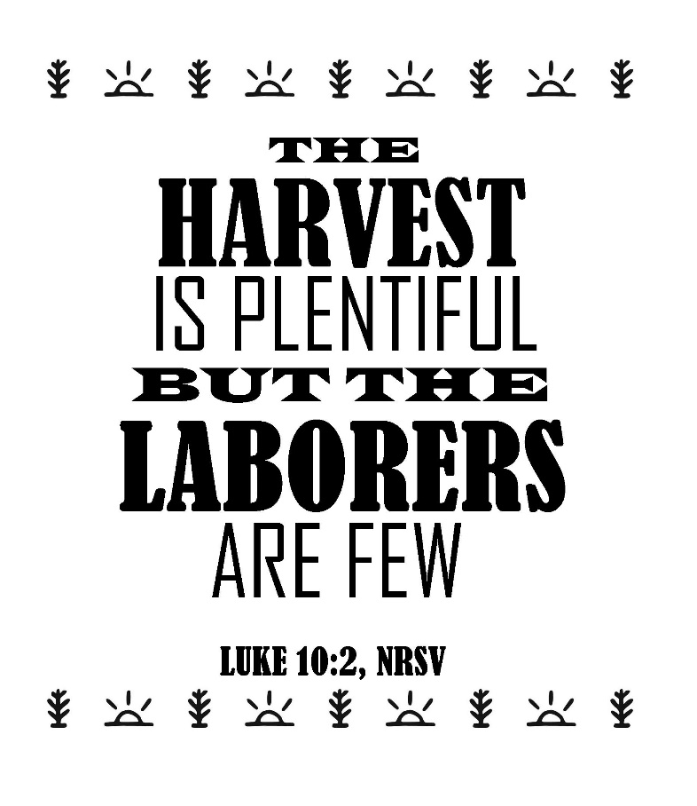

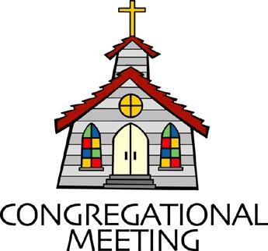
July 7, 2019 - 10:30 am

WELCOME VISITORS! We're glad you are here! Cards at the ends of each pew are for you to fill out and drop in the Offering Plate. Please let us know you are visiting, and join us for refreshments and fellowship following the service. The Sanctuary has an induction loop system to assist the hearing impaired. The system will also work on the telephone setting of hearing aids.

Springfield Presbyterian Church is rooted in the gospel of Jesus Christ, led by the Holy Spirit, and called to loving relationships through vibrant worship and service. Valuing all people, we are committed to developing disciples and fostering stewardship.
PREPARATION FOR THE WORD
(* those who are able are invited to stand)

PRELUDE

GATHERING OF THE PEOPLE

The Lord be with you! And also with you! (Greeting)

LIGHTING THE CHRIST CANDLE
Leader: Whenever we light this candle we proclaim:
People: Christ is the Light of the world and the center of our lives.

CALL TO WORSHIP [Excerpts of Psalm 30]
Leader: Sing praises to the Lord, O you faithful ones,
People: Let us give thanks to His holy name.
Leader: For His anger is but for a moment,
People: Yet God’s favor is for a lifetime.
Leader: Weeping may linger for the night,
People: But joy comes in the morning.
Leader: You have turned our mourning into dancing,
People: You have taken off our sackcloth and clothed us with joy,
Leader: So that our soul may praise you and not be silent.
People: O Lord my God, we will give thanks to you forever!
ALL: Let us praise God’s holy name! Alleluia! Amen!

* HYMN God Is Here!

God is here! As we your people meet to offer praise and prayer,
May we find in fuller measure what it is in Christ we share.
Here, as in the world around us, all our varied skills and arts
Wait the coming of the Spirit into open minds and hearts.

Here are symbols to remind us of our lifelong need of grace;
Here are table, font, and pulpit; here the cross has central place.
Here in honesty of preaching, here in silence, as in speech,
Here, in newness and renewal, God the Spirit comes to each.

Here our children find a welcome in the Shepherd's flock and fold;
Here, as bread and wine are taken, Christ sustains us as of old.
Here the servants of the Servant seek in worship to explore
What it means in daily living to believe and to adore.

Lord of all, of church and kingdom, in an age of change and doubt
Keep us faithful to the gospel; help us work your purpose out.
Here, in this day's dedication, all we have to give, receive:
We, who cannot live without you, we adore you! We believe!

PRAYER OF CONFESSION (Unison)
Generous God, we like our affinity groups – we like the people who make us comfortable and like to inhabit the places that feel easy. Yet you call us out of our comfort zone and into places where peace is not present. You ask us to move our feet, responsibly use our voices, and speak on behalf of those who are underrepresented. You ask us to be your disciples and bring peace, but we are a people who are often busy, distracted, or overwhelmed by that call. Help us and renew us and restore us, giving us new energy by your Spirit to be peacemakers and bring hope to the hopeless. Amen.

SILENT PRAYERS OF CONFESSION

RESPONSE Remember Not, O God
O Lord, our Savior, help, and glorify your name;
Deliver us from all our sins and take away our shame.
WORDS OF ASSURANCE
Leader: Our righteousness is found in Christ alone, a gift of God by faith.
People: We are the beloved people of God, so let us believe the good news: through the grace of Jesus Christ we are forgiven! Thanks be to God!

* MUSICAL RESPONSE OF PRAISE Great Is Thy Faithfulness
Great is thy faithfulness! Great is thy faithfulness! Morning by morning new mercies I see. All I have needed thy hand hath provided. Great is thy faithfulness Lord unto me.

* THE PEACE The peace of Christ be with you! And also with you!
(You may greet those around you.)

* RESPONSE Here I Am, Lord
Here I am, Lord, Is it I, Lord? I have heard you calling in the night.
I will go, Lord, if you lead me. I will hold your people in my heart.

THE PROCLAMATION OF THE WORD

PRAYER OF ILLUMINATION
Leader: Speak to us, living God, as you have spoken to our ancestors: through the voices of your prophets, the breath of your Spirit, and the life of your Son, so that we may live according to your word; through Jesus Christ our Lord. Amen.

FIRST SCRIPTURE LESSON Galatians 6:1-6
My friends, if anyone is detected in a transgression, you who have received the Spirit should restore such a one in a spirit of gentleness. Take care that you yourselves are not tempted. ²Bear one another’s burdens, and in this way you will fulfil the law of Christ. ³For if those who are nothing think they are something, they deceive themselves. ⁴All must test their own work; then that work, rather than their neighbor’s work, will become a cause for pride. ⁵For all must carry their own loads. ⁶Those who are taught the word must share in all good things with their teacher.

SECOND SCRIPTURE LESSON Luke 10:1-11
After this the Lord appointed seventy others and sent them on ahead of him in pairs to every town and place where he himself intended to go. ²He said to them, ‘The harvest is plentiful, but the laborers are few; therefore ask the Lord of the harvest to send out laborers into his harvest. ³Go on your way. See, I am sending you out like lambs into the midst of wolves. ⁴Carry no purse, no bag, no sandals; and greet no one on the road. ⁵Whatever house you enter, first say, “Peace to this house!” ⁶And if anyone is there who shares in peace, your peace will rest on that person; but if not, it will return to you. ⁷Remain in the same house, eating and drinking whatever they provide, for the laborer deserves to be paid. Do not move about from house to house. ⁸Whenever you enter a town and its people welcome you, eat what is set before you; ⁹cure the sick who are there, and say to them, “The kingdom of God has come near to you.” ¹⁰But whenever you enter a town and they do not welcome you, go out into its streets and say, ¹¹“Even the dust of your town that clings to our feet, we wipe off in protest against you. Yet know this: the kingdom of God has come near.”

Leader: Hear what the Spirit is saying to the Church.
All: Thanks be to God.

TIME WITH YOUNG PEOPLE

SERMON Called to the Art of Peace-Making Rev. Becca Crate

THE RESPONSE TO THE WORD

* HYMN I Come with Joy

I come with joy, a child of God, forgiven, loved, and free,
The life of Jesus to recall, in love laid down for me,
In love laid down for me.

I come with Christians far and near to find, as all are fed,
The new community of love in Christ’s communion bread,
In Christ’s communion bread.

As Christ breaks bread and bids us share, each proud division ends.
The love that made us, makes us one, and strangers now are friends,
And strangers now are friends.

The Spirit of the risen Christ, unseen, but ever near,
Is in such friendship better known, alive among us here,
Alive among us here.

Together met, together bound by all that God has done,
We’ll go with joy, to give the world the love that makes us one,
The love that makes us one.

THE COMMUNION OF THE PEOPLE

INVITATION

THE GREAT PRAYER OF THANKSGIVING
Leader: The Lord be with you.
People: And also with you.
Leader: Lift up your hearts.
People: We lift them up to the Lord.
Leader: Let us give thanks to the Lord our God.
People: It is right to give our thanks and praise.
[The Pastor continues… “…who forever sing to the glory of your name.”]

IN PRAISE OF GOD Tune #552
Holy, holy, holy, Lord, God of Power and might.
Heaven and earth are full of your glory, Hosanna in the highest!
Blessed is He who comes in the name of the Lord.
Hosanna in the highest, hosanna in the highest.
[The Pastor continues… “…proclaim the One crucified and risen...”]

IN PRAISE OF CHRIST Tune #553
Christ has died; Christ is risen; Christ will come again.
Christ has died; Christ is risen; Christ will come again.

PASTORAL PRAYER AND THE LORD’S PRAYER
“For this I pray to God.” / “For this I give thanks to God.”
Congregational Response: “Hear our prayer, O God.”

WORDS OF INSTITUTION

SHARING OF THE MEAL

PRAYER OF DEDICATION (Unison)
Dear God, take us out to live as changed people because we have shared the living bread and cannot remain the same. Ask much of us, expect much from us, enable much by us, encourage many through us. So, Lord, may we live to your glory, both as inhabitants of the earth, and citizens of the commonwealth of Heaven. Through Christ, with Christ, in Christ, in the unity of the Holy Spirit, all glory and honor are yours, almighty God, now and forever. Amen.

PRESENTATION OF TITHES AND OFFERINGS
OFFERTORY
* SONG OF THANKS As Those of Old Their Firstfruits Brought
In gratitude and humble trust we bring our best today,
To serve your cause and share your love with all along life’s way.
O God who gave yourself to us in Jesus Christ your Son,
Help us to give ourselves each day until life’s work is done.
* PRAYER OF DEDICATION

* HYMN We All Are One in Mission

We all are one in mission; we all are one in call,
Our varied gifts united by Christ, the Lord of all.
A single, great commission compels us from above
To plan and work together that all may know Christ's love.

We all are called for service to witness in God's name.
Our ministries are different; our purpose is the same:
To touch the lives of others by God's surprising grace,
So every folk and nation may feel God's warm embrace.

Now let us be united and let our song be heard.
Now let us be a vessel for God's redeeming word.
We all are one in mission; we all are one in call,
Our varied gifts united by Christ, the Lord of all.

* CHARGE AND BENEDICTION
Leader: We are called to speak,
People: To speak God’s word of peace.
Leader: We are called to move,
People: To take tangible action in loving one another.
Leader: We are called to be your disciples,
People: And so we covenant to love and peace-making through the power of your Holy Spirit.

* UNISON AMEN

POSTLUDE

Assisting in Worship: We appreciate those who serve:
Today 7/7 Next Week 7/14
Sunday Opener Bob Rogers Beth Oates
Greeters & Ushers Connie Robinson & Amy Vasbinder &
Martha Streaker Bob Rogers
Lay Leader Tim Oates Sharon Pappas
Children’s Activity Connie Robinson Connie Robinson
Fellowship Barbara Nickell Sandy Newsome

Communion Servers Today: (Intinction)
1. Linda Caviglia 3. Kathy Russ
2. Jennifer Wise 4. Barbara Cornell

Church Attendance: June 23 – 28 June 30 - 31

Church Cleaning: July 12, 13 or 14 – Belle Vasbinder &
Barbara Nickell

Happy Birthday! July 8 – Tony Caviglia
July 8 – Sharon Pappas
July 8 – Cynthia Smith

Happy Anniversary! July 11 – Chad & Shannon Stewart

Sunday July 14 Lectionary
Amos 7:7-17; Psalm 82; Colossians 1:1-14; Luke 10:25-37
Announcements

Big Tent: Volunteers are needed for Big Tent on August 1 – 3 in Baltimore. Big Tent is PCUSA’s 3-day conference featuring bible studies, learning opportunities, worship, workshops, and speakers from around the country. To learn more and sign up to help, go to http://oga.pcusa.org/section/big-tent-2019/volunteer-opportunities/ or email Sonce Reese at sonce.reese@pcusa.org.

Interested in trying out bell ringing? Linda Caviglia is planning to have introductory bell sessions on 3 Sundays over the summer - July 21, August 4, and August 18, time to be announced. There is a signup sheet on the bulletin board in the Narthex if you are interested (Fall 2019 going into 4th grade and up).

Summer Music for Worship: If you'd like to share some of your musical talents (all levels of accomplishment) over the summer while the choir and bell choir take a rest, we'd love to have you participate. There is a sign-up sheet in the Narthex for each Sunday over the summer. Please talk with Linda Caviglia about your thoughts/plans if you need Aaron to accompany you, or would like some other "backup" music.

Prayer Group: This summer, Springfield’s prayer group will take a break from its scheduled meetings until September. We still believe in the power of our prayers and want to know your praises and concerns, so the electronic version of the prayer group will continue. If you would like to be a part of this E-group, please let Sandy Newsome know. As always, contact her at sandy.newsome814@gmail.com with your prayer requests.

Blessing Bags are in the Narthex. Please feel free to pick up a few. Handing one out to someone in need gives you a very real way to meet their immediate needs by providing them with some basic supplies.
Weekly Announcements: If you have an announcement to include with next week’s bulletin, please call the Office at 410-795-6152 or email to spc.office@verizon.net by Wednesday each week.

Prayers & Thanksgivings

~ Continued prayers of healing for Max Carroll and prayers of comfort and strength for Margaret Carroll.
~ Continued prayers of healing for Shona Klein who had surgery.
~ Prayers for Mt. Hebron Presbyterian Church from our Ministry Group.

The Congregational Care team wants to know what YOU or someone you know needs...a visit...a call...a meal. Please contact Diana Steppling or Connie Robinson.

Today:
Sunday July 7
10:30 am Worship
11:30 am Fellowship
3:00 pm Concert

This Week:
Monday July 8
7:00 pm HeadHuggers (Manse)

Looking Ahead:
Sunday July 14
10:30 am Worship
11:30 am Fellowship
Monday July 15
9:30 am Feed My Sheep (Wesley Freedom)
Friday July 19 7:00 pm Family Game Night

Office Hours: Tuesday, Wednesday, Friday 9:00 am - 3:00 pm

Springfield Presbyterian Church

10:30 am Worship
11:30 am Fellowship
Website: www.springfield-church.org Church Office: 410-795-6152
Like us on Facebook: www.facebook.com/SpringfieldPresbyterianChurch
Pastor: Rev. Becca Crate
Email: springfieldpastor@gmail.com
Clerk of Session: Sharon Pappas
Minister of Music: Linda Caviglia
Accompanist: Aaron Thacker Organist: Jennifer Wise
Youth Group Coordinators: Charles & Deb Sperling
Sunday School Coordinator: Connie Robinson
Administrative Assistant: Donna Mazer
e-mail: spc.office@verizon.net

