Springfield Presbyterian Church (USA)
7300 Spout Hill Road, Sykesville, MD 21784 410-795-6152
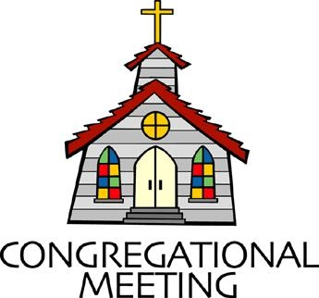

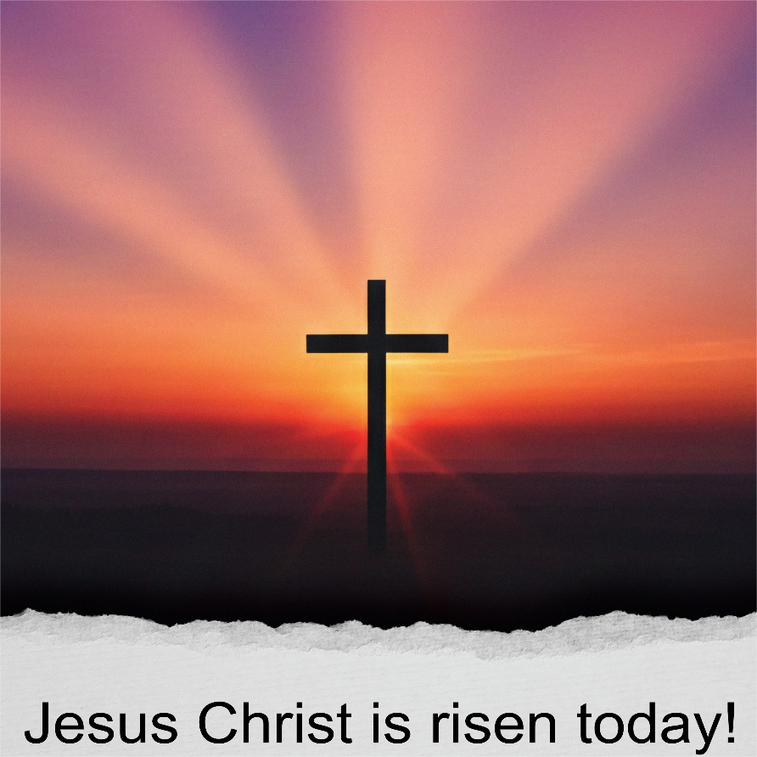

April 5, 2026 - 10:30 am

WELCOME VISITORS!

We're glad you are here! Cards at the ends of each pew are for you to fill out and drop in the Offering Plate. Please let us know you are visiting and join us for refreshments and fellowship following the service. The Sanctuary has an induction loop system to assist the hearing impaired. The system will also work on the telephone setting of hearing aids.

Springfield Presbyterian Church is rooted in the gospel of Jesus Christ, led by the Holy Spirit, and called to loving relationships through vibrant worship and service. Valuing all people, we are committed to developing disciples and fostering stewardship.
PREPARATION FOR THE WORD
(* those who are able are invited to stand)
PRELUDE

GATHERING OF THE PEOPLE

The Lord be with you! And also with you! (Greetings and Announcements)

LIGHTING THE CHRIST CANDLE
Leader: Whenever we light this candle we proclaim:
People: Christ is the Light of the world and the center of our lives.

CALL TO WORSHIP
Leader: Christ is Risen! Shout Hosanna!
People: Hosanna! Hosanna!
Leader: Celebrate this day of days!
People: Hosanna! Hosanna!
Leader: Let all creation be amazed!
People: Hosanna! Hosanna! Christ is Risen!

* HYMN Jesus Christ Is Risen Today GTG #232

Jesus Christ is risen today, Alleluia! Our triumphant holy day, Alleluia!
Who did once upon the cross, Alleluia! Suffer to redeem our loss. Alleluia!

Hymns of praise then let us sing, Alleluia! Unto Christ, our heavenly King, Alleluia!
Who endured the cross and grave, Alleluia! Sinners to redeem and save. Alleluia!

But the pains which he endured, Alleluia! Our salvation have procured. Alleluia!
Now above the sky he's King, Alleluia! Where the angels ever sing. Alleluia!

Sing we to our God above, Alleluia! Praise eternal as God's love. Alleluia!
Praise our God, ye heavenly host, Alleluia! Father, Son, and Holy Ghost. Alleluia!

CALL TO CONFESSION
Leader: The joy of this Easter Sunday reminds us of God’s resurrecting power.
Let us confess all that turns us toward death, so we can know the grace of new life through Christ.

PRAYER OF CONFESSION
Savior God, forgive our life-alienating ways, our exclusion and judgment of others; the way we evaluate and compare. Forgive our death-dealing sins, our habits that demean and degrade, our addiction to violent and destructive behavior. Redeem us. Restore us. Resurrect us for life in Christ. Amen.

SILENT PRAYERS OF CONFESSION

RESPONSE Restore in Us, O God GTG #434 (v. 1)
Restore in us, O God, the splendor of your love;
Renew your image in our hearts, and all our sins remove.

WORDS OF ASSURANCE
“Jesus Christ is risen today. But the pains which he endured, our salvation have procured.” In the name of Jesus Christ, we are forgiven. Alleluia. Amen.

* MUSICAL RESPONSE OF PRAISE Alleluia, Alleluia! Give Thanks
GTG #240 (refrain only)
Alleluia, alleluia! Give thanks to the risen Lord.
Alleluia, alleluia! Give praise to his name.

* THE PEACE The peace of Christ be with you! And also with you!
(You may greet those around you.)

* RESPONSE Here I Am, Lord GTG #69
Here I am, Lord. Is it I, Lord? I have heard you calling in the night.
I will go, Lord, if you lead me. I will hold your people in my heart.

THE PROCLAMATION OF THE WORD

PRAYER FOR ILLUMINATION
Divine Redeemer, bearer of life, open us to the wisdom of your Word today and enlighten us with your truth. Liberate us from all that distracts and turns us from your path. Guide us and ground us in Christ’s everlasting hope. Amen.

SCRIPTURE LESSON John 20:1-18 NT page 108
¹Early on the first day of the week, while it was still dark, Mary Magdalene came to the tomb and saw that the stone had been removed from the tomb. ²So she ran and went to Simon Peter and the other disciple, the one whom Jesus loved, and said to them, "They have taken the Lord out of the tomb, and we do not know where they have laid him." ³Then Peter and the other disciple set out and went toward the tomb. ⁴The two were running together, but the other disciple outran Peter and reached the tomb first. ⁵He bent down to look in and saw the linen wrappings lying there, but he did not go in. ⁶Then Simon Peter came, following him, and went into the tomb. He saw the linen wrappings lying there,
⁷and the cloth that had been on Jesus' head, not lying with the linen wrappings but rolled up in a place by itself. ⁸Then the other disciple, who reached the tomb first, also went in, and he saw and believed; ⁹for as yet they did not understand the scripture, that he must rise from the dead. ¹⁰Then the disciples returned to their homes. ¹¹But Mary stood weeping outside the tomb. As she wept, she bent over to look into the tomb; ¹²and she saw two angels in white, sitting where the body of Jesus had been lying, one at the head and the other at the feet. ¹³They said to her, "Woman, why are you weeping?" She said to them, "They have taken away my Lord, and I do not know where they have laid him." ¹⁴When she had said this, she turned around and saw Jesus standing there, but she did not know that it was Jesus. ¹⁵Jesus said to her, "Woman, why are you weeping? Whom are you looking for?" Supposing him to be the gardener, she said to him, "Sir, if you have carried him away, tell me where you have laid him, and I will take him away." ¹⁶Jesus said to her, "Mary!" She turned and said to him in Hebrew, "Rabbouni!" (which means Teacher). ¹⁷Jesus said to her, "Do not hold on to me, because I have not yet ascended to the Father. But go to my brothers and say to them, "I am ascending to my Father and your Father, to my God and your God.' "
¹⁸Mary Magdalene went and announced to the disciples, "I have seen the Lord"; and she told them that he had said these things to her.

SERMON Where’s Jesus? By Troy Bailey

AFFIRMATION OF FAITH
This is the good news which we have received, in which we stand, and by which we are saved, if we hold it fast: that Christ died for our sins according to the scriptures, that he was buried, that he was raised on the third day, and that he appeared first to the women, then to Peter, and to the Twelve, and then to many faithful witnesses. We believe that Jesus is the Christ, the Son of the living God. Jesus Christ is the first and the last,
the beginning and the end; he is our Lord and our God. Amen.

THE RESPONSE TO THE WORD

* HYMN Christ Is Alive! GTG #246

Christ is alive! Let Christians sing. The cross stands empty to the sky.
Let streets and homes with praises ring. Love, drowned in death, shall never die.

Christ is alive! No longer bound to distant years in Palestine,
But saving, healing, here and now, and touching every place and time.

In every insult, rift, and war where color, scorn, or wealth divide,
Christ suffers still, yet loves the more, and lives, where even hope has died.

Women and men, in age and youth, can feel the Spirit, hear the call,
And find the way, the life, the truth, revealed in Jesus, freed for all.

Christ is alive, and comes to bring good news to this and every age,
Till earth and sky and ocean ring with joy, with justice, love, and praise.

THE COMMUNION OF THE PEOPLE

INVITATION

THE GREAT PRAYER OF THANKSGIVING
Leader: The Lord be with you.
People: And also with you.
Leader: Lift up your hearts.
People: We lift them up to the Lord.
Leader: Let us give thanks to the Lord our God.

People: It is right to give our thanks and praise.
[The Pastor continues… “Therefore with all creation we sing your praise.”]

IN PRAISE OF GOD Tune #552
Holy, holy, holy, Lord, God of Power and might.
Heaven and earth are full of your glory, Hosanna in the highest!
Blessed is He who comes in the name of the Lord.
Hosanna in the highest, hosanna in the highest.
[The Pastor continues… “Great is the mystery of faith.”]

IN PRAISE OF CHRIST Tune #553
Christ has died; Christ is risen; Christ will come again.
Christ has died; Christ is risen; Christ will come again.
[The Pastor continues… “almighty God, now and forever.”]

GREAT AMEN Tune #554

PASTORAL PRAYER AND THE LORD’S PRAYER

WORDS OF INSTITUTION

SHARING OF THE MEAL

PRAYER OF DEDICATION
Leader: God of abundance, with this bread of life and cup of salvation you have
united us with Christ, making us one with all your people. Now send us forth in
the power of your Spirit that we may proclaim your redeeming love to the world
and continue forever in the risen life of Jesus Christ, our Lord.
All: Amen.

PRESENTATION OF TITHES AND OFFERINGS
OFFERTORY Alleluia, He Is Risen by: Cindy Berry (see last page)
* SONG OF THANKS God, We Honor You GTG #709
God, we honor you. God, we trust in you. God, we worship and adore you.
Take what we bring, offered to you. Teach us to show your abundant blessings. Alleluia, alleluia, alleluia, amen.
* PRAYER OF DEDICATION

* HYMN Let All Things Now Living GTG #37

Let all things now living a song of thanksgiving to God our Creator triumphantly raise;
Who fashioned and made us, protected and stayed us, by guiding us on to the end of our days.
God’s banners are o’er us; pure light goes before us, a pillar of fire shining forth in the night:
Till shadows have vanished, all fearfulness banished, as forward we travel from light into light.

By law God enforces, the stars in the courses, the sun in its orbit obediently shine;
The hills and the mountains, the rivers and fountains, the depths of the ocean proclaim God divine.
We too should be voicing our love and rejoicing; with glad adoration, a song let us raise,
Till all things now living unite in thanksgiving: to God in the highest, hosanna and praise!

* CHARGE AND BENEDICTION
Celebrate this day of days! Rejoice in God, your Savior! Know the new life gifted through Jesus Christ! Shout your Alleluia’s for all to hear! May the grace, hope, peace and love of God our Creator, Redeemer, and Sustainer be with us all, now and forever. Amen.

* UNISON AMEN GTG #601

POSTLUDE

© Presbyterian Outlook, 2026; Liturgy written by Teri McDowell Ott and provided for free distribution

Sunday April 12, 2026 Lectionary
Acts 2:14a, 22-32; Psalm 16; Peter 1:3-9; John 20:19-31
Assisting in Worship: We appreciate those who serve:

Today 4/5 Next Week 4/12
Sunday Opener: Barbara Cornell Linda Caviglia
Ushers/Greeters: Connie Gibbons Steve & Donna Mazer
Leah Halvorson
Lay Leader: Barbara Cornell Max Carroll
Pulpit Supply: Troy Bailey Heather Russell von Marko
Comm. Servers: Mark Kearney
Don Vasbinder
Tony Caviglia
Sharon Pappas
Alex McClung
Mark Chaplik
Diane Chaplik
Bobby Barrett
Barbara Nickell
Offering Count: Andra Kwako & Vol. Andrea Kwako & Linda C.
Fellowship Hosts: Rebekah, Barb N., Christy Linda Caviglia

Happy Birthday! April 7 – Wes McClung
April 12 – Lisa Rogers

Announcements

Welcome! We welcome Troy Bailey to our pulpit again today! Troy recently served in a bridge role as commissioned lay pastor of Dickey Memorial Presbyterian Church in Baltimore. Originally from Pittsburgh, he is a lifelong Presbyterian and ruling elder since 2013. Troy studied at the St. Mary's Ecumenical Institute and United Theological Seminary of the Twin Cities. He lives with his wife in Owings Mills and works in risk management for an insurance company.

A Big Welcome to Michael Hall as our new Accompanist!

Pastor Search Committee: The Pastor Search Committee is happy to announce that Heather Russell von Marko accepted the contract with Session to be our Ministry Associate beginning April 7. We have been fortunate to have her fill our pulpit several times recently, she comes with a variety of experiences, and looks forward to her graduation from seminary at the end of May. We will hold a big fellowship-time welcome for both Heather and our accompanist Michael Hall on April 19, when Michael can be present too.

There is more to share about Heather’s background and our continuing process so watch for an email or mailing.

Graduation Celebration: We will celebrate our high school and college graduates on May 17 during fellowship. Please let Diana Steppling or Connie Gibbons know if you have a child or grandchild graduating from high school or college this year.

Congregational Care: If you know of someone who would benefit from a card or a phone call, please text or call Connie Gibbons at 410-935-3467.

Electronic Giving: Below is a QR code you can scan to make your contribution a new way! The page you get will ask for your name, email and phone

number. You can choose from a dropdown menu for selecting where the donation should go: General Fund, Capital Fund, Concert, Memorial. There is a fee for using a credit card, and you will be given the option to pay that fee along with your donation, but you don’t have to include it if you don’t want to.

Today:
Sunday April 5 – Easter Sunday
10:30 am Worship
11:30 am Fellowship

This Week:
Monday April 6
7:00 pm Headhuggers (Manse)
Wednesday April 8
6:15 – 7:15 pm Bell Choir Practice
7:30 – 8:45 pm Adult Choir Practice

Next Week:
Sunday April 12
10:30 am Worship
11:30 am Fellowship
Wednesday April 15
6:15 – 7:15 pm Bell Choir Practice
7:30 – 8:45 pm Adult Choir Practice
Thursday April 16
7:00 pm Session Meeting (Manse)

Office Hours: Tuesday, Wednesday, Friday, 10 am – 3 pm
Springfield Presbyterian Church
10:30 am Worship (and Sunday School 1st & 3rd Sundays)
11:30 am Fellowship
Website: www.springfield-church.org Church Office: 410-795-6152
Like us on Facebook: www.facebook.com/SpringfieldPresbyterianChurch
Ministry Associate: Heather Russell von Marko
Email: spc.office@verizon.net
Clerk of Session: Sharon Pappas
Minister of Music: Vacant
Accompanist: Michael Hall
Bell Choir Director: Vacant
Youth Group Coordinator: Dylan Vasbinder
Administrative Assistant: Donna Mazer Email: spc.office@verizon.net

The flowers in the Sanctuary were given by:

Tony and Linda Caviglia
In Memory of Gary Irons
In Appreciation for Ron Holmes

Michael Courbron
In Honor of Mary Ann Courbron

Ron and Gwen Grubb
In Memory of Clyde and Florence Miller, William and Ruth Grubb

Barbara Nickell
In Memory of Jim Nickell, Jr., Parents and Grandparents
In Honor of Deloris Nickell

Judy Rhoades
In Appreciation for Springfield Church Workers

Bob and Diana Steppling
In Memory of our Parents no longer with us
In Honor of Ida Evans and Phil Evans and John Steppling

Amy Vasbinder-Garcia and Family
In Appreciation for Our Families and Friends

Vasbinder Family
In Memory of William and Isabelle, George and Jeannette, Janet and Bob,
Kurt, Brian, Nettie Studley

