(Large Print)

Springfield Presbyterian Church (USA)
7300 Spout Hill Road, Sykesville, MD 21784 410-795-6152

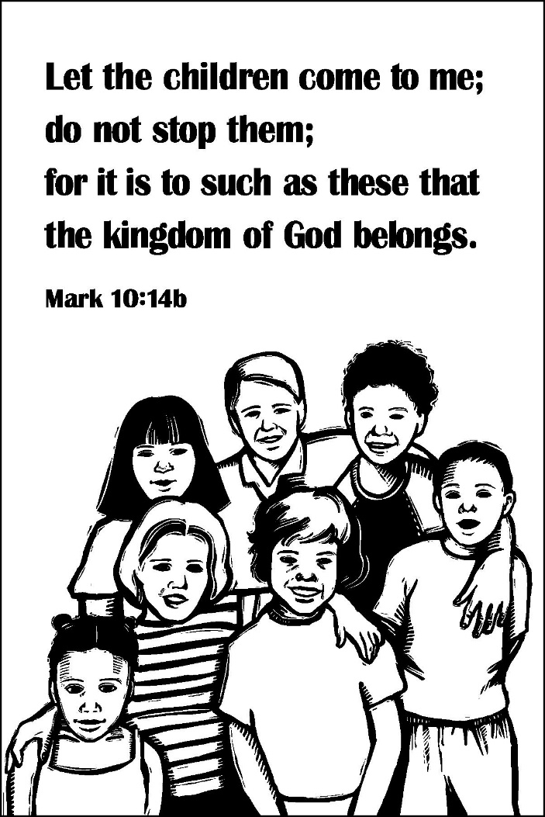

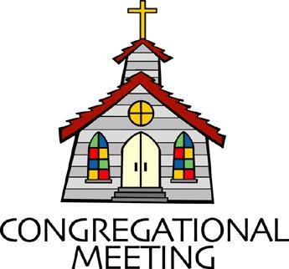
October 3, 2021 - 10:30 am

WELCOME VISITORS! We're glad you are here! Cards at the ends of each pew are for you to fill out and drop in the Offering Plate. Please let us know you are visiting, and join us for refreshments and fellowship following the service. The Sanctuary has an induction loop system to assist the hearing impaired. The system will also work on the telephone setting of hearing aids.

Springfield Presbyterian Church is rooted in the gospel of Jesus Christ, led by the Holy Spirit, and called to loving relationships through vibrant worship and service. Valuing all people, we are committed to developing disciples and fostering stewardship.
PREPARATION FOR THE WORD
(* those who are able are invited to stand)

PRELUDE

GATHERING OF THE PEOPLE

The Lord be with you! And also with you! (Greeting)

LIGHTING THE CHRIST CANDLE
Leader: Whenever we light this candle we proclaim:
People: Christ is the Light of the world and the center of our lives.

CALL TO WORSHIP [Rev. Gloria Ulloa - Colombia]
Leader: We gather from the west to the east,
People: We gather from the south to the north.
Leader: We gather to celebrate the God of peace who accompanies us in our acts of peace.
People: This God of peace accompanies us in each and every circumstance around us.
Leader: We praise God’s name!
People: Alleluia! Amen!

* HYMN Savior, like a Shepherd Lead Us #187

Savior, like a shepherd lead us; much we need your tender care.
In your pleasant pastures feed us; for our use your fold prepare.
Blessed Jesus, blessed Jesus, you have bought us: we are yours.
Blessed Jesus, blessed Jesus, you have bought us: we are yours.

We are yours: in love befriend us; be the guardian of our way.
Keep your flock: from sin defend us; seek us when we go astray.
Blessed Jesus, blessed Jesus, hear your children when we pray.
Blessed Jesus, blessed Jesus, hear your children when we pray.

You have promised to receive us, poor and sinful though we be;
You have mercy to relieve us, grace to cleanse, and power to free.
Blessed Jesus, blessed Jesus, early let us turn to you.
Blessed Jesus, blessed Jesus, early let us turn to you.

Early let us seek your favor; early let us do your will.
Blessed Lord and only Savior, with your love our spirits fill.
Blessed Jesus, blessed Jesus, you have loved us; love us still.
Blessed Jesus, blessed Jesus, you have loved us; love us still.

PRAYER OF CONFESSION
Gracious Lord, creator of this universe, in your generosity you have given us a world of abundance and diversity, yet we live guided by greed and selfishness. We confess that we have defaced your creation and poisoned our environment through our consumerist behavior and for personal gain. In Christ, you made us brothers and sisters and intended for us to be united, and yet we have built walls to separate us from those who are different from us. You gave us wisdom and creativity and we have used those to trick each other and to develop weapons of destruction and death. You gave us laws to order our lives and we have abused them to take revenge and punish our enemies. We love war rather than strive for peace. We ignore the poor and the weak and honor the rich and powerful. In all this we have not lived according to your will. Forgive us, Lord, for daring to boast in our human achievements and for failing to recognize that you alone are worthy of praise. In your mercy, forgive us our sins.

SILENT PRAYERS OF CONFESSION

RESPONSE Hear My Prayer, O God Tune #782
Hear my prayer, O God, and listen to my plea;
Faithful, righteous One, give ear and answer me.
WORDS OF ASSURANCE [Shant Agoushian - Armenian]
Leader: “God accepted us simply because of our faith in Christ,” through whom our sins were forgiven.
People: May He help us to continue to “preach peace to those who are near and far.” Amen.

* MUSICAL RESPONSE OF PRAISE O My Soul, Bless Your Redeemer
Bless your Maker, all you creatures, ever under God’s control,
All throughout God’s vast dominion; bless the Lord of all, my soul!

* THE PEACE The peace of Christ be with you! And also with you!
(You may greet those around you.)

* RESPONSE Here I Am, Lord
Here I am, Lord, Is it I, Lord? I have heard you calling in the night.
I will go, Lord, if you lead me. I will hold your people in my heart.

THE PROCLAMATION OF THE WORD

PRAYER OF ILLUMINATION [Magdaléna Trgalová – Czech Republic]
Holy Spirit, grant us openness and give us understanding of what each one of us needs to receive through Holy Scripture. When we are facing a difficult choice between the easy and the right decision, help us to choose the narrow path. We also pray for all who are about to set on an adventurous journey of faith anywhere in the world. Amen.

FIRST SCRIPTURE LESSON Psalm 8
¹ O Lord, our Sovereign, how majestic is your name in all the earth! You have set your glory above the heavens. ² Out of the mouths of babes and infants you have founded a bulwark because of your foes, to silence the enemy and the avenger. ³ When I look at your heavens, the work of your fingers, the moon and the stars that you have established;
⁴ what are human beings that you are mindful of them, mortals that you care for them? ⁵ Yet you have made them a little lower than God, and crowned them with glory and honor. ⁶ You have given them dominion over the works of your hands; you have put all things under their feet, ⁷ all sheep and oxen, and also the beasts of the field, ⁸ the birds of the air, and the fish of the sea, whatever passes along the paths of the seas. ⁹ O Lord, our Sovereign, how majestic is your name in all the earth!

SECOND SCRIPTURE LESSON Mark 10:2-16
²Some Pharisees came, and to test him they asked, ‘Is it lawful for a man to divorce his wife?’ ³He answered them, ‘What did Moses command you?’ ⁴They said, ‘Moses allowed a man to write a certificate of dismissal and to divorce her.’ ⁵But Jesus said to them, ‘Because of your hardness of heart he wrote this commandment for you. ⁶But from the beginning of creation, “God made them male and female.” ⁷“For this reason a man shall leave his father and mother and be joined to his wife, ⁸and the two shall become one flesh.” So they are no longer two, but one flesh. ⁹Therefore what God has joined together, let no one separate.’ ¹⁰Then in the house the disciples asked him again about this matter. ¹¹He said to them, ‘Whoever divorces his wife and marries another commits adultery against her; ¹²and if she divorces her husband and marries another, she commits adultery.’ ¹³People were bringing little children to him in order that he might touch them; and the disciples spoke sternly to them. ¹⁴But when Jesus saw this, he was indignant and said to them, ‘Let the little children come to me; do not stop them; for it is to such as these that the kingdom of God belongs. ¹⁵Truly I tell you, whoever does not receive the kingdom of God as a little child will never enter it.’ ¹⁶And he took them up in his arms, laid his hands on them, and blessed them.
Leader: Hear what the Spirit is saying to the Church.
All: Thanks be to God.

SERMON All in the Family Rev. Becca Crate-Price

THE RESPONSE TO THE WORD

* HYMN Hosanna, Loud Hosanna (verses 1 & 3) #197

Hosanna, loud hosanna, the little children sang;
Through pillared court and temple the joyful anthem rang.
To Jesus, who had blessed them, close folded to his breast,
The children sang their praises, the simplest and the best.

“Hosanna in the highest!” That ancient song we sing,
For Christ is our Redeemer; the Lord of heaven, our King.
O may we ever praise him with heart and life and voice,
And in his blissful presence eternally rejoice.

INVITATION TO THE COMMUNION TABLE [Iona Community]

INVITATION

THE GREAT PRAYER OF THANKSGIVING
Leader: The Lord be with you.
People: And also with you.
Leader: Lift up your hearts.
People: We lift them up to the Lord.
Leader: Let us give thanks to the Lord our God.
People: It is right to give our thanks and praise.
[The Pastor continues… “…who forever sing to the glory of your name.”]

IN PRAISE OF GOD Tune #552
Holy, holy, holy, Lord, God of Power and might.
Heaven and earth are full of your glory, Hosanna in the highest!
Blessed is He who comes in the name of the Lord.
Hosanna in the highest, hosanna in the highest.
[The Pastor continues… “…proclaim the one crucified and risen.”]

IN PRAISE OF CHRIST Tune #553
Christ has died; Christ is risen; Christ will come again.
Christ has died; Christ is risen; Christ will come again.

PASTORAL PRAYER AND THE LORD’S PRAYER

WORDS OF INSTITUTION

SHARING OF THE MEAL

PRAYER OF DEDICATION (Unison)
Dear God, take us out to live as changed people because we have shared the living bread and cannot remain the same. Ask much of us, expect much from us, enable much by us, encourage many through us. So, Lord, may we live to your glory, both as inhabitants of the earth, and citizens of the commonwealth of Heaven. Through Christ, with Christ, in Christ, in the unity of the Holy Spirit, all glory and honor are yours, almighty God, now and forever. Amen.
PRESENTATION OF TITHES AND OFFERINGS
* PRAYER OF DEDICATION

* HYMN I Come with Joy #515

I come with joy, a child of God, forgiven, loved, and free,
The life of Jesus to recall, in love laid down for me,
In love laid down for me.

I come with Christians far and near to find, as all are fed,
The new community of love in Christ’s communion bread,
In Christ’s communion bread.

As Christ breaks bread and bids us share, each proud division ends.
The love that made us, makes us one, and strangers now are friends,
And strangers now are friends.

The Spirit of the risen Christ, unseen, but ever near,
Is in such friendship better known, alive among us here,
Alive among us here.

Together met, together bound by all that God has done,
We’ll go with joy, to give the world the love that makes us one,
The love that makes us one.

* CHARGE AND BENEDICTION
Leader: The Lord bless you and keep you,
People: The Lord make his face shine upon you and be gracious to you,
Leader: The Lord turn his face toward you and give you peace.
People: May the grace of the Lord Jesus Christ, and the love of God, and the fellowship of the Holy Spirit be with you all from now and forevermore. Amen.

* UNISON AMEN POSTLUDE
Sunday October 10, 2021 Lectionary
Amos 5:6-7, 10-15; Psalm 90:12-17; Hebrews 5:1-10; Mark 10:17-31

Assisting in Worship: We appreciate those who serve:

Today 10/3 Next Week 10/10
Sunday Opener Beth Oates Ron Holmes
Greeters & Ushers Bob Rogers & Sharon Pappas &
Amy Vasbinder Jim Wise
Lay Leader Elizabeth Meirowitz Bob Steppling
Fellowship Need Volunteer Need Volunteer

Happy Birthday! October 6 – Mary Rhodes

Happy Anniversary! October 5 – Connie Gibbons & Cathy Marsh
October 10 – Scott & Stephanie Schroeder

Announcements

Special Offering: Peace and Global Witness is the third of our four special offerings and supports peacemaking and reconciliation ministries throughout the world. With this offering, each congregation is able to use one-quarter of the offering to support an organization of their choice. We want to assist with those needing some legal assistance. Legal Services Corporation, America's Partner for Equal Justice (LSC, tax-exempt organization) is the single largest funder of civil legal services in the country. They play a vital role in a public-private partnership focused on fulfilling America's pledge of equal justice for all. Since its founding more than four decades ago. LSC has been making a difference in the lives of low-income Americans by funding high-quality civil legal assistance to veterans, the elderly, victims of domestic abuse, tenants facing unlawful evictions, and others who cannot afford to pay for legal assistance.
Congregational Care / Mission & Outreach: The Congregational Care/Mission & Outreach Committee would like your help. As we emerge from this pandemic, there is a greater than usual need to make every effort to connect with one another. Do you know of a member or friend of our church family who is ill, needs prayers, would like call, a visit or a card, or might benefit from meal train? If so, please contact the Church Office (410-795-6152), Cathy Marsh (410-549-6916) or Diana Steppling (862-266-2242).

Upcoming Concert: Next Sunday, October 10, we will feature John Bullard, classical banjo and Markus Compton, pianist at 3:00 pm in our Sanctuary, followed by fellowship (outdoors if possible). Mark your calendars!

Prayers & Thanksgivings

~ We would like to thank everyone for the cards, texts, emails, and phone calls that we continue to receive. They are very encouraging and help to get us through the difficult days. This is such a wonderful ministry. ~ With Love & Prayers, Barb & Jim Nickell

Today:
Sunday October 3
10:30 am Worship
11:30 am Fellowship

This Week:
Wednesday October 6
No Choir Practice

Looking Ahead:
Sunday October 10
10:30 am Worship
11:30 am Fellowship
3:00 pm Concert
Tuesday October 12
7:00 pm Congregational Care/Mission & Outreach Meeting
(Manse and also via Zoom)
Thursday October 14
7:00 pm Session Meeting (Manse and also via Zoom)

Office Hours: Tuesday, Wednesday & Friday
Springfield Presbyterian Church

10:30 am Worship
11:30 am Fellowship
Website: www.springfield-church.org Church Office: 410-795-6152
Like us on Facebook: www.facebook.com/SpringfieldPresbyterianChurch
Pastor: Rev. Becca Crate
Email: springfieldpastor@gmail.com
Clerk of Session: Sharon Pappas
Minister of Music: Linda Caviglia
Accompanist: Aaron Thacker Organist: Jennifer Wise
Youth Group Coordinators: Charles & Deb Sperling
Sunday School Coordinator: Connie Robinson
Administrative Assistant: Donna Mazer e-mail: spc.office@verizon.net

