(Large Print)

Springfield Presbyterian Church (USA)
7300 Spout Hill Road, Sykesville, MD 21784 410-795-6152

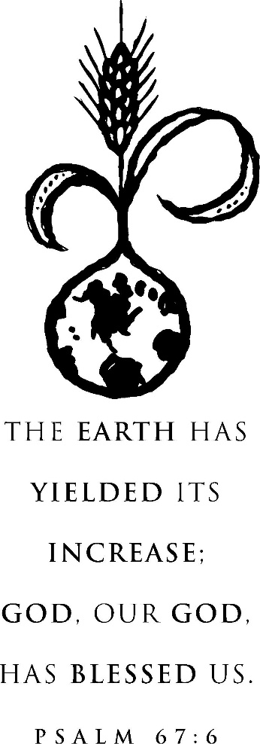

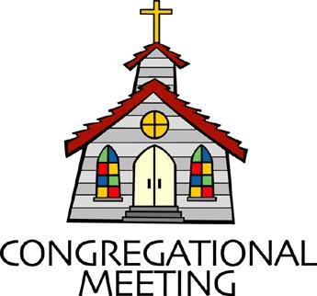
May 26, 2019 - 10:30 am

WELCOME VISITORS! We're glad you are here! Cards at the ends of each pew are for you to fill out and drop in the Offering Plate. Please let us know you are visiting, and join us for refreshments and fellowship following the service. The Sanctuary has an induction loop system to assist the hearing impaired. The system will also work on the telephone setting of hearing aids.

Springfield Presbyterian Church is rooted in the gospel of Jesus Christ, led by the Holy Spirit, and called to loving relationships through vibrant worship and service. Valuing all people, we are committed to developing disciples and fostering stewardship.
PREPARATION FOR THE WORD
(* those who are able are invited to stand)

PRELUDE

GATHERING OF THE PEOPLE

The Lord be with you! And also with you! (Greeting)

LIGHTING THE CHRIST CANDLE
Leader: Whenever we light this candle we proclaim:
People: Christ is the Light of the world and the center of our lives.

CALL TO WORSHIP [Selections of Psalm 9]
Leader: We will give thanks to the Lord with our whole heart;
People: We will tell of all God’s wonderful deeds.
Leader: We will be glad and exult in you;
People: We will sing praise to your name, O Most High.
Leader: The Lord sits enthroned forever,
People: The Lord judges the world with righteousness.
Leader: The Lord judges the people with equity.
People: Our God is a stronghold for the oppressed,
Leader: God is a stronghold in times of trouble.
People: Those who know your name, O God, put their trust in you.
Leader: Let us sing praises to the Lord!
People: Let us declare His deeds among the peoples!
All: Let us worship our God!

* HYMN O For a World

O for a world where everyone respects each other’s ways,
Where love is lived and all is done with justice and with praise.

O for a world where goods are shared and misery relieved,
Where truth is spoken, children spared, equality achieved.

We welcome one world family and struggle with each choice
That opens us to unity and give our vision voice.

The poor are rich; the weak are strong; the foolish ones are wise.
Tell all who mourn: outcasts belong, who perishes will rise.

O for a world preparing for God’s glorious reign of peace,
Where time and tears will be no more, and all but love will cease.

PRAYER OF CONFESSION (Unison) [From “Ministry Matters”]
Lord, you know how easy it is for us to sit here, tethered to our darkness and fear. We get bound up by chains of mistrust. We dare not to hope, for so many times before we have been disappointed. So we sit here and wonder where you are. We are not unlike the disciples who wondered also, who feared. Lord, come to us in our darkness. Flood us with your powerful light of love and mercy. Help open our eyes to the good news of your eternal glory. Give to us visions of the place in which love and hope will reign. Forgive our stubborn resistance to your mercy and your love. For we ask this in Jesus’ name. Amen.

SILENT PRAYERS OF CONFESSION

RESPONSE Restore in Us, O God
Restore in us, O God, the splendor of your love;
Renew your image in our hearts, and all our sins remove.

WORDS OF ASSURANCE [Psalm 103:17]
Leader: Anyone who is in Christ is a new creation. The old life has gone; a new life has begun.
People: Let us declare, in the name of Jesus Christ, we are forgiven! Amen!

* MUSICAL RESPONSE OF PRAISE Alleluia, Alleluia! Give Thanks
Alleluia, alleluia! Give thanks to the risen Lord.
Alleluia, alleluia! Give praise to His name.

* THE PEACE The peace of Christ be with you! And also with you!
(You may greet those around you.)
* RESPONSE Here I Am, Lord
Here I am, Lord, Is it I, Lord? I have heard you calling in the night.
I will go, Lord, if you lead me. I will hold your people in my heart.

THE PROCLAMATION OF THE WORD

PRAYER OF ILLUMINATION
Dear God, please open our hearts and minds as we seek to hear your Word and apply it to our lives. Amen.

FIRST SCRIPTURE LESSON Psalm 67
¹ May God be gracious to us and bless us and make his face to shine upon us, ² that your way may be known upon earth, your saving power among all nations. ³ Let the peoples praise you, O God; let all the peoples praise you. ⁴ Let the nations be glad and sing for joy, for you judge the peoples with equity and guide the nations upon earth.
⁵ Let the peoples praise you, O God; let all the peoples praise you.
⁶ The earth has yielded its increase; God, our God, has blessed us.
⁷ May God continue to bless us; let all the ends of the earth revere him.

SECOND SCRIPTURE LESSON Acts 16:9-15
⁹During the night Paul had a vision: there stood a man of Macedonia pleading with him and saying, ‘Come over to Macedonia and help us.’ ¹⁰When he had seen the vision, we immediately tried to cross over to Macedonia, being convinced that God had called us to proclaim the good news to them. ¹¹We set sail from Troas and took a straight course to Samothrace, the following day to Neapolis, ¹²and from there to Philippi, which is a leading city of the district of Macedonia and a Roman colony. We remained in this city for some days. ¹³On the sabbath day we went outside the gate by the river, where we supposed there was a place of prayer; and we sat down and spoke to the women who had gathered there. ¹⁴A certain woman named Lydia, a worshipper
of God, was listening to us; she was from the city of Thyatira and a dealer in purple cloth. The Lord opened her heart to listen eagerly to what was said by Paul. ¹⁵When she and her household were baptized, she urged us, saying, ‘If you have judged me to be faithful to the Lord, come and stay at my home.’ And she prevailed upon us.

Leader: Hear what the Spirit is saying to the Church.
All: Thanks be to God.

TIME WITH YOUNG PEOPLE

SERMON A Gospel for All People Rev. Becca Crate

THE RESPONSE TO THE WORD

* HYMN For Everyone Born

For everyone born, a place at the table,
For everyone born, clean water and bread,
A shelter, a space, a safe place for growing,
For everyone born, a star overhead.

Refrain:
And God will delight when we are creators
of justice and joy, compassion and peace:
yes, God will delight when we are creators of justice, justice and joy!

For woman and man, a place at the table,
Revising the roles, deciding the share,
With wisdom and grace, dividing the power,
For woman and man, a system that's fair. [Refrain]

For young and for old, a place at the table,
A voice to be heard, a part in the song,
The hands of a child in hands that are wrinkled,
For young and for old, the right to belong. [Refrain]

For just and unjust, a place at the table,
Abuser, abused, with need to forgive,
In anger, in hurt, a mindset of mercy,
For just and unjust, a new way to live. [Refrain]

For everyone born, a place at the table,
To live without fear, and simply to be,
To work, to speak out, to witness and worship,
For everyone born, the right to be free. [Refrain]

PASTORAL PRAYER AND THE LORD’S PRAYER
“For this I pray to God.” / “For this I give thanks to God.”
Congregational Response: “Hear our prayer, O God.”

PRESENTATION OF TITHES AND OFFERINGS
OFFERTORY
* SONG OF THANKS God, We Honor You
God, we honor you. God, we trust in you. God, we worship and adore you. Take what we bring, offered to you. Teach us to show your abundant blessings. Alleluia, alleluia, alleluia, amen.
* PRAYER OF DEDICATION

* HYMN In Christ There Is No East or West

In Christ there is no east or west, in him no south or north,
But one great fellowship of love throughout the whole wide earth.

In Christ shall true hearts everywhere, their high communion find;
His service is the golden cord close-binding humankind.

Join hands, disciples of the faith, whate'er your race may be.
All children of the living God are surely kin to me.

In Christ now meet both east and west; in him meet south and north.
All Christly souls are one in him throughout the whole wide earth.

* CHARGE AND BENEDICTION
Leader: We expect the unexpected:
People: Where all people know God’s goodness.
Leader: We expect the unexpected:
People: So we take part in God’s will.
Leader: We expect the unexpected:
People: And live out God’s call in this world.

* UNISON AMEN

POSTLUDE

Sunday June 2 Lectionary
Acts 16:16-34; Psalm 97; Revelation 22:12-14, 16-17, 20-21;
John 17:20-26
Assisting in Worship: We appreciate those who serve:

Today 5/26 Next Week 6/2
Sunday Opener Jennifer Wise Ron Holmes
Greeters & Ushers Jim Wise & Sharon Pappas &
Amy Vasbinder Jim Wise
Lay Leader Linda Black Diana Steppling
Sunday School Connie Robinson Connie Robinson
Fellowship Sandy Newsome Connie Gibbons &
Cathy Marsh
Church Attendance: May 12 – 47 May 19 - 35

Church Cleaning: May 31, June 1 or 2 – Jim & Mary Rhodes

Happy Birthday! May 29 – Shona Klein

Announcements

Memorial Day Flags: After Worship TODAY, we will be placing American flags on approximately 120 of the graves in Springfield Cemetery to honor the veterans interred there. Please see Ron Holmes if you are able to help out.

C.I.A. (Community In Action) will meet will meet for the last time (until the Fall) on Monday, June 3 from 4:30-6 pm at the Manse. Pizza and drinks provided. Friends are welcome and encouraged to attend! C.I.A is a group open to all religious and non-religious people as a means of providing the community with acts of kindness. We will be doing different activities throughout the school year to help people in our community who are in need. Come and be a part of giving back to our community!

Freedom Area Ringers Concert: On Thursday, May 30 in our Sanctuary at 7:00 pm, the Freedom Area Ringers (FAR) will be giving their year-end concert. We also have members of Springfield who participate in this community group - Stephanie and Noella Izaguirre, Christy Yeager. Kathy Hiltz, who has been playing with our Presbytones group, is also a part of the FAR group. All are invited to this concert and reception following the music!

Pentecost Offering: Pentecost Offering, one of four PC(USA) yearly offerings, is to be received on June 2 and 9. The Pentecost Offering unites us in a church-wide effort to support young people by inspiring them to share their faith, ideas, and unique gifts with the church and the world and to build a life of faith. For this offering congregations retain 40% for local programs focused on children at risk and development of youth and young adults; 25% Presbyterian Mission sends to programs supporting young adults in fellowship, worship and service throughout the world; 25% goes to guiding youth in their walk; 10% goes to child advocacy protecting and educating our children and youth in mind, body and spirit. Springfield’s Mission Team agreed to again send our portion to Mission of Mercy, a traveling medical van, serving western Carroll and Frederick counties to provide health care to those children not receiving health care.

Interested in trying out bell ringing? Linda Caviglia is planning to have introductory bell sessions on 3 Sundays over the summer - July 21, August 4, and August 18, time to be announced. There is a signup sheet on the bulletin board in the Narthex if you are interested (Fall 2019 going into 4th grade and up).

Summer Music for Worship: If you'd like to share some of your musical talents (all levels of accomplishment) over the summer while the choir and bell choir take a rest, we'd love to have you

participate. There is a sign-up sheet in the Narthex for each Sunday over the summer. Please talk with Linda Caviglia about your thoughts/plans if you need Aaron to accompany you, or would like some other "backup" music.

Blessing Bags are in the Narthex. Please feel free to pick up a few. Handing one out to someone in need gives you a very real way to meet their immediate needs by providing them with some basic supplies.

Weekly Announcements: If you have an announcement to include with next week’s bulletin, please call the Office at 410-795-6152 or email to spc.office@verizon.net by Wednesday each week.

Prayers & Thanksgivings

~ Prayers for First of Howard County from our Ministry Group.

The Congregational Care team wants to know what YOU or someone you know needs...a visit...a call...a meal. Please contact Diana Steppling or Connie Robinson.

Today:
Sunday May 26
10:30 am Worship & Sunday School
11:30 am Fellowship
12:00 noon Placing Flags in Cemetery

This Week:
Tuesday May 28
10:30 am Prayer Group (Manse)
7::00 pm Congregational Care Meeting (Manse)
Thursday May 30
7:00 pm Freedom Area Ringers Concert (Sanctuary)

Looking Ahead:
Sunday June 2
10:30 am Worship & Sunday School
11:30 am Fellowship
Monday June 3
4:30 pm C.I.A. Meeting (Manse)
Wednesday June 5
6:30 pm Adult Choir Practice (Linda Caviglia’s House)
Thursday June 6
7:00 pm Session Meeting (Fellowship Room)

Office Hours: Tuesday, Wednesday, Friday 9:00 am - 3:00 pm

Springfield Presbyterian Church

10:30 am Worship & Sunday School
11:30 am Fellowship
Website: www.springfield-church.org Church Office: 410-795-6152
Like us on Facebook: www.facebook.com/SpringfieldPresbyterianChurch
Pastor: Rev. Becca Crate
Email: springfieldpastor@gmail.com
Clerk of Session: Sharon Pappas
Minister of Music: Linda Caviglia
Accompanist: Aaron Thacker Organist: Jennifer Wise
Youth Group Coordinators: Charles & Deb Sperling
Sunday School Coordinator: Connie Robinson
Administrative Assistant: Donna Mazer
e-mail: spc.office@verizon.net

