(Large Print)

Springfield Presbyterian Church (USA)
7300 Spout Hill Road, Sykesville, MD 21784 410-795-6152

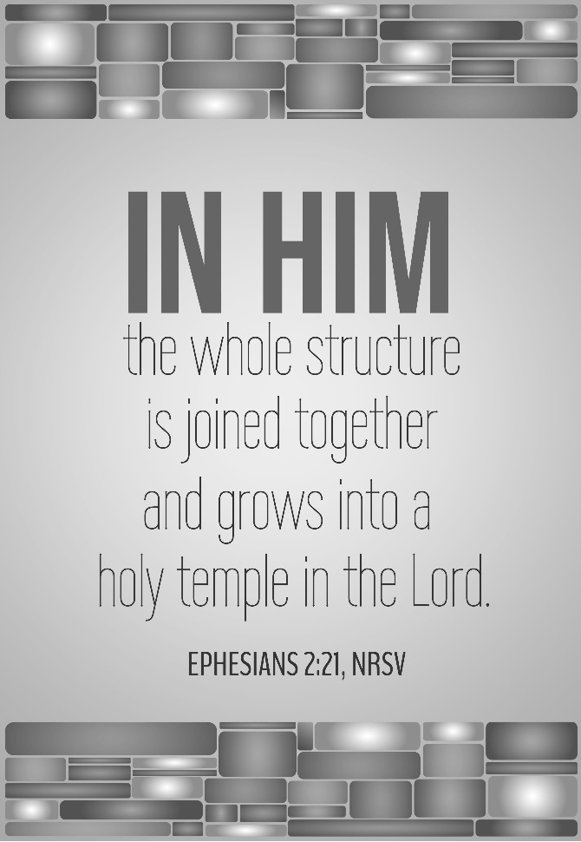

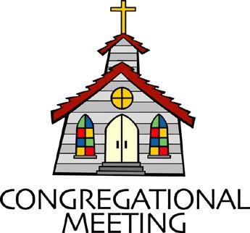
July 18, 2021 - 10:30 am

WELCOME VISITORS! We're glad you are here! Cards at the ends of each pew are for you to fill out and drop in the Offering Plate. Please let us know you are visiting, and join us for refreshments and fellowship following the service. The Sanctuary has an induction loop system to assist the hearing impaired. The system will also work on the telephone setting of hearing aids.

Springfield Presbyterian Church is rooted in the gospel of Jesus Christ, led by the Holy Spirit, and called to loving relationships through vibrant worship and service. Valuing all people, we are committed to developing disciples and fostering stewardship.
PREPARATION FOR THE WORD
(* those who are able are invited to stand)

PRELUDE

GATHERING OF THE PEOPLE

The Lord be with you! And also with you! (Greeting)

LIGHTING THE CHRIST CANDLE
Leader: Whenever we light this candle we proclaim:
People: Christ is the Light of the world and the center of our lives.

CALL TO WORSHIP [Psalm 47]
Leader: Clap your hands, all you peoples; shout to God with loud songs of joy.
People: For the Lord, the Most High, is awesome, a great king over all the earth.
Leader: He subdued peoples under us, and nations under our feet.
People: He chose our heritage for us, the pride of Jacob whom He loves.
Leader: God has gone up with a shout, the Lord with the sound of a trumpet.
People: Sing praises to God, sing praises; sing praises to our King, sing praises.
Leader: For God is the king of all the earth; sing praises with a psalm.
People: God is king over the nations; God sits on His holy throne.
Leader: The princes of the peoples gather as the people of the God of Abraham.
People: For the shields of the earth belong to God; He is highly exalted.
ALL: Let us praise our faithful and loving God!

* HYMN My Song Forever Shall Record #67

My song forever shall record the tender mercies of the Lord;
Your faithful love will I proclaim, and every age shall know your name.

I sing of mercies that endure, forever firm, forever sure,
A strong support that never dies, established changeless in the skies.

Almighty God, your lofty throne has justice for its cornerstone,
And shining bright before your face are truth and love and boundless grace.

With blessing is the nation crowned whose people know the joyful sound;
They in the light, O Lord, shall live, the light your face and favor give.

PRAYER OF CONFESSION
Generous God, you call us to live together in harmony, to trust in one another, and to offer grace upon grace. As the body of Christ, we are one people, of many abilities to be shared amongst the body. Help us when we forget the value of our siblings. Forgive us for not seeking mercy, grace, and unity with one another. Renew us again to your call, to be one people, in ministry and in faith. Amen.

SILENT PRAYERS OF CONFESSION

RESPONSE Spirit of the Living God
Spirit of the living God, fall afresh on me. Spirit of the living God, fall afresh on me. Melt me; mold me; fill me; use me. Spirit of the living God, fall afresh on me.

WORDS OF ASSURANCE [Isaiah 43:1, 19]
Leader: Do not fear, says the Lord, for I have redeemed you. I have called you by name; you are mine.
People: Beloved people of God, believe the good news: through the grace of Jesus Christ we are forgiven. Thanks be to God! Amen.

* MUSICAL RESPONSE OF PRAISE Great is Thy Faithfulness
Great is thy faithfulness! Great is thy faithfulness! Morning by morning, new mercies I see. All I have needed thy hand hath provided. Great is thy faithfulness, Lord unto me!

* THE PEACE The peace of Christ be with you! And also with you!
(You may greet those around you.)

* RESPONSE Here I Am, Lord
Here I am, Lord, Is it I, Lord? I have heard you calling in the night.
I will go, Lord, if you lead me. I will hold your people in my heart.

THE PROCLAMATION OF THE WORD

PRAYER OF ILLUMINATION
Guide us, O God, by your word and Spirit, that in your light we may see light, in your truth find freedom, and in your will discover your peace; through Jesus Christ our Lord. Amen.

FIRST SCRIPTURE LESSON Psalm 89:20-37
²⁰ I have found my servant David; with my holy oil I have anointed him;
²¹ my hand shall always remain with him; my arm also shall strengthen him. ²² The enemy shall not outwit him, the wicked shall not humble him. ²³ I will crush his foes before him and strike down those who hate him. ²⁴ My faithfulness and steadfast love shall be with him; and in my name his horn shall be exalted. ²⁵ I will set his hand on the sea and his
right hand on the rivers. ²⁶ He shall cry to me, “You are my Father, my God, and the Rock of my salvation!” ²⁷ I will make him the firstborn, the highest of the kings of the earth. ²⁸ For-ever I will keep my steadfast love for him, and my covenant with him will stand firm. ²⁹ I will establish his line for ever, and his throne as long as the heavens endure. ³⁰ If his children forsake my law and do not walk according to my ordinances,
³¹ if they violate my statutes and do not keep my commandments,
³² then I will punish their transgression with the rod and their iniquity with scourges; ³³ but I will not remove from him my steadfast love, or be false to my faithfulness. ³⁴ I will not violate my covenant, or alter the word that went forth from my lips. ³⁵ Once and for all I have sworn by my holiness; I will not lie to David. ³⁶ His line shall continue for ever, and his throne endure before me like the sun. ³⁷ It shall be established for ever like the moon, an enduring witness in the skies.’

SECOND SCRIPTURE LESSON Ephesians 2:11-22
¹¹So then, remember that at one time you Gentiles by birth, called ‘the uncircumcision’ by those who are called ‘the circumcision’—a physical circumcision made in the flesh by human hands— ¹²remember that you were at that time without Christ, being aliens from the commonwealth of Israel, and strangers to the covenants of promise, having no hope and without God in the world. ¹³But now in Christ Jesus you who once were far off have been brought near by the blood of Christ. ¹⁴For he is our peace; in his flesh he has made both groups into one and has broken down the dividing wall, that is, the hostility between us. ¹⁵He has abolished the law with its commandments and ordinances, so that he might create in himself one new humanity in place of the two, thus making peace, ¹⁶and might reconcile both groups to God in one body through the cross, thus putting to death that hostility through it. ¹⁷So he came and proclaimed peace to you who were far off and peace to those who were near; ¹⁸for through him both of us have access in one Spirit to the Father. ¹⁹So then you are no longer strangers and aliens, but you are citizens with the saints and also members of the household of God, ²⁰built upon the foundation of the apostles and prophets, with Christ Jesus himself as the cornerstone. ²¹In him the whole structure is joined together and grows into a holy temple in the Lord; ²²in whom you also are built together spiritually into a dwelling-place for God.

Leader: Hear what the Spirit is saying to the Church.
All: Thanks be to God.

SERMON Division Now United Rev. Becca Crate

THE RESPONSE TO THE WORD

* HYMN We Are One in the Spirit #300
We are one in the Spirit; we are one in the Lord;
We are one in the Spirit; we are one in the Lord,
And we pray that all unity may one day be restored:

Refrain:
And they’ll know we are Christians by our love, by our love,
Yes, they’ll know we are Christians by our love.

We will walk with each other; we will walk hand in hand;
We will walk with each other; we will walk hand in hand,
And together we’ll spread the news that God is in our land: Refrain

We will work with each other; we will work side by side;
We will work with each other; we will work side by side,
And we’ll guard human dignity and save human pride: Refrain

All praise to the Father, from whom all things come,
And all praise to Christ Jesus, God’s only Son,
And all praise to the Spirit, who makes us one: Refrain

PASTORAL PRAYER AND THE LORD’S PRAYER
“For this I pray to God.” / “For this I give thanks to God.”
Congregational Response: “Hear our prayer, O God.”

PRESENTATION OF TITHES AND OFFERINGS
OFFERTORY
* SONG OF THANKS For the Beauty of the Earth (refrain)
Lord of all, to thee we raise this our hymn of grateful praise.
* PRAYER OF DEDICATION

* HYMN Called as Partners in Christ’s Service
Called as partners in Christ’s service, called to ministries of grace,
We respond with deep commitment, fresh new lines of faith to trace.
May we learn the art of sharing, side by side and friend with friend,
Equal partners in our caring, to fulfill God’s chosen end.

Christ’s example, Christ’s inspiring, Christ’s clear call to work and worth,
Let us follow, never faltering, reconciling folk on earth.
Men and women, richer, poorer, all God’s people, young and old,
Blending human skills together, gracious gifts from God unfold.

Thus new patterns for Christ’s mission, in a small or global sense,
Help us bear each other’s burdens, breaking down each wall or fence.
Words of comfort, words of vision, words of challenge, said with care,
Bring new power and strength for action, make us colleagues, free and fair.

So God grant us for tomorrow, ways to order human life.
That surround each person’s sorrow, with a calm that conquers strife.
Make us partners in our living, our compassion to increase,
Messengers of faith, thus giving hope and confidence and peace.

* CHARGE AND BENEDICTION
Leader: As we learn to break down walls of division,
People: Let us first break down the walls that live in us.
Leader: Then as a renewed people,
People: Let us go from this place and seek unity.
Leader: So that the body of Christ is joined,
People: In peace and harmony. Amen.

* UNISON AMEN

POSTLUDE

Assisting in Worship: We appreciate those who serve:

Today 7/18 Next Week 7/25
Sunday Opener Ron Holmes Bob Rogers
Greeters & Ushers Amy Vasbinder & Cynthia Smith &
Bob Rogers Amy Vasbinder
Lay Leader Mark Kearney Don Vasbinder
Fellowship Linda Caviglia

Happy Birthday! July 21 – Ross Anderson
July 22 – Brian Spicer
July 24 – Becca Crate

Sunday July 25, 2021 Lectionary
2 Kings 4:42-44; Psalm 145:10-18; Ephesians 3:14-21; John 6:1-21

Announcements

Congregational Care / Mission & Outreach: The Congregational Care/Mission & Outreach Committee would like your help. As we emerge from this pandemic, there is a greater than usual need to make every effort to connect with one another. Do you know of a member or friend of our church family who is ill, needs prayers, would like call, a visit or a card, or might benefit from meal train? If so, please contact the Church Office (410-795-6152), Cathy Marsh (410-549-6916) or Diana Steppling (862-266-2242).

Memorial Information for Dorothy Schafer and Donald Clarke:
Friday, July 23 – visitation at Haight Funeral Home from 6-8 pm
Saturday, July 24 – private family only burial for Dorothy and Donald that morning
Saturday, July 24 – Memorial Service in Bishop’s Chapel at Fairhaven at 1:00 pm with reception there following

Ruth Gosnell Education Fund (RGEF) Committee is in need of a volunteer to serve on the committee. Meetings are quarterly. If you are interested, please see Amy Vasbinder.

Office Hours: Tuesday, Wednesday & Friday
Springfield Presbyterian Church

10:30 am Worship
11:30 am Fellowship
Website: www.springfield-church.org Church Office: 410-795-6152
Like us on Facebook: www.facebook.com/SpringfieldPresbyterianChurch
Pastor: Rev. Becca Crate
Email: springfieldpastor@gmail.com
Clerk of Session: Sharon Pappas
Minister of Music: Linda Caviglia
Accompanist: Aaron Thacker Organist: Jennifer Wise
Youth Group Coordinators: Charles & Deb Sperling
Sunday School Coordinator: Connie Robinson
Administrative Assistant: Donna Mazer e-mail: spc.office@verizon.net

