Springfield Presbyterian Church (USA)
7300 Spout Hill Road, Sykesville, MD 21784 410-795-6152
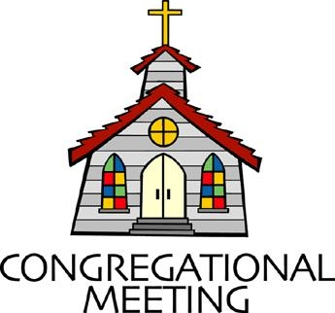

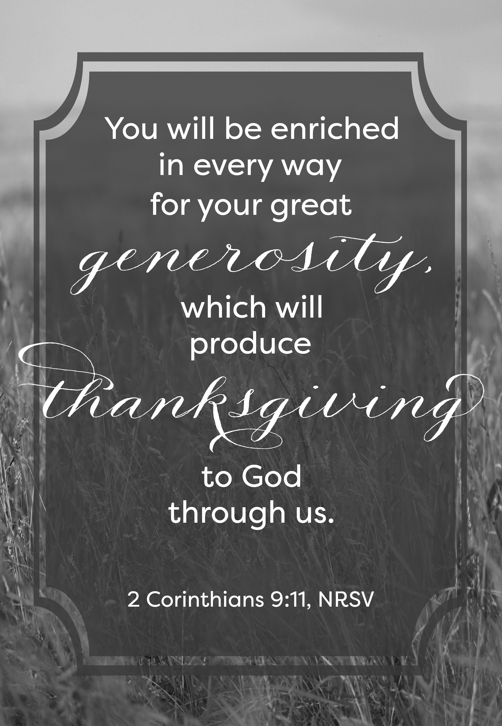

November 16, 2025 - 10:30 am

WELCOME VISITORS!

We're glad you are here! Cards at the ends of each pew are for you to fill out and drop in the Offering Plate. Please let us know you are visiting and join us for refreshments and fellowship following the service. The Sanctuary has an induction loop system to assist the hearing impaired. The system will also work on the telephone setting of hearing aids.

Springfield Presbyterian Church is rooted in the gospel of Jesus Christ, led by the Holy Spirit, and called to loving relationships through vibrant worship and service. Valuing all people, we are committed to developing disciples and fostering stewardship.

PREPARATION FOR THE WORD
(* those who are able are invited to stand)
PRELUDE

GATHERING OF THE PEOPLE

The Lord be with you! And also with you! (Greetings and Announcements)

LIGHTING THE CHRIST CANDLE
Leader: Whenever we light this candle we proclaim:
People: Christ is the Light of the world and the center of our lives.

CALL TO WORSHIP
Leader: The first frost has settled on the ground.
People: The grain has been gathered.
Leader: The leaves have fallen to the Earth.
People: The firewood huddles together, ready to warm our homes.
Leader: As the harvest season is upon us, we give thanks.
People: We give thanks to God, who has provided all we need to live and thrive.
Leader: We share gratitude with one another, as we help and serve.
People: We bless the gifts that have been gathered.
Leader: We, as a people of God, rejoice.
People: Let us come together and praise the God of this great harvest!

* HYMN Today We All Are Called to Be Disciples GTG #757

Today we all are called to be disciples of the Lord, to help to set the captive free, make plowshare out of sword, to feed the hungry, quench their thirst, make love and peace our fast, to serve the poor and homeless first, our ease and comfort last.

God made the world and at its birth ordained our human race to live as stewards of the earth, responding to God’s grace. But we are vain and sadly proud; we sow not peace but strife. Our discord spreads a deadly cloud that threatens all of life.

Pray justice may come rolling down as in a mighty stream, with righteousness in field and town to cleanse us and redeem. For God is longing to restore an earth where conflicts cease, a world that was created for a harmony of peace.

May we in service to our God act out the living word, and walk the road the saints have trod till all have seen and heard. As stewards of the earth may we give thanks in one accord to God who calls us all to be disciples of the Lord.

CALL TO CONFESSION
Leader: We come before God, acknowledging this time of harvest as one that is bountiful. We know that the Earth’s seasons shift, and the fall leaves have changed into beautiful hues of red and orange and yellow. Yet, we are immersed in our lives; we often overlook God’s creation as normal and move along. We have lost our sense of awe and wonder. We have lost a deep sense of gratitude. Let us lean into God’s invitation to see God at work within our world, as we confess our sin together:

PRAYER OF CONFESSION
Generous and Loving God, we forget your beauty, we neglect the awe you have provided us, simply by being a human on this Earth. You have shown us beauty in your ever-changing world, but we have been caught up in our own lives. We ask for your loving forgiveness, as we seek anew to be a grateful people. Help us to be people who stop and seek awe and wonder, and plant gratitude within us as we dwell in this harvest season. Amen.

SILENT PRAYERS OF CONFESSION

RESPONSE Remember Not, O God GTG #430 (v. 1)
Remember not, O God, the sins of long ago;
In tender mercy visit us, distressed and humbled low.

WORDS OF ASSURANCE
Leader: When we come before God and faithfully confess our sin, God is quick to redeem us and awake us again in the waters of baptism.

People: Thanks be to God whose love is constant, even in the changing of the seasons and God’s forgiveness that never fails. Amen.

* MUSICAL RESPONSE OF PRAISE How Great Thou Art (refrain only) #625
Then sings my soul, my Savior God, to thee:
How great thou art! How great thou art!
Then sings my soul, my Savior God, to thee:
How great thou art! How great thou art!

* THE PEACE The peace of Christ be with you! And also with you!
(You may greet those around you.)

* RESPONSE Here I Am, Lord GTG #69
Here I am, Lord. Is it I, Lord? I have heard you calling in the night.
I will go, Lord, if you lead me. I will hold your people in my heart.

THE PROCLAMATION OF THE WORD

PRAYER FOR ILLUMINATION
Loving God, you promised never to break your covenant with us. Amid all the changing words of our generation, speak your eternal Word that does not change. Enable us to respond to your gracious promises with faithful and obedient lives. Through Jesus Christ our Lord, Amen.

FIRST SCRIPTURE LESSON Proverbs 3:1-10, 21-31 OT page 553
My child, do not forget my teaching, but let your heart keep my commandments; ² for length of days and years of life and abundant welfare they will give you. ³ Do not let loyalty and faithfulness forsake you; bind them round your neck, write them on the tablet of your heart.
⁴ So you will find favor and good repute in the sight of God and of people. ⁵ Trust in the Lord with all your heart, and do not rely on your own insight. ⁶ In all your ways acknowledge him, and he will make straight your paths. ⁷ Do not be wise in your own eyes; fear the Lord, and turn away from evil. ⁸ It will be a healing for your flesh and a refreshment for your body. ⁹ Honor the Lord with your substance and with the first fruits of all your produce; ¹⁰ then your barns will be filled with plenty, and your vats will be bursting with wine. ²¹ My child, do not let these escape from your sight: keep sound wisdom and prudence,
²² and they will be life for your soul and adornment for your neck.
²³ Then you will walk on your way securely and your foot will not stumble. ²⁴ If you sit down, you will not be afraid; when you lie down, your sleep will be sweet. ²⁵ Do not be afraid of sudden panic, or of the storm that strikes the wicked; ²⁶ for the Lord will be your confidence and will keep your foot from being caught. ²⁷ Do not withhold good from those to whom it is due, when it is in your power to do it. ²⁸ Do not say to your neighbor, ‘Go, and come again; tomorrow I will give it’—when you have it with you. ²⁹ Do not plan harm against your neighbor who lives trustingly beside you. ³⁰ Do not quarrel with anyone without cause, when no harm has been done to you. ³¹ Do not envy the violent and do not choose any of their ways.

SECOND SCRIPTURE LESSON 2 Corinthians 9 NT page 172
Now it is not necessary for me to write to you about the ministry to the saints, ²for I know your eagerness, which is the subject of my boasting about you to the people of Macedonia, saying that Achaia has been ready since last year; and your zeal has stirred up most of them. ³But I am sending the brothers in order that our boasting about you may not prove to have been empty in this case, so that you may be ready, as I said you would be; ⁴otherwise, if some Macedonians come with me and find that you are not ready, we would be humiliated—to say nothing of you—in this undertaking. ⁵So I thought it necessary to urge the brothers to go on ahead to you, and arrange in advance for this bountiful gift that you have promised, so that it may be ready as a voluntary gift and not as an extortion. ⁶The point is this: the one who sows sparingly will also reap sparingly, and the one who sows bountifully will also reap bountifully. ⁷Each of you must give as you have made up your mind, not reluctantly or under compulsion, for God loves a cheerful giver. ⁸And God is able to provide you with every blessing in abundance, so that by always having enough of everything, you may share abundantly in every good work. ⁹As it is written, ‘He scatters abroad, he gives to the poor; his righteousness endures for ever.’ ¹⁰He who supplies seed to the sower and bread for food will supply and multiply your seed for sowing and increase the harvest of your righteousness. ¹¹You will be enriched in every way for your great generosity, which will produce thanksgiving to God through us; ¹²for the rendering of this ministry not only supplies the needs of the saints but also overflows with many thanksgivings to God. ¹³Through the testing of this ministry you glorify God by your obedience to the confession of the gospel of Christ and by the generosity of your sharing with them and with all others, ¹⁴while they long for you and pray for you because of the surpassing grace of God that he has given you. ¹⁵Thanks be to God for his indescribable gift!

Leader: Hear what the Spirit is saying to the Church.
All: Thanks be to God.

SERMON The Future By Bob Steppling

THE RESPONSE TO THE WORD

* HYMN Take Thou Our Minds, Dear Lord GTG #707

Take thou our minds, dear Lord, we humbly pray;
Give us the mind of Christ each passing day;
Teach us to know the truth that sets us free;
Grant us in all our thoughts to honor thee.

Take thou our hearts, O Christ; they are thine own;
Come thou within our souls and claim thy throne;
Help us to shed abroad thy deathless love;
Use us to make the earth like heaven above.

Take thou our wills, Most High! Hold thou full sway;
Have in our inmost souls thy perfect way;
Guard thou each sacred hour from selfish ease;
Guide thou our ordered lives as thou dost please.

Take thou ourselves, O Lord, heart, mind, and will;
Through our surrendered souls thy plans fulfill.
We yield ourselves to thee: time, talents, all;
We hear, and henceforth heed, thy sovereign call.

PASTORAL PRAYER AND THE LORD’S PRAYER

PRESENTATION OF TITHES AND OFFERINGS
OFFERTORY Surrender By Heather Sorenson (see lyrics on last page)
* SONG OF THANKS We Give Thee but Thine Own GTG #708 (v. 1)
We give thee but thine own, what-e’er the gift may be;
All that we have is thine alone, a trust, O Lord, from thee.
* PRAYER OF DEDICATION

* HYMN As Those of Old Their Firstfruits Brought GTG #712

As those of old their first-fruits brought of vineyard, flock, and field
To God, the giver of all good, the source of bounteous yield,
So we today our first-fruits bring, the wealth of this good land:
Of farm and market, shop and home, of mind and heart and hand.

A world in need now summons us to labor, love, and give,
To make our life an offering that all may truly live.
The church of Christ is calling us to make the dream come true:
A world redeemed by Christ-like love, all life in Christ made new.

In gratitude and humble trust we bring our best today,
To serve your cause and share your love with all along life’s way.
O God who gave yourself to us in Jesus Christ your Son,
Help us to give ourselves each day until life's work is done.

* CHARGE AND BENEDICTION
Leader: For this plentiful harvest,
People: We give our thanks and praise.
Leader: We bless all the gifts that have come before us,
People: And keep our eyes and hearts wide open to be in awe and wonder.
Leader: And as we go from this place,
People: We take these gifts, moved by the Spirit, and use them to serve God in our community and beyond. Amen.

* UNISON AMEN

POSTLUDE

Sunday November 23, 2025 Lectionary
Jeremiah 23:1-6; Psalm 46; Colossians 1:11-20; Luke 23:33-43

Assisting in Worship: We appreciate those who serve:

Today 11/16 Next Week 11/23
Sunday Opener: Barbara Cornell Ron Holmes
Ushers/Greeters: Sharon Pappas Steve & Donna Mazer
Elizabeth Meirowitz
Lay Leader: Linda Caviglia Don Vasbinder
Pulpit Supply: Bob Steppling Rev. Michele Wallen
Fellowship Hosts: Potluck Luncheon Belle & Don Vasbinder
Offering Count: Andrea Kwako & Linda C. Andrea Kwako & Sharon
Happy Anniversary! November 17 – Shona & Albert Klein

Happy Birthday! November 20 – Cathy White

Announcements

Congregational Meeting: The Session has called a congregational meeting TODAY after worship to vote on the Dissolution of the Pastoral Relationship with Pastor Becca and that Dissolution Agreement. Copies of those documents will be available at the meeting for you to see and will be visible on Zoom. We will include a time for clarifying questions. Members must be present, in the Sanctuary or on Zoom, to vote.

TODAY is Stewardship Sunday. After the Congregational Meeting, we will celebrate with a special fellowship time featuring a potluck luncheon!

It’s Time to Order Christmas Flowers! Attached is the Christmas flower order form. Orders are due by November 18. Extra order forms are available in the Narthex.
Zoom Link for Worship Services: The Zoom link for church services is on the SPC website, not on the Facebook page. The Bulletin is also available on the website as well.

Collecting Pill Bottles: Have you wondered what's the best way to recycle/re-purpose plastic pill bottles? An organization called Matthew 25: Ministries (m25m.org) collects them to send along with donations of medical supplies.
We will have a collection box at Fellowship for several weeks or until we fill it up!
~ Thanks, Barbara Cornell

Congregational Care: If you know of someone who would benefit from a card or a phone call, please text or call Connie Gibbons at 410-935-3467.


Electronic Giving: Here is a QR code you can scan to make your contribution a new way! The page you get will ask for your name, e-mail and phone number. You can choose from a dropdown menu for selecting where the donation should go: General Fund, Capital Fund, Concert, Memorial. There is a fee for using a credit card, and you will be given the option to pay that fee along with your donation, but you don’t have to include it if you don’t want to.

Today:
Sunday November 16
10:30 am Worship
11:30 am Called Congregational Meeting
12:00 noon Potluck Luncheon

This Week:
Tuesday November 18
7:00 pm CoCaMO Meeting (Manse)
Wednesday November 19
6:15 – 7:15 pm Bell Choir Proactice
7:30 – 8:45 pm Adult Choir Practice
Saturday November 22
7:00 pm Family Game Night (Fellowship Room)

Next Week:
Sunday November 23
10:30 am Worship
11:30 am Fellowship
Wednesday November 26
No Bell Choir or Adult Choir Practice

Surrender By Heather Sorenson

Take my life and let it be an offering unto Thee, an offering for my King.
Take my gifts and let them be the light of Christ for all to see.

Take my sickness and my health, my poverty and wealth, and use them for Thy good.
Take my brokenness and pain; receive them as my tithe for heaven’s gain.

Take my hands, unclench my fist holding dreams that I insist are mine alone to keep.
Take the failures I confess; redeem them to Thy righteousness.

Take these objects I possess, trite measures of success, given me on loan.
Take the dwelling that I own, and remind me that Thou are my home.

Take my wounds that never healed, Thy lavish mercy to reveal.
Take desires not yet fulfilled and align them to Thy will.

Take my life and let it be an offering to Thee, an offering for my King.
Take my gifts and let them be the light of Christ for all to see.

Take this song to fill Thy heart, my praise through humble art, a melody of love.
Take my accolades and fame. Take any honor I might claim, and shine them back on Jesus’ name.

Office Hours: Tuesday, Wednesday, Friday, 10 am – 3 pm

Springfield Presbyterian Church
10:30 am Worship (and Sunday School 1st & 3rd Sundays)
11:30 am Fellowship
Website: www.springfield-church.org Church Office: 410-795-6152
Like us on Facebook: www.facebook.com/SpringfieldPresbyterianChurch
Pastor: Rev. Becca Crate
Email: springfieldpastor@gmail.com
Clerk of Session: Sharon Pappas
Minister of Music/Accompanist: Aaron Thacker
Bell Choir Director: Vacant
Youth Group Coordinator: Dylan Vasbinder
Administrative Assistant: Donna Mazer Email: spc.office@verizon.net

