(Large Print)

Springfield Presbyterian Church (USA)
7300 Spout Hill Road, Sykesville, MD 21784 410-795-6152

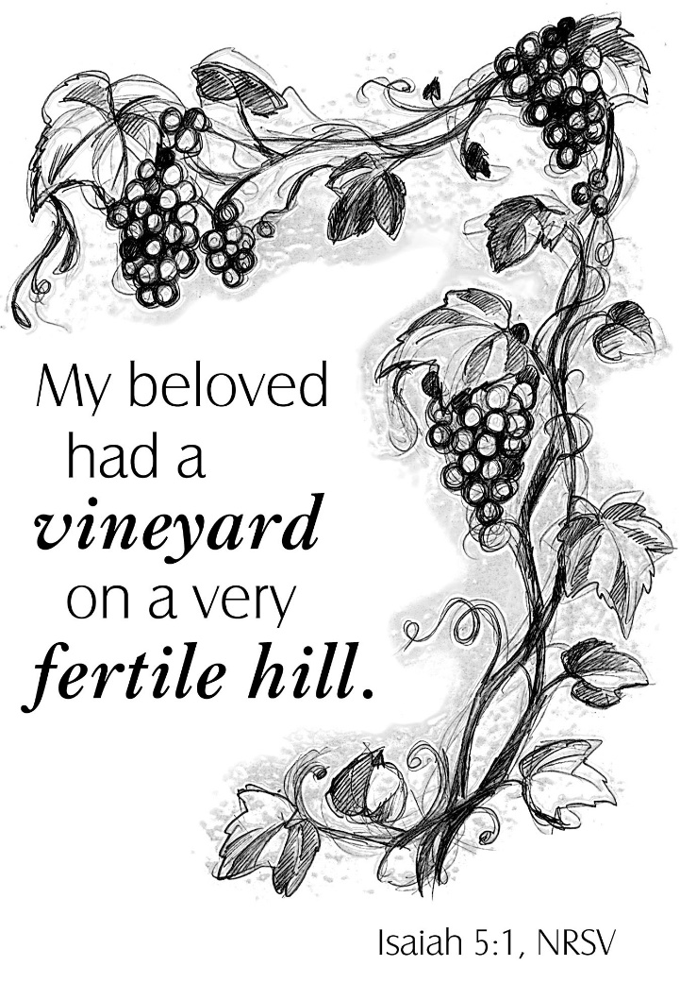

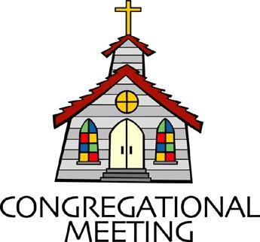
August 14, 2022 - 10:30 am

WELCOME VISITORS!
We're glad you are here! Cards at the ends of each pew are for you to fill out and drop in the Offering Plate. Please let us know you are visiting, and join us for refreshments and fellowship following the service. The Sanctuary has an induction loop system to assist the hearing impaired. The system will also work on the telephone setting of hearing aids.

Springfield Presbyterian Church is rooted in the gospel of Jesus Christ, led by the Holy Spirit, and called to loving relationships through vibrant worship and service. Valuing all people, we are committed to developing disciples and fostering stewardship.
PREPARATION FOR THE WORD
(* those who are able are invited to stand)

PRELUDE

GATHERING OF THE PEOPLE

The Lord be with you! And also with you! (Greeting)

LIGHTING THE CHRIST CANDLE
Leader: Whenever we light this candle we proclaim:
People: Christ is the Light of the world and the center of our lives.

CALL TO WORSHIP
Leader: You are the vine,
People: And we are the branches.
Leader: So we come before the Creator of all,
People: In humility, praise, and longing.
Leader: As we worship,
People: Teach us again what it means to be your faithful disciples.
Leader: As we raise our voices to sing,
People: May the words magnify your vision for this world.
Leader: As we pray together,
People: Lead us as we grow closer to you and to one another.
Leader: May the vine and branch intertwine,
People: As we come and worship your holy name. Amen.

* HYMN I Sing the Mighty Power of God GTG #32

I sing the mighty power of God that made the mountains rise,
That spread the flowing seas abroad and built the lofty skies.
I sing the wisdom that ordained the sun to rule the day.
The moon shines full at God's command, and all the stars obey.

I sing the goodness of the Lord who filled the earth with food.
God formed the creatures through the Word, and then pronounced them good.
Lord, how thy wonders are displayed, where'er I turn my eye,
If I survey the ground I tread, or gaze upon the sky!

There's not a plant or flower below but makes thy glories known.
And clouds arise, and tempests blow, by order from thy throne,
While all that borrows life from thee is ever in thy care,
And everywhere that we can be, thou, God, art present there.

CALL TO CONFESSION
Leader: There are many metaphors of the relationship between God and humans and this morning we explore the vineyard. In these texts, we know that our power, growth, and energy to grow and be fruitful come from God. As we think about this metaphor, let us come together and atone for the ways in which we have failed to be part of this covenant vineyard.

PRAYER OF CONFESSION
Generous God, we know that you are the vine and we are the branches. We declare that all goodness comes from you, and you alone. Yet we do not make time in our lives for growth. We find ways to outsource our work as disciples so that we do not need to engage in the hard work of being tilled and harvested. We do not submit to your power, and in all these ways, we have fallen short of your glory. In your power, forgive us, for we have sinned, and in your mercy, restore us once again to be the people you call us to be. Amen.

SILENT PRAYERS OF CONFESSION

RESPONSE The Woman Hiding in the Crowd Tune #178
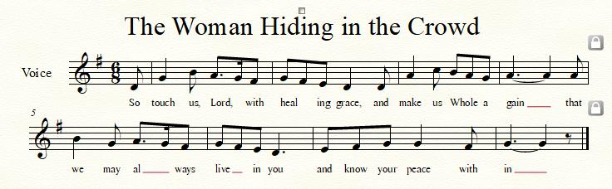

WORDS OF ASSURANCE [Isa. 43:1, 19]
Leader: Do not fear, says the Lord, for I have redeemed you. I have called you by name; you are mine.
People: God is doing a new thing; now it springs forth! By the grace of Jesus Christ, we are forgiven, forgiven indeed! Alleluia and amen!

* MUSICAL RESPONSE OF PRAISE O My Soul, Bless Your Redeemer
Bless your Maker, all you creatures, ever under God’s control,
All throughout God’s vast dominion; bless the Lord of all, my soul!

* THE PEACE The peace of Christ be with you! And also with you!
(You may greet those around you.)

* RESPONSE Here I Am, Lord
Here I am, Lord, Is it I, Lord? I have heard you calling in the night.
I will go, Lord, if you lead me. I will hold your people in my heart.

THE PROCLAMATION OF THE WORD

PRAYER OF ILLUMINATION
Loving God, you are the fountain of every blessing. We ask that you open unto us your life-giving word, and fill us with your Holy Spirit, so that living water may flow through our hearts – a spring of hope for a thirsty world; through Jesus Christ our Lord. Amen.

FIRST SCRIPTURE LESSON Isaiah 5:1-7
Let me sing for my beloved my love-song concerning his vineyard: My beloved had a vineyard on a very fertile hill. ² He dug it and cleared it of stones, and planted it with choice vines; he built a watch-tower in the midst of it, and hewed out a wine vat in it; he expected it to yield grapes, but it yielded wild grapes. ³ And now, inhabitants of Jerusalem and people of Judah, judge between me and my vineyard. ⁴ What more was there to do for my vineyard that I have not done in it? When I expected it to yield grapes, why did it yield wild grapes? ⁵ And now I will tell you what I will do to my vineyard. I will remove its hedge, and it shall be devoured; I will break down its wall, and it shall be trampled down. ⁶ I will make it a waste; it shall not be pruned or hoed, and it shall be overgrown with briers and thorns; I will also command the clouds that they rain no rain upon it. ⁷ For the vineyard of the Lord of hosts is the house of Israel, and the people of Judah are his pleasant planting;
he expected justice, but saw bloodshed; righteousness, but heard a cry!

SECOND SCRIPTURE LESSON Psalm 80:1-2, 8-19
¹ Give ear, O Shepherd of Israel, you who lead Joseph like a flock! You who are enthroned upon the cherubim, shine forth ² before Ephraim and Benjamin and Manasseh. Stir up your might, and come to save us!
⁸ You brought a vine out of Egypt; you drove out the nations and planted it. ⁹ You cleared the ground for it; it took deep root and filled the land. ¹⁰ The mountains were covered with its shade, the mighty cedars with its branches; ¹¹ it sent out its branches to the sea, and its shoots to the River. ¹² Why then have you broken down its walls, so that all who pass along the way pluck its fruit? ¹³ The boar from the forest ravages it, and all that move in the field feed on it. ¹⁴ Turn again, O God of hosts; look down from heaven, and see; have regard for this vine,
¹⁵ the stock that your right hand planted. ¹⁶ They have burned it with fire, they have cut it down; may they perish at the rebuke of your countenance. ¹⁷ But let your hand be upon the one at your right hand, the one whom you made strong for yourself. ¹⁸ Then we will never turn back from you; give us life, and we will call on your name. ¹⁹ Restore us, O Lord God of hosts; let your face shine, that we may be saved.

Leader: Hear what the Spirit is saying to the Church.
All: Thanks be to God.

SERMON A Parched Vineyard Rev. Becca Crate-Price

THE RESPONSE TO THE WORD

* HYMN Great Is Thy Faithfulness GTG #39

Great is thy faithfulness, O God my Father;
there is no shadow of turning with thee.
Thou changest not; thy compassions they fail not.
As thou hast been thou forever wilt be.

Refrain:
Great is thy faithfulness!
Great is thy faithfulness!
Morning by morning, new mercies I see.
All I have needed thy hand hath provided.
Great is thy faithfulness, Lord unto me!

Summer and winter, and springtime and harvest,
sun, moon, and stars in their courses above
join with all nature in manifold witness
to thy great faithfulness, mercy, and love. [Refrain]

Pardon for sin and a peace that endureth,
thine own dear presence to cheer and to guide,
strength for today and bright hope for tomorrow:
blessings all mine, with ten thousand beside! [Refrain]

PASTORAL PRAYER AND THE LORD’S PRAYER

OFFERTORY
SONG OF THANKS As Those of Old Their Firstfruits Brought #712
In gratitude and humble trust we bring our best today, to serve your cause and share your love with all along life’s way. O God who gave yourself to us in Jesus Christ your Son, help us to give ourselves each day until life’s work is done.
PRAYER OF DEDICATION

* HYMN There’s a Wideness in God’s Mercy GTG #435

There’s a wideness in God’s mercy, like the wideness of the sea.
There’s a kindness in God’s justice, which is more than liberty.
There is no place where earth’s sorrows are more felt that up in heaven.
There is no place where earth’s failings have such kindly judgment given.

For the love of God is broader than the measures of the mind.
And the heart of the Eternal is most wonderfully kind.
If our love were but more faithful, we would gladly trust God’s Word,
And our lives reflect thanksgiving for the goodness of our Lord.

* CHARGE AND BENEDICTION
Leader: As we go from this place,
People: Let your light shine upon us.
Leader: Make us people of growth,
People: Seeking your wisdom as we stretch beyond ourselves.
Leader: And lead us out into the heat of the summer day,
People: Ready for the great harvest that only you provide. Amen.

* UNISON AMEN

POSTLUDE

Sunday, August 21 2022 Lectionary
Isaiah 58:9b-14; Psalm 103:1-8; Hebrews 12:18-29; Luke 13:10-17

Assisting in Worship: We appreciate those who serve:

Today 8/14 Next Week 8/21
Sunday Opener Ron Holmes Bob Rogers
Ushers/Greeters Don Vasbinder & Tim & Beth
Bob Rogers Oates
Lay Leader Tony Caviglia Christy Yeager

Happy Anniversary! August 16 – Connie & Craig Robinson

Happy Birthday! August 16 – Kari Anderson
August 19 – Madelyn McClung

Announcements

Concert Today: Join us TODAY at 3:00 pm when we will present The Satyr Hill Band. Although primarily a bluegrass band, they play a variety of music and styles which include bluegrass, new grass (as in Revival), progressive, acoustic country and rock & roll, as well as innovative originals. An ice cream social will follow. Bring your family and friends!
Mask Update: Due to the uptick in COVID-19 cases, the Session has decided to strongly encourage masking and social distancing. Though it is not a mandate, we seek to love one another by keeping each other as safe as possible. Thank you for your help in this endeavor.
Sunday School is back! On the 1st and 3rd Sundays of the month, we will be offering Sunday School! See Pastor Becca for details…

Summer Mission Project: It won’t be long before school starts again. Preparing for a new school year includes buying items on the STUDENT SUPPLY LIST. For some children and their families, this can be a challenge and in some instances buying needed supplies just isn’t possible. For that reason, during July and August, we will be collecting school supplies to help these children. The GIVING TREE is in the Narthex. If you would like to help with this project, you can take a tag from the tree and buy the item written on it or simply choose from the below items (taken from Sykesville Middle School STUDENT SUPPLY LIST). Please place your donated items in the designated basket in the Narthex. Thank you! ~ CoCaMO Committee

3-ring binders-1, 1 ½ or 2” Pencil pouch Glue sticks
Loose-leaf paper Pack of #2 pencils Pair of Ear Buds
Pack of 5-tab binder dividers Pocket folders Scissors
Blue, black or red pens Block or cap erasers Sticky notes
3X5 ruled index cards Dry erase markers Crayons
Folders with brads 10-pack colored pencils
Spiral notebook-200 pgs. Pencil sharpener
Multi-colored highlighters Composition book

Pastor-Parish Committee: The Pastor-Parish Committee invites you to share your concerns, suggestions, and gratitude. We have a form in the Narthex and a lock-box that we will open weekly and we ask that you share your name and be specific. We look forward to reading your comments so that we can continue to grow into the body of Christ.

Springfield Membership: Are you interested in finding out more about our faith community and becoming a member? We would love to answer any questions you have. Please contact Pastor Becca at springfieldpastor@gmail.com for more information.

Congregational Care / Mission & Outreach: Do you know of a member or friend of our church family who is ill, needs prayers, would like call, a visit or a card, or might benefit from meal train? If so, please contact the Church Office (410-795-6152), Cathy Marsh (410-549-6916) or Diana Steppling (862-266-2242).

Fellowship Help Needed: If you are interested in helping with Fellowship, please contact Barbara Cornell (240-308-0035). A sign-up sheet will also be available.

Today:
Sunday August 14
10:30 am Worship
11:30 am Fellowship
3:00 pm Concert & Ice Cream Social

This Week:
Thursday August 18
7:00 pm Session Meeting

Looking Ahead:
Sunday August 21
10:30 am Worship
11:30 am Fellowship

Office Hours: Tuesday, Wednesday & Friday
Springfield Presbyterian Church

10:30 am Worship
11:30 am Fellowship
Website: www.springfield-church.org Church Office: 410-795-6152
Like us on Facebook: www.facebook.com/SpringfieldPresbyterianChurch
Pastor: Rev. Becca Crate-Price
Email: springfieldpastor@gmail.com
Clerk of Session: Sharon Pappas
Minister of Music: Linda Caviglia
Accompanist/Organist: Aaron Thacker
Youth Group Coordinator: Dylan Vasbinder
Administrative Assistant: Donna Mazer e-mail: spc.office@verizon.net

