(Large Print)

Springfield Presbyterian Church (USA)
7300 Spout Hill Road, Sykesville, MD 21784 410-795-6152

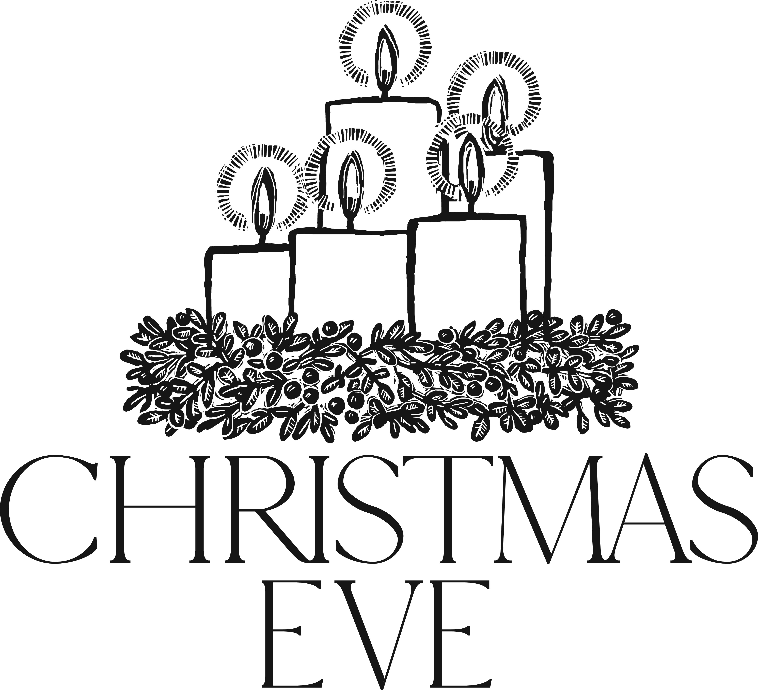

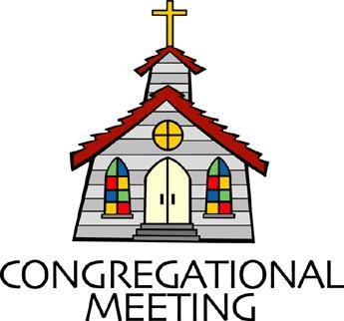
December 24, 2018 - 8:00 pm

WELCOME VISITORS! We're glad you are here! Cards at the ends of each pew are for you to fill out and drop in the Offering Plate. Please let us know you are visiting, and join us for refreshments and fellowship following the service. The Sanctuary has an induction loop system to assist the hearing impaired. The system will also work on the telephone setting of hearing aids.

Springfield Presbyterian Church is rooted in the gospel of Jesus Christ, led by the Holy Spirit, and called to loving relationships through vibrant worship and service. Valuing all people, we are committed to developing disciples and fostering stewardship.
PREPARATION FOR THE WORD
(* those who are able are invited to stand)

Please prepare for worship by listening to the music of the Prelude.

PRELUDE Come and Worship Medley arr. Clydesdale

Now is Born the Divine Christ Child arr. Kevin McChesney

See Amid the Winter’s Snow by Alan Lohr

I Wonder as I Wander Aaron Thacker, Vocals

Go, Tell It On the Mountain

GATHERING OF THE PEOPLE

The Lord be with you! And also with you! (Greeting)

ADVENT CANDLE LIGHTING
Advent Reading Christmas Eve [Luke 2:10-11]
Tonight we hear the Good News that Jesus Christ has come to Earth to be our hope and our salvation. We hear the timeless words, “I am bringing you good news of great joy for all the people: to you is born this day in the city of David, a Savior, who is the Messiah, the Lord.”

Lighting of the Candle
In our watching and waiting, we welcome the source of our hope, joy, peace, and love – Jesus Christ – into the world. May this light radiate not only tonight, but in our hearts, forevermore.

Congregation joins choir in singing: Infant Holy, Infant Lowly
Flocks were sleeping; shepherds keeping vigil till the morning new,
Saw the glory, heard the story, tidings of the gospel true.
Thus rejoicing, free from sorrow, praises voicing greet the morrow;
Christ the babe was born for you! Christ the babe was born for you!

CALL TO WORSHIP [Adapted from Psalm 96]
Leader: O sing to the Lord a new song; sing to the Lord, all the earth!
People: For great is the Lord, and greatly to be praised!
Leader: Honor and majesty are before Him; strength and beauty are in His sanctuary.
People: Ascribe to the Lord the glory due His name; bring an offering and come into His courts.
Leader: Worship the Lord in holy splendor!
People: The Lord is coming!
ALL: Let us worship Him, all the earth!

* HYMN: Good Christian Friends, Rejoice
Good Christian friends, rejoice, with heart and soul and voice;
give ye heed to what we say: Jesus Christ is born today;
Ox and ass before him bow, and he is in the manger now.
Christ is born today! Christ is born today!

Good Christian friends, rejoice, with heart and soul and voice;
Now ye hear of endless bliss: Jesus Christ was born for this!
He has opened heaven’s door, and we are blest forevermore.
Christ was born for this! Christ was born for this!

Good Christian friends, rejoice, with heart and soul and voice;
Now ye need not fear the grave: Jesus Christ was born to save!
Calls you one and calls you all, to gain the everlasting hall.
Christ was born to save! Christ was born to save!

PRAYER OF CONFESSION
God of grace and truth, in Jesus Christ you came among us as light shining in the darkness. We confess that we have not welcomed the light, or trusted good news to be good. We have closed our eyes to glory in our midst, expecting little, and hoping for less. Forgive our doubt, and renew our hope, so that we may receive the fullness of your grace, and live in the truth of Christ our Lord. Amen.

SILENT PRAYERS OF CONFESSION

RESPONSE O Little Town of Bethlehem (verse 3) GTG Tune #121
How silently, how silently, the wondrous gift is given!
So God imparts to human hearts the blessings of His heaven.
No ear may hear His coming, but in this world of sin,
Where meek souls will receive Him, still the dear Christ enters in.

WORDS OF ASSURANCE
Leader: Christ our Savior gave Himself for us, that He might redeem us from our sin and claim us as His own people.
People: In the name of Jesus Christ, we are forgiven! Amen!

* MUSICAL RESPONSE OF PRAISE Angels, from the Realms of Glory
All creation, join in praising God the Father, Spirit, Son,
Ever more your voices raising to the eternal Three in One:
Come and worship, come and worship, worship Christ the newborn King!

* THE PEACE The peace of Christ be with you! And also with you!

* RESPONSE Here I Am, Lord (refrain) Tune #69
Here I am, Lord, Is it I, Lord? I have heard you calling in the night.
I will go, Lord, if you lead me. I will hold your people in my heart.

THE PROCLAMATION OF THE WORD

PRAYER OF ILLUMINATION
Gracious God, by the gift of your Holy Spirit show us the Word made flesh – good news of great joy for all – so that we may sing with the angels: glory in the highest and peace on earth; through Jesus Christ our Lord. Amen.

FIRST SCRIPTURE LESSON Isaiah 9:2-7
² The people who walked in darkness have seen a great light; those who lived in a land of deep darkness—on them light has shined. ³ You have multiplied the nation, you have increased its joy; they rejoice before you as with joy at the harvest, as people exult when dividing plunder. ⁴ For the yoke of their burden, and the bar across their shoulders, the rod of their oppressor, you have broken as on the day of Midian. ⁵ For all the boots of the tramping warriors and all the garments rolled in blood shall be burned as fuel for the fire. ⁶ For a child has been born for us, a son given to us; authority rests upon his shoulders; and he is named Wonderful Counsellor, Mighty God, Everlasting Father, Prince of Peace. ⁷ His authority shall grow continually, and there shall be endless peace for the throne of David and his kingdom. He will establish and uphold it with justice and with righteousness from this time onwards and for evermore. The zeal of the Lord of hosts will do this.

SECOND SCRIPTURE LESSON Luke 2:1-14
In those days a decree went out from Emperor Augustus that all the world should be registered. ²This was the first registration and was taken while Quirinius was governor of Syria. ³All went to their own towns to be registered. ⁴Joseph also went from the town of Nazareth in Galilee to Judea, to the city of David called Bethlehem, because he was descended from the house and family of David. ⁵He went to be registered with Mary, to whom he was engaged and who was expecting a child. ⁶While they were there, the time came for her to deliver her child. ⁷And she gave birth to her firstborn son and wrapped him in bands of cloth, and laid him in a manger, because there was no place for them in the inn. ⁸In that region there were shepherds living in the fields, keeping watch over their flock by night. ⁹Then an angel of the Lord stood before them, and the glory of the Lord shone around them, and they were terrified. ¹⁰But the angel said to them, ‘Do not be afraid; for see—I am bringing you good news of great joy for all the people: ¹¹to you is born this day in the city of David a Savior, who is the Messiah, the Lord. ¹²This will be a sign for you: you will find a child wrapped in bands of cloth and lying in a manger.’ ¹³And suddenly there was with the angel a multitude of the heavenly host, praising God and saying, ¹⁴ ‘Glory to God in the highest heaven, and on earth peace among those whom he favors!’
Leader: Hear what the Spirit is saying to the church.
All: Thanks be to God.

SPECIAL MUSIC Cradle Carol arr. Victor C. Johnson

TIME WITH YOUNG PEOPLE

SERMON: A Light in the Darkness Rev. Becca Crate

THE RESPONSE TO THE WORD

* HYMN: Hark! The Herald Angels Sing
Hark! The herald angels sing, “Glory to the newborn king.
Peace on earth and mercy mild, God and sinners reconciled!”
Joyful all ye nations, rise; join the triumph of the skies;
With the angelic host proclaim, “Christ is born in Bethlehem!”
Hark! The herald angels sing, “Glory to the newborn king!”

Christ, by highest heaven adored, Christ the everlasting Lord,
Late in time behold him come, offspring of the virgin’s womb.
Veiled in flesh the Godhead see; hail the incarnate deity,
Pleased in flesh with us to dwell, Jesus, our Emmanuel.
Hark! The herald angels sing, “Glory to the newborn king!”

Hail the heaven-born Prince of Peace! Hail the sun of righteousness!
Light and life to all he brings, risen with healing in his wings.
Mild he lays his glory by, born that we no more may die,
Born to raise us from the earth, born to give us second birth.
Hark! The herald angels sing, “Glory to the newborn king!”

PRESENTATION OF TITHES AND OFFERINGS
OFFERTORY Minuet Noel arr. Jean Anne Shafferman
* SONG OF THANKS: As with Gladness Men of Old
As they offered gifts most rare, at the manger rude and bare;
So may we with holy joy, pure, and free from sin’s alloy.
All our costliest treasures bring, Christ, to Thee, our heavenly King.
* PRAYER OF DEDICATION

THE SACRAMENT OF HOLY COMMUNION

INVITATION
Leader: A child is born for us in Bethlehem, wrapped in bands of cloth and lying in a manger;
People: He will be our Shepherd, feeding His flock in the strength of the Lord.

THE GREAT PRAYER OF THANKSGIVING
Leader: The Lord be with you.
People: And also with you.
Leader: Lift up your hearts.

People: We lift them up to the Lord.
Leader: Let us give thanks to the Lord our God.
People: It is right to give our thanks and praise.

[The Pastor continues… “…who forever sing to the glory of your name.”]

IN PRAISE OF GOD
Holy, holy, holy, Lord, God of Power and might.
Heaven and earth are full of your glory, Hosanna in the highest!
Blessed is He who comes in the name of the Lord.
Hosanna in the highest, hosanna in the highest.

[The Pastor continues… “…dedicated to your service.”]

IN PRAISE OF CHRIST
Dying, you destroyed our death; rising, you restored our life.
Lord Jesus, come in glory.

PASTORAL PRAYER AND THE LORD’S PRAYER
“For this I pray to God.” / “For this I give thanks to God.”
Congregational Response: “Hear our prayer, O God.”

WORDS OF INSTITUTION

SHARING OF THE MEAL

PRAYER OF DEDICATION (Unison)
God of grace and peace, as you have shared your life with us through the child in the manger and this simple meal together, let us share your life with others as the body of Christ in the world; Amen.

* HYMN: Silent Night

Silent night, holy night! All is calm, all is bright
’Round yon virgin mother and child! Holy Infant, so tender and mild,
Sleep in heavenly peace, sleep in heavenly peace.

Silent night, holy night! Shepherds quake at the sight;
Glories stream from heaven afar, heavenly hosts sing “Alleluia:
Christ the Savior is born; Christ the Savior is born!”

Silent night, holy night! Son of God, love’s pure light
Radiant beams from thy holy face, with the dawn of redeeming grace,
Jesus, Lord, at thy birth, Jesus, Lord, at thy birth.

Silent night, holy night! Wondrous star, lend thy light;
With the angels let us sing Alleluia to our King:
Christ the Savior is born; Christ the Savior is born.

* LIGHTING THE CANDLES
The candle lighting will take place during the singing of Silent Night.

* PRAYER OF THANKSGIVING (extinguishing the candles)

* CLOSING HYMN: Still, Still, Still

Still, still, still, he sleeps this night so chill!
The virgin’s tender arms enfolding, warm and safe the child holding.
Still, still, still, he sleeps this night so chill.

Sleep, sleep, sleep, he lies in slumber deep
While angel hosts from heaven come winging, sweetest songs of joy are singing.
Sleep, sleep, sleep, he lies in slumber deep.

* CHARGE AND BENEDICTION
Leader: Arise and shine! The light has come!
People: We are no longer a people who walk in darkness!
Leader: We are a people beloved,
People: No longer a burden on our back, a rod across our shoulders.
Leader: We are a free people!
People: For Christ has come into the world! Alleluia!

* UNISON AMEN

POSTLUDE To the World, Joy arr. Joel Raney

Sunday December 30 Lectionary
1 Samuel 2:18-20, 26; Psalm 148; Colossians 3:12-17; Luke 2:41-52

Assisting in Worship: We appreciate those who serve:

Christmas Eve 12/24 Next Week
Sunday Opener Jennifer Wise Linda Caviglia
Greeters & Ushers Steve & Donna Tim Doyle &
Mazer (8:00 pm) Bob Rogers
Lay Leader Linda Black (8:00 pm) Max Carroll
Sunday School N/A Connie Robinson
Fellowship N/A Linda Caviglia

Christmas Eve Communion Servers:
5:30 pm Service 8:00 pm Service
1. Diana Steppling 1. Don Vasbinder 6. Sharon Pappas
2. Bob Steppling 2. Jim Wise 7. Barbara Nickell
3. Connie Robinson 3. Sue Holmes 8. Ed Newsome
4. Charlie Sperling 4. Diana Steppling 9. Linda Black
5. Bob Rogers

Church Attendance: December 9 - 51 December 16 - 40
Concert - 22

Church Cleaning: Dec. 28, 29 or 30 - Jim & Mary Rhodes

Happy Anniversary! December 27 - Leah & Jeff Halvorson

Happy Birthday! December 31 - Lindsey Mazer

Announcements

2019 Sunday School: New beginnings! Starting in January, 2019, Sunday School will begin after the sermon. Stay tuned for further information…

Weekly Announcements: If you have an announcement to include with next week’s bulletin, please call the Office at 410-795-6152 or email to spc.office@verizon.net by Wednesday each week.

Prayers & Thanksgivings

~ Prayers of comfort for Belle Vasbinder and her family on the sudden loss of her sister, Janet Sevits, on December 14. The graveside service is planned for December 27 in Somerset, PA, and a memorial service will be held at a later date.
~ Prayers for Mt. Hebron Presbyterian from our Ministry Group.

The Congregational Care team wants to know what YOU or someone you know needs...a visit...a call...a meal. Please contact Diana Steppling or Connie Robinson.

Today:
Monday December 24 - Christmas Eve
5:30 pm Family Christmas Eve Service
8:00 pm Traditional Christmas Eve Service
11:00 pm Contemplative Christmas Eve Service
This Week:
Wednesday December 26
No Choir Practices

Looking Ahead:
Sunday December 30
10:30 am Worship & Sunday School
11:30 am Fellowship
Wednesday January 2
6:30 pm Bell Choir Practice
7:45 pm Adult Choir Practice

The Christmas Flowers in the Sanctuary were given by:

Julie Ballard - In Memory of Philip A. Ballard, Jr.
In Memory of Shirley Babiarz, Joseph Babiarz

Tony & Linda Caviglia - In Honor of Elaine Cleland
In Memory of Charles L. Cleland

Donald Clarke & Dorothy Clarke Schafer - In Memory of Norma & Clarence Clarke; Sylvia & Mamie Clarke; May Hobbs &
John H.L. Clarke

Kay Freas - In Memory of John Freas

Ron & Sue Holmes - In Appreciation for Our Children & Grandchildren - Ryan, Alice, Lauren, Garrett, Carter, Hudson & Roger-Dogdog

Albert & Shona Klein - In Memory of Mr. & Mrs. Keith Woodruff
In Memory of Mrs. Dorothy Klein
Steve & Donna Mazer - In Appreciation for Family & Friends
In Memory of Kay Freas

Ed & Sandy Newsome - In Appreciation for Members of the Armed Forces
In Memory of Elwood LaBrosse

Jim & Barbara Nickell - In Memory of Harvey & Sara Noyes,
James F. Nickell, Sr.
In Appreciation for Deloris Nickell

Sharon Pappas - In Appreciation for My Springfield Family

The Vests, Robinsons, Bankards - In Memory of Willie W. Vest,
Ashley Vest

Bob & Lisa Rogers - In Memory of Mary Williams & Theresa Rogers

Charles & Deb Sperling - In Memory of Deb’s Mom, Irene Schwarzkopf
In Honor of Ron & Judy Sperling, & Alex Schwarzkopf

Bob & Diana Steppling - In Memory of Jack & Betty Steppling
In Memory of Ira Evans & Philip Evans

Belle & Don Vasbinder & Family - In Memory of Parents Jeannette & George, Isabelle & Bill; Nephew Kurt; Nettie Studley &
Brian Schlecht; Bob & Janet Sevits

Christy & Shane Yeager & Family - In Memory of Alan Hefflon, Elizabeth Yeager, Renee Garner, & Phyllis Houston

Office Hours: Tuesday, Wednesday, Friday 9:00 am - 3:00 pm
Springfield Presbyterian Church

10:30 am Worship & Sunday School
11:30 am Fellowship
Website: www.springfield-church.org Church Office: 410-795-6152
Like us on Facebook: www.facebook.com/SpringfieldPresbyterianChurch
Pastor: Rev. Becca Crate
Email: springfieldpastor@gmail.com
Clerk of Session: Sharon Pappas
Minister of Music: Linda Caviglia
Accompanist: Aaron Thacker Organist: Jennifer Wise
Youth Group Coordinators: Charles & Deb Sperling
Sunday School Coordinator: Connie Robinson
Administrative Assistant: Donna Mazer
e-mail: spc.office@verizon.net

