(Large Print)

Springfield Presbyterian Church (USA)
7300 Spout Hill Road, Sykesville, MD 21784 410-795-6152

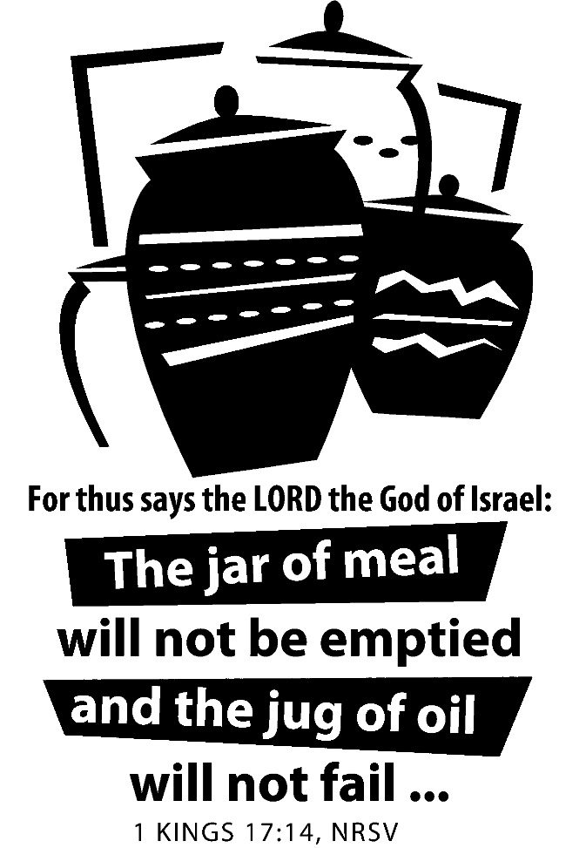

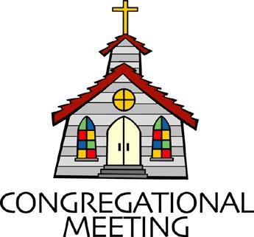
July 10, 2022 - 10:30 am

WELCOME VISITORS!
We're glad you are here! Cards at the ends of each pew are for you to fill out and drop in the Offering Plate. Please let us know you are visiting, and join us for refreshments and fellowship following the service. The Sanctuary has an induction loop system to assist the hearing impaired. The system will also work on the telephone setting of hearing aids.

Springfield Presbyterian Church is rooted in the gospel of Jesus Christ, led by the Holy Spirit, and called to loving relationships through vibrant worship and service. Valuing all people, we are committed to developing disciples and fostering stewardship.
PREPARATION FOR THE WORD
(* those who are able are invited to stand)
PRELUDE

GATHERING OF THE PEOPLE

The Lord be with you! And also with you! (Greeting)

LIGHTING THE CHRIST CANDLE
Leader: Whenever we light this candle we proclaim:
People: Christ is the Light of the world and the center of our lives.

CALL TO WORSHIP
Leader: Today is a new day,
People: One we were never promised.
Leader: So today we delight in God’s gift of life.
People: Today we celebrate the impossible becoming possible.
Leader: We, as Christians, become a people of new possibilities, new ventures, and a positivity as we look toward the future.
People: Every day we can look around and say, “look what our God is doing!”
Leader: We come with those promises in our hearts,
People: So in humility, gratitude, and grace, we come to worship our God together.

* HYMN Here in This Place (Gather Us In) GTG #401

Here in the place the new light is streaming; now is the darkness vanished away; see in this space our fears and our dreamings brought here to you in the light of this day.
Gather us in, the lost and forsaken; gather us in, the blind and the lame; call to us now, and we shall awaken; we shall arise at the sound of our name.

We are the young, our lives are a mystery. We are the old who yearn for your face. We have been sung throughout all of history, called to be light in the whole human race.
Gather us in, the rich and the haughty; gather us in, the proud and the strong; give us a heart, so meek and so lowly; give us the courage to enter the song.

Here we will take the wine and the water; here we will take the bread of new birth. Here you shall call your sons and your daughters, call us anew to be salt for the earth.
Give us to drink the wine of compassion; give us to eat the bread that is you; nourish us well, and teach us to fashion live that are holy and hearts that are true.

Not in the dark of buildings confining, not in some heaven, light years away: here in this place the new light is shining; now is the kingdom, and now is the day.
Gather us in and hold us forever; gather us in and make us your own; gather us in, all peoples together, fire of love in our flesh and our bone.

CALL TO CONFESSION
Leader: Have you ever come to prayer, wondering if your sin can be forgiven? What if it feels impossible or foolish? One of the wonderful things about our God is that He says that the impossible is possible and that forgiveness comes to us every time we sincerely atone. We see it in our Scriptures, we see that God often calls the flawed and the unexpected, so let us come before God, acknowledging our sins, and gratefully accepting God’s forgiveness in His mercy and grace:

PRAYER OF CONFESSION
Eternal God, in whom we live and move and have our being, whose face is hidden from us by our sins, and whose mercy we forget in the blindness of our hearts: cleanse us from all our offenses, and deliver us from proud thoughts and vain desires, that with reverent and humble hearts we may draw near to you, confessing our faults, confiding in your grace, and finding in you our refuge and strength; through Jesus Christ your Son. Amen.

SILENT PRAYERS OF CONFESSION

RESPONSE The Woman Hiding in the Crowd Tune #178
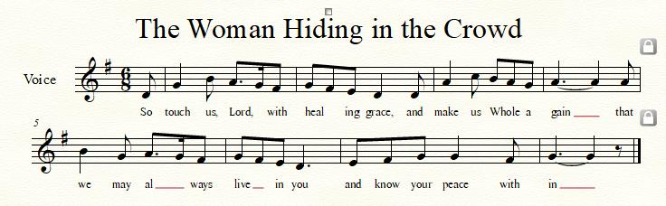

WORDS OF ASSURANCE [Isaiah 43:1, 19]
Leader: Do not fear, says the Lord, for I have redeemed you. I have called you by name; you are mine.
People: God is doing a new thing and now it springs forth! By the grace of Jesus Christ, we are forgiven! Alleluia and amen!

* MUSICAL RESPONSE OF PRAISE O My Soul, Bless Your Redeemer
Bless your Maker, all you creatures, ever under God’s control,
All throughout God’s vast dominion; bless the Lord of all, my soul!

* THE PEACE The peace of Christ be with you! And also with you!
(You may greet those around you.)

* RESPONSE Here I Am, Lord
Here I am, Lord, Is it I, Lord? I have heard you calling in the night.
I will go, Lord, if you lead me. I will hold your people in my heart.
THE PROCLAMATION OF THE WORD

PRAYER OF ILLUMINATION
Generous God, guide us by your Word and Spirit that in your light we may see light, in your truth find freedom, and in your will discover your peace; through Jesus Christ our Lord. Amen.

FIRST SCRIPTURE LESSON 1 Kings 17:8-16
⁸Then the word of the Lord came to him, saying, ⁹‘Go now to Zarephath, which belongs to Sidon, and live there; for I have commanded a widow there to feed you.’ ¹⁰So he set out and went to Zarephath. When he came to the gate of the town, a widow was there gathering sticks; he called to her and said, ‘Bring me a little water in a vessel, so that I may drink.’ ¹¹As she was going to bring it, he called to her and said, ‘Bring me a morsel of bread in your hand.’ ¹²But she said, ‘As the Lord your God lives, I have nothing baked, only a handful of meal in a jar, and a little oil in a jug; I am now gathering a couple of sticks, so that I may go home and prepare it for myself and my son, that we may eat it, and die.’ ¹³Elijah said to her, ‘Do not be afraid; go and do as you have said; but first make me a little cake of it and bring it to me, and afterwards make something for yourself and your son. ¹⁴For thus says the Lord the God of Israel: The jar of meal will not be emptied and the jug of oil will not fail until the day that the Lord sends rain on the earth.’ ¹⁵She went and did as Elijah said, so that she as well as he and her household ate for many days. ¹⁶The jar of meal was not emptied, neither did the jug of oil fail, according to the word of the Lord that he spoke by Elijah.

SECOND SCRIPTURE LESSON Galatians 1:11-24
¹¹For I want you to know, brothers and sisters, that the gospel that was proclaimed by me is not of human origin; ¹²for I did not receive it from a human source, nor was I taught it, but I received it through a revelation of Jesus Christ. ¹³You have heard, no doubt, of my earlier life in Judaism. I was violently persecuting the church of God and was trying to destroy it. ¹⁴I advanced in Judaism beyond many among my people of the same age, for I was far more zealous for the traditions of my ancestors. ¹⁵But when God, who had set me apart before I was born and called me through his grace, was pleased ¹⁶to reveal his Son to me, so that I might proclaim him among the Gentiles, I did not confer with any human being, ¹⁷nor did I go up to Jerusalem to those who were already apostles before me, but I went away at once into Arabia, and afterwards I returned to Damascus. ¹⁸Then after three years I did go up to Jerusalem to visit Cephas and stayed with him for fifteen days; ¹⁹but I did not see any other apostle except James the Lord’s brother. ²⁰In what I am writing to you, before God, I do not lie! ²¹Then I went into the regions of Syria and Cilicia, ²²and I was still unknown by sight to the churches of Judea that are in Christ; ²³they only heard it said, ‘The one who formerly was persecuting us is now proclaiming the faith he once tried to destroy.’ ²⁴And they glorified God because of me.

Leader: Hear what the Spirit is saying to the Church.
All: Thanks be to God.

SERMON Elder Alex McClung

THE RESPONSE TO THE WORD

* HYMN Faith Begins by Letting Go GTG #684

Faith begins by letting go, giving up what had seemed sure,
Taking risks and pressing on, though the way feels less secure:
Pilgrimage both right and odd, trusting all our life to God.

Faith endures by holding on, keeping memory’s roots alive
So that hope may bear its fruit; promise-fed, our souls will thrive,
Not through merit we possess but by God’s great faithfulness.

Faith matures by reaching out, stretching minds, enlarging hearts,
Sharing struggles, living prayer, binding up the broken parts;
Till we find the commonplace ripe with witness to God’s grace.

PASTORAL PRAYER AND THE LORD’S PRAYER

OFFERTORY
SONG OF THANKS As Those of Old Their Firstfruits Brought #712
In gratitude and humble trust we bring our best today, to serve your cause and share your love with all along life’s way. O God who gave yourself to us in Jesus Christ your Son, help us to give ourselves each day until life’s work is done.
PRAYER OF DEDICATION

* HYMN Lord, When I Came into This Life GTG #691

Lord, when I came into this life you called me by my name;
Today I come, commit myself, responding to your claim.

Within the circle of the faith, as member of your cast,
I take my place with all the saints of future, present, past.

In all the tensions of my life, between my faith and doubt,
Let your great Spirit give me hope, sustain me, lead me out.

So help me in my unbelief and let my life be true:
Feet firmly planted on the earth, my sights set high on you.

* CHARGE AND BENEDICTION
Leader: Let us go from this place,
People: Joyfully celebrating all that God has put in place.
Leader: From the impossible to the possible,
People: Our dreams become renewed and restored.
Leader: So, with that positivity,
People: We go out into the world to be ambassadors for Christ.

* UNISON AMEN

POSTLUDE

Sunday July 17, 2022 Lectionary
Genesis 18:1-10a; Psalm 15; Colossians 1:15-28; Luke 10:38-42

Assisting in Worship: We appreciate those who serve:

Today 7/10 Next Week 7/17
Sunday Opener Barbara Cornell Beth Oates
Ushers/Greeters Henry Halvorson Steve & Donna
Bob Rogers Mazer
Lay Leader Sharon Pappas Mark Kearney

Announcements

Mask Update: Due to the uptick in COVID-19 cases, the Session has decided to strongly encourage masking and social distancing. Though it is not a mandate, we seek to love one another by keeping each other as safe as possible. Thank you for your help in this endeavor.

Sunday School is back! On the 1st and 3rd Sundays of the month, we will be offering Sunday School! See Pastor Becca for details…
Summer Mission Project: It won’t be long before school starts again. Preparing for a new school year includes buying items on the STUDENT SUPPLY LIST. For some children and their families, this can be a challenge and in some instances buying needed supplies just isn’t possible. For that reason, during July and August, we will be collecting school supplies to help these children. The GIVING TREE is in the Narthex. If you would like to help with this project, you can take a tag from the tree and buy the item written on it or simply choose from the below items (taken from Sykesville Middle School STUDENT SUPPLY LIST). Please place your donated items in the designated basket in the Narthex. Thank you! ~ CoCaMO Committee

3-ring binders-1, 1 ½ or 2” Pencil pouch Glue sticks
Loose-leaf paper Pack of #2 pencils Pair of Ear Buds
Pack of 5-tab binder dividers Pocket folders Scissors
Blue, black or red pens Block or cap erasers Sticky notes
3X5 ruled index cards Dry erase markers Crayons
Folders with brads 10-pack colored pencils
Spiral notebook-200 pgs. Pencil sharpener
Multi-colored highlighters Composition book

Pastor-Parish Committee: The Pastor-Parish Committee invites you to share your concerns, suggestions, and gratitude. We have a form in the Narthex and a lock-box that we will open weekly and we ask that you share your name and be specific. We look forward to reading your comments so that we can continue to grow into the body of Christ.

Springfield Membership: Are you interested in finding out more about our faith community and becoming a member? We would love to answer any questions you have. Please contact Pastor Becca at springfieldpastor@gmail.com for more information.

Congregational Care / Mission & Outreach: Do you know of a member or friend of our church family who is ill, needs prayers, would like call, a visit or a card, or might benefit from meal train? If so, please contact the Church Office (410-795-6152), Cathy Marsh (410-549-6916) or Diana Steppling (862-266-2242).

Fellowship Help Needed: If you are interested in helping with Fellowship, please contact Barbara Cornell (240-308-0035). A sign-up sheet will also be available.

Today:
Sunday July 10
10:30 am Worship
11:30 am Fellowship

Looking Ahead:
Sunday July 17
10:30 am Worship
11:30 am Fellowship

Office Hours: Tuesday, Wednesday & Friday
Springfield Presbyterian Church

10:30 am Worship
11:30 am Fellowship
Website: www.springfield-church.org Church Office: 410-795-6152
Like us on Facebook: www.facebook.com/SpringfieldPresbyterianChurch
Pastor: Rev. Becca Crate-Price
Email: springfieldpastor@gmail.com
Clerk of Session: Sharon Pappas
Minister of Music: Linda Caviglia
Accompanist/Organist: Aaron Thacker
Youth Group Coordinator: Dylan Vasbinder
Administrative Assistant: Donna Mazer e-mail: spc.office@verizon.net

