(Large Print)

Springfield Presbyterian Church (USA)
7300 Spout Hill Road, Sykesville, MD 21784 410-795-6152

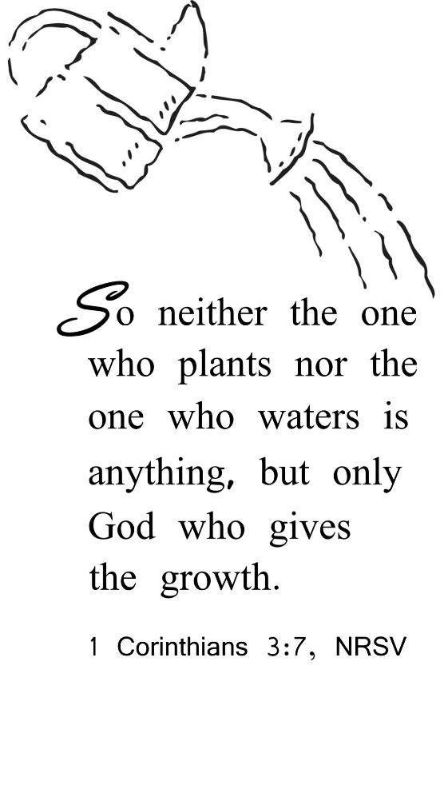

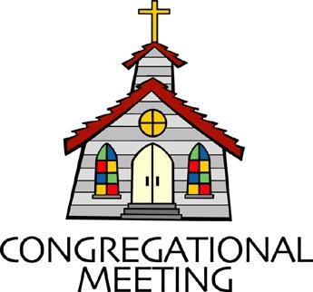
February 12, 2023 - 10:30 am

WELCOME VISITORS!
We're glad you are here! Cards at the ends of each pew are for you to fill out and drop in the Offering Plate. Please let us know you are visiting, and join us for refreshments and fellowship following the service. The Sanctuary has an induction loop system to assist the hearing impaired. The system will also work on the telephone setting of hearing aids.

Springfield Presbyterian Church is rooted in the gospel of Jesus Christ, led by the Holy Spirit, and called to loving relationships through vibrant worship and service. Valuing all people, we are committed to developing disciples and fostering stewardship.
PREPARATION FOR THE WORD
(* those who are able are invited to stand)

PRELUDE

GATHERING OF THE PEOPLE

The Lord be with you! And also with you! (Greeting)

LIGHTING THE CHRIST CANDLE
Leader: Whenever we light this candle we proclaim:
People: Christ is the Light of the world and the center of our lives.

CALL TO WORSHIP [Psalm 100]
Leader: Make a joyful noise to the Lord, all the earth.
People: Serve the Lord with gladness; come into His presence with singing.
Leader: Know that the Lord is God.
People: It is He who made us, and we are His; we are His people and the sheep of His pasture.
Leader: Enter His gates with thanksgiving and His courts with praise.
People: Give thanks to Him; bless His name.
Leader: For the Lord is good;
People: His steadfast love endures forever and His faithfulness to all generations.
ALL: Let us worship our faithful God!

* HYMN We Gather Together GTG #336

We gather together to ask the Lord's blessing;
he chastens and hastens his will to make known;
the wicked oppressing now cease from distressing.
Sing praises to his name; he forgets not his own.

Beside us to guide us, our God with us joining,
ordaining, maintaining his kingdom divine;
so from the beginning the fight we were winning;
thou, Lord, wast at our side; all glory be thine!

We all do extol thee, thou leader triumphant,
and pray that thou still our defender wilt be.
Let thy congregation escape tribulation;
thy name be ever praised! O Lord, make us free!

CALL TO CONFESSION
Leader: When asked about who led you to this faith, to these pews this morning, what name or names do you offer? I can think of a few folks who helped me blossom and grow into who I am today as a spiritual person. What I often forget is that those folks who formed me were formed by God, and God is the one who is at work within all of us. I can point to those faithful humans who raised me, but I need to be better about pointing to God as the one who calls me beloved all the days of my life. I know I’m not alone in this journey, so let us gather and reorient ourselves to God alone who deserves our thanks and praise.

PRAYER OF CONFESSION
Generous and Loving God, we give you thanks for those servants of the faith who raised us. We ask for forgiveness though when we become blind to the fact that you are the one doing the good work of growth and transformation within us. Restore us to remembering ourselves as your own, claiming that you call us beloved. Enrich our vision once again to see how you are at work. Help us to worship you in thanks, service, and praise. Amen.

SILENT PRAYERS OF CONFESSION

RESPONSE Just as I Am, without One Plea Tune #442
Just as I am, thou wilt receive, wilt welcome, pardon, cleanse, relieve;
Because thy promise I believe, O Lamb of God, I come; I come!

WORDS OF ASSURANCE [Isaiah 43:1, 19]
Leader: Do not fear, says the Lord, for I have redeemed you. I have called you by name; you are mine.
People: God is doing a new thing; now it springs forth! By the grace of Jesus Christ, we are forgiven! Alleluia and amen!

* MUSICAL RESPONSE OF PRAISE We Praise You, O God Tune #612
We praise you, O God, our Redeemer, Creator;
In grateful devotion our tribute we bring.
We lay it before you; we kneel and adore you;
We bless your holy name; glad praises we sing.

* THE PEACE The peace of Christ be with you! And also with you!
(You may greet those around you.)

* RESPONSE Here I Am, Lord
Here I am, Lord, Is it I, Lord? I have heard you calling in the night.
I will go, Lord, if you lead me. I will hold your people in my heart.

THE PROCLAMATION OF THE WORD

PRAYER OF ILLUMINATION
God of mercy, you promised never to break your covenant with us. Amid all the changing words of our generation, speak your eternal word that does not change. Then may we respond to your gracious promises with faithful and obedient lives; through our Lord Jesus Christ. Amen.

FIRST SCRIPTURE LESSON Psalm 119:1-8
¹ Happy are those whose way is blameless, who walk in the law of the Lord. ² Happy are those who keep his decrees, who seek him with their whole heart, ³ who also do no wrong, but walk in his ways. ⁴ You have commanded your precepts to be kept diligently. ⁵ O that my ways may be steadfast in keeping your statutes! ⁶ Then I shall not be put to shame, having my eyes fixed on all your commandments. ⁷ I will praise you with an upright heart, when I learn your righteous ordinances.
⁸ I will observe your statutes; do not utterly forsake me.

SECOND SCRIPTURE LESSON 1 Corinthians 3:1-9
And so, brothers and sisters, I could not speak to you as spiritual people, but rather as people of the flesh, as infants in Christ. ²I fed you with milk, not solid food, for you were not ready for solid food. Even now you are still not ready, ³for you are still of the flesh. For as long as there is jealousy and quarrelling among you, are you not of the flesh, and behaving according to human inclinations? ⁴For when one says, ‘I belong to Paul’, and another, ‘I belong to Apollos’, are you not merely human? ⁵What then is Apollos? What is Paul? Servants through whom you came to believe, as the Lord assigned to each. ⁶I planted, Apollos watered, but God gave the growth. ⁷So neither the one who plants nor the one who waters is anything, but only God who gives the growth. ⁸The one who plants and the one who waters have a common purpose, and each will receive wages according to the labor of each. ⁹For we are God’s servants, working together; you are God’s field, God’s building.

SERMON Who Do I Belong To? Rev. Becca Price

THE RESPONSE TO THE WORD

* HYMN The Church’s One Foundation GTG #321

The church's one foundation is Jesus Christ her Lord.
She is his new creation by water and the word.
From heaven he came and sought her to be his holy bride.
With his own blood he bought her, and for her life he died.

Elect from every nation, yet one o'er all the earth,
Her charter of salvation: one Lord, one faith, one birth.
One holy name she blesses, partakes one holy food,
And to one hope she presses, with every grace endued.

Though with a scornful wonder this world sees her oppressed,
By schisms rent asunder, by heresies distressed,
Yet saints their watch are keeping; their cry goes up: "How long?"
And soon the night of weeping shall be the morn of song.

Mid toil and tribulation, and tumult of her war,
She waits the consummation of peace forevermore:
Till with the vision glorious her longing eyes are blest,
And the great church victorious shall be the church at rest.

Yet she on earth has union with God, the Three in One,
And mystic sweet communion with those whose rest is won:
O happy ones and holy! Lord, give us grace that we,
Like them, the meek and lowly, may live eternally.

AFFIRMING OUR FAITH TOGETHER The Apostle’s Creed
I believe in God, the Father almighty, creator of heaven and earth. I believe in Jesus Christ, God’s only Son, our Lord, who was conceived by the Holy Spirit, born of the Virgin Mary, suffered under Pontius Pilate, was crucified, died, and was buried; he descended to the dead. On the third day he rose again; he ascended into heaven, he is seated at the right hand of the Father,

and he will come to judge the living and the dead. I believe in the Holy Spirit, the holy catholic church, the communion of saints, the forgiveness of sins, the resurrection of the body, and the life everlasting. Amen.

PASTORAL PRAYER AND THE LORD’S PRAYER

OFFERTORY Write Your Word Upon My Heart Larson/Parker
* SONG OF THANKS Take My Life Tune #697
Take my silver and my gold; not a mite would I withhold;
Take my intellect and use every power as thou shalt choose,
Every power as thou shalt choose.
* PRAYER OF DEDICATION

* HYMN Our God, Our Help in Ages Past GTG #687

Our God, our help in ages past, our hope for years to come,
Our shelter from the stormy blast, and our eternal home:

Beneath the shadow of thy throne thy saints have dwelt secure;
Sufficient is thine arm alone, and our defense is sure.

Before the hills in order stood, or earth received its frame,
From everlasting thou art God, to endless years the same.

A thousand ages in thy sight are like an evening gone,
Short as the watch that ends the night before the rising sun.

Time, like an ever rolling stream, bears all our years away;
They fly forgotten, as a dream dies at the opening day.

Our God, our help in ages past, our hope for years to come,
Be thou our guard while life shall last, and our eternal home.

* CHARGE AND BENEDICTION
Leader: Who am I?
People: A beloved child of God.
Leader: Who are we?
People: We are beloved children of God.
Leader: For God calls us all beloved,
People: So, we will proclaim this good news in word, act, and deed!

* UNISON AMEN

POSTLUDE

Assisting in Worship: We appreciate those who serve:
Today 2/12 Next Week 2/19
Sunday Opener: Ron Holmes Bob Rogers
Ushers/Greeters: Don Vasbinder Need Volunteers
Henry Halvorson
Lay Leader: Hubert Hoehn Alex McClung

Happy Birthday! February 12 – Megan Anderson

Sunday February 19, 2023 Lectionary
Exodus 24:12-18; Psalm 2 or 99; 2 Peter 1:16-21; Matthew 17:1-9

Announcements

Congregational Meeting: The annual congregational meeting TODAY is called for the purpose of presenting the annual committee reports and the 2023 budget. The meeting will be held in the sanctuary and on Zoom immediately following this morning’s worship service. Hard copies of the reports will be provided.

Fellowship: TODAY we will gather for our annual "Souper Bowl of Caring" soup lunch -- right after our Congregational Meeting. A variety of soups will be served, including chili and a vegetarian option.
The "Souper Bowl of Caring" is an opportunity for fellowship and sharing, but it is also a chance to give to people who are food-insecure. Our youth are spearheading this collection, so give generously. Thank you, Barbara Cornell

Easter Flowers: Yes, it’s time to order Easter flowers! See the order form included in your Bulletin. Deadline for orders is TODAY or you can email it to the office by Tuesday, February 14 and follow up with your payment as soon as possible.

Comfort Bag Update: Do you know of anyone who is in need of a little comfort? New comfort bags are now available in the Narthex. Feel free to scoop one up and pass it along to someone in need. “No act of kindness, no matter how small, is ever wasted.” ~ Aesop

Springfield Membership: Are you interested in finding out more about our faith community and becoming a member? We would love to answer any questions you have. Please contact Pastor Becca at springfieldpastor@gmail.com for more information.

Congregational Care / Mission & Outreach (CoCaMO): Do you know of a member or friend of our church family who is ill, needs prayers, would like call, a visit or a card, or might benefit from meal train? If so, please contact the Church Office (410-795-6152), Cathy Marsh (410-549-6916) or Diana Steppling (862-266-2242).

Today:
Sunday February 12
10:30 am Worship
11:30 am Congregational Meeting (Sanctuary)
12:00 noon Souper Bowl Luncheon

This Week:
Tuesday February 14
7:00 pm CoCaMO Meeting (Manse)
Wednesday February 15
6:15 – 7:15 pm Bell Choir Practice
7:30 – 8:45 pm Adult Choir Practice

Looking Ahead:
Sunday February 19
10:30 am Worship
11:30 am Fellowship
12:00 noon Worship Committee Meeting
Wednesday February 22 – Ash Wednesday
7:00 pm Worship

Office Hours: Tuesday, Wednesday and Friday, 10:00 am - 3:00 pm
Springfield Presbyterian Church

10:30 am Worship
11:30 am Fellowship
Website: www.springfield-church.org Church Office: 410-795-6152
Like us on Facebook: www.facebook.com/SpringfieldPresbyterianChurch
Pastor: Rev. Becca Price
Email: springfieldpastor@gmail.com
Clerk of Session: Sharon Pappas
Minister of Music: Linda Caviglia
Accompanist/Organist: Aaron Thacker
Youth Group Coordinator: Dylan Vasbinder
Administrative Assistant: Donna Mazer e-mail: spc.office@verizon.net

