Springfield Presbyterian Church (USA)
7300 Spout Hill Road, Sykesville, MD 21784 410-795-6152
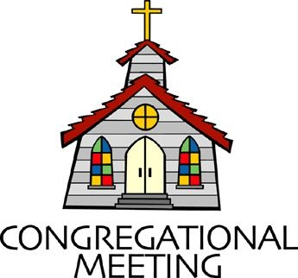

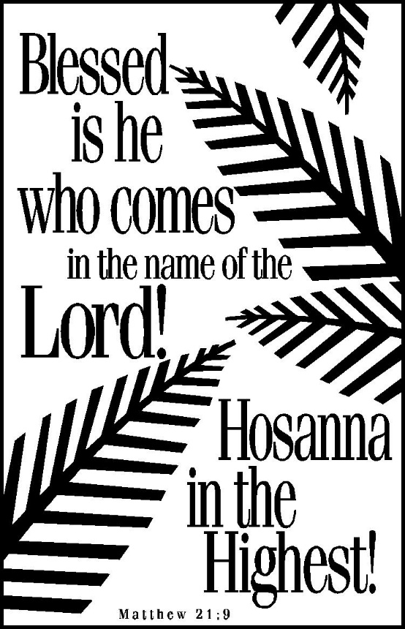

March 29, 2026 - 10:30 am

WELCOME VISITORS!

We're glad you are here! Cards at the ends of each pew are for you to fill out and drop in the Offering Plate. Please let us know you are visiting and join us for refreshments and fellowship following the service. The Sanctuary has an induction loop system to assist the hearing impaired. The system will also work on the telephone setting of hearing aids.

Springfield Presbyterian Church is rooted in the gospel of Jesus Christ, led by the Holy Spirit, and called to loving relationships through vibrant worship and service. Valuing all people, we are committed to developing disciples and fostering stewardship.

PREPARATION FOR THE WORD
(* those who are able are invited to stand)

PRELUDE Dona Nobis Pacem Arr. Margaret Tucker

GATHERING OF THE PEOPLE

The Lord be with you! And also with you! (Greetings and Announcements)

LIGHTING THE CHRIST CANDLE
Leader: Whenever we light this candle we proclaim:
People: Christ is the Light of the world and the center of our lives.

CALL TO WORSHIP
Leader: “Hosanna!” They shouted. “Save us!”
People: “Hosanna!” We’re shouting. “Save us!”
Leader: Savior, ride into our hearts again,
People: Wash us with excitement and hope,
Leader: Give us a reason to praise
People: And to shout again, “Hosanna! Hosanna!”

* HYMN All Glory, Laud, and Honor GTG #196

Refrain: All glory, laud, and honor to thee, Redeemer, King,
To whom the lips of children made sweet hosannas ring!

Thou art the King of Israel, thou David’s royal Son,
Who in the Lord’s name comest, the King and blessed One. [Refrain]

The people of the Hebrews with palms before thee went;
Our praise and prayers and anthems before thee we present. [Refrain]

To thee, before thy passion, they sang their hymns of praise;
To thee, now high exalted, our melody we raise. [Refrain]

Thou didst accept their praises; accept the prayers we bring,
Who in all good delightest, thou good and gracious King! [Refrain]

CALL TO CONFESSION
Leader: When we say, “We don’t sin,” we deny who we are. But when we say,
“There’s no way out,” we deny who God is. Trusting that God’s grace is
more powerful than our sin, let us confess our sins together.

PRAYER OF CONFESSION
Holy Christ, we confess that amidst all the Palm Sunday crowds, we find ourselves in more turmoil than triumph. Our faith is unsteady. Our wisdom is eroding. Our resolve is shaken. Our mercy is hardening. Our hope is weakening. Come again and save us from these sins. Give us strength to follow you, our humble Savior, our all in all. Amen.

SILENT PRAYERS OF CONFESSION

RESPONSE O Lord, Hear My Prayer GTG #471 (sing 2 times)
O Lord, hear my prayer. O Lord, hear my prayer. When I call, answer me.
O Lord, hear my prayer. O Lord, hear my prayer. Come and listen to me.

WORDS OF ASSURANCE
Leader: Hear this promise: Jesus has set his face toward the cross. Nothing we do can deter him. He has determined that we are worth saving. By the power of the cross, by the power of wondrous love, we are forgiven. Thanks be to God. Amen.

* MUSICAL RESPONSE OF PRAISE Praise Ye the Lord, the Almighty
GTG #35 (v. 3)
Praise ye the Lord! O let all that is in me adore him!
All that hath life and breath, come now with praises before him!
Let the amen sound from his people again; gladly for aye we adore him.

* THE PEACE The peace of Christ be with you! And also with you!
(You may greet those around you.)

* RESPONSE Here I Am, Lord GTG #69
Here I am, Lord. Is it I, Lord? I have heard you calling in the night.
I will go, Lord, if you lead me. I will hold your people in my heart.

THE PROCLAMATION OF THE WORD

PRAYER OF ILLUMINATION
Holy Spirit, share with us your wisdom; gift us with your hope; sustain us with your truth. Be in our hearing and our thinking, that through the words of Scripture we might know your call on our lives. Amen.

FIRST SCRIPTURE LESSON Matthew 21:1-15 NT page 21
¹When they had come near Jerusalem and had reached Bethphage, at the Mount of Olives, Jesus sent two disciples, ²saying to them, "Go into the village ahead of you, and immediately you will find a donkey tied, and a colt with her; untie them and bring them to me. ³If anyone says anything to you, just say this, "The Lord needs them.' And he will send them immediately." ⁴This took place to fulfill what had been spoken through the prophet, saying, ⁵"Tell the daughter of Zion, Look, your king is coming to you, humble, and mounted on a donkey, and on a colt, the foal of a donkey." ⁶The disciples went and did as Jesus had directed them; ⁷they brought the donkey and the colt, and put their cloaks on them, and he sat on them. ⁸A very large crowd spread their cloaks on the road, and others cut branches from the trees and spread them on the road. ⁹The crowds that went ahead of him and that followed were shouting, "Hosanna to the Son of David! Blessed is the one who comes in the name of the Lord! Hosanna in the highest heaven!" ¹⁰When he entered Jerusalem, the whole city was in turmoil, asking, "Who is this?" ¹¹The crowds were saying, "This is the prophet Jesus from Nazareth in Galilee." ¹²Then Jesus entered the temple and drove out all who were selling and buying in the temple, and he overturned the tables of the money changers and the seats of those who sold doves. ¹³He said to them, "It is written, ‘My house shall be called a house of prayer'; but you are making it a den of robbers." ¹⁴The blind and the lame came to him in the temple, and he cured them. ¹⁵But when the chief priests and the scribes saw the amazing things that he did, and heard the children crying out in the temple, "Hosanna to the Son of David," they became angry…

SECOND SCRIPTURE LESSON Matthew 26:1-5 NT page 28
¹When Jesus had finished saying all these things, he said to his disciples, ²"You know that after two days the Passover is coming, and the Son of Man will be handed over to be crucified." ³Then the chief priests and the elders of the people gathered in the palace of the high priest, who was called Caiaphas, ⁴and they conspired to arrest Jesus by stealth and kill him. ⁵But they said, "Not during the festival, or there may be a riot among the people."

Leader: Hear what the Spirit is saying to the Church.
All: Thanks be to God.

SERMON Where is This Leading? By Kathy Welsh Smith

THE RESPONSE TO THE WORD

* HYMN Beneath the Cross of Jesus GTG #216

Beneath the cross of Jesus I fain would take my stand,
The shadow of a mighty rock within a weary land;
A home within the wilderness, a rest upon the way,
From the burning of the noontide heat, and the burden of the day.

Upon the cross of Jesus mine eye at times can see
The very dying form of One who suffered there for me;
And from my stricken heart with tears two wonders I confess:
The wonders of redeeming love and my unworthiness.

I take, O cross, thy shadow for my abiding place;
I ask no other sunshine than the sunshine of his face;
Content to let the world go by, to know no gain or loss,
My sinful self my only shame, my glory all the cross.

PASTORAL PRAYER AND THE LORD’S PRAYER

PRESENTATION OF TITHES AND OFFERINGS
OFFERTORY Steadfast Assurance By: Jason W. Krug

* SONG OF THANKS Lord of All Good GTG #711 (v. 1)
Lord of all good, our gifts we bring to you;
Use them your holy purpose to fulfill,
Tokens of love and pledges brought anew,
That our whole life is offered to your will.
* PRAYER OF DEDICATION

* HYMN What Wondrous Love Is This GTG #215

What wondrous love is this, O my soul, O my soul,
What wondrous love is this, O my soul!
What wondrous love is this that caused the Lord of bliss
To bear the dreadful curse for my soul, for my soul,
To bear the dreadful curse for my soul!

When I was sinking down, sinking down, sinking down,
When I was sinking down, sinking down,
When I was sinking down beneath God's righteous frown,
Christ laid aside his crown for my soul, for my soul,
Christ laid aside his crown for my soul!

To God and to the Lamb, I will sing, I will sing,
To God and to the Lamb, I will sing;
To God and to the Lamb who is the great I am,
While millions join the theme, I will sing, I will sing;
While millions join the theme, I will sing!

And when from death I’m free, I’ll sing on, I’ll sing on;
And when from death I’m free, I’ll sing on;
And when from death I’m free, I’ll sing and joyful be,
And through eternity, I’ll sing on, I’ll sing on;
And through eternity I’ll sing on.

* CHARGE AND BENEDICTION
Leader: Today we have hailed you as our champion.
People: Tomorrow distractions will overtake us, and our enthusiasm may
fade.
Leader: Help us keep our eyes on you this week:
People: On Monday, when you clear the temple of greed and deceit;
Leader: On Tuesday, when you challenge our comfort and ease;
People: On Wednesday, the last day before the world tilts;
Leader: On Thursday, when you wash your disciples’ feet, and promise us a new covenant of your own body and blood, and are betrayed and arrested while you pray;
People: On Friday, when you are examined, found guilty, and executed
and plead with your last breath for our forgiveness;
Leader: On Saturday, when you lie dead in the tomb, and it seems all is lost.
People: The story is ancient, but the promises are fresh. So keep our eyes on you this week, and bring us back together on Sunday, when we will see what God has done.
Leader: And wherever you go, may you be kept in the love of God, the mercy of
Christ, and the power of the Spirit, now and forevermore. Amen.

* UNISON AMEN GTG #601

POSTLUDE Within the Darkest Night By: Derek K. Hakes

© Presbyterian Outlook, 2026; Liturgy written by Carol Prickett and provided for free distribution

Happy Birthday! March 31 – Judy Rhoades
April 3 – Barbara Cornell
April 3 – India Oates

Sunday April 5, 2026 Lectionary
Acts 10:34-43; Psalm 118:1-2, 14-24; Colossians 3:1-4; Matthew 28:1-10
Assisting in Worship: We appreciate those who serve:

Today 3/29 Maundy Thurs. Next Week 4/5
Sunday Opener: Ron Holmes Barbara C. Barbara Cornell
Ushers/Greeters: Tim & Beth Oates Connie Gibbons
Leah Halvorson
Lay Leader: Mark Chaplik Ron Holmes Barbara Cornell
Pulpit Supply: Kathy Welsh Smith Heather Russell Troy Bailey
Comm. Servers: Bob Steppling Mark Kearney
Barbara Nickell Don Vasbinder
Sue Holmes Tony Caviglia
Sharon Pappas
Alex McClung
Mark Chaplik
Diane Chaplik
Bobby Barrett
Barbara Nickell
Offering Count: Andrea K. & Mark C. Andra Kwako & Vol.
Fellowship Hosts: Beth Oates Rebekah, Barb N., Christy

Announcements

Welcome! We welcome Kathy Welsh Smith to our pulpit again today!
After a long career in collegiate campus ministry, Kathy made the leap to working in the church in 2017. She most recently served as the Director of Discipleship at Central Presbyterian. Kathy is now a Candidate for Minister of Word and Sacrament and a recent graduate of United Seminary, Twin Cities. She is married to Rob, who works at Loyola University, and together they are the parents of two adult children and the grandparents of the 3 (objectively!) cutest grandsons in the world.

Welcome also to Michael Hall, our guest accompanist again today! Michael is a Peabody University of Cincinnati graduate with degrees in French horn performance. The bulk of his work is as a freelance horn player. He serves as principal horn with National Philharmonic and Mid Atlantic Symphony, and he subs with many other groups, including the BSO. As a pianist, Michael has worked as an accompanist at both Catholic U and the Duke Ellington School for the Arts, and fills in for worship from time to time at several churches and synagogues in the Baltimore/DC region. He also maintains a small private studio for horn and piano students at his home in Violetville, Baltimore.

One Great Hour of Sharing: This program had its beginning in 1949 as the world worked to rebuild communities following WWII. TODAY we receive the OGHS offering, continuing that focus on helping our neighbors build a better, safer world. Around the world, millions of people lack access to sustainable food sources, clean water, sanitation, education, and opportunity. The work done in support of the causes supported by One Great Hour of Sharing (OGHS) — disaster, hunger, poverty, climate change, and immigration/migration and refugees — serves individuals and communities in need. This work provides people with safety, sustenance, and hope.

Noisy Offering: TODAY is NOISY OFFERING Sunday! Drop that spare change in the offering plate and make some noise. It’s amazing how our small change can make a BIG difference. The recipient of this NOISY OFFERING is Second Harvest Heartland, a leading hunger relief organization and a member of Feeding America, a nationwide network of more than 200 food banks that help feed people across the country. Their membership provides access to millions of pounds of surplus food and grocery donations.

We Need Your Help… An Easter egg hunt is planned for Easter Sunday. If you are able to donate any of the following items by TODAY, it would be greatly appreciated – small wrapped candy and/or small trinkets (to fit into a plastic egg), and plastic eggs. A basket is in the Narthex for donations. Thank you in advance! ~ The CoCaMO Committee

Maundy Thursday: Join us for worship on Thursday, April 2 at 7:00 pm as we remember Jesus' Last Supper and his example of service.

Good Friday: On April 3, the sanctuary will be open from 12pm to 3pm for quiet reflection, meditation, and prayer on the sacrifice of Christ. There will be resources available to you.

Flowering of the Cross: On Saturday, April 4 from 1:00-3:00pm, we invite you to participate in the "Flowering of the Cross." A supply of artificial flowers will be available, or you may bring your own fresh or artificial flowers. Please join us for this annual tradition as we celebrate the coming of Easter.

Graduation Celebration: We will celebrate our high school and college graduates on May 17 during fellowship. Please let Diana Steppling or Connie Gibbons know if you have a child or grandchild graduating from high school or college this year.

Congregational Care: If you know of someone who would benefit from a card or a phone call, please text or call Connie Gibbons at 410-935-3467.

Electronic Giving: Below is a QR code you can scan to make your contribution a new way! The page you get will ask for your name, email and phone

number. You can choose from a dropdown menu for selecting where the donation should go: General Fund, Capital Fund, Concert, Memorial. There is a fee for using a credit card, and you will be given the option to pay that fee along with your donation, but you don’t have to include it if you don’t want to.

Today:
Sunday March 29
10:30 am Worship
11:30 am Fellowship

This Week:
Wednesday April 1
6:15 – 7:15 pm Bell Choir Practice
7:30 – 8:45 pm Adult Choir Practice
Thursday April 2 – Maundy Thursday
7:00 pm Worship
Friday April 3 – Good Friday Reflection
12:00 noon – 3:00 pm Sanctuary open for reflection and meditation
Saturday April 4
1:00 pm – 3:00 pm Flowering of the Cross

Next Week:
Sunday April 5 – Easter Sunday
10:30 am Worship
11:30 am Fellowship
Monday April 6
7:00 pm Headhuggers (Manse)
Wednesday April 8
6:15 – 7:15 pm Bell Choir Practice
7:30 – 8:45 pm Adult Choir Practice

Office Hours: Tuesday, Wednesday, Friday, 10 am – 3 pm
Springfield Presbyterian Church
10:30 am Worship (and Sunday School 1st & 3rd Sundays)
11:30 am Fellowship
Website: www.springfield-church.org Church Office: 410-795-6152
Like us on Facebook: www.facebook.com/SpringfieldPresbyterianChurch
Pastor: Vacant
Email: spc.office@verizon.net
Clerk of Session: Sharon Pappas
Minister of Music/Accompanist: Vacant
Bell Choir Director: Vacant
Youth Group Coordinator: Dylan Vasbinder
Administrative Assistant: Donna Mazer Email: spc.office@verizon.net

