(Large Print)

Springfield Presbyterian Church (USA)
7300 Spout Hill Road, Sykesville, MD 21784 410-795-6152

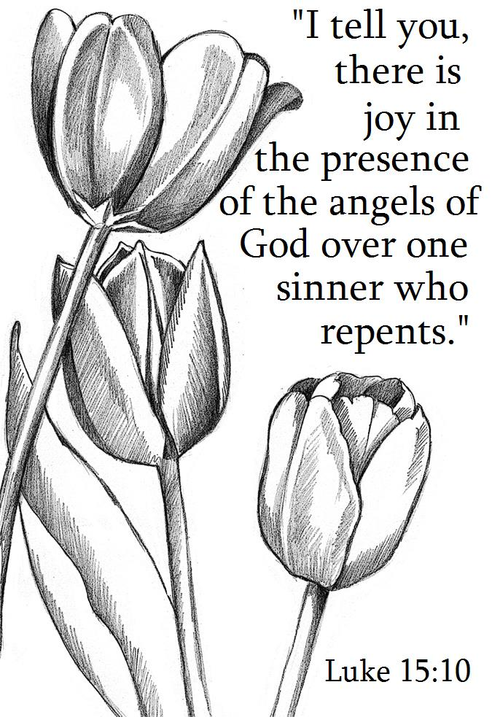

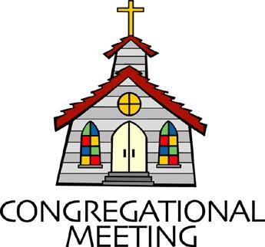
September 15, 2019 - 10:30 am

WELCOME VISITORS! We're glad you are here! Cards at the ends of each pew are for you to fill out and drop in the Offering Plate. Please let us know you are visiting, and join us for refreshments and fellowship following the service. The Sanctuary has an induction loop system to assist the hearing impaired. The system will also work on the telephone setting of hearing aids.

Springfield Presbyterian Church is rooted in the gospel of Jesus Christ, led by the Holy Spirit, and called to loving relationships through vibrant worship and service. Valuing all people, we are committed to developing disciples and fostering stewardship.
PREPARATION FOR THE WORD
(* those who are able are invited to stand)

PRELUDE

GATHERING OF THE PEOPLE

The Lord be with you! And also with you! (Greeting)

LIGHTING THE CHRIST CANDLE
Leader: Whenever we light this candle we proclaim:
People: Christ is the Light of the world and the center of our lives.

CALL TO WORSHIP
Leader: Loving God, we come to you in worship and thanksgiving. You are greater than we can understand;
People: Open our eyes that we may see the wonderful truths you have shown to us in Jesus.
Leader: You are more loving than our hearts can respond to;
People: Help us to give ourselves to you in worship so that we learn what you want us to be.
Leader: You are wiser than we can know;
People: Still our minds as we worship you so that we can understand the things you are saying to us.
Leader: Loving God, in Jesus, you chose to come into the world in humility. You chose the path the world saw as foolish. You used what the world considered weak.
ALL: We worship and adore you! Amen!

* HYMN The King of Love My Shepherd Is

The King of love my shepherd is, whose goodness faileth never;
I nothing lack if I am his and he is mine forever.

Where streams of living water flow my ransomed soul he leadeth,
And where the verdant pastures grow, with food celestial feedeth.

Perverse and foolish oft I strayed, but yet in love he sought me,
And on his shoulder gently laid, and home, rejoicing, brought me.

In death's dark vale I fear no ill with thee, dear Lord, beside me;
Thy rod and staff my comfort still, thy cross before to guide me.

Thou spread’st a table in my sight; thy unction grace bestoweth;
And O what transport of delight from thy pure chalice floweth!

And so through all the length of days thy goodness faileth never;
Good Shepherd, may I sing thy praise within thy house forever.

PRAYER OF CONFESSION (Unison)
Almighty God, you love us, but we have not loved you. You call, but we have not listened. We walk away from neighbors in need, wrapped in our own concerns. We condone evil, prejudice, warfare, and greed. God of grace, help us to admit our sin, so that as you come to us in mercy, we may repent, turn to you, and receive forgiveness; through Jesus Christ our redeemer. Amen.

SILENT PRAYERS OF CONFESSION

RESPONSE Lord Jesus, Think on Me
Lord Jesus, think on me, and purge away my sin.
From earth-born passions set me free, and make me pure within.

WORDS OF ASSURANCE
Leader: Hear the good news! Hope does not disappoint us, for God’s love has been poured into our hearts through the Holy Spirit given to us in baptism.
People: Believe this good news and give thanks; in Jesus Christ, you are forgiven!

* MUSICAL RESPONSE OF PRAISE From All That Dwell Below the Skies
Eternal are thy mercies, Lord; eternal truth attends thy word: Alleluia! Alleluia!
Thy praise shall sound from shore to shore, till suns shall rise and set no more. Alleluia! Alleluia! Alleluia! Alleluia! Alleluia!

* THE PEACE The peace of Christ be with you! And also with you!
(You may greet those around you.)

* RESPONSE Here I Am, Lord
Here I am, Lord, Is it I, Lord? I have heard you calling in the night.
I will go, Lord, if you lead me. I will hold your people in my heart.

THE PROCLAMATION OF THE WORD

PRAYER OF ILLUMINATION
Leader: God of mercy, you promised never to break your covenant with us. Amid all the changing words of our generation, speak your eternal word that does not change. Then may we respond to your gracious promises with faithful and obedient lives; through Jesus Christ. Amen.

FIRST SCRIPTURE LESSON Psalm 51
Have mercy on me, O God, according to your steadfast love; according to your abundant mercy blot out my transgressions. ² Wash me thoroughly from my iniquity, and cleanse me from my sin. ³ For I know my transgressions, and my sin is ever before me. ⁴ Against you, you alone, have I sinned, and done what is evil in your sight, so that you are justified in your sentence and blameless when you pass judgement.
⁵ Indeed, I was born guilty, a sinner when my mother conceived me.
⁶ You desire truth in the inward being; therefore teach me wisdom in my secret heart. ⁷ Purge me with hyssop, and I shall be clean; wash me, and I shall be whiter than snow. ⁸ Let me hear joy and gladness; let the bones that you have crushed rejoice. ⁹ Hide your face from my sins, and blot out all my iniquities. ¹⁰ Create in me a clean heart, O God, and put a new and right spirit within me. ¹¹ Do not cast me away from your presence, and do not take your holy spirit from me. ¹² Restore to me the joy of your salvation, and sustain in me a willing spirit. ¹³ Then I will teach transgressors your ways, and sinners will return to you. ¹⁴ Deliver me from bloodshed, O God, O God of my salvation, and my tongue will sing aloud of your deliverance. ¹⁵ O Lord, open my lips, and my mouth will declare your praise. ¹⁶ For you have no delight in sacrifice; if I were to give a burnt-offering, you would not be pleased. ¹⁷ The sacrifice acceptable to God is a broken spirit; a broken and contrite heart, O God, you will not despise. ¹⁸ Do good to Zion in your good pleasure; rebuild the walls of Jerusalem, ¹⁹ then you will delight in right sacrifices, in burnt-offerings and whole burnt-offerings; then bulls will be offered on your altar.

SECOND SCRIPTURE LESSON Luke 15:1-10
Now all the tax-collectors and sinners were coming near to listen to him. ²And the Pharisees and the scribes were grumbling and saying, ‘This fellow welcomes sinners and eats with them.’ ³So he told them this parable: ⁴‘Which one of you, having a hundred sheep and losing one of them, does not leave the ninety-nine in the wilderness and go after the one that is lost until he finds it? ⁵When he has found it, he lays it on his shoulders and rejoices. ⁶And when he comes home, he calls together his friends and neighbors, saying to them, “Rejoice with me, for I have found my sheep that was lost.” ⁷Just so, I tell you, there will be more joy in heaven over one sinner who repents than over ninety-nine righteous people who need no repentance. ⁸ ‘Or what woman having ten silver coins, if she loses one of them, does not light a lamp, sweep the house, and search carefully until she finds it? ⁹When she has found it, she calls together her friends and neighbors, saying, “Rejoice with me, for I have found the coin that I had lost.” ¹⁰Just so, I tell you, there is joy in the presence of the angels of God over one sinner who repents.’

Leader: Hear what the Spirit is saying to the Church.
All: Thanks be to God.

TIME WITH YOUNG PEOPLE

SERMON Incomplete Rev. Becca Crate

THE RESPONSE TO THE WORD

* HYMN We Are God’s People
We are God’s people, the chosen of the Lord,
Born of the Spirit, established by the Word.
Our cornerstone is Christ alone, and strong in Christ we stand;
O let us live transparently and walk heart to heart and hand in hand.

We are God’s loved ones, the Bride of Christ, our Lord,
For we have known it, the love of God outpoured.
Now let us learn how to return the gift of love once given;
O let us share each joy and care and live with a zeal that pleases heaven.

We are the body of which the Lord is Head, called to obey Christ,
Now risen from the dead.
God wills us be a family diverse, yet truly one;
O let us give our gifts to God and so shall God’s work on earth be done.

We are a temple, the Spirit’s dwelling place, formed in great weakness, a cup to hold God’s grace.
We die alone for on its own each ember loses fire;
Yet joined in one the flame burns on to give warmth and light and to inspire.

PASTORAL PRAYER AND THE LORD’S PRAYER
“For this I pray to God.” / “For this I give thanks to God.”
Congregational Response: “Hear our prayer, O God.”

PRESENTATION OF TITHES AND OFFERINGS
OFFERTORY
* SONG OF THANKS Take Thou Our Minds, Dear Lord Tune #707
Take thou ourselves, O Lord, heart, mind, and will; through our surrendered souls thy plans fulfill. We yield ourselves to thee: time, talents, all; we hear, and henceforth heed, thy sovereign call.
* PRAYER OF DEDICATION

* HYMN The Spirit Sends Us Forth to Serve

The Spirit sends us forth to serve; we go in Jesus’ name.
To bring glad tidings to the poor, God’s favor to proclaim.

We go to comfort those who mourn and set the burdened free;
Where hope is dim, to share a dream and help the blind to see.

We go to be the hands of Christ, to scatter joy like seed,
And, all our days, to cherish life, to do the loving deed.

Then let us go to serve in peace, the gospel to proclaim.
God’s Spirit has empowered us; we go in Jesus’ name.

* CHARGE AND BENEDICTION
Leader: Jesus sought out the one that went astray,
People: So we look too for those who are lost.
Leader: With God’s Spirit,
People: We let people know they are beloved.
Leader: And with compassionate hearts,
People: Welcome them with love into the fold.

* UNISON AMEN

POSTLUDE

Assisting in Worship: We appreciate those who serve:

Today 9/15 Next Week 9/22
Sunday Opener Beth Oates Bob Rogers
Greeters & Ushers Sharon Pappas & Don Vasbinder &
Martha Streaker Charlie Sperling
Lay Leader Mark Kearney Barbara Cornell
Sunday School Connie Robinson Connie Robinson
Fellowship Connie Gibbons & Jim & Mary Rhodes
Cathy Marsh

Church Attendance: September 1 – 32 September 8 - 40

Church Cleaning: September 20, 21 or 22 – Ron & Sue Holmes

Happy Birthday! September 17 – Harrison Rachin

Sunday September 22 Lectionary
Jeremiah 8:18-9:1; Psalm 79:1-9; 1 Timothy 2:1-7; Luke 16:1-13
Announcements

C.I.A. (Community in Action): Meets TOMORROW from 4:30 to 6 pm in the Manse. Pizza is provided! Please plan on attending to support OUR community!

C.I.A. is a group open to all religious and non-religious people as a means of providing the community with acts of kindness. We will be doing different activities throughout the school year to help people in
our community who are in need.

Youth Group: Woodberry Crossing trip has been postponed until November. We will have a Scavenger Hunt on September 22 at Columbia Mall at 3:00 pm. Watch your email box for further details.
Children/Youth Activities: If your child/youth is participating in any activities this Fall, please let Connie Robinson know as we want to be part of the activity.

Prayer Group: Prayer Group will resume its 10:30 am meetings beginning Tuesday, September 24. Our regular schedule of meeting the 2nd and 4th Tuesdays of each month at 10:30 am at the Manse will start in October. Our group welcomes your attendance; we also have members who cannot attend but commit to taking time on those Tuesdays to pray for Springfield, its members and programs, and other joys and concerns that have been shared. If you have a prayer request or joy to share, please contact Sandy Newsome at sandy.newsome814@gmail.com.

Blessing Bags are in the Narthex. Please feel free to pick up a few. Handing one out to someone in need gives you a very real way to meet their immediate needs by providing them with some basic supplies.

Weekly Announcements: If you have an announcement to include with next week’s bulletin, please call the Office at 410-795-6152 or email to spc.office@verizon.net by Wednesday each week.

Prayers & Thanksgivings

~ Continued prayers of comfort and healing for Barbara Nickell who broke her wrist. If you would like to provide a meal for the Nickells, please see Connie Robinson.
~ Prayers for Hope Presbyterian Church from our Ministry Group.

The Congregational Care team wants to know what YOU or someone you know needs...a visit...a call...a meal. Please contact Diana Steppling or Connie Robinson. If you are in need of pastoral care, please contact Pastor Becca at 410-795-6152 or springfieldpastor@gmail.com.

Today:
Sunday September 15
10:30 am Worship & Sunday School
11:30 am Fellowship

This Week:
Monday September 16
9:30 am Feed My Sheep
4:30 pm C.I.A. Meeting (Manse)
Wednesday September 18
6:30 pm Bell Choir Practice
7:45 pm Adult Choir Practice
Friday September 20
7:00 pm Family Game Night (Fellowship Room)

Looking Ahead:
Sunday September 22
10:30 am Worship & Sunday School
11:30 am Fellowship
3:00 pm Youth Group Scavenger Hunt (Columbia Mall)
Tuesday September 24
10:30 am Prayer Group (Manse)
Wednesday September 25
6:30 pm Bell Choir Practice
7:45 pm Adult Choir Practice

Office Hours: Tuesday, Wednesday, Friday 9:00 am - 3:00 pm
Springfield Presbyterian Church

10:30 am Worship & Sunday School
11:30 am Fellowship
Website: www.springfield-church.org Church Office: 410-795-6152
Like us on Facebook: www.facebook.com/SpringfieldPresbyterianChurch
Pastor: Rev. Becca Crate
Email: springfieldpastor@gmail.com
Clerk of Session: Sharon Pappas
Minister of Music: Linda Caviglia
Accompanist: Aaron Thacker Organist: Jennifer Wise
Youth Group Coordinators: Charles & Deb Sperling
Sunday School Coordinator: Connie Robinson
Administrative Assistant: Donna Mazer
e-mail: spc.office@verizon.net

