Springfield Presbyterian Church (USA)
7300 Spout Hill Road, Sykesville, MD 21784 410-795-6152

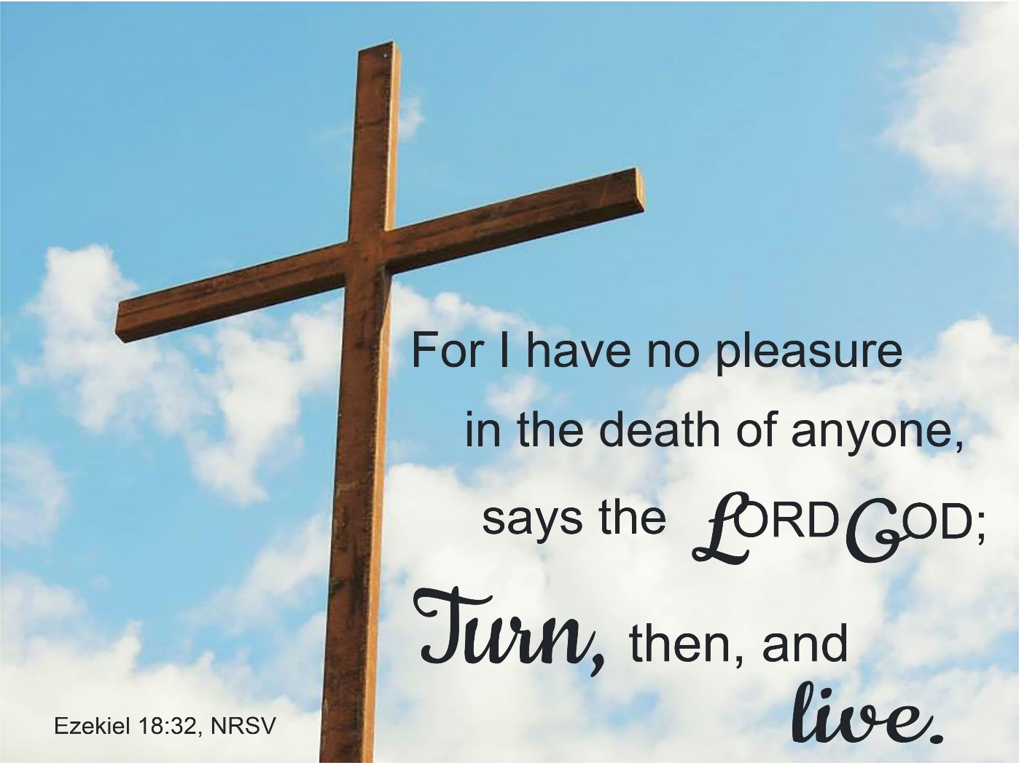

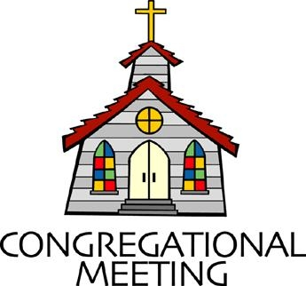
September 27, 2026 - 10:30 am

WELCOME VISITORS!

We're glad you are here! Cards at the ends of each pew are for you to fill out and drop in the Offering Plate. Please let us know you are visiting and join us for refreshments and fellowship following the service. The Sanctuary has an induction loop system to assist the hearing impaired. The system will also work on the telephone setting of hearing aids.

Springfield Presbyterian Church is rooted in the gospel of Jesus Christ, led by the Holy Spirit, and called to loving relationships through vibrant worship and service. Valuing all people, we are committed to developing disciples and fostering stewardship.
PREPARATION FOR THE WORD
(* those who are able are invited to stand)

PRELUDE

PASTOR’S WELCOME

GATHERING OF THE PEOPLE

The Lord be with you! And also with you! (Greetings and Announcements)

LIGHTING THE CHRIST CANDLE
Leader: Whenever we light this candle we proclaim:
People: Christ is the Light of the world and the center of our lives.

CALL TO WORSHIP
Leader: God calls us to worship together,
All: when we are tired or grumpy, hungry or thirsty.
Leader: God calls us to worship
All: when we are full of energy, ready to praise God!
Leader: God calls us to worship
All: when we ask, “Why?”
Leader: God calls us to worship
All: when we are sad and lonely, or grateful and joyful.
Leader: God calls us to worship together today:
All: Let us worship God!

* HYMN Come, Thou Fount of Every Blessing GTG #475

Come, thou Fount of every blessing; tune my heart to sing thy grace;
Streams of mercy, never ceasing, call for songs of loudest praise.
Teach me some melodious sonnet, sung by flaming tongues above;
Praise the mount! I’m fixed upon it, mount of God’s unchanging love!

Here I raise my Ebenezer; hither by thy help I’m come;
And I hope, by thy good pleasure, safely to arrive at home.
Jesus sought me when a stranger, wandering from the fold of God;
He, to rescue me from danger, interposed his precious blood.

O to grace how great a debtor daily I’m constrained to be!
Let that grace now, like a fetter, bind my wandering heart to thee.
Prone to wander, Lord, I feel it, prone to leave the God I love;
Here’s my heart; O take and seal it; seal it for thy courts above.

CALL TO CONFESSION
Leader: We all make mistakes. Yet God calls us to repent, to say we’re sorry, and to turn towards God. Together, let’s turn towards the back of the sanctuary as a posture of repentance or turning. Please join me in the Unison Prayer for Forgiveness:

UNISON PRAYER FOR FORGIVENESS
We sometimes use our words to hurt others. We twist our words to avoid telling the truth. We yell and argue rather than cooperate. We do not always make brave space to be honest with love. We insist on our own way. Forgive us. Give us new hearts and new words. Turn us away from evil - turn us toward you. Teach us better ways to live: to love each other as you love us. As we offer to God in silence what we would rather not say out loud, let us turn back towards the front of the room to respond.

SILENT PRAYERS OF CONFESSION

RESPONSE Hear My Prayer, O God GTG #782 (v. 1)
Hear my prayer, O God, and listen to my plea;
Faithful, righteous One, give ear and answer me.
Judge me not, I pray; no merit dare I claim;
Knowing my own faults, I trust in your just Name.

WORDS OF ASSURANCE
Heather: Friends, no matter how far we stray from God’s path; no matter how many times we mess up, God will not turn away from us. Hear the good news of the Gospel: In Jesus, we are not alone. God loves us. God forgives us. Thanks be to God, Amen.

* MUSICAL RESPONSE OF PRAISE O, For a Thousand Tongues to Sing
GTG #610 (v.5)
To God all glory, praise and love be now and ever given,
By saints below and saints above, the church in earth and heaven.

* THE PEACE The peace of Christ be with you! And also with you!
(You may greet those around you.)

* RESPONSE Here I Am, Lord GTG #69
Here I am, Lord. Is it I, Lord? I have heard you calling in the night.
I will go, Lord, if you lead me. I will hold your people in my heart.

THE PROCLAMATION OF THE WORD

PRAYER OF ILLUMINATION
Leader: God our teacher, by your Holy Spirit, open our minds, that as the scriptures are read, and your word is proclaimed, the scales may fall from our eyes, and the light of understanding may shine on us, so that we might walk in your ways and glorify your holy name, for the sake of Jesus Christ our Savior. Amen.

FIRST READING: Psalm 25:1-9 OT page 475
¹To you, O Lord, I lift up my soul. ²O my God, in you I trust; do not let me be put to shame; do not let my enemies exult over me. ³Do not let those who wait for you be put to shame; let them be ashamed who are wantonly treacherous.
⁴Make me to know your ways, O Lord; teach me your paths. ⁵Lead me in your truth, and teach me, for you are the God of my salvation; for you I wait all day long. ⁶Be mindful of your mercy, O Lord, and of your steadfast love, for they have been from of old. ⁷Do not remember the sins of my youth or my transgressions; according to your steadfast love remember me, for your goodness' sake, O Lord! ⁸Good and upright is the Lord; therefore he instructs sinners in the way. ⁹He leads the humble in what is right, and teaches the humble his way.

TIME FOR ALL GOD’S CHILDREN

SECOND READING: Ezekiel 18:1-4, 25-32 OT page 737
¹The word of the Lord came to me: ²What do you mean by repeating this proverb concerning the land of Israel, "The parents have eaten sour grapes, and the children's teeth are set on edge"? ³As I live, says the Lord God, this proverb shall no more be used by you in Israel. ⁴Know that all lives are mine; the life of the parent as well as the life of the child is mine: it is only the person who sins that shall die.

²⁵Yet you say, "The way of the Lord is unfair." Hear now, O house of Israel: Is my way unfair? Is it not your ways that are unfair? ²⁶When the righteous turn away from their righteousness and commit iniquity, they shall die for it; for the iniquity that they have committed they shall die. ²⁷Again, when the wicked turn away from the wickedness they have committed and do what is lawful and right, they shall save their life. ²⁸Because they considered and turned away from all the transgressions that they had committed, they shall surely live; they shall not die.
²⁹Yet the house of Israel says, "The way of the Lord is unfair." O house of Israel, are my ways unfair? Is it not your ways that are unfair? ³⁰Therefore I will judge you, O house of Israel, all of you according to your ways, says the Lord God. Repent and turn from all your transgressions; otherwise iniquity will be your ruin.
³¹Cast away from you all the transgressions that you have committed against me, and get yourselves a new heart and a new spirit! Why will you die, O house of Israel? ³²For I have no pleasure in the death of anyone, says the Lord God. Turn, then, and live.

Leader: This is the Word of the Lord. All: Thanks be to God.

SERMON Learning to Love Our Enemies: Loving the Enemy Within By Heather Russell

THE RESPONSE TO THE WORD

* HYMN Wild and Lone the Prophet’s Voice GTG #163

Wild and lone the prophet's voice echoes through the desert still,
Calling us to make a choice, bidding us to do God's will:
"Turn from sin and be baptized; cleanse your heart and mind and soul.
Quitting all the sins you prized, yield your life to God's control.
"Bear the fruit repentance sows: lives of justice, truth, and love.
Trust no other claim than those; set your heart on things above.
Soon the Lord will come in power, burning clean the threshing floor:
Then will flames the chaff devour; wheat alone shall fill God's store."

With such preaching, stark and bold, John proclaimed salvation near,
And his timeless warnings hold words of hope to all who hear.
So we dare to journey on, led by faith through ways untrod,
Till we come at last like John to behold the Lamb of God.

RECEIVING NEW MEMBERS
Heather: Hear these words from scripture: There is one body and one Spirit, just as you were called to the one hope of your calling,
All: One Lord, one faith, one baptism, one God and Father of all, who is above all and through all and in all.

PROFESSION OF FAITH
Heather: As members of the body of Christ, please stand, in body or in spirit, and let us reaffirm the faith into which we were baptized:

APOSTLES’ CREED
I believe in God, the Father almighty, creator of heaven and earth.
I believe in Jesus Christ, God’s only son, our Lord, who was conceived by the Holy Spirit, born of the Virgin Mary, suffered under Pontius Pilate, was crucified, died, and was buried; he descended to the dead.
On the third day he rose again; he ascended into heaven, he is seated at the right hand of the Father, and he will come to judge the living and the dead.
I believe in the Holy Spirit, the holy catholic church, the communion of saints, the forgiveness of sins, the resurrection of the body, and the life everlasting. Amen.

PRAYERS OF THE PEOPLE AND THE LORD’S PRAYER
Our Father, who art in heaven, hallowed be thy name, thy kingdom come, thy will be done, on earth as it is in heaven. Give us this day our daily bread; and forgive us our debts, as we forgive our debtors; and lead us not
into temptation, but deliver us from evil. For thine is the kingdom, and the power, and the glory, forever, Amen.
PRESENTATION OF TITHES AND OFFERINGS
OFFERTORY Stained Glass
* SONG OF THANKS Great God of Every Blessing GTG #694 (v. 1)
Great God of every blessing, of faithful, loving care,
You are the fount of goodness, the daily bread we share.
How can we hope to thank you? Our praise is but a start:
Sincerely and completely I offer you my heart.
* PRAYER OF DEDICATION

* HYMN All Hail the Power of Jesus’ Name! GTG #263

All hail the power of Jesus' name! Let angels prostrate fall;
Bring forth the royal diadem, and crown him Lord of all!
Bring forth the royal diadem, and crown him Lord of all!

Ye chosen seed of Israel's race, ye ransomed from the fall,
Hail him who saves you by his grace, and crown him Lord of all!
Hail him who saves you by his grace, and crown him Lord of all!

Let every kindred, every tribe on this terrestrial ball
To him all majesty ascribe, and crown him Lord of all!
To him all majesty ascribe, and crown him Lord of all!

O that with yonder sacred throng we at his feet may fall!
We'll join the everlasting song, and crown him Lord of all!
We'll join the everlasting song, and crown him Lord of all!

* CHARGE AND BENEDICTION
Heather: As you go out from here, love one another with mutual affection; outdo one another in showing honor. Live in harmony with one another, rejoice in hope, be patient in affliction, persevere in prayer. Love and serve the Lord, in the name of the Father, and of the Son, and of the Holy Spirit, Amen.

* UNISON AMEN GTG #601

POSTLUDE

Some liturgy adapted from Child Of Blessing Lectionary Resource, Presbyterian Association of Musicians
Sunday, October 4 Lectionary:
Isaiah 5:1-7; Psalm 80:7-15; Philippians 3:4b-14; Matthew 21:33-46

Assisting in Worship: We appreciate those who serve:

Today 9/27 Next Week 10/4
Sunday Opener: Barbara Cornell Beth Oates
Ushers/Greeters: Sharon Pappas Tim & Beth Oates
Leah Halvorson
Lay Leader: Mark Chaplik Barbara Cornell
Communion Servers: Mark Kearney
Sharon Pappas
Don Vasbinder
Bobby Barrett
Barbara Nickell
Offering Counters: Mark C. & Volunteer Beth O. & Christy Y.
Fellowship Hosts: Sharon Pappas Rebekah Schermer

Announcements

New Members: We welcome two new members, Linda Craig and Sage von Marko, to our congregation today:

Linda Craig grew up in Omaha, Nebraska and graduated from St. Louis University to become a math and English teacher in Jacksonville, Florida. After a series of career changes including grocery store manager, (which brought her back to Nebraska), real estate broker and loan officer, she met the love of her life and spent 26 wonderful years married to Will Craig. Upon his passing, she moved to Naples, Florida where they had been snow birds, and for nine years hosted her extended family on “close to the beach” vacations. When it became clear that Naples was too far away to share the joys of the growing family, she moved closer and found a new home at Fairhaven. Of her two stepdaughters, five grandchildren and thirteen great grand kids, eight are within easy driving distance here. She is delighted to have found Springfield Presbyterian Church to help her on her continuing journey.
Sage von Marko is coming to Springfield Presbyterian Church from First Presbyterian Church of Westminster. She is 23 years old and lives with her family in Taneytown, MD. In her free time, she likes to go on long walks, read, and make art. Sage joined this church to be with her mom, Heather Russell, who is the Ministry Associate/Pastor here at Springfield. She hopes to continue to make new friends here and is excited to become a new member!

Heather’s Ordination: Heather’s ordination service will be held TODAY at
4:00 pm at First Presbyterian Church of Westminster. All are invited to attend! There will be a meal following the service.

Connie’s Celebration of Life: Connie Gibbons’ celebration of life will be held on Friday, October 2 at 10:30 am here in our Sanctuary, followed by a reception at Liberatore’s Restaurant at 6300 Georgetown Boulevard in Eldersburg. All are welcome to attend.

World Communion Sunday: The World Communion Offering (formerly Peace and Global Witness), received on October 4 and October 11, works to ensure all God’s people flourish as God intends through ministries working for racial justice, gender justice, peacemaking, global witness, and ecumenical and interfaith relations.

Book Group: During the month of October, we will meet three times to discuss the book "How We Learn to Be Brave", by Mariann Edgar Budde. Budde is the first woman to serve as the Bishop of the Episcopal Diocese of Washington, a
position she has held since her consecration in November 2011. A vocal advocate for social justice, Budde has focused on issues such as racial equity, gun violence prevention, immigration reform, LGBTQ+ inclusion, and environmental stewardship. Please purchase your own book, or check out a copy from the library. We will meet 10/4, 10/11, and 10/18 for discussion in the Manse after fellowship time, for about an hour. Please let Heather know if you plan to join the group.

Sykesville Middle School – Supplies Donations: We would like to thank our amazing and generous congregation! On 9/10, we were able to deliver quite a nice pile of needed items to Sykesville Middle School. Needless to say… they were beyond grateful and once again noted how very much these items were needed for their students. We received big thank yous and hugs for the donations. As always, you have stepped up to the plate to make this important cause such a success. We thank you from the bottom of our backpacks!

We also received a handwritten thank you note and a thank you letter from the Carroll County School Superintendent for the $251 we sent to help with student lunch debt at Sykesville Middle School. ~ Sincerely, The CoCaMO Committee

Livestreaming Coming Soon! We will be moving to livestreaming on YouTube over the next several weeks. If you have any concerns about this, please see Heather. We will continue to have Zoom as an option, as well.

Congregational Care: If you know of someone who would benefit from a card or a phone call, please text or call Diana Steppling at 862-266-2242.

Electronic Giving: Below is a QR code you can scan to make your contribution a new way! The page you get will ask for your name, email and phone

number. You can choose from a dropdown menu for selecting where the donation should go: General Fund, Capital Fund, Concert, Memorial. There is a fee for using a credit card, and you will be given the option to pay that fee along with your donation, but you don’t have to include it if you don’t want to.

Today:
Sunday September 27
10:30 am Worship
11:30 am Fellowship
4:00 pm Heather’s Ordination
(First Presbyterian of Westminster)

This Week:
Tuesday September 29
7:00 pm ESCAPE Lunch Packing (Manse)
Wednesday September 30
6:15 pm Bell Choir Practice
7:30 pm Adult Choir Practice
Friday October 2
10:30 am Connie Gibbons’ Celebration of Life (Sanctuary)
11:30 am Reception (Liberatore’s Restaurant, Sykesville)

Next Week:
Sunday October 4
10:30 am Worship
11:30 am Fellowship
12:00 noon Finance Committee Meeting (Library)
1:00 pm Book Group (Manse)
Monday October 5
7:00 pm Headhuggers (Manse)
Wednesday October 7
6:15 pm Bell Choir Practice
7:30 pm Adult Choir Practice
Thursday October 8
7:00 pm Session Meeting (Manse)

Heather’s In Office Hours: Tuesday, Friday, Sunday
8:30 am – 2:00 pm
Heather’s Home Office Hours: Wednesday, Thursday
8:30 am – 2:00 pm
Heather’s Sabbath Day: Mondays

Reminder: In case of an emergency, please contact Heather directly: springfieldpres.pastor@gmail.com
cell 443-280-9712 (texts welcomed, please identify yourself)


Springfield Presbyterian Church
10:30 am Worship
11:30 am Fellowship
Website: www.springfield-church.org Church Office: 410-795-6152
Like us on Facebook: www.facebook.com/SpringfieldPresbyterianChurch
Ministry Associate: Heather Russell von Marko
Email: springfieldpres.pastor@gmail.com
Clerk of Session: Sharon Pappas
Music Director: Robin Kochanski
Accompanist: Michael Hall
Office Manager: Donna Mazer
Email: springfieldpres.office@gmail.com

