(Large Print)

Springfield Presbyterian Church (USA)
7300 Spout Hill Road, Sykesville, MD 21784 410-795-6152

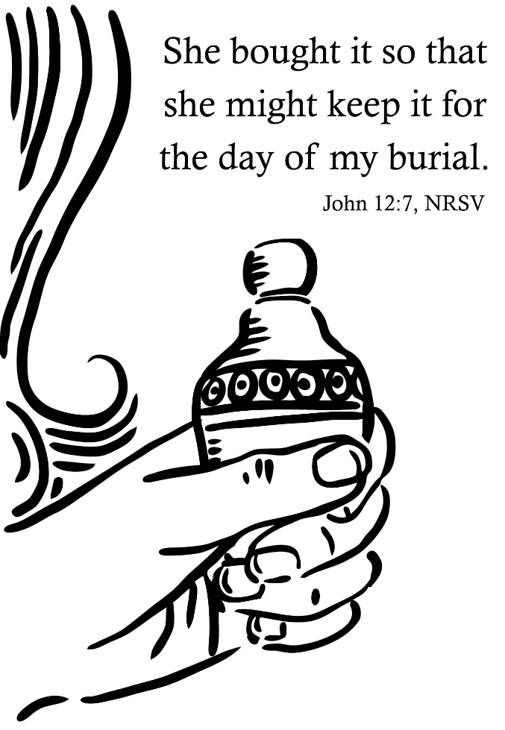

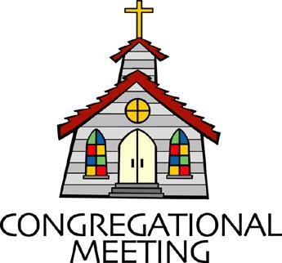
April 7, 2019 - 10:30 am

WELCOME VISITORS! We're glad you are here! Cards at the ends of each pew are for you to fill out and drop in the Offering Plate. Please let us know you are visiting, and join us for refreshments and fellowship following the service. The Sanctuary has an induction loop system to assist the hearing impaired. The system will also work on the telephone setting of hearing aids.

Springfield Presbyterian Church is rooted in the gospel of Jesus Christ, led by the Holy Spirit, and called to loving relationships through vibrant worship and service. Valuing all people, we are committed to developing disciples and fostering stewardship.
PREPARATION FOR THE WORD
(* those who are able are invited to stand)

Please prepare for worship by listening to the music of the Prelude.

PRELUDE

GATHERING OF THE PEOPLE

The Lord be with you! And also with you! (Greeting)

LIGHTING THE CHRIST CANDLE
Leader: Whenever we light this candle we proclaim:
People: Christ is the Light of the world and the center of our lives.

CALL TO WORSHIP [Psalm 126]
Leader: When the Lord restored the fortunes of Zion,
People: We were like those who dream.
Leader: Our mouths were filled with laughter,
People: Our tongues with shouts of joy;
Leader: Then it was said among the nations,
People: “The Lord has done great things for them.” The Lord has done great things for us and we rejoiced.
Leader: Restore our fortunes, O Lord. May those who sow in tears,
People: May they reap with shouts of joy.
Leader: May those who go out weeping, bearing the seed for sowing,
People: May they come home with shouts of joy.
ALL: We worship our God of abundance and faithfulness!

* HYMN Guide Me, O Thou Great Jehovah
Guide me, O thou great Jehovah, pilgrim through this barren land.
I am weak, but thou art mighty. Hold me with thy powerful hand.
Bread of heaven, bread of heaven, feed me till I want no more;
Feed me till I want no more.
Open now the crystal fountain, whence the healing stream doth flow.
Let the fire and cloudy pillar lead me all my journey through.
Strong deliverer, strong deliverer, be thou still my strength and shield;
Be thou still my strength and shield.

When I tread the verge of Jordan, bid my anxious fears subside.
Death of death, and hell's destruction, land me safe on Canaan's side.
Songs of praises, songs of praises, I will ever give to thee;
I will ever give to thee.

PRAYER OF CONFESSION
Gracious God, we want to jump ahead, to jump to the moment of resurrection and excitement without walking through these dark times. Yet, you share with us that it is only in dark that we can acknowledge the light. Forgive us when we are not obedient in following this Lenten road of learning, study, and faithfulness. Redeem and renew us again to this time, restoring our faith, and guiding us by the power of your Holy Spirit. Amen.

SILENT PRAYERS OF CONFESSION

RESPONSE O Lord, Hear My Prayer (sing two times)
O Lord, hear my prayer. O Lord, hear my prayer. When I call, answer me.
O Lord, hear my prayer. O Lord, hear my prayer. Come and listen to me.

WORDS OF ASSURANCE
Leader: Jesus knows our every weakness, and loves us still. Awaken to the promise of Christ’s amazing grace.
People: We believe the good news of the gospel – in Jesus Christ we are forgiven! Amen!

* MUSICAL RESPONSE OF PRAISE Magnificat (sung in the round)
Magnificat. Magnificat. Magnificat anima mea Dominum.
Magnificat. Magnificat. Magnificat anima mea!
(Translation: Sing out, my soul. Sing out, my soul. Sing out and glorify the Lord who sets us free. Sing out, my soul. Sing out, my soul. Sing out and glorify the Lord God!)

* THE PEACE The peace of Christ be with you! And also with you!
(You may greet those around you.)

* RESPONSE Here I Am, Lord
Here I am, Lord, Is it I, Lord? I have heard you calling in the night.
I will go, Lord, if you lead me. I will hold your people in my heart.

THE PROCLAMATION OF THE WORD

PRAYER OF ILLUMINATION
O Lord, your Word is a lamp to our feet and a light to our path. Give us grace to receive your truth in faith and love, and strength to follow on the path you set before us; through Jesus Christ, Amen.

FIRST SCRIPTURE LESSON Isaiah 43:16-21
¹⁶ Thus says the Lord, who makes a way in the sea, a path in the mighty waters, ¹⁷ who brings out chariot and horse, army and warrior; they lie down, they cannot rise, they are extinguished, quenched like a wick:
¹⁸ Do not remember the former things, or consider the things of old.
¹⁹ I am about to do a new thing; now it springs forth, do you not perceive it? I will make a way in the wilderness and rivers in the desert.
²⁰ The wild animals will honor me, the jackals and the ostriches; for I give water in the wilderness, rivers in the desert, to give drink to my chosen people, ²¹ the people whom I formed for myself so that they might declare my praise.

SECOND SCRIPTURE LESSON John 12:1-8
Six days before the Passover Jesus came to Bethany, the home of Lazarus, whom he had raised from the dead. ²There they gave a dinner for him. Martha served, and Lazarus was one of those at the table with him. ³Mary took a pound of costly perfume made of pure nard, anointed Jesus’ feet, and wiped them with her hair. The house was filled with the fragrance of the perfume. ⁴But Judas Iscariot, one of his disciples (the one who was about to betray him), said, ⁵‘Why was this perfume not sold for three hundred denarii and the money given to the poor?’ ⁶(He said this not because he cared about the poor, but because he was a thief; he kept the common purse and used to steal what was put into it.) ⁷Jesus said, ‘Leave her alone. She bought it so that she might keep it for the day of my burial. ⁸You always have the poor with you, but you do not always have me.’

Leader: Hear what the Spirit is saying to the Church.
All: Thanks be to God.

TIME WITH YOUNG PEOPLE

SERMON The Sweet Smell of Hospitality Rev. Becca Crate

THE RESPONSE TO THE WORD

* HYMN Savior, An Offering Costly and Sweet

Savior, an offering costly and sweet Mary of Bethany laid at your feet;
May our love’s incense rise sweeter than sacrifice.
Savior to you, dear Savior to you.

Daily our lives would show weakness made strong,
Toilsome and gloomy ways brightened with song,
Some deeds of kindness done, some souls by patience won,
Savior to you, dear Savior to you.
Some word of hope for hearts burdened with fears,
Some balm of peace for eyes swollen with tears,
Some dews of mercy shed, some wayward footsteps led,
Savior to you, dear Savior to you.

Thus, ever serving you, till eventide closes the day of life,
May we abide; and when earth’s labors cease, bid us depart in peace,
Savior to you, dear Savior to you.

RECEPTION OF NEW MEMBERS

PRESENTATION
Leader: Hear these words from Scripture: There is one body and one Spirit, just as you were called to the one hope of your calling,
People: One Lord, one faith, one baptism, one God and Creator of all, who is above all and through all and in all.

* PROFESSION OF FAITH The Apostles’ Creed (unison)
I believe in God, the Father almighty, Maker of heaven and earth, and in Jesus Christ his only Son, our Lord; who was conceived by the Holy Ghost, born of the Virgin Mary, suffered under Pontius Pilate, was crucified, dead, and buried; he descended into hell; the third day he rose again from the dead; he ascended into heaven, and sitteth on the right hand of God the Father Almighty; from thence he shall come to judge the quick and the dead. I believe in the Holy Ghost; the holy catholic church; the communion of saints; the forgiveness of sins; the resurrection of the body; and the life everlasting. Amen.

WELCOME

RESPONSE Take My Life (verse 5)
Take my will and make it thine; it shall be no longer mine.
Take my heart, it is thine own; it shall be thy royal throne,
It shall be thy royal throne.

THE COMMUNION OF THE PEOPLE

INVITATION

THE GREAT PRAYER OF THANKSGIVING
Leader: The Lord be with you.
People: And also with you.
Leader: Lift up your hearts.
People: We lift them up to the Lord.
Leader: Let us give thanks to the Lord our God.
People: It is right to give our thanks and praise.
[The Pastor continues… “…who forever sing to the glory of your name.”]

IN PRAISE OF GOD Tune #552
Holy, holy, holy, Lord, God of Power and might.
Heaven and earth are full of your glory, Hosanna in the highest!
Blessed is He who comes in the name of the Lord.
Hosanna in the highest, hosanna in the highest.
[The Pastor continues… “…proclaim the One crucified and risen...”]

IN PRAISE OF CHRIST Tune #553
Christ has died; Christ is risen; Christ will come again.
Christ has died; Christ is risen; Christ will come again.

PASTORAL PRAYER AND THE LORD’S PRAYER
“For this I pray to God.” / “For this I give thanks to God.”
Congregational Response: “Hear our prayer, O God.”

WORDS OF INSTITUTION

SHARING OF THE MEAL

PRAYER OF DEDICATION (Unison)
Dear God, take us out to live as changed people because we have shared the living bread and cannot remain the same. Ask much of us, expect much from us, enable much by us, encourage many through us. So, Lord, may we live to your glory, both as inhabitants of the earth, and citizens of the commonwealth of Heaven. Through Christ, with Christ, in Christ, in the unity of the Holy Spirit, all glory and honor are yours, almighty God, now and forever. Amen.

PRESENTATION OF TITHES AND OFFERINGS
OFFERTORY
* SONG OF THANKS In the Lord I’ll Be Ever Thankful
In the Lord I’ll be ever thankful; in the Lord I will rejoice!
Look to God; do not be afraid. Lift up your voices; the Lord is near.
Lift up your voices; the Lord is near.
* PRAYER OF DEDICATION

* HYMN My Hope Is Built on Nothing Less

My hope is built on nothing less than Jesus' blood and righteousness;
I dare not trust the sweetest frame, but wholly lean on Jesus' name.

Refrain:
On Christ, the solid Rock, I stand; all other ground is sinking sand;
All other ground is sinking sand.

When darkness seems to hide his face, I rest on his unchanging grace;
In every high and stormy gale, my anchor holds within the veil. [Refrain]

His oath, his covenant, his blood support me in the whelming flood;
When all around my soul gives way, he then is all my hope and stay. [Refrain]

When he shall come with trumpet sound,
O may I then in him be found, dressed in his righteousness alone,
Faultless to stand before the throne. [Refrain]

* CHARGE AND BENEDICTION
Leader: It is down this road we must go,
People: To journey with Christ on the road to Calvary.
Leader: With sweet perfume and adoration,
People: We worship the one who foresees.
Leader: So we follow with hushed voices,
People: To where the palms and passion lies.

* UNISON AMEN

POSTLUDE

Sunday April 14 Lectionary
Palms: Luke 19:28-40; Psalm 118:1-2, 19-29
Passion: Isaiah 50:4-9a; Psalm 31:9-16; Philippians 2:5-11;
Luke 22:14-23:56 or Luke 23:1-49
Assisting in Worship: We appreciate those who serve:

Today 4/7 Next Week 4/14
Sunday Opener Bob Rogers Ron Holmes
Greeters & Ushers Sharon Pappas & Connie Robinson &
Martha Streaker Ed Newsome
Lay Leader Elizabeth Meirowitz Max Carroll
Sunday School Connie Robinson Connie Robinson
Fellowship Brittany & Danny Rachin Palm Sunday Bake Sale

Communion Servers Today:
1. Linda Black 4. Don Vasbinder
2. Connie Robinson 5. Sharon Pappas
3. Diana Steppling

Church Attendance: March 24 – 53 March 31 - 41

Church Cleaning: April 19, 20 or 21 – Ron & Sue Holmes

Happy Birthday!
April 3 – Barbara Cornell April 10 – Michelle Newsome
April 3 – India Oates April 12 – Lisa Rogers
April 7 – Wes McClung April 13 – Kelsey Robinson

Announcements

Called Congregational Meeting: On Sunday, April 14 immediately after Worship, we will meet to elect new officers. Session fulfills all of the duties of trustees, deacons and elders, and we are delighted that Sue Holmes, Julie Ballard and Don Vasbinder have agreed to join us for the Class of 2021. Terms are for two years, elders are eligible for a second term, and we are pleased that Sue will serve a second term. At this congregational meeting, we will also name a youth member for the 2019-2020 year.
Blessing Bags are in the Narthex. Please feel free to pick up a few. Handing one out to someone in need gives you a very real way to meet their immediate needs by providing them with some basic supplies.

Spring Clean-Up: A big THANK YOU to the many hands who came out yesterday to clean-up around the Church and Manse!

Giving Opportunities: Over the next several weeks there are three offerings. We want you to know about all three if you would like to participate in them along with your regular pledge.
- Heifer International has been supported by our Sunday school and Youth programs. Last year the money given now and at CIA Camp was used to buy a llama. This year Heifer is matching donations and we hope to buy goats(s).
- A new offering received on fifth Sundays (there are four this year) is an opportunity to empty your loose change, making a Noisy Offering. This will be collected by our youth and will support the work of our Mission/Outreach Committee. (Our musicians will work with this new sound element.)
- Presbytery’s One Great Hour of Sharing is collected on April 14 and 21. This offering supports Presbyterian Disaster Relief, global hunger relief, and self-development of people programs.

Bake Sale: Next Sunday, Palm Sunday, is our bake sale to benefit the Camp and Conference Fund. We need bakers and eaters! We also need youth to man the table. Please see Connie Robinson if you can help.

C.I.A. (Community In Action) will meet on April 15 from 4:30-6 pm at the Manse. Pizza and drinks provided. Friends are welcome and encouraged to attend! C.I.A is a group open to all religious and non-religious people as a means of providing the community with acts of kindness. We will be doing different activities throughout the school year to help people in our community who are in need. Come and be part of giving back to our community. We need Easter eggs and candy for the youth to prepare for Easter. Please drop off your donations in the Narthex or the Manse.

Weekly Announcements: If you have an announcement to include with next week’s bulletin, please call the Office at 410-795-6152 or email to spc.office@verizon.net by Wednesday each week.

Easter Vigil: We have had some interest expressed in holding an Easter Vigil this year. It's been some time since we did this, and I am trying to find out how much interest there is. I have posted a sign-up sheet with one-hour time periods through the event. How have we observed the Easter Vigil? The Sanctuary would be open from 9 pm Saturday, April 20 through 8 am Sunday, April 21 (Easter) if there is enough interest in the idea. People will sign up for an hour to come to the Sanctuary to meditate, sing, pray or just be, as we await Easter morning. We will provide meditative music, materials for reading and reflection, and candles which may be lit as you spend some quiet time with God in anticipation of the resurrection of our Lord, Jesus Christ.
We will also arrange to have someone in the Fellowship Room for the night as a "watch person" so that no one will be completely alone in the building. Please sign-up or speak to Linda Caviglia or Rev. Crate if you are interested and/or want more information.

The Congregational Care team wants to know what YOU or someone you know needs...a visit...a call...a meal. Please contact Diana Steppling or Connie Robinson.

Prayers & Thanksgivings

~ Prayers for Mt. Paran Presbyterian Church from our Ministry Group.

Today:
Sunday April 7
10:30 am Worship & Sunday School
11:30 am Fellowship
4:00 pm Confirmation Class

This Week:
Monday April 8
7:00 pm HeadHuggers (Manse)
Tuesday April 9
10:30 am Prayer Group (Manse)
Wednesday April 10
6:30 pm Bell Choir Practice
7:45 pm Adult Choir Practice
Thursday April 11
7:00 pm Session Meeting (Manse)

Looking Ahead:
Sunday April 14 – Palm Sunday
10:30 am Worship & Sunday School
11:30 am Fellowship & Bake Sale
3:00 pm Concert
6:30 pm Youth Movie Night
Monday April 15
9:30 am Feed My Sheep (Wesley Freedom)
4:30 pm C.I.A. Meeting (Manse)
Thursday April 18 – Maundy Thursday
7:30 pm Worship

Office Hours: Tuesday, Wednesday, Friday 9:00 am - 3:00 pm
Springfield Presbyterian Church

10:30 am Worship & Sunday School
11:30 am Fellowship
Website: www.springfield-church.org Church Office: 410-795-6152
Like us on Facebook: www.facebook.com/SpringfieldPresbyterianChurch
Pastor: Rev. Becca Crate
Email: springfieldpastor@gmail.com
Clerk of Session: Sharon Pappas
Minister of Music: Linda Caviglia
Accompanist: Aaron Thacker Organist: Jennifer Wise
Youth Group Coordinators: Charles & Deb Sperling
Sunday School Coordinator: Connie Robinson
Administrative Assistant: Donna Mazer
e-mail: spc.office@verizon.net

