(Large Print)

Springfield Presbyterian Church (USA)
7300 Spout Hill Road, Sykesville, MD 21784 410-795-6152

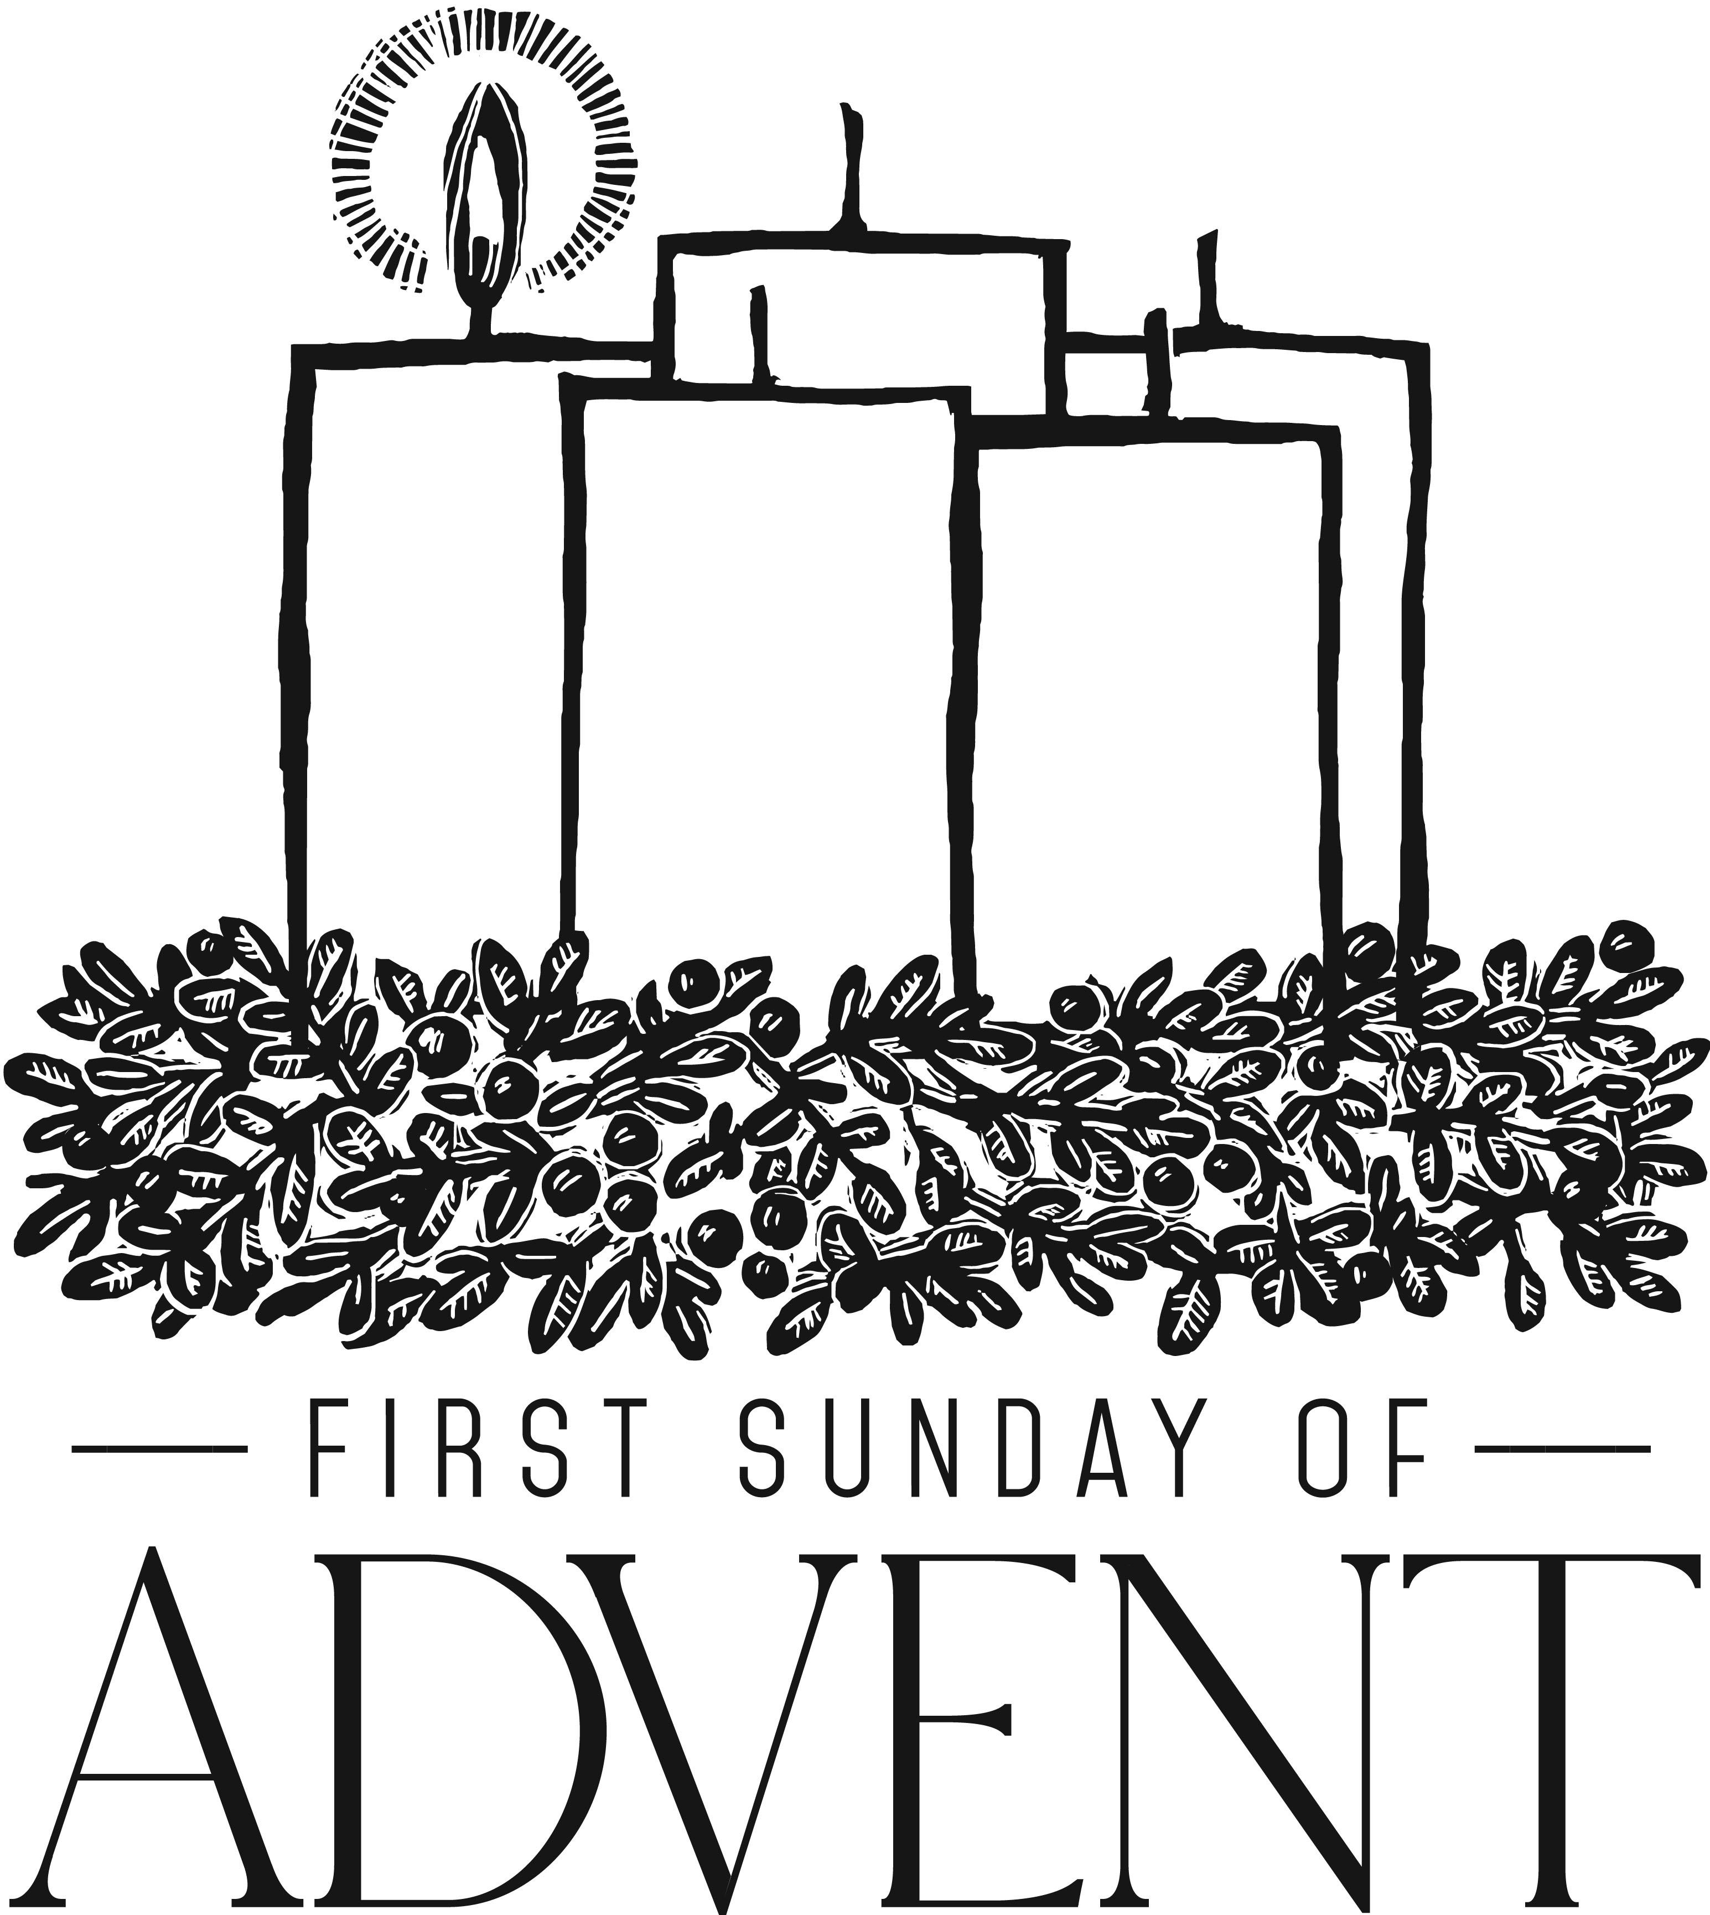

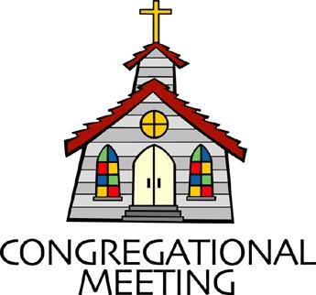
December 2, 2018 - 10:30 am

WELCOME VISITORS! We're glad you are here! Cards at the ends of each pew are for you to fill out and drop in the Offering Plate. Please let us know you are visiting, and join us for refreshments and fellowship following the service. The Sanctuary has an induction loop system to assist the hearing impaired. The system will also work on the telephone setting of hearing aids. A head set is available upon request.

Springfield Presbyterian Church is rooted in the gospel of Jesus Christ, led by the Holy Spirit, and called to loving relationships through vibrant worship and service. Valuing all people, we are committed to developing disciples and fostering stewardship.
PREPARATION FOR THE WORD
(* those who are able are invited to stand)

Please prepare for worship by listening to the music of the Prelude.

PRELUDE Lo, How a Rose arr. by Lani Smith

GATHERING OF THE PEOPLE

The Lord be with you! And also with you! (Greeting)

ADVENT CANDLE LIGHTING
Choir sings: Light the Candle (reading and candle lighting during music)
Advent Reading - Week 1 Hope [Jeremiah 29:11]
The promises of God are promises of hope. “For surely I know the plans I have for you, says the Lord, plans for your welfare and not for harm, to give you a future with hope.” (Attributed to Bernard of Clairvaux, 12th C.; translated by Edward Caswall, 1849)

Lighting of the Candle
O hope of every contrite heart; O joy of all the meek. To those who fall, how kind Thou art! How good to those who seek.

Congregation joins choir in singing: Light the Candle
Light the candle of HOPE today, the Giver of hope will come!
Welcome the hope we long and wait for, but only Christ can give.
Flicker and flame and glow - with hope, light up the world around you.
Flicker and flame and glow - with hope, light up the world around you.

CALL TO WORSHIP [From Psalm 25]
Leader: To you, O Lord, we lift up our souls.
People: O our God, in you we trust; do not let us be put to shame; do not let our enemies exult over us.
Leader: Do not let those who wait for you be put to shame;
People: Make us to know your ways, O Lord.
Leader: Teach us your paths.
People: Lead us in your truth, and teach us, for you are the God of our salvation and for you we will wait all day long.
Leader: Be mindful of your mercy, O Lord, and of your steadfast love, for they have been from of old.
People: Do not remember the sins of our youth or our transgressions; according to your steadfast love remember us.
Leader: Good and upright is the Lord; therefore He instructs sinners in the way.
People: He leads the humble in what is right, and teaches the humble His way.
ALL: All the paths of the Lord are steadfast love and faithfulness, for those who keep His covenant and His degrees. Let us worship our God!

* HYMN We Gather Together

We gather together to ask the Lord's blessing;
he chastens and hastens his will to make known;
the wicked oppressing now cease from distressing.
Sing praises to his name; he forgets not his own.

Beside us to guide us, our God with us joining,
ordaining, maintaining his kingdom divine;
so from the beginning the fight we were winning;
thou, Lord, wast at our side; all glory be thine!

We all do extol thee, thou leader triumphant,
and pray that thou still our defender wilt be.
Let thy congregation escape tribulation;
thy name be ever praised! O Lord, make us free!

PRAYER OF CONFESSION
God of the Future, you are coming in power to bring all nations under your rule. We confess that we have not expected your kingdom, for we live casual lives, ignoring your promised judgment. We accept lies as truth, exploit neighbors, abuse the earth, and refuse your justice and peace. In your mercy, forgive us. Grant us wisdom to welcome your way, and to seek things that will endure when Christ comes to judge the world. Amen.

SILENT PRAYERS OF CONFESSION

RESPONSE O Little Town of Bethlehem (verse 3)
How silently, how silently, the wondrous gift is given!
So God imparts to human hearts the blessings of His heaven.
No ear may hear His coming, but in this world of sin,
Where meek souls will receive Him, the dear Christ enters in.

WORDS OF ASSURANCE [From Psalm 103]
Leader: Do not fear, says the Lord, for I have redeemed you. I have called you by name; you are mine.
People: God is doing a new thing; now it springs forth! By the grace of Jesus Christ, we are forgiven! Amen.

* MUSICAL RESPONSE OF PRAISE Angels, from the Realms of Glory
All creation, join in praising God the Father, Spirit, Son,
Ever more your voices raising to the eternal Three in One:
Come and worship, come and worship, worship Christ the newborn King!

* THE PEACE The peace of Christ be with you! And also with you!
(You may greet those around you.)

* RESPONSE Here I Am, Lord
Here I am, Lord, Is it I, Lord? I have heard you calling in the night.
I will go, Lord, if you lead me. I will hold your people in my heart.

THE PROCLAMATION OF THE WORD

PRAYER OF ILLUMINATION
Dear God, prepare our hearts, O God, to accept your Word. Silence in us any voices but your own, so that we may hear your Word and also do it, through Christ our Lord. Amen.

FIRST SCRIPTURE LESSON Jeremiah 33:14-16
¹⁴The days are surely coming, says the Lord, when I will fulfil the promise I made to the house of Israel and the house of Judah. ¹⁵In those days and at that time I will cause a righteous Branch to spring up for David; and he shall execute justice and righteousness in the land. ¹⁶In those days Judah will be saved and Jerusalem will live in safety. And this is the name by which it will be called: ‘The Lord is our righteousness.’

SECOND SCRIPTURE LESSON Luke 21:25-36
²⁵ ‘There will be signs in the sun, the moon, and the stars, and on the earth distress among nations confused by the roaring of the sea and the waves. ²⁶People will faint from fear and foreboding of what is coming upon the world, for the powers of the heavens will be shaken. ²⁷Then they will see “the Son of Man coming in a cloud” with power and great glory. ²⁸Now when these things begin to take place, stand up and raise your heads, because your redemption is drawing near.’
²⁹Then he told them a parable: ‘Look at the fig tree and all the trees; ³⁰as soon as they sprout leaves you can see for yourselves and know that summer is already near. ³¹So also, when you see these things taking place, you know that the kingdom of God is near. ³²Truly I tell

you, this generation will not pass away until all things have taken place. ³³Heaven and earth will pass away, but my words will not pass away.
³⁴ ‘Be on guard so that your hearts are not weighed down with dissipation and drunkenness and the worries of this life, and that day does not catch you unexpectedly, ³⁵like a trap. For it will come upon all who live on the face of the whole earth. ³⁶Be alert at all times, praying that you may have the strength to escape all these things that will take place, and to stand before the Son of Man.’

Leader: Hear what the Spirit is saying to the Church.
All: Thanks be to God.

TIME WITH YOUNG PEOPLE

SERMON Awaiting Restoration Rev. Becca Crate

THE RESPONSE TO THE WORD

* HYMN Savior of the Nations, Come

Savior of the nations, come; virgin’s son, make here your home. Married now, O heaven and earth, that the Lord chose such a birth.

From God’s heart the Savior speeds; back to God his pathway leads; out to vanquish death’s command, back to reign at God’s right hand.

Now your manger, shining bright, hallows night with newborn light. Night cannot this light subdue; let our faith shine ever new.

Praise we sing to Christ the Lord, virgin’s son, incarnate Word!
To the holy Trinity praise we sing eternally.

THE SACRAMENT OF HOLY COMMUNION

INVITATION

THE GREAT PRAYER OF THANKSGIVING
Leader: The Lord be with you.
People: And also with you.
Leader: Lift up your hearts.
People: We lift them up to the Lord.
Leader: Let us give thanks to the Lord our God.
People: It is right to give our thanks and praise.

[The Pastor continues… “…who forever sing to the glory of your name.”]

IN PRAISE OF GOD Tune #581
Holy, holy, holy, Lord, God of Power and might.
Heaven and earth are full of your glory, Hosanna in the highest!
Blessed is He who comes in the name of the Lord.
Hosanna in the highest, hosanna in the highest.

[The Pastor continues… “and all creation might be restored.”]

IN PRAISE OF CHRIST Tune #582
Dying, you destroyed our death; rising, you restored our life.
Lord Jesus, come in glory.

PASTORAL PRAYER AND THE LORD’S PRAYER
“For this I pray to God.” / “For this I give thanks to God.”
Congregational Response: “Hear our prayer, O God.”

WORDS OF INSTITUTION

SHARING OF THE MEAL

PRAYER OF DEDICATION (Unison)
Dear God, take us out to live as changed people because we have shared the living bread and cannot remain the same. Ask much of us, expect much from us, enable much by us, encourage many through us. So, Lord, may we live to your glory, both as inhabitants of the earth, and citizens of the commonwealth of Heaven. Through Christ, with Christ, in Christ, in the unity of the Holy Spirit, all glory and honor are yours, almighty God, now and forever. Amen.

PRESENTATION OF TITHES AND OFFERINGS
OFFERTORY O Come, O Come Emmanuel
* SONG OF THANKS As with Gladness Men of Old
As they offered gifts most rare, at the manger rude and bare;
So may we with holy joy, pure, and free from sin’s alloy.
All our costliest treasures bring, Christ, to Thee, our heavenly King.
* PRAYER OF DEDICATION

* HYMN My Soul Cries Out with a Joyful Shout

My soul cries out with a joyful shout that the God of my heart is great, and my spirit sings of the wondrous things that you bring to the ones who wait. You fixed your sight on your servant’s plight, and my weakness you did not spurn, so from east to west shall my name be blest. Could the world be about to turn?

Refrain:
My heart shall sing of the day you bring. Let the fires of your justice burn. Wipe away all tears, for the dawns draws near, and the world is about to turn.

Though I am small, my God, my all, you work great things in me, and your mercy will last from the depths of the past to the end of the age to be. Your very name puts the proud to shame, and to those who would for you yearn, you will show your might, put the strong to flight, for the world is about to turn. [Refrain]

From the halls of power to the fortress tower, not a stone will be left on stone. Let the king beware for your justice tears every tyrant from his throne. The hungry poor shall weep no more, for the food they can never earn; there are tables spread; every mouth be fed, for the world is about to turn. [Refrain]

Though the nations rage from age to age, we remember who hold us fast: God’s mercy must deliver us from the conqueror’s crushing grasp. This saving word that our forebears heard is the promise which holds us bound, till the spear and rod can be crushed by God, who is turning the world around. [Refrain]

* CHARGE AND BENEDICTION

* UNISON AMEN

POSTLUDE [All are invited to stay and listen, but feel free to leave after the Unison Amen if you prefer.]

Sunday December 9 Lectionary
Malachi 3:1-4; Luke 1:68-79; Philippians 1:3-11; Luke 3:1-6
Assisting in Worship: We appreciate those who serve:

Today 12/2 Next Week 12/9
Sunday Opener Barbara Cornell Ron Holmes
Greeters & Ushers Amy Vasbinder & Jim Wise &
Bob Rogers Connie Robinson
Lay Leader Mark Kearney Tim Oates
Sunday School Connie Robinson Connie Robinson
Fellowship Advent Craft Fair Barbara Nickell

Communion Servers Today:
1. Tony Caviglia 4. Linda Black
2. Linda Caviglia 5. Bob Rogers
3. Barbara Nickell

Church Attendance: November 18 - 33 November 25 - 38

Church Cleaning: Dec. 14, 15 or 16 - Belle Vasbinder &
Barbara Nickell

Happy Birthday! December 3 - Angel Carbaugh
December 4 - Ryley Brown

Announcements

Advent Craft Fair/SERRV Sale: Our Advent Craft Fair/SERRV Sale will be TODAY after Worship - food, cotton candy, crafts, music, memories, and a special Christmas photo booth! Once again the Mission Committee has arranged for a consignment SERRV sale. Shop SERRV's unique, handcrafted, fair trade items from around the world. Fill your home and kitchen with authentic decor, handmade dishware and stunning handcrafted baskets. Adorn yourself with gorgeous fair trade jewelry, scarves and bags. Indulge in delicious chocolate and fair trade gourmet coffee. Give special fair trade gifts that will impact so many lives. Items sold through SERRV will help to fight poverty and build the communities of impoverished artisans and farmers. These artisans and farmers live in challenging circumstances and work diligently to provide for themselves and their families. SERRV items will also be available on December 16 and 23 after Worship.

C.I.A. (Community In Action): C.I.A. is a group open to all religious and non-religious people as a means of providing the community with acts of kindness. We will be doing different activities throughout the school year to help people in our community who are in need. Our next meeting will be on December 10 from 4:30 to 6:00 pm at the Manse. Pizza and drinks provided! We will be preparing for the Family Shelter Christmas party - we will wrap gifts, put together stockings and other holiday goodies.

Holy Cow’ Conversations Assessment: If you haven’t already done so, please complete the assessment on line (there are also pen and paper questionnaires available) to get a better sense of where the Spirit is leading us. We are looking forward to hearing your voice and kicking off the new year with the assessment in hand. It’s exciting to see where the Spirit will take us!

Gift Tree: The Christmas tree in the Narthex has gift tags for residents at Springfield Hospital. Please bring in unwrapped gifts to place under the tree by December 15. If you have any questions, please see Connie Robinson.

Weekly Announcements: If you have an announcement to include with next week’s bulletin, please call the Office at 410-795-6152 or email to spc.office@verizon.net by Wednesday each week.

Prayers & Thanksgivings

~ Prayers for 1st of Westminster from our Ministry Group.

The Congregational Care team wants to know what YOU or someone you know needs...a visit...a call...a meal. Please contact Diana Steppling or Connie Robinson.

Today:
Sunday December 2
9:00 am Red Sea Parting Practice
10:30 am Worship & Sunday School
11:30 am Advent Craft Fair & SERRV Sale

This Week:
Wednesday December 5
6:30 pm Bell Choir Practice
7:45 pm Adult Choir Practice

Looking Ahead:
Sunday December 9 - Second Sunday of Advent
9:00 am Red Sea Parting Practice
10:30 am Worship & Sunday School
11:30 am Fellowship
3:00 pm Concert - Iron Ridge Band (Bluegrass)
6:30 pm Youth Movie Night (Manse)
Monday December 10
4:30 pm C.I.A. Meeting (Manse)
7:00 pm Headhuggers (Manse)
Tuesday December 11
10:30 am Prayer Group (Manse)
7:00 pm ESCAPE Lunch Packing (Manse)

Office Hours: Tuesday, Wednesday, Friday 9:00 am - 3:00 pm
Springfield Presbyterian Church

10:30 am Worship & Sunday School
11:30 am Fellowship
Website: www.springfield-church.org Church Office: 410-795-6152
Like us on Facebook: www.facebook.com/SpringfieldPresbyterianChurch
Pastor: Rev. Becca Crate
Email: springfieldpastor@gmail.com
Clerk of Session: Sharon Pappas
Minister of Music: Linda Caviglia
Accompanist: Aaron Thacker Organist: Jennifer Wise
Youth Group Coordinators: Charles & Deb Sperling
Sunday School Coordinator: Connie Robinson
Administrative Assistant: Donna Mazer
e-mail: spc.office@verizon.net

