PREPARATION FOR THE WORD

(* those who are able are invited to stand)

Please prepare for worship by listening to the music of the Prelude.

PRELUDE

GATHERING OF THE PEOPLE The Lord be with you! And also with you!
(Greeting and Announcements)

LIGHTING THE CHRIST CANDLE
Leader: Whenever we light this candle we proclaim:
People: Christ is the Light of the world and the center of our lives.

CALL TO WORSHIP [Excerpts from Psalm 96 NRSV]
Leader: O sing to the Lord a new song; sing to the Lord, all the earth.
People: Sing to the Lord, bless His name; tell of His salvation from day to day.
Leader: Declare His glory among the nations, His marvelous works among all the peoples.
People: For great is the Lord, and greatly to be praised; He is to be revered above all gods.
Leader: For all the gods of the people are idols, but the Lord made the heavens.
People: Honor and majesty are before Him; strength and beauty are in His sanctuary.
Leader: Ascribe to the Lord, O families of the peoples; ascribe to the Lord glory and strength.
People: Ascribe to the Lord the glory due His name; bring an offering, and come into His courts.
Leader: Worship the Lord in holy splendor; tremble before Him, all the earth.
People: Let the heavens be glad, and let the earth rejoice; let the sea roar, and all that fills it; let the field exult, and everything in it.
Leader: Then shall all the trees of the forest sing for joy before the Lord.
People: Let us worship God who is worthy to be praised!

* HYMN Immortal, Invisible, God Only Wise #263

PRAYER OF CONFESSION
Generous God, you love us in abundance. We cannot fathom the heights, the lengths, the depths to which you love us and have redeemed us by grace. Yet, at times, we take that for granted. We forget to live in awe, we become complacent, we forget how good the good news is in our lives. We operate lives with our intellect, but are cautious to let our heart spill open, allowing you to enter into our lives in new ways. We are fearful of being vulnerable to you, even though we know your love will always hold us, no matter what we bear. We ask that you forgive us, O God, for denying the strength of your love and for not seeking that love in our everyday lives. We pray that you work with us and through us that we may bear your love in our own lives and in the lives of those around us. Amen.

SILENT PRAYERS OF CONFESSION

RESPONSE Kyrie Tune #572
Lord, have mercy upon us. Christ, have mercy upon us. Lord, have mercy upon us.

WORDS OF ASSURANCE
Leader: The mercy of the Lord is from everlasting to everlasting. I declare to you, in the name of Jesus Christ, we are forgiven!
People: May the God of mercy, who forgives all our sins, strengthen us in goodness and by the power of the Holy Spirit, keep us in eternal life. Amen.

* MUSICAL RESPONSE OF PRAISE How Great Thou Art Tune #467
Then sings my soul, my Savior God, to Thee, how great Thou art, how great Thou art.
Then sings my soul, my Savior God, to Thee, how great Thou art, how great Thou art!

* THE PEACE The peace of Christ be with you! And also with you!
(You may greet those around you.)

* RESPONSE Here I Am, Lord
Here I am, Lord, Is it I, Lord? I have heard you calling in the night.
I will go, Lord, if you lead me. I will hold your people in my heart.

THE PROCLAMATION OF THE WORD

FIRST SCRIPTURE LESSON Psalm 145:10-18 OT page 549
SECOND SCRIPTURE LESSON Ephesians 3:14-21 NT page 182
Leader: Hear what the Spirit is saying to the Church.
All: Thanks be to God.

TIME WITH YOUNG PEOPLE

SERMON The Length, The Height, The Depth Rev. Becca Crate

THE RESPONSE TO THE WORD

* HYMN Your Faithfulness, O Lord, Is Sure #251

PASTORAL PRAYER AND THE LORD’S PRAYER
“For this I pray to God” / “For this I give thanks to God.”
Congregational Response: “Hear our prayer, O God.”

PRESENTATION OF TITHES AND OFFERINGS
OFFERTORY
* SONG OF THANKS Doxology Tune #592
Praise God from whom all blessings flow; Praise Him, all creatures here below;
Praise Him above, ye heavenly host; Praise Father, Son and Holy Ghost. Amen.
* PRAYER OF DEDICATION

* HYMN I Will Come to You (You Are Mine) Glory to God #7

* CHARGE AND BENEDICTION
Leader: The heights of God’s love is beyond our comprehension.
People: May we live in awe.
Leader: The lengths of God’s love are beyond our understanding.
People: May we dwell and take comfort in that truth.
Leader: The depths of God’s love are unparalleled.
People: May that love dwell in us, through us, and from us, this day and always. Amen.

* UNISON AMEN

POSTLUDE [All are invited to stay and listen, but feel free to leave after the Unison Amen.]
Springfield Presbyterian Church (USA)
7300 Spout Hill Road, Sykesville, MD 21784 410-795-6152

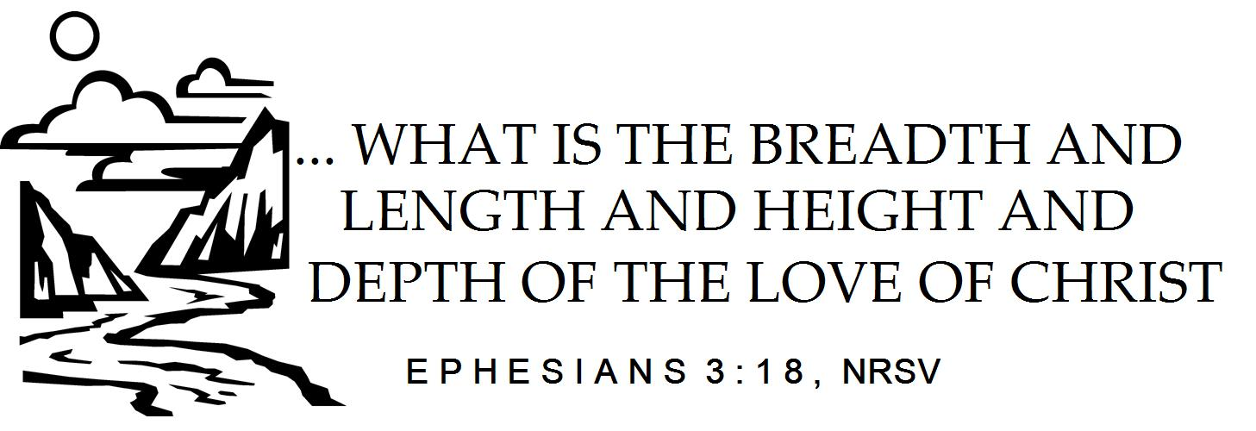

July 29, 2018 - 9:30 am

WELCOME VISITORS!
We're glad you are here! Cards at the ends of each pew are for you to fill out and drop in the Offering Plate. Please let us know you are visiting, and join us for refreshments and fellowship following the service. The Sanctuary has an induction loop system to assist the hearing impaired. The system will also work on the telephone setting of hearing aids. A head set is available upon request.

Springfield Presbyterian Church is rooted in the gospel of Jesus Christ, led by the Holy Spirit, and called to loving relationships through vibrant worship and service. Valuing all people, we are committed to developing disciples and fostering stewardship.

