(Large Print)

Springfield Presbyterian Church (USA)
7300 Spout Hill Road, Sykesville, MD 21784 410-795-6152

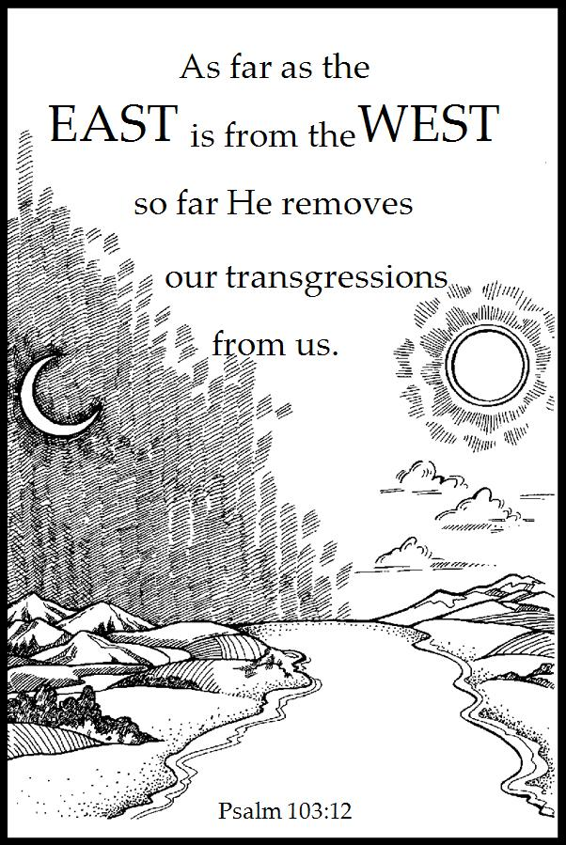

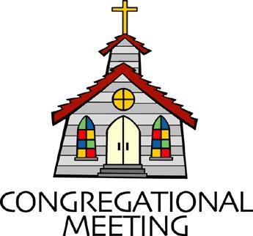
October 14, 2018 - 10:30 am

WELCOME VISITORS! We're glad you are here! Cards at the ends of each pew are for you to fill out and drop in the Offering Plate. Please let us know you are visiting, and join us for refreshments and fellowship following the service. The Sanctuary has an induction loop system to assist the hearing impaired. The system will also work on the telephone setting of hearing aids. A head set is available upon request.

Springfield Presbyterian Church is rooted in the gospel of Jesus Christ, led by the Holy Spirit, and called to loving relationships through vibrant worship and service. Valuing all people, we are committed to developing disciples and fostering stewardship.
PREPARATION FOR THE WORD
(* those who are able are invited to stand)

Please prepare for worship by listening to the music of the Prelude.

PRELUDE

GATHERING OF THE PEOPLE

The Lord be with you! And also with you! (Greeting)

LIGHTING THE CHRIST CANDLE
Leader: Whenever we light this candle we proclaim:
People: Christ is the Light of the world and the center of our lives.

CALL TO WORSHIP
Leader: We gather this morning to hear about the story of our faith, about God’s mighty acts, and about the noble and courageous work of those who live out their commitment to the Lord and to their best selves.
People: We open ourselves to become immersed in this story by striving to find our role within it, by interpreting it anew as it touches our spirits and circumstances, and by allowing it to change us.
Unison: So let us celebrate this wondrous story as translators of love into action, as creators of justice and peace, and as followers of the Lord who embrace life together with a true sense of joy and devotion.

* HYMN God Is Here!
God is here! As we Your people, meet to offer praise and prayer,
May we find in fuller measure, what it is in Christ we share.
Here, as in the world around us, all our varied skills and arts
Wait the coming of the Spirit, into open minds and hearts.
Here are symbols to remind us, of our lifelong need of grace;
Here are table, font, and pulpit; here the cross has central place.
Here in honesty of preaching, here in silence, as in speech,
Here, in newness and renewal, God the Spirit comes to each.

Here our children find a welcome, in the Shepherd's flock and fold,
Here as bread and wine are taken, Christ sustains us as of old.
Here the servants of the Servant, seek in worship to explore
What it means in daily living, to believe and to adore.

Lord of all, of church and kingdom, in an age of change and doubt
Keep us faithful to the gospel, help us work Your purpose out.
Here, in this day's dedication, all we have to give, receive;
We, who cannot live without You, we adore you! We believe!

PRAYER OF CONFESSION
Gracious Lord, we confess that we have not always lived for you. You have invited us into new life, yet we have closed our hearts and lives against that invitation. You have shown us the way to love, yet we have chosen too often the path of uncaring. You have called us to the ministry of reconciliation, yet often we find ourselves tempted to turn away from others. You have challenged us to generosity, but many times we would rather keep to ourselves. Enter our lives once again, dear God. Release us from the bonds of self-centeredness. Create in us a renewed openness to your love, that we may share your love with others. Hear us now as we continue in silent prayer …

SILENT PRAYERS OF CONFESSION

RESPONSE Have Mercy on Us, Living Lord Tune #195
Have mercy on us, living Lord, remember not our sin.
According to your steadfast love, come, cleanse us deep within.

ASSURANCE OF PARDON (Psalm 103:8-12)
Leader: The Lord is merciful and gracious, slow to anger and abounding in steadfast love.
People: He does not deal with us according to our sins, nor repay us according to our iniquities.
Leader: For as the heavens are high above the earth, so great is God's
steadfast love toward those who fear him.
Unison: As far as the east is from the west, so far does He remove our transgressions from us. In Jesus Christ we are forgiven.

* MUSICAL RESPONSE OF PRAISE Let Us with a Gladsome Mind
Let us with a gladsome mind, praise the Lord who is so kind:
For God’s mercies shall endure, ever faithful, ever sure.

* THE PEACE The peace of Christ be with you! And also with you!
(You may greet those around you.)

* RESPONSE Here I Am, Lord
Here I am, Lord, Is it I, Lord? I have heard you calling in the night.
I will go, Lord, if you lead me. I will hold your people in my heart.

THE PROCLAMATION OF THE WORD

SCRIPTURE LESSON 1 Peter 2:4-10 (The Message)
⁴Come to him, a living stone, though rejected by mortals yet chosen and precious in God’s sight, and ⁵like living stones, let yourselves be built into a spiritual house, to be a holy priesthood, to offer spiritual sacrifices acceptable to God through Jesus Christ. ⁶For it stands in scripture: ‘See, I am laying in Zion a stone, a cornerstone chosen and precious; and whoever believes in him will not be put to shame.’ ⁷To you then who believe, he is precious; but for those who do not believe,
‘The stone that the builders rejected has become the very head of the corner’, ⁸and ‘A stone that makes them stumble, and a rock that makes them fall.’ They stumble because they disobey the word, as they were destined to do. ⁹But you are a chosen race, a royal priesthood, a holy nation, God’s own people, in order that you may proclaim the mighty acts of him who called you out of darkness into his marvelous light. ¹⁰Once you were not a people, but now you are God’s people;
once you had not received mercy, but now you have received mercy.

Leader: Hear what the Spirit is saying to the Church.
All: Thanks be to God.

TIME WITH YOUNG PEOPLE

SERMON Beyond Bowling Alone Rev. Robert Culp

THE RESPONSE TO THE WORD

* HYMN We Are Your People

We are your people: Lord, by Your grace,
You dare to make us Christ to our neighbors of every nation and race.

Called to portray You, help us to live, closer than neighbors, open to strangers, able to clash and forgive.

Glad of tradition, help us to see, in all life's changing where You are leading, where our best efforts should be.

Joined in community, breaking Your bread, may we discover gifts in each other, willing to lead and be led.

Lord, as we minister in different ways, may all we're doing show that you're living, meeting Your love with our praise.

PASTORAL PRAYER AND THE LORD’S PRAYER
“For this I pray to God.” / “For this I give thanks to God.”
Congregational Response: “Hear our prayer, O God.”

PRESENTATION OF TITHES AND OFFERINGS
OFFERTORY I Know Your Heart of Grace Patricia Mock
* SONG OF THANKS My Gratitude Now Accept, O God STF #2044 All that is living belongs to you; all that I am in your hands kept. From the abundance of your hand, gifts from the heart accept.
* PRAYER OF DEDICATION

* HYMN Today We All Are Called to Be Disciples

Today we all are called to be disciples of the Lord,
To help to set the captives free, make plow-shares out of sword,
To feed the hungry, quench their thirst, make love and peace our fast,
To serve the poor and homeless first, our ease and comfort last.

God made the world and at its birth, ordained our human race
To live as stewards of the earth, responding to God’s grace.
But we are vain and sadly proud, we sow not peace but strife,
Our discord spreads a deadly cloud that threatens all of life.

Pray justice may come rolling down as in a mighty stream,
With righteousness in field and town to cleanse us and redeem.
For God is longing to restore an earth where conflicts cease,
A world that was created for a harmony of peace.

May we in service to our God act out the living Word,
And walk the road the saints have trod till all have seen and heard.
As stewards of the earth may we give thanks in one accord
To God who calls us all to be disciples of the Lord.

* CHARGE AND BENEDICTION

* UNISON AMEN

POSTLUDE

Assisting in Worship: We appreciate those who serve:

Today 10/14 Next Week 10/21
Sunday Opener Ron Holmes Ed Newsome
Greeters & Ushers Sharon Pappas & Tim Doyle &
Jim Wise Bob Rogers
Lay Leader Elizabeth Meirowitz Sharon Pappas
Sunday School Connie Robinson Connie Robinson
Fellowship Barbara Cornell Sandy & Ed Newsome

Church Attendance: September 30 - 47 October 7 - 38

Church Cleaning: October 19, 20 or 21 - The Oates Family

Happy Anniversary! October 15 - Jim & Barbara Nickell
October 18 - Jim & Mary Rhodes

Happy Birthday! October 15 - Jessica Lane
October 17 - Beth Oates
October 19 - Martha Streaker

Sunday October 21 Lectionary
Job 38:1-7 (34-41); Psalm 104:1-9, 24, 35c; Hebrews 5:1-10;
Mark 10:35-45
Announcements

We welcome the Rev. Robert Culp to our pulpit today!

Dakota Presbytery: On October 21, Chrystie Adams, the Chair of the Baltimore Dakota Steering Committee will be making a presentation about the unique relationship between Baltimore Presbytery and the Dakota Presbytery. The Dakota Presbytery is comprised of all Native American congregations representing the Eastern Sioux (Dakota) and the Western Sioux (Lakota) Nations. Chrystie will have slides and be available to answer any questions arising from her presentation during fellowship.

Newsletter Deadline: The deadline for the November newsletter is October 21. Please submit your information to spc.office@verizon.net. Thank you!

Blessing of the Pets: Mark your calendars for the Blessing of the Pets service scheduled for Sunday, October 28 at 1:00 pm on the lawn. Rain date is Nov. 4.

Presbyterian Disaster Assistance: Presbyterian Disaster Assistance programs are responding to Hurricane Florence relief efforts and are still working in older areas like the California mudslides, Guatemala volcano, and many other events. See their website at https://pda.pcusa.org/situations/national/ for updates on their work. If you are able, make a note on your donation check and it will be sent along to PDA. There is a line item in our Church budget for PDA and congregational donations will be added to that.

Stewardship Sunday: Stewardship Sunday will be on November 11. Individual letters have gone out to members and friends. If you haven’t received your letter by October 19, please contact the office at spc.office@verizon.net or 410-795-6152 for a copy.
Needed: New volunteers for Ushers/Greeters for the following dates: March 10, 2019, April 28, 2019, May 19, 2019, August 4, 2019, Oct. 6, 2019, Dec. 24, 2019 (8 pm service). If you are able to serve any or all of these dates, please contact Kathy Russ at 410-795-2587 before the end of November. Many thanks!

Weekly Announcements: If you have an announcement to include with next week’s bulletin, please call the Office at 410-795-6152 or email to spc.office@verizon.net by Wednesday each week.

Prayers & Thanksgivings

~ Prayers of strength and healing for Leah Halvorson’s brother, Carl, whose cancer has become very aggressive.
~ “Prayers of thanksgiving to all of the Springfield Church members who have said prayers and helped in many ways with my Dad.”
~ Becky LaBrosse
~ Prayers of strength and healing for Charlie Sperling’s mom and dad and Deb’s dad who are all facing health issues.
~ Prayers of strength and comfort for Joy Barwick and her grandson, Dylan, while Dylan’s medical problems are addressed.
~ Prayers for Brenda McClung’s mom, Liz Old, as she transitions to memory care at Copper Ridge. Also prayers for Alex McClung’s mom, Sandy, who is struggling with memory issues. She is at Broadmead in Hunt Valley and will be transitioning from independent living to assisted living in the next few months.
~ Prayers of healing for Dr. Elwood LaBrosse, permanently moved to Room 222 in the Fairhaven Health Unit. He would love to have visitors!
~ Prayers for Northminster Presbyterian from our Ministry Group.

The Congregational Care team wants to know what YOU or someone you know needs...a visit...a call...a meal. Please contact Kay Freas or Connie Robinson.

Today:
Sunday October 14
10:30 am Worship & Sunday School
11:30 am Fellowship
3:00 pm Concert - Beatrice Gilbert, Lyric Soprano

This Week:
Monday October 15
9:30 am Feed My Sheep (Wesley Freedom)
4:30 pm C.I.A. Meeting (Manse)
Wednesday October 17
6:30 pm Bell Choir Practice
7:45 pm Adult Choir Practice
Friday October 19
7:00 pm Game Night (Fellowship Room)

Looking Ahead:
Sunday October 21
10:30 am Worship & Sunday School
11:30 am Fellowship
Tuesday October 23
10:30 am Prayer Group (Manse)
Wednesday October 24
6:30 pm Bell Choir Practice
No Adult Choir Practice

Office Hours: Tuesday, Wednesday, Friday 9:00 am - 3:00 pm
Springfield Presbyterian Church

10:30 am Worship & Sunday School
11:30 am Fellowship
Website: www.springfield-church.org Church Office: 410-795-6152
Like us on Facebook: www.facebook.com/SpringfieldPresbyterianChurch
Pastor: Rev. Becca Crate
Email: springfieldpastor@gmail.com
Clerk of Session: Sharon Pappas
Minister of Music: Linda Caviglia
Accompanist: Aaron Thacker Organist: Jennifer Wise
Youth Group Coordinators: Charles & Deb Sperling
Sunday School Coordinator: Connie Robinson
Administrative Assistant: Donna Mazer
e-mail: spc.office@verizon.net

