(Large Print)

Springfield Presbyterian Church (USA)
7300 Spout Hill Road, Sykesville, MD 21784 410-795-6152

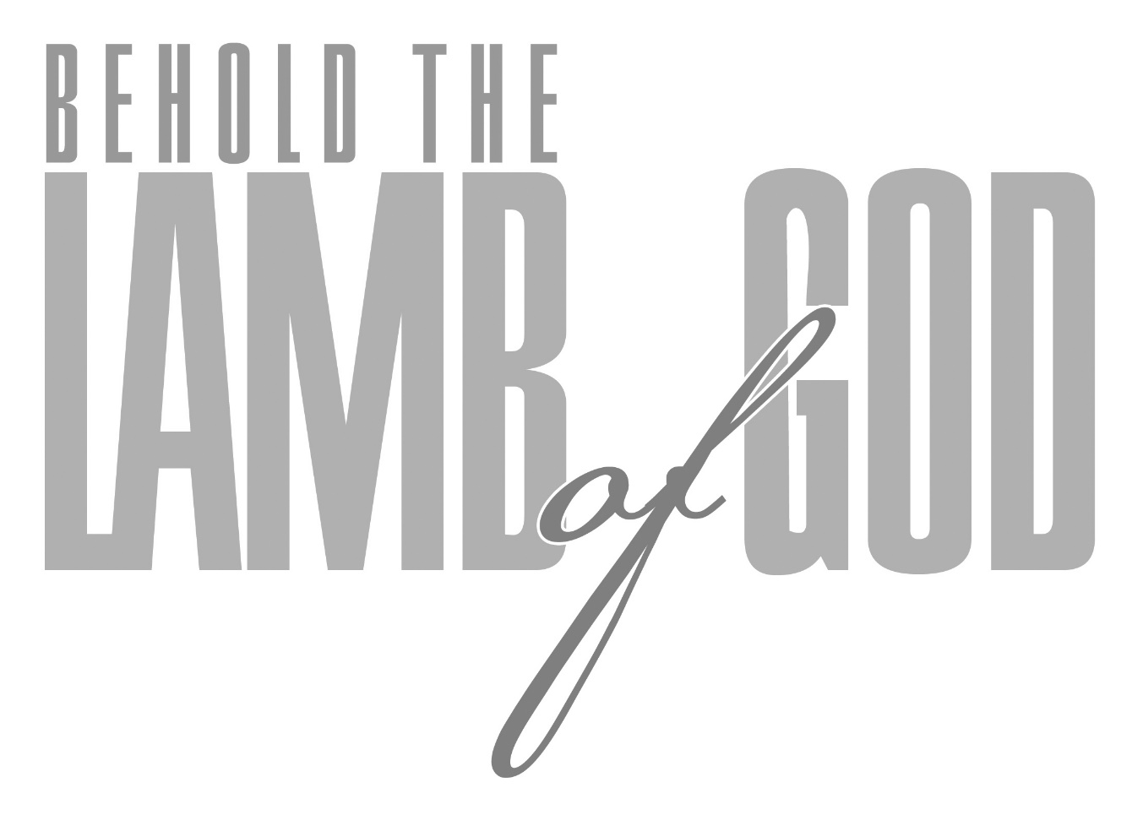

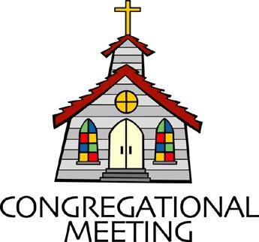
January 26, 2020 - 10:30 am

WELCOME VISITORS! We're glad you are here! Cards at the ends of each pew are for you to fill out and drop in the Offering Plate. Please let us know you are visiting, and join us for refreshments and fellowship following the service. The Sanctuary has an induction loop system to assist the hearing impaired. The system will also work on the telephone setting of hearing aids.

Springfield Presbyterian Church is rooted in the gospel of Jesus Christ, led by the Holy Spirit, and called to loving relationships through vibrant worship and service. Valuing all people, we are committed to developing disciples and fostering stewardship.
PREPARATION FOR THE WORD
(* those who are able are invited to stand)

PRELUDE

GATHERING OF THE PEOPLE

The Lord be with you! And also with you! (Greeting)

LIGHTING THE CHRIST CANDLE
Leader: Whenever we light this candle we proclaim:
People: Christ is the Light of the world and the center of our lives.

CALL TO WORSHIP [Excerpts of Psalm 40]
Leader: We waited patiently for the Lord; He inclined to us and heard our cry.
People: He drew us up from the pit, out of the miry bog.
Leader: He set our feet upon a rock, making our steps secure.
People: He put a new song in our mouths, a song of praise to our God.
Leader: Many will see and fear, and put their trust in the Lord.
People: Happy are those who make the Lord their trust, who do not turn to the proud, who do not go astray after false gods.
Leader: You have multiplied, O Lord my God, your wondrous deeds and your thoughts towards us; none can compare with you.
People: Were we to proclaim and tell of them – they would be more than can be counted!
Leader: Sacrifice and offering you do not desire, but you have given us an open ear.
People: We delight to do your will, O God, your law is within our hearts. Let your steadfast love and your faithfulness keep us safe forever.
ALL: Let us worship our God!

* HYMN Great Is Thy Faithfulness

Great is thy faithfulness, O God my Father;
There is no shadow of turning with thee.
Thou changest not; thy compassions they fail not.
As thou hast been thou forever wilt be.

Refrain:
Great is thy faithfulness! Great is thy faithfulness!
Morning by morning, new mercies I see.
All I have needed thy hand hath provided.
Great is thy faithfulness, Lord unto me!

Summer and winter, and springtime and harvest,
Sun, moon, and stars in their courses above
Join with all nature in manifold witness
To thy great faithfulness, mercy, and love. [Refrain]

Pardon for sin and a peace that endureth,
thine own dear presence to cheer and to guide,
strength for today and bright hope for tomorrow:
blessings all mine, with ten thousand beside! [Refrain]

PRAYER OF CONFESSION
Merciful God, through this Christmas and Epiphany season, we remember that you are both human and divine, and that you came to earth to be with us. Yet, you ask us, “What are we looking for?” and we do not know. We are caught up in the world, sometimes aimless, and do not put our trust fully in you. Forgive us, renew us, and restore us, making us stronger disciples and faithful leaders. Amen.

SILENT PRAYERS OF CONFESSION

RESPONSE Spirit of the Living God
Spirit of the living God, fall afresh on me. Spirit of the living God, fall afresh on me. Melt me; mold me; fill me; use me. Spirit of the living God, fall afresh on me.

WORDS OF ASSURANCE
Leader: Encouraged by your grace, claimed as your own, and called to be your disciples, you forgive your people with abundant love.
People: We are a grateful people, grateful for the grace that you so willingly bestow. We are forgiven, forgiven indeed!

* MUSICAL RESPONSE OF PRAISE Glory Be to the Father
Glory be to the Father, and to the Son, and to the Holy Ghost;
As it was in the beginning, is now, and every shall be,
World without end. Amen, amen.

* THE PEACE The peace of Christ be with you! And also with you!
(You may greet those around you.)

* RESPONSE Here I Am, Lord
Here I am, Lord, Is it I, Lord? I have heard you calling in the night.
I will go, Lord, if you lead me. I will hold your people in my heart.

THE PROCLAMATION OF THE WORD

PRAYER OF ILLUMINATION
Leader: May the words of our mouths and the meditations of our hearts be pleasing unto you, O God, our light, our life, our redeemer. Amen.

FIRST SCRIPTURE LESSON Isaiah 49:1-7
Listen to me, O coastlands, pay attention, you peoples from far away!
The Lord called me before I was born, while I was in my mother’s womb he named me. ² He made my mouth like a sharp sword, in the shadow of his hand he hid me; he made me a polished arrow, in his quiver he hid me away. ³ And he said to me, ‘You are my servant, Israel, in whom I will be glorified.’ ⁴ But I said, ‘I have labored in vain, I have spent my strength for nothing and vanity; yet surely my cause is with the Lord, and my reward with my God.’ ⁵ And now the Lord says, who formed me in the womb to be his servant, to bring Jacob back to him, and that Israel might be gathered to him, for I am honored in the sight of the Lord, and my God has become my strength— ⁶ he says, ‘It is too light a thing that you should be my servant to raise up the tribes of Jacob and to restore the survivors of Israel; I will give you as a light to the nations, that my salvation may reach to the end of the earth.’
⁷ Thus says the Lord, the Redeemer of Israel and his Holy One, to one deeply despised, abhorred by the nations, the slave of rulers, ‘Kings shall see and stand up, princes, and they shall prostrate themselves,
because of the Lord, who is faithful, the Holy One of Israel, who has chosen you.’

SECOND SCRIPTURE LESSON John 1:29-42
²⁹The next day he saw Jesus coming towards him and declared, ‘Here is the Lamb of God who takes away the sin of the world! ³⁰This is he of whom I said, “After me comes a man who ranks ahead of me because he was before me.” ³¹I myself did not know him; but I came baptizing with water for this reason, that he might be revealed to Israel.’ ³²And John testified, ‘I saw the Spirit descending from heaven like a dove, and it remained on him. ³³I myself did not know him, but the one who sent me to baptize with water said to me, “He on whom you see the Spirit descend and remain is the one who baptizes with the Holy Spirit.” ³⁴And I myself have seen and have testified that this is the Son of God.’
³⁵The next day John again was standing with two of his disciples, ³⁶and as he watched Jesus walk by, he exclaimed, ‘Look, here is the Lamb of God!’ ³⁷The two disciples heard him say this, and they followed Jesus. ³⁸When Jesus turned and saw them following, he said to them, ‘What are you looking for?’ They said to him, ‘Rabbi’ (which translated means Teacher), ‘where are you staying?’ ³⁹He said to them, ‘Come and see.’ They came and saw where he was staying, and they remained with him that day. It was about four o’clock in the afternoon. ⁴⁰One of the two who heard John speak and followed him was Andrew, Simon Peter’s brother. ⁴¹He first found his brother Simon and said to him, ‘We have found the Messiah’ (which is translated Anointed). ⁴²He brought Simon to Jesus, who looked at him and said, ‘You are Simon son of John. You are to be called Cephas’ (which is translated Peter).

Leader: Hear what the Spirit is saying to the Church.
All: Thanks be to God.

TIME WITH YOUNG PEOPLE

SERMON What Are You Looking For? Rev. Becca Crate

THE RESPONSE TO THE WORD

* HYMN In Christ There Is No East or West

In Christ there is no east or west, in him no south or north,
But one great fellowship of love throughout the whole wide earth.

In Christ shall true hearts everywhere their high communion find;
His service is the golden cord close-binding humankind.

Join hands, disciples of the faith, whate'er your race may be.
All children of the living God are surely kin to me.

In Christ now meet both east and west; in him meet south and north.
All Christly souls are one in him throughout the whole wide earth.

PASTORAL PRAYER AND THE LORD’S PRAYER
“For this I pray to God.” / “For this I give thanks to God.”
Congregational Response: “Hear our prayer, O God.”

PRESENTATION OF TITHES AND OFFERINGS
OFFERTORY Who At My Door is Standing Arr. K. Lee Scott
* SONG OF THANKS Take My Life (verse 4)
Take my silver and my gold; not a mite would I withhold;
Take my intellect and use every power as thou shalt choose,
Every power as thou shalt choose.
* PRAYER OF DEDICATION

* HYMN Be Still, My Soul
Be still, my soul: the Lord is on thy side.
Bear patiently the cross of grief or pain.
Leave to thy God to order and provide,
who through all changes faithful will remain.
Be still, my soul: thy best, thy heavenly Friend
through thorny ways leads to a joyful end.

Be still, my soul: thy God doth undertake
to guide the future surely as the past.
Thy hope, thy confidence let nothing shake;
all now mysterious shall be bright at last.
Be still, my soul: the waves and winds still know
his voice who ruled them while he dwelt below.

Be still, my soul: the hour is hastening on
when we shall be forever with the Lord;
when disappointment, grief, and fear are gone,
sorrow forgot, love’s purest joys restored.
Be still, my soul: when change and tears are past
all safe and blessed we shall meet at last.
* CHARGE AND BENEDICTION
Leader: What are you looking for?
People: A life rooted in Christ.
Leader: How do we find it?
People: By faithfully following Christ.
Leader: Who will we become?
People: Leaders who love, peacemakers, and change-driven, so all may know and feel the love of God.

* UNISON AMEN

POSTLUDE

Assisting in Worship: We appreciate those who serve:

Today 1/26 Next Week 2/2
Sunday Opener Bob Rogers Jennifer Wise
Greeters & Ushers Sharon Pappas & Amy Vasbinder &
Cynthia Smith Jim Wise
Lay Leader Mark Kearney Tim Oates
Sunday School Connie Robinson Connie Robinson
Fellowship Diana Steppling Connie Gibbons &
Cathy Marsh

Church Attendance: January 12 – 44 January 19 - 30

Church Cleaning: Feb. 7, 8 or 9 – Belle Vasbinder & Barbara Nickell

Happy Birthday! February 1 – Steve & Donna Mazer

Sunday February 2 Lectionary
Micah 6:1-8; Psalm 15; 1 Corinthians 1:18-31; Matthew 5:1-12

Announcements

Blood Drive: Wesley Freedom United Methodist Church is hosting the American Red Cross Blood Drive on Saturday, February 8 from 7:30 am to 1:00 pm. Please contact Phil Salmon at 410-236-6882 or visit redcrossblood.org and enter Sponsor Code:
WesleyFreedomUMCEldersburg to schedule your appointment.

Congregational Meeting: There will be a Congregational Meeting on Sunday, February 9 immediately following Worship. The purpose of the meeting is to approve the 2020 budget and review the 2019 Annual Report.

Inclement Weather: If we feel the need to cancel Worship and Sunday School, there will be a message on the Church answering machine, as well as on Facebook. You may also receive an email with that information.

Coat Drive: Shepherd’s Staff is collecting new or gently used coats, hats, mittens, gloves and socks. Bring them (clean) to church and Julie Ballard will deliver them to Shepherd’s Staff throughout the winter.

Blessing Bags are in the Narthex. Please feel free to pick up a few. Handing one out to someone in need gives you a very real way to meet their immediate needs by providing them with some basic supplies.

Prayers & Thanksgivings
~ Prayers of thanksgiving for Josh Newsome who has returned from deployment!
~ Continued prayers of healing for Shona Klein.
~ Prayers for St. Andrew’s of Mt. Airy from our Ministry Group.
The Congregational Care team wants to know what YOU or someone you know needs...a visit...a call...a meal. Please contact Diana Steppling or Connie Robinson. If you are in need of pastoral care, please contact Pastor Becca at 410-795-6152 or springfieldpastor@gmail.com.

Today:
Sunday January 26
10:30 am Worship
11:30 am Fellowship
12:00 noon Social Justice Book Group (Library)

This Week:
Tuesday January 28
10:30 am Prayer Group (Manse)
Wednesday January 29
6:30 pm Bell Choir Practice
7:45 pm Adult Choir Practice

Looking Ahead:
Sunday February 2
9:00 am Red Sea Parting Practice
10:30 am Worship
11:30 am Fellowship – Souper Bowl
Monday February 3
4:30 pm C.I.A. Meeting (Manse)
Wednesday February 5
6:30 pm Bell Choir Practice
7:45 pm Adult Choir Practice
Saturday February 8
7:30 am – 1:00 pm Wesley Freedom Blood Drive

Office Hours: Tuesday, Wednesday, Friday 9:00 am - 3:00 pm

Springfield Presbyterian Church

10:30 am Worship & Sunday School
11:30 am Fellowship
Website: www.springfield-church.org Church Office: 410-795-6152
Like us on Facebook: www.facebook.com/SpringfieldPresbyterianChurch
Pastor: Rev. Becca Crate
Email: springfieldpastor@gmail.com
Clerk of Session: Sharon Pappas
Minister of Music: Linda Caviglia
Accompanist: Aaron Thacker Organist: Jennifer Wise
Youth Group Coordinators: Charles & Deb Sperling
Sunday School Coordinator: Connie Robinson
Administrative Assistant: Donna Mazer
e-mail: spc.office@verizon.net

