(Large Print)

Springfield Presbyterian Church (USA)
7300 Spout Hill Road, Sykesville, MD 21784 410-795-6152

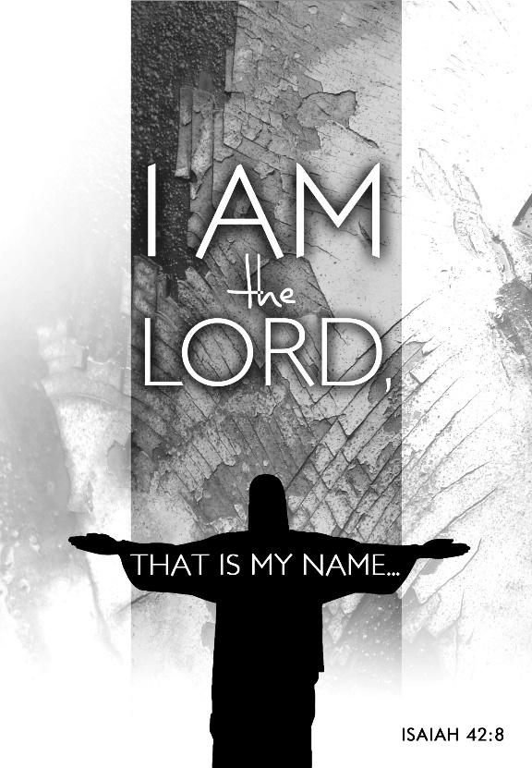

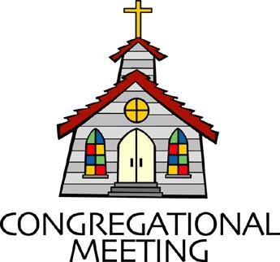
January 15, 2023 - 10:30 am

WELCOME VISITORS!
We're glad you are here! Cards at the ends of each pew are for you to fill out and drop in the Offering Plate. Please let us know you are visiting, and join us for refreshments and fellowship following the service. The Sanctuary has an induction loop system to assist the hearing impaired. The system will also work on the telephone setting of hearing aids.

Springfield Presbyterian Church is rooted in the gospel of Jesus Christ, led by the Holy Spirit, and called to loving relationships through vibrant worship and service. Valuing all people, we are committed to developing disciples and fostering stewardship.

PREPARATION FOR THE WORD
(* those who are able are invited to stand)

PRELUDE

GATHERING OF THE PEOPLE

The Lord be with you! And also with you! (Greeting)

LIGHTING THE CHRIST CANDLE
Leader: Whenever we light this candle we proclaim:
People: Christ is the Light of the world and the center of our lives.

CALL TO WORSHIP Psalm 40:5-8
Leader: You, Lord my God, you’ve done so many things—your wonderful deeds and your plans for us—no one can compare with you!
People: If we were to proclaim and talk about all of them, they would be too numerous to count!
Leader: You don’t relish sacrifices or offerings, you don’t require entirely burnt offerings or compensation offerings—but you have given me ears!
People: So I said, “Here I come! I’m inscribed in the written scroll. I want to do your will, my God. Your instruction is deep within me.”

* HYMN Great Is Thy Faithfulness GTG #39

Great is thy faithfulness, O God my Father;
there is no shadow of turning with thee.
Thou changest not; thy compassions they fail not.
As thou hast been thou forever wilt be.

Refrain:
Great is thy faithfulness! Great is thy faithfulness!
Morning by morning, new mercies I see.
All I have needed thy hand hath provided.
Great is thy faithfulness, Lord unto me!

Summer and winter, and springtime and harvest,
sun, moon, and stars in their courses above
join with all nature in manifold witness
to thy great faithfulness, mercy, and love. [Refrain]

Pardon for sin and a peace that endureth,
thine own dear presence to cheer and to guide,
strength for today and bright hope for tomorrow:
blessings all mine, with ten thousand beside! [Refrain]

CALL TO CONFESSION
Leader: We are eager to be in God’s presence, our hearts yearn for the peace and love we find only in God. And yet, as we draw near, we are also aware of the things in our lives and in our hearts that separate us from God. God offers grace to us as we confess these things and look for God’s forgiveness. Join me in our prayer of confession.

PRAYER OF CONFESSION
Loving God, you have called us by name. Yet we so often ignore your call and take for granted the indescribable privilege it is to be your child. We let our own achievements define us instead of finding our identity in you. And we let our own wants and needs direct us instead of listening to your call on our lives. Forgive our self-centeredness and give us grace to live in a way that demonstrates we are your beloved children.

SILENT PRAYERS OF CONFESSION

RESPONSE Just as I Am, without One Plea Tune #442
Just as I am, thou wilt receive, wilt welcome, pardon, cleanse, relieve;
Because thy promise I believe, O Lamb of God, I come; I come!

WORDS OF ASSURANCE
Leader: By grace alone, God hears our prayers for forgiveness and lovingly and joyfully embraces us once again.
People: We are forgiven! Thanks be to God!

* MUSICAL RESPONSE OF PRAISE We Praise You, O God Tune #612
We praise you, O God, our Redeemer, Creator;
In grateful devotion our tribute we bring.
We lay it before you; we kneel and adore you;
We bless your holy name; glad praises we sing.

* THE PEACE The peace of Christ be with you! And also with you!
(You may greet those around you.)

* RESPONSE Here I Am, Lord
Here I am, Lord, Is it I, Lord? I have heard you calling in the night.
I will go, Lord, if you lead me. I will hold your people in my heart.

THE PROCLAMATION OF THE WORD

FIRST SCRIPTURE LESSON Psalm 40:1-11
¹ I waited patiently for the Lord; he inclined to me and heard my cry.
² He drew me up from the desolate pit, out of the miry bog, and set my feet upon a rock, making my steps secure. ³ He put a new song in my mouth, a song of praise to our God. Many will see and fear, and put their trust in the Lord. ⁴ Happy are those who make the Lord their trust,
who do not turn to the proud, to those who go astray after false gods.
⁵ You have multiplied, O Lord my God, your wondrous deeds and your thoughts towards us; none can compare with you. Were I to proclaim and tell of them, they would be more than can be counted.
⁶ Sacrifice and offering you do not desire, but you have given me an open ear. Burnt-offering and sin-offering you have not required.
⁷ Then I said, ‘Here I am; in the scroll of the book it is written of me.
⁸ I delight to do your will, O my God; your law is within my heart.’
⁹ I have told the glad news of deliverance in the great congregation;
see, I have not restrained my lips, as you know, O Lord. ¹⁰ I have not hidden your saving help within my heart, I have spoken of your faithfulness and your salvation; I have not concealed your steadfast love and your faithfulness from the great congregation. ¹¹ Do not, O Lord, withhold your mercy from me; let your steadfast love and your faithfulness keep me safe for ever.

SECOND SCRIPTURE LESSON John 1:29-42
²⁹The next day he saw Jesus coming towards him and declared, ‘Here is the Lamb of God who takes away the sin of the world! ³⁰This is he of whom I said, “After me comes a man who ranks ahead of me because he was before me.” ³¹I myself did not know him; but I came baptizing with water for this reason, that he might be revealed to Israel.’ ³²And John testified, ‘I saw the Spirit descending from heaven like a dove, and it remained on him. ³³I myself did not know him, but the one who sent me to baptize with water said to me, “He on whom you see the Spirit descend and remain is the one who baptizes with the Holy Spirit.” ³⁴And I myself have seen and have testified that this is the Son of God.’
³⁵The next day John again was standing with two of his disciples, ³⁶and as he watched Jesus walk by, he exclaimed, ‘Look, here is the Lamb of God!’ ³⁷The two disciples heard him say this, and they followed Jesus. ³⁸When Jesus turned and saw them following, he said to them, ‘What are you looking for?’ They said to him, ‘Rabbi’ (which translated means Teacher), ‘where are you staying?’ ³⁹He said to them, ‘Come and see.’ They came and saw where he was staying, and they remained with him that day. It was about four o’clock in the afternoon. ⁴⁰One of the two who heard John speak and followed him was Andrew, Simon Peter’s brother. ⁴¹He first found his brother Simon and said to him, ‘We have found the Messiah’ (which is translated Anointed). ⁴²He brought Simon to Jesus, who looked at him and said, ‘You are Simon son of John. You are to be called Cephas’ (which is translated Peter).

SERMON What’s in a Name? Elder Debbie Schmidt

THE RESPONSE TO THE WORD

* HYMN The Summons GTG #726
Will you come and follow me if I but call your name?
Will you go where you don’t know and never be the same?
Will you let my love be shown, will you let my name be known,
Will you let my life be grown in you and you in me?

Will you leave yourself behind if I but call your name?
Will you care for cruel and kind and never be the same?
Will you risk the hostile stare should your life attract or scare?
Will you let me answer prayer in you and you in me?

Will you let the blinded see if I but call your name?
Will you set the prisoners free and never be the same?
Will you kiss the leper clean, and do such as this unseen,
And admit to what I mean in you and you in me?

Will you love the “you” you hide if I but call your name?
Will you quell the fear inside and never be the same?
Will you use the faith you’ve found to reshape the world around,
Through my sight and touch and sound in you and you in me?

Lord, your summons echoes true when you but call my name.
Let me turn and follow you and never be the same.
In your company I’ll go where your love and footsteps show.
Thus I’ll move and live and grow in you and you in me.

PASTORAL PRAYER AND THE LORD’S PRAYER

OFFERTORY Speak, O Lord arr. Lloyd Larson
* SONG OF THANKS Take My Life Tune #697
Take my silver and my gold; not a mite would I withhold;
Take my intellect and use every power as thou shalt choose,
Every power as thou shalt choose.
* PRAYER OF DEDICATION

* HYMN Wild and Lone the Prophet’s Voice GTG #163
Wild and lone the prophet's voice echoes through the desert still,
Calling us to make a choice, bidding us to do God's will:
"Turn from sin and be baptized; cleanse your heart and mind and soul.
Quitting all the sins you prized, yield your life to God's control.

"Bear the fruit repentance sows: lives of justice, truth, and love.
Trust no other claim than those; set your heart on things above.
Soon the Lord will come in power, burning clean the threshing floor:
Then will flames the chaff devour; wheat alone shall fill God's store."

With such preaching, stark and bold, John proclaimed salvation near,
And his timeless warnings hold words of hope to all who hear.
So we dare to journey on, led by faith through ways untrod,
Till we come at last like John to behold the Lamb of God.

* CHARGE AND BENEDICTION
Leader: God has called each of us by name.
People: We are God’s people!
Leader: May God alone make you holy through and through. May each spirit, soul, and body be kept blameless. The One who calls you is faithful.
All: God will do it!

* UNISON AMEN

POSTLUDE

Assisting in Worship: We appreciate those who serve:

Today 1/15 Next Week 1/22
Sunday Opener: Ron Holmes Bob Rogers
Ushers/Greeters: Tim & Beth Oates Sharon Pappas
Cynthia Smith
Lay Leader: Elizabeth Meirowitz Mark Kearney

Happy Birthday! January 15 – Elizabeth Meirowitz
January 20 – Henry Halvorson
January 21 – Max Carroll

Sunday January 22, 2023 Lectionary
Isaiah 9:1-4; Psalm 27:1, 4-9; 1 Corinthians 1:10-18; Matthew 4:12-23

Announcements

We welcome Elder Debbie Schmidt to our pulpit today!

Upcoming Concert: Mark your calendars for Sunday, February 5 at 3:00 pm when we welcome the Eric Byrd Trio, enthusiastic ambassadors of jazz, for a concert in our Sanctuary!

Springfield Membership: Are you interested in finding out more about our faith community and becoming a member? We would love to answer any questions you have. Please contact Pastor Becca at springfieldpastor@gmail.com for more information.

Winter Fellowship Time: A new year has started--time to make our plans for Fellowship in the new year! We'd love to have your help providing and serving the goodies we share as we visit after worship. If you have not hosted Fellowship yet, we can pair you with someone who knows the routine, and how to make the coffee.
If you don't want to host, we would be happy to have you sign up to bring something in. We always have a supply of crackers and cookies in the kitchen, but our table often includes fruit, cheese and baked goods. Let us know on the sign-up sheet in the kitchen or email me what you'd like to bring. Thanks so much!
Barbaracornell@gmail.com or 240-308-0035

Congregational Care / Mission & Outreach (CoCaMO): Do you know of a member or friend of our church family who is ill, needs prayers, would like call, a visit or a card, or might benefit from meal train? If so, please contact the Church Office (410-795-6152), Cathy Marsh (410-549-6916) or Diana Steppling (862-266-2242).

Prayers & Thanksgivings

~ Prayers of healing for Jeanie Nicholas (Julie Ballard’s niece) who is struggling with cancer.
~ Continued prayers for Diana Steppling who was recently diagnosed with Parkinson’s.

Today:
Sunday January 15
10:30 am Worship
11:30 am Fellowship

This Week:
Wednesday January 18
7:30 – 8:45 pm Adult Choir Practice
Thursday January 19
7:00 pm Session Meeting (Manse)

Looking Ahead:
Sunday January 22
10:30 am Worship
11:30 am Fellowship

Office Hours: Tuesday, Wednesday and Friday, 10:00 am - 3:00 pm
Springfield Presbyterian Church

10:30 am Worship
11:30 am Fellowship
Website: www.springfield-church.org Church Office: 410-795-6152
Like us on Facebook: www.facebook.com/SpringfieldPresbyterianChurch
Pastor: Rev. Becca Price
Email: springfieldpastor@gmail.com
Clerk of Session: Sharon Pappas
Minister of Music: Linda Caviglia
Accompanist/Organist: Aaron Thacker
Youth Group Coordinator: Dylan Vasbinder
Administrative Assistant: Donna Mazer e-mail: spc.office@verizon.net

