(Large Print)

Springfield Presbyterian Church (USA)
7300 Spout Hill Road, Sykesville, MD 21784 410-795-6152

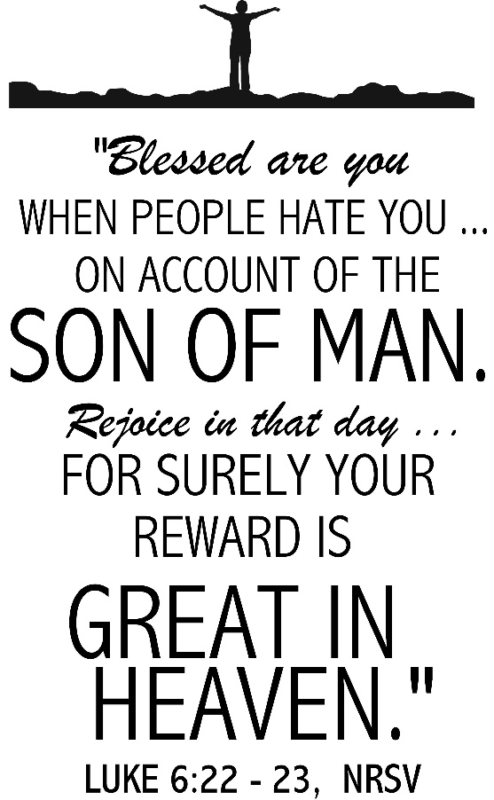

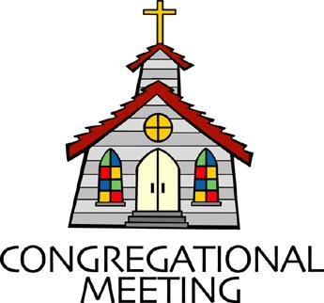
February 13, 2022 - 10:30 am

WELCOME VISITORS! We're glad you are here! Cards at the ends of each pew are for you to fill out and drop in the Offering Plate. Please let us know you are visiting, and join us for refreshments and fellowship following the service. The Sanctuary has an induction loop system to assist the hearing impaired. The system will also work on the telephone setting of hearing aids.

Springfield Presbyterian Church is rooted in the gospel of Jesus Christ, led by the Holy Spirit, and called to loving relationships through vibrant worship and service. Valuing all people, we are committed to developing disciples and fostering stewardship.
PREPARATION FOR THE WORD
(* those who are able are invited to stand)
PRELUDE

GATHERING OF THE PEOPLE

The Lord be with you! And also with you! (Greeting)

LIGHTING THE CHRIST CANDLE
Leader: Whenever we light this candle we proclaim:
People: Christ is the Light of the world and the center of our lives.

CALL TO WORSHIP [Psalm 1 altered]
Leader: Happy are those who do not follow the advice of the wicked, or take the path that sinners tread, or sit in the seat of scoffers.
People: Happy are those whose delight is in the law of the Lord, and on His law they meditate day and night.
Leader: Those people are like trees planted by streams of water, which yield their fruit in its season and their leaves do not wither. In all that they do, they prosper.
People: But the wicked are not so, but are like chaff that the wind drives away.
Leader: Therefore the wicked will not stand in the judgment, nor sinners in the congregation of the righteous;
People: For the Lord watches over the way of the righteous, but the way of the wicked will perish.
ALL: Let us worship our faithful and righteous God. Amen.

* HYMN Dear Lord, Creator Good and Kind #169

Dear Lord, Creator good and kind, forgive our foolish ways;
Reclothe us in our rightful mind, in purer lives thy service find,
In deeper reverence, praise.
In simple trust like theirs who heard beside the Syrian sea
The gracious calling of the Lord, let us, like them, without a word
Rise up and follow thee.

O Sabbath rest by Galilee, O calm of hills above,
Where Jesus knelt to share with thee the silence of eternity,
Interpreted by love!

Drop thy still dews of quietness, till all our strivings cease;
Take from our souls the strain and stress, and let our ordered lives Confess the beauty of thy peace.

Breathe through the heats of our desire thy coolness and thy balm;
Let sense be dumb, let flesh retire; speak through the earthquake, wind, and fire, O still, small voice of calm!

CALL TO CONFESSION
Leader: As we come together as the body of Christ, we admit our sin and our fault before God. We know that when we are able to be vulnerable and share our deepest grief and the ways we have done wrong to ourselves and others, God’s love will always intercede. Now, with that confidence, let us come before the Lord to ask for God’s forgiveness in reverence.

PRAYER OF CONFESSION
Generous God, we confess that we have fallen short of your Word. You tell us in many words and phrases where we can be blessings, yet we choose not to step fully into discipleship. You also show us what it means to be wicked, giving us ample images, but we remain wicked some days in our words and thoughts. We confess that we are a work in progress and we ask that you forgive us. Help us to move daily toward being a people of blessing and renew and restore us by your Word to be a faithful congregation. Amen.

SILENT PRAYERS OF CONFESSION

RESPONSE Come and Fill Our Hearts Tune #466
Come and fill our hearts with your peace. You alone, O Lord, are holy.
Come and fill our hearts with your peace. Alleluia!

WORDS OF ASSURANCE
Leader: God’s mercy and grace is beyond our understanding, always there to meet our deepest need.
People: In Christ, we have found forgiveness and we give thanks. Let us live as changed people because of this newness we have found in Jesus. Amen.

* MUSICAL RESPONSE OF PRAISE Now Thank We All Our God
All praise and thanks to God, who reigns in highest heaven,
To Father and to Son and Spirit now be given.
The one eternal God, whom heaven and earth adore,
The God who was, and is, and shall be ever more.

* THE PEACE The peace of Christ be with you! And also with you!
(You may greet those around you.)

* RESPONSE Here I Am, Lord
Here I am, Lord, Is it I, Lord? I have heard you calling in the night.
I will go, Lord, if you lead me. I will hold your people in my heart.

THE PROCLAMATION OF THE WORD

PRAYER OF ILLUMINATION
Generous God, by the power of your Spirit, help us to see your Word in a new way. As we reclaim these words as our own, help us to gain insight into how to live into them today. Remove any obstacle or barrier from fully hearing your Word and let us be moved by it to live as a reflection of you in our world. Amen.

FIRST SCRIPTURE LESSON Jeremiah 17:5-10
⁵ Thus says the Lord: Cursed are those who trust in mere mortals and make mere flesh their strength, whose hearts turn away from the Lord.
⁶ They shall be like a shrub in the desert, and shall not see when relief comes. They shall live in the parched places of the wilderness, in an uninhabited salt land. ⁷ Blessed are those who trust in the Lord, whose trust is the Lord. ⁸ They shall be like a tree planted by water, sending out its roots by the stream. It shall not fear when heat comes, and its leaves shall stay green; in the year of drought it is not anxious, and it does not cease to bear fruit. ⁹ The heart is devious above all else; it is perverse— who can understand it? ¹⁰ I the Lord test the mind and search the heart, to give to all according to their ways, according to the fruit of their doings.

SECOND SCRIPTURE LESSON Luke 6:17-26
¹⁷He came down with them and stood on a level place, with a great crowd of his disciples and a great multitude of people from all Judea, Jerusalem, and the coast of Tyre and Sidon. ¹⁸They had come to hear him and to be healed of their diseases; and those who were troubled with unclean spirits were cured. ¹⁹And all in the crowd were trying to touch him, for power came out from him and healed all of them.
²⁰Then he looked up at his disciples and said: ‘Blessed are you who are poor, for yours is the kingdom of God. ²¹ ‘Blessed are you who are hungry now, for you will be filled. ‘Blessed are you who weep now, for you will laugh. ²² ‘Blessed are you when people hate you, and when they exclude you, revile you, and defame you on account of the Son of Man. ²³Rejoice on that day and leap for joy, for surely your reward is

great in heaven; for that is what their ancestors did to the prophets.
²⁴ ‘But woe to you who are rich, for you have received your consolation.
²⁵ ‘Woe to you who are full now, for you will be hungry. ‘Woe to you who are laughing now, for you will mourn and weep. ²⁶ ‘Woe to you when all speak well of you, for that is what their ancestors did to the false prophets.

Leader: Hear what the Spirit is saying to the Church.
All: Thanks be to God.

SERMON Blessed Are Those… Rev. Becca Crate-Price

THE RESPONSE TO THE WORD

* HYMN Give to the Winds Thy Fears #815

Give to the winds thy fears; hope, and be undismayed.
God hears thy sighs and counts thy tears; God shall lift up thy head.

Through waves and clouds and storms God gently clears the way.
Wait patiently; so shall this night soon end in joyous day.

Leave to God’s sovereign sway to choose and to command.
So shalt thou, wondering, own God’s way, how wise, how strong God’s hand!

Let us in life, in death, thy steadfast truth declare,
And publish with our final breath thy love and guardian care.

PASTORAL PRAYER AND THE LORD’S PRAYER

ANTHEM No Greater Alleluia

* HYMN Come, Thy Faithful, Raise the Strain #234

Come, you faithful, raise the strain of triumphant gladness!
God has brought forth Israel into joy from sadness,
Loosed from Pharaoh’s bitter yoke Jacob’s sons and daughters;
Led them with unmoistened foot through the Red Sea waters.

’Tis the spring of souls today: Christ has burst his prison,
And from three days’ sleep in death as a sun has risen.
All the winter of our sins, long and dark, is flying
From the Light, to whom we give laud and praise undying.

Now the queen of seasons, bright with the day of splendor,
With the royal feast of feasts comes its joy to render;
Comes to glad Jerusalem, who with true affection
Welcomes in unwearied strains Jesus’ resurrection!

Neither could the gates of death, nor the tomb’s dark portal,
Nor the watchers, nor the seal hold you as a mortal:
But today, among your own, you appear, bestowing
Your deep peace, which evermore passes human knowing.

* CHARGE AND BENEDICTION
Leader: Let us embody blessing,
People: So that all may know your love.
Leader: In our actions, thoughts, and words,
People: Let us bring forth your kingdom.
Leader: And as we leave this space,
People: Continue to light this flame and conviction within us. Amen.

* UNISON AMEN

POSTLUDE
Sunday February 20, 2022 Lectionary
Genesis 45:3-11, 15; Psalm 37:1-11, 39-40; 1 Corinthians 15:35-38, 42-50; Luke 6:27-38

Assisting in Worship: We appreciate those who serve:

Today 2/13 Next Week 2/20
Sunday Opener Ron Holmes Bob Rogers
Greeter Bobby Barrett Steve Mazer
Lay Leader Linda Black Kathy Russ

Announcements

Congregational Meeting: TODAY is our annual Congregational Meeting immediately following Worship, both in person and virtually. At this meeting the congregation receives all the committee reports for work done in 2021. The new 2022 budget is also presented. Hard copies will be handed out. There is much to celebrate and we hope all will stay. No votes will be taken at this meeting.

Upcoming Concert: We are excited to welcome Candice Mowbray and Danny Webber to our concert TODAY at 3:00 pm, a guitar duo performing on electric and acoustic instruments covering a range of musical styles. Due to our COVID protocols, all attendees will be required to wear a mask while indoors for the concert. Hope to see you there!

Happy-Thon Thank You: Thank you to those who gave donations to this local and worthy cause. Thanks to your generosity we were able to send a donation of $246.00 to help support this annual event. We look forward to sponsoring this community event each year and your open hearts help to make this happen. ~ CoCaMO Committee

Per Capita: Per Capita is how we Presbyterian congregations care for each other and stay connected. It funds mission work, support and training for pastors and congregations, and administration expenses. Our portion this year is $38.13; $28 remains at Presbytery, $1.15 to Synod, and $8.98 to General Assembly. You will find this expense in our budget but you can help offset that and show your support by contributing that portion as faithful members. There is a wonderful article by J. Herbert Nelson, Stated Clerk for PC(USA) that can be found by going to baltimorepresbytery.org/percapita and then scroll to the bottom of the page to click on Stated Clerk: What per capita pays for, why it matters.

Easter Flowers: Believe it our not, it is time to order your Easter flowers! Attached is a flyer for your use. Orders need to be in to the Office no later than February 20.

Fellowship Reminder: Following the Worship service, we will gather downstairs for fellowship, but will not have food and will continue to wear our masks. We, as a Session, have made this decision out of an abundance of caution and the desire to keep our family of Christ safe and healthy.

Congregational Care / Mission & Outreach: Do you know of a member or friend of our church family who is ill, needs prayers, would like call, a visit or a card, or might benefit from meal train? If so, please contact the Church Office (410-795-6152), Cathy Marsh (410-549-6916) or Diana Steppling (862-266-2242).

Inclement Weather: If we feel the need to cancel Worship, there will be a message on the Church answering machine, as well as on Facebook. You may also receive an email with that information.

Today:
Sunday February 13
10:30 am Worship
11:30 am Congregational Meeting
12:00 noon Fellowship
3:00 pm Concert

This Week:
Wednesday February 16
6:15 – 7:15 pm Bell Choir Practice
7:30 – 8:45 pm Adult Choir Practice

Looking Ahead:
Sunday February
10:30 am Worship
11:30 am Fellowship
Wednesday February 23
6:15 – 7:15 pm Bell Choir Practice
7:30 – 8:45 pm Adult Choir Practice

Office Hours: Tuesday, Wednesday & Friday
Springfield Presbyterian Church

10:30 am Worship
11:30 am Fellowship
Website: www.springfield-church.org Church Office: 410-795-6152
Like us on Facebook: www.facebook.com/SpringfieldPresbyterianChurch
Pastor: Rev. Becca Crate-Price
Email: springfieldpastor@gmail.com
Clerk of Session: Sharon Pappas
Minister of Music: Linda Caviglia
Accompanist/Organist: Aaron Thacker
Youth Group Coordinator: Dylan Vasbinder
Administrative Assistant: Donna Mazer e-mail: spc.office@verizon.net

