(Large Print)

Springfield Presbyterian Church (USA)
7300 Spout Hill Road, Sykesville, MD 21784 410-795-6152

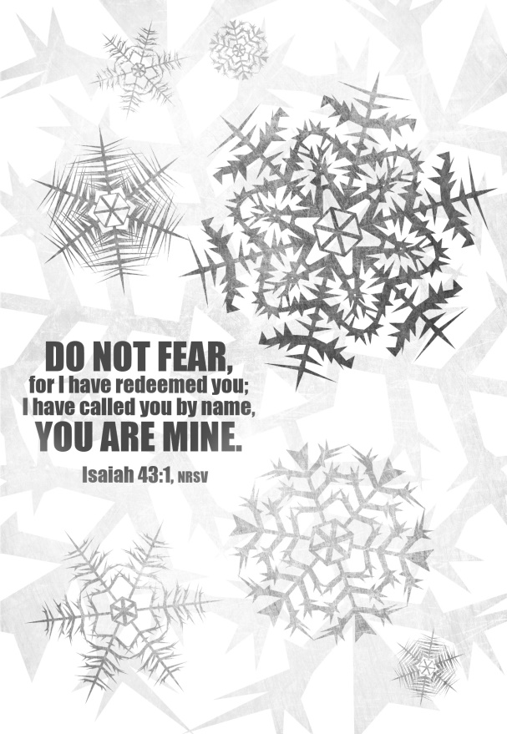

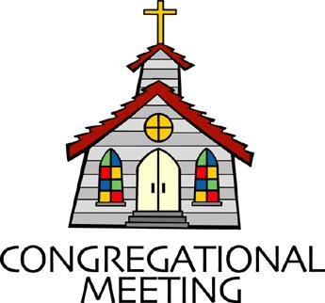
January 20, 2019 - 10:30 am

WELCOME VISITORS! We're glad you are here! Cards at the ends of each pew are for you to fill out and drop in the Offering Plate. Please let us know you are visiting, and join us for refreshments and fellowship following the service. The Sanctuary has an induction loop system to assist the hearing impaired. The system will also work on the telephone setting of hearing aids. A head set is available upon request.

Springfield Presbyterian Church is rooted in the gospel of Jesus Christ, led by the Holy Spirit, and called to loving relationships through vibrant worship and service. Valuing all people, we are committed to developing disciples and fostering stewardship.

PREPARATION FOR THE WORD
(* those who are able are invited to stand)

Please prepare for worship by listening to the music of the Prelude.

PRELUDE

GATHERING OF THE PEOPLE

The Lord be with you! And also with you! (Greeting)

LIGHTING THE CHRIST CANDLE
Leader: Whenever we light this candle we proclaim:
People: Christ is the Light of the world and the center of our lives.

CALL TO WORSHIP [Based on Psalm 139 NRSV]
Leader: O Lord, you have searched us and known us.
People: You know when we sit down and when we wake up.
Leader: You discern our thoughts from far away.
People: You search out our path and our lying down,
Leader: You are acquainted with all our ways.
People: Even before a word is on our tongue,
Leader: O Lord, you know it completely.
People: You hem us in, behind and before, and lay your hands upon us.
Leader: Such knowledge is too wonderful for us; it is so high we cannot attain it.
People: For it was you who formed our inward parts;
Leader: It was you who knit us together in our mother’s wombs.
People: We praise you, for we are fearfully and wonderfully made.
ALL: Let us praise our God!

* HYMN All Glory, Laud and Honor

Refrain:
All glory, laud, and honor to thee, Redeemer, King,
To whom the lips of children made sweet hosannas ring!

Thou art the King of Israel, thou David’s royal Son,
Who in the Lord’s name comest, the King and blessed One. [Refrain]

The people of the Hebrews with palms before thee went;
Our praise and prayers and anthems before thee we present. [Refrain]

To thee, before thy passion, they sang their hymns of praise;
To thee, now high exalted, our melody we raise. [Refrain]

Thou didst accept their praises; accept the prayers we bring,
Who in all good delightest, thou good and gracious King! [Refrain]

PRAYER OF CONFESSION
Generous God, we ask ourselves where we belong, who we are, what makes us worthy, but we look in the wrong places. We look to our schoolmates and teachers to tell us that we are good enough. We look at our colleagues and supervisors to tell us that we are good people. We look at our family and friends and pray that they will tell us that we are worthwhile. And while you’ve put these people in our path to encourage us, we forget that our real encouragement and worth is from you. It is from you we were created, out of your extraordinary and generous love. We ask for your forgiveness when we seek applause elsewhere, and ask that you usher us back into your arms where we are loved, no matter what. Amen.

SILENT PRAYERS OF CONFESSION

RESPONSE Spirit of the Living God
Spirit of the living God, fall afresh on me.
Spirit of the living God, fall afresh on me.
Melt me; mold me; fill me; use me.
Spirit of the living God, fall afresh on me.

WORDS OF ASSURANCE
Leader: Christ did not come to this world and the people to condemn them, but He came to save us.
People: Thanks be to Christ, God with us, whose mercy and love casts out our sin. Amen.

* MUSICAL RESPONSE OF PRAISE O Day of Rest and Gladness
O day of rest and gladness, O day of joy and light;
O balm for care and sadness, most beautiful, most bright;
On you, the high and lowly, through ages joined in tune,
Sing “Holy, holy, holy” to the great God triune.

* THE PEACE The peace of Christ be with you! And also with you!
(You may greet those around you.)

* RESPONSE Here I Am, Lord
Here I am, Lord, Is it I, Lord? I have heard you calling in the night.
I will go, Lord, if you lead me. I will hold your people in my heart.

THE PROCLAMATION OF THE WORD

PRAYER OF ILLUMINATION
Saving God, source of our calling, your Word is full of power and glory. Pour out your Holy Spirit upon us so that we may receive your grace and live as your beloved children; through Jesus Christ our Lord. Amen.

FIRST SCRIPTURE LESSON Psalm 29
¹ Ascribe to the Lord, O heavenly beings, ascribe to the Lord glory and strength. ² Ascribe to the Lord the glory of his name; worship the Lord in holy splendor. ³ The voice of the Lord is over the waters; the God of glory thunders, the Lord, over mighty waters. ⁴ The voice of the Lord is powerful; the voice of the Lord is full of majesty. ⁵ The voice of the Lord breaks the cedars; the Lord breaks the cedars of Lebanon. ⁶ He makes Lebanon skip like a calf, and Sirion like a young wild ox. ⁷ The voice of the Lord flashes forth flames of fire. ⁸ The voice of the Lord shakes the wilderness; the Lord shakes the wilderness of Kadesh. ⁹ The voice of the Lord causes the oaks to whirl, and strips the forest bare; and in his temple all say, ‘Glory!’ ¹⁰ The Lord sits enthroned over the flood; the Lord sits enthroned as king for ever. ¹¹ May the Lord give strength to his people! May the Lord bless his people with peace!

SECOND SCRIPTURE LESSON Isaiah 43:1-7
But now thus says the Lord, he who created you, O Jacob, he who formed you, O Israel: Do not fear, for I have redeemed you; I have called you by name, you are mine. ² When you pass through the waters, I will be with you; and through the rivers, they shall not overwhelm you;
when you walk through fire you shall not be burned, and the flame shall not consume you. ³ For I am the Lord your God, the Holy One of Israel, your Savior. I give Egypt as your ransom, Ethiopia and Seba in exchange for you. ⁴ Because you are precious in my sight, and honoured, and I love you, I give people in return for you, nations in exchange for your life. ⁵ Do not fear, for I am with you; I will bring your offspring from the east, and from the west I will gather you; ⁶ I will say to the north, ‘Give them up’, and to the south, ‘Do not withhold;
bring my sons from far away and my daughters from the end of the earth— ⁷ everyone who is called by my name, whom I created for my glory, whom I formed and made.’

Leader: Hear what the Spirit is saying to the Church.
All: Thanks be to God.

TIME WITH YOUNG PEOPLE

SERMON Worthy of the Waters Rev. Becca Crate

THE RESPONSE TO THE WORD

* HYMN I Will Come to You (You Are Mine)

I will come to you in the silence,
I will lift you from all your fear.
You will hear my voice, I claim you as my choice.
Be still and know I am here.

Refrain:
Do not be afraid, I am with you.
I have called you each by name.
Come and follow me, I will bring you home;
I love you and you are mine.

I am hope for all who are hopeless,
I am eyes for all who long to see.
In the shadows of the night, I will be your light.
Come and rest in me. [Refrain]

I am strength for all the despairing,
Healing for the ones who dwell in shame.
All the blind will see, the lame will all run free,
And all will know my name. [Refrain]

I am the word that leads all to freedom,
I am the peace the world cannot give.
I will call your name, embracing all your pain.
Stand up, now walk and live! [Refrain]

COMMUNION OF GOD’S PEOPLE

INVITATION

THE GREAT PRAYER OF THANKSGIVING
Leader: The Lord be with you.
People: And also with you.
Leader: Lift up your hearts.
People: We lift them up to the Lord.
Leader: Let us give thanks to the Lord our God.
People: It is right to give our thanks and praise.

[The Pastor continues… “…who forever sing to the glory of your name.”]

IN PRAISE OF GOD
Holy, holy, holy, Lord, God of Power and might.
Heaven and earth are full of your glory, Hosanna in the highest!
Blessed is He who comes in the name of the Lord.
Hosanna in the highest, hosanna in the highest.

[The Pastor continues… “…dedicated to your service.”]

IN PRAISE OF CHRIST
Dying, you destroyed our death; rising, you restored our life.
Lord Jesus, come in glory.

PASTORAL PRAYER AND THE LORD’S PRAYER
“For this I pray to God.” / “For this I give thanks to God.”
Congregational Response: “Hear our prayer, O God.”

WORDS OF INSTITUTION

SHARING OF THE MEAL

PRAYER OF DEDICATION (Unison)
God of grace and peace, as you have shared your life with us through the child in the manger and this simple meal together, let us share your life with others as the body of Christ in the world; Amen.

PRESENTATION OF TITHES AND OFFERINGS
OFFERTORY Christ, When For Us You Were Baptized
* SONG OF THANKS We Praise You, O God
We praise you, O God, our Redeemer, Creator;
In grateful devotion our tribute we bring.
We lay it before you; we kneel and adore you;
We bless your holy name; glad praises we sing.
* PRAYER OF DEDICATION

* HYMN The Church’s One Foundation
The church's one foundation is Jesus Christ her Lord.
She is his new creation by water and the word.
From heaven he came and sought her to be his holy bride.
With his own blood he bought her, and for her life he died.

Elect from every nation, yet one o'er all the earth,
Her charter of salvation: one Lord, one faith, one birth.
One holy name she blesses, partakes one holy food,
and to one hope she presses, with every grace endued.

Though with a scornful wonder, this world sees her oppressed,
By schisms rent asunder, by heresies distressed,
Yet saints their watch are keeping; their cry goes up: "How long?"
And soon the night of weeping shall be the morn of song.

Mid toil and tribulation, and tumult of her war,
She waits the consummation of peace forevermore:
Till with the vision glorious, her longing eyes are blest,
And the great church victorious shall be the church at rest.

* CHARGE AND BENEDICTION
Leader: In the waters of baptism,
People: We remember whose we are.
Leader: In the waters of baptism,
People: We are reconciled.
Leader: In the waters of baptism,
People: We join together in ministry as the beloved children of God. Amen.

* UNISON AMEN

POSTLUDE [All are invited to stay and listen, but feel free to leave after the Unison Amen if you prefer.]

Sunday January 20 Lectionary
Isaiah 62:1-5; Psalm 36:5-10; 1 Corinthians 12:1-11; John 2:1-11
Assisting in Worship: We appreciate those who serve:

Today 1/13 Next Week 1/20
Sunday Opener Barbara Cornell Ron Holmes
Greeters & Ushers Elizabeth Meirowitz & Jim & Mary Rhodes
Connie Robinson
Lay Leader Barbara Cornell Elizabeth Meirowitz
Sunday School Connie Robinson Connie Robinson
Fellowship Barbara Nickell Diana Steppling

Communion Servers Today: (Traditional)
1. Sharon Pappas 4. Connie Robinson
2. Barbara Nickell 5. Jim Wise
3. Linda Black

Church Attendance: December 30 - 32 January 6 - 39

Church Cleaning: Jan. 25, 26 or 27 - Lisa & Bob Rogers

Happy Birthday! January 15 - Elizabeth Meirowitz
January 20 - Henry Halvorson

Announcements

2019 Sunday School: Starting TODAY, Sunday School will begin after the sermon.

Shepherd’s Staff Coat Drive: If you would like to donate a new or gently used coat to Shepherd’s Staff, please see Julie Ballard TODAY.

Weekly Announcements: If you have an announcement to include with next week’s bulletin, please call the Office at 410-795-6152 or email to spc.office@verizon.net by Wednesday each week.
C.I.A. (Community In Action) will meet TOMORROW and on
January 21 from 4:30 - 6 pm at the Manse. Pizza and drinks provided. Friends are welcome and encouraged to attend! C.I.A is a group open to all religious and non-religious people as a means of providing the community with acts of kindness. We will be doing different activities throughout the school year to help people in our community who are in need. Come and be part of giving back to our community. Beginning in February, C.I.A. will meet on the 1st and 3rd Monday each month.

Souper Bowl Sunday: This year our Souper Bowl bread and soup luncheon will be on February 3 after Worship. If you would like to help out, please see Diana Steppling.

Prayers & Thanksgivings

~ Prayers for Northminster Presbyterian Church from our Ministry Group.

The Congregational Care team wants to know what YOU or someone you know needs...a visit...a call...a meal. Please contact Diana Steppling or Connie Robinson.

Today:
Sunday January 13
10:30 am Worship & Sunday School
11:30 am Fellowship
12:00 noon Worship Committee Meeting (Library)
6:00 pm Confirmation Class (Manse)

This Week:
Monday January 14
4:30 pm C.I.A. Meeting (Manse)
7:00 pm Headhuggers (Manse)
Wednesday January 16
7:00 pm Adult Choir Practice
Friday January 18
7:00 pm Game Night (Fellowship Room)

Looking Ahead:
Sunday January 20
9:00 am Red Sea Parting Practice
10:30 am Worship & Sunday School
11:30 am Fellowship
12:00 noon Calendar Planning Meeting (Library)
Monday January 21
9:30 am Feed My Sheep (Wesley Freedom)
4:30 pm C.I.A. Meeting (Manse)
Tuesday January 22
10:30 am Prayer Group (Manse)
Wednesday January 23
No Choir Practices

Office Hours: Tuesday, Wednesday, Friday 9:00 am - 3:00 pm
Springfield Presbyterian Church

10:30 am Worship & Sunday School
11:30 am Fellowship
Website: www.springfield-church.org Church Office: 410-795-6152
Like us on Facebook: www.facebook.com/SpringfieldPresbyterianChurch
Pastor: Rev. Becca Crate
Email: springfieldpastor@gmail.com
Clerk of Session: Sharon Pappas
Minister of Music: Linda Caviglia
Accompanist: Aaron Thacker Organist: Jennifer Wise
Youth Group Coordinators: Charles & Deb Sperling
Sunday School Coordinator: Connie Robinson
Administrative Assistant: Donna Mazer
e-mail: spc.office@verizon.net

JANUARY 20, 2019 ANNOUNCEMENTS

Newsletter Deadline: The deadline for submission of information for the February newsletter is Tuesday, January 22. Please submit your info to spc.office@verizon.net.

Happy Birthday! January 20 - Henry Halvorson
January 21 - Max Carroll
January 23 - Natalie Halvorson

Happy Anniversary! January 23 - Carl & Kari Anderson

Prayers & Thanksgivings

~ Prayers of comfort for Martha Streaker and her family on the loss of her sister, Grace Scrivnor Bevard Erb, on January 12, 2019. Funeral services will be held at St. Benjamin’s Lutheran Church (700 Krider’s Cemetery Road, Westminster) on Monday, January 21 at 11:00 am. Visitation will be held at 10:00 am at the church prior to the service. In lieu of flowers, the family asks that memorial gifts be made to the Nature Conservancy, The Historical Society of Carroll County, McDaniel College or the charity of your choice.
~ Prayers for St. John United Presbyterian Church from our Ministry Group.

The Congregational Care team wants to know what YOU or someone you know needs....a visit...a call....a meal. Please contact Diana Steppling or Connie Robinson.

Sunday January 27 Lectionary
Nehemiah 8:1-3, 5-6, 8-10; Psalm 19; 1 Corinthians 12:12-31a; Luke 4:14-21

Assisting in Worship: We appreciate those who serve:

Today 1/20 Next Week 1/27
Sunday Opener Ron Holmes Jennifer Wise
Greeters & Ushers Jim & Mary Rhodes Sharon Pappas & Martha Streaker
Lay Leader Elizabeth Meirowitz Mark Kearney
Sunday School Connie Robinson Connie Robinson
Fellowship Diana Steppling Linda Caviglia

