(Large Print)

Springfield Presbyterian Church (USA)
7300 Spout Hill Road, Sykesville, MD 21784 410-795-6152

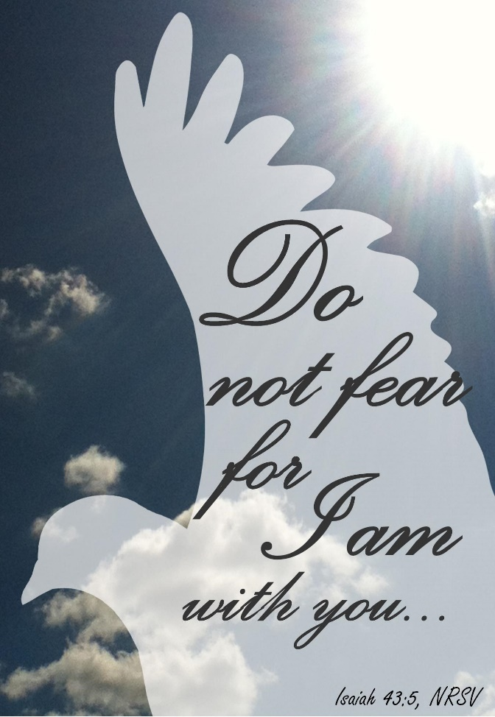

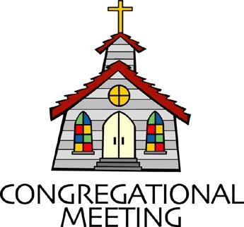
May 29, 2022 - 10:30 am

WELCOME VISITORS! We're glad you are here! Cards at the ends of each pew are for you to fill out and drop in the Offering Plate. Please let us know you are visiting, and join us for refreshments and fellowship following the service. The Sanctuary has an induction loop system to assist the hearing impaired. The system will also work on the telephone setting of hearing aids.

Springfield Presbyterian Church is rooted in the gospel of Jesus Christ, led by the Holy Spirit, and called to loving relationships through vibrant worship and service. Valuing all people, we are committed to developing disciples and fostering stewardship.
PREPARATION FOR THE WORD
(* those who are able are invited to stand)
PRELUDE

GATHERING OF THE PEOPLE

The Lord be with you! And also with you! (Greeting)

LIGHTING THE CHRIST CANDLE
Leader: Whenever we light this candle we proclaim:
People: Christ is the Light of the world and the center of our lives.

CALL TO WORSHIP
Leader: Today we take time to remember the diversity of minds on this earth.
People: We remember those whose struggle is often unspoken.
Leader: Those who live with depression, anxiety, bi-polar, schizophrenia, personality disorders, and more.
People: We know that some of those diagnoses may apply to us and to those we love.
Leader: So help us as we worship you today to remember that you are the God of all people.
People: Help us to destigmatize and be the welcoming place you so long for us to be.
Leader: Let the church be a true sanctuary; a sanctuary for any struggle.
People: May we do all these things, as we bless your holy name. Amen.

* HYMN How Firm a Foundation #463
How firm a foundation, ye saints of the Lord,
is laid for your faith in God's excellent Word!
What more can be said than to you God hath said,
to you who for refuge to Jesus have fled?

"Fear not, I am with thee, O be not dismayed,
for I am thy God, and will still give thee aid;
I'll strengthen thee, help thee, and cause thee to stand,
upheld by my righteous, omnipotent hand.

"When through the deep waters I call thee to go,
the rivers of sorrow shall not overflow;
for I will be near thee, thy troubles to bless,
and sanctify to thee thy deepest distress.

"When through fiery trials thy pathway shall lie,
my grace, all sufficient, shall be thy supply;
the flame shall not hurt thee; I only design
thy dross to consume, and thy gold to refine.

"The soul that on Jesus hath leaned for repose,
I will not, I will not desert to its foes;
that soul, though all hell should endeavor to shake,
I'll never, no, never, no, never forsake."

CALL TO CONFESSION
Leader: On this Mental Health Awareness Sunday, we remember that you have created each of us uniquely and each experience we have had has informed how we live together today. Some of us need to forgive ourselves – we need to give ourselves grace for those times when depression sinks in or anxiety keeps us confined. We need to give grace to others, when we treat people unkindly when they are hurting or when we do not know the trauma they’ve walked through. Growing to be more grace-filled daily is certainly an admirable virtue, and so we seek to do just that as we come before God and admit our sin.

PRAYER OF CONFESSION
Generous God, we humbly admit that we are guilty of not offering grace to ourselves and to others. We live in a world where we judge each other without knowing the full story and all that lies beyond appearances. We have disregarded others as ‘lazy’ or ‘antsy’ when we do not know the depression and anxiety that lies underneath. We are also guilty of naming people by their diagnosis and not embracing them for all that they are powerfully gifted to do through your Spirit. Forgive us, again, O Lord, and renew us as we remember the beautiful diversity among us.

SILENT PRAYERS OF CONFESSION

RESPONSE Restore in Us, O God Tune #434
Restore in us, O God, the splendor of your love;
Renew your image in our hearts, and all our sins remove.

WORDS OF ASSURANCE
Leader: When we come before God and admit our sin, we can be assured that God’s grace is more powerful than our guilt.
People: So we rejoice as we say together: “We are forgiven, forgiven indeed! Alleluia, amen!”

* MUSICAL RESPONSE OF PRAISE Alleluia, Alleluia! Give Thanks
Alleluia, alleluia! Give thanks to the risen Lord.
Alleluia, alleluia! Give praise to his name.

* THE PEACE The peace of Christ be with you! And also with you!
(You may greet those around you.)

* RESPONSE Here I Am, Lord
Here I am, Lord, Is it I, Lord? I have heard you calling in the night.
I will go, Lord, if you lead me. I will hold your people in my heart.
THE PROCLAMATION OF THE WORD

PRAYER OF ILLUMINATION
Generous God, we remember that we are much more than skin and bones, but a soul that needs tender and loving care. We come before you, seeking to open our eyes more fully, so we can be better disciples and better people in hearing Your Word for us today.

FIRST SCRIPTURE LESSON Isaiah 43:1-5, 15-19
But now thus says the Lord, he who created you, O Jacob, he who formed you, O Israel: Do not fear, for I have redeemed you; I have called you by name, you are mine. ² When you pass through the waters, I will be with you; and through the rivers, they shall not overwhelm you;
when you walk through fire you shall not be burned, and the flame shall not consume you. ³ For I am the Lord your God, the Holy One of Israel, your Savior. I give Egypt as your ransom, Ethiopia and Seba in exchange for you. ⁴ Because you are precious in my sight, and honored, and I love you, I give people in return for you, nations in exchange for your life. ⁵ Do not fear, for I am with you; I will bring your offspring from the east, and from the west I will gather you; ¹⁵ I am the Lord, your Holy One, the Creator of Israel, your King. ¹⁶ Thus says the Lord, who makes a way in the sea, a path in the mighty waters, ¹⁷ who brings out chariot and horse, army and warrior; they lie down, they cannot rise, they are extinguished, quenched like a wick: ¹⁸ Do not remember the former things, or consider the things of old. ¹⁹ I am about to do a new thing; now it springs forth, do you not perceive it? I will make a way in the wilderness and rivers in the desert.

SECOND SCRIPTURE LESSON Romans 8:31-39
³¹What then are we to say about these things? If God is for us, who is against us? ³²He who did not withhold his own Son, but gave him up for all of us, will he not with him also give us everything else? ³³Who will bring any charge against God’s elect? It is God who justifies. ³⁴Who is to condemn? It is Christ Jesus, who died, yes, who was raised, who is at the right hand of God, who indeed intercedes for us. ³⁵Who will separate us from the love of Christ? Will hardship, or distress, or persecution, or famine, or nakedness, or peril, or sword? ³⁶As it is written, ‘For your sake we are being killed all day long; we are accounted as sheep to be slaughtered.’ ³⁷No, in all these things we are more than conquerors through him who loved us. ³⁸For I am convinced that neither death, nor life, nor angels, nor rulers, nor things present, nor things to come, nor powers, ³⁹nor height, nor depth, nor anything else in all creation, will be able to separate us from the love of God in Christ Jesus our Lord.

Leader: Hear what the Spirit is saying to the Church.
All: Thanks be to God.

SERMON Lead With a Limp Rev. Becca Crate-Price

THE RESPONSE TO THE WORD

* HYMN I Will Come to You (You Are Mine) #177

I will come to you in the silence,
I will lift you from all your fear.
You will hear my voice, I claim you as my choice.
Be still and know I am here.

Refrain:
Do not be afraid, I am with you.
I have called you each by name.
Come and follow me, I will bring you home;
I love you and you are mine.

I am hope for all who are hopeless,
I am eyes for all who long to see.
In the shadows of the night, I will be your light.
Come and rest in me. [Refrain]

I am strength for all the despairing,
Healing for the ones who dwell in shame.
All the blind will see, the lame will all run free,
And all will know my name. [Refrain]

I am the word that leads all to freedom,
I am the peace the world cannot give.
I will call your name, embracing all your pain.
Stand up, now walk and live! [Refrain]

PASTORAL PRAYER AND THE LORD’S PRAYER

OFFERTORY
SONG OF THANKS We Give Thee but Thine Own #708
We give thee but thine own, what e’er the gift may be;
All that we have is thine alone, a trust, O Lord, from thee.
PRAYER OF DEDICATION

* HYMN Go, My Children, with My Blessing

Go, my children, with my blessing, never alone.
Waking, sleeping, I am with you, you are my own.
In my love’s baptismal river I have made you mine forever.
Go, my children, with my blessing, you are my own.

Go, my children, sins forgiven, at peace and pure.
Here you learned how much I love you, what I can cure.
Here you heard my dear Son’s story; here you touched him, saw his glory.
Go, my children, sins forgiven, at peace and pure.

Go, my children, fed and nourished, closer to me.
Grow in love and love by serving, joyful and free.
Here my Spirit’s power filled you; here my tender comfort stilled you.
Go, my children, fed and nourished, joyful and free.

* CHARGE AND BENEDICTION
Leader: As we leave this place,
People: We remember that we are more than flesh and bone.
Leader: We acknowledge that each soul needs tender care.
People: We strive to be people who choose grace and acceptance.
Leader: We hope to be disciples who are quick to listen and to help.
People: May Your love guide the way. Amen.

* UNISON AMEN

POSTLUDE

Assisting in Worship: We appreciate those who serve:

Today 5/29 Next Week 6/5
Sunday Opener Bob Rogers Barbara Cornell
Ushers/Greeters Sharon Pappas Tim & Beth Oates
Alex McClung
Lay Leader Diana Steppling Ron Holmes

Sunday June 5, 2022 Lectionary
Acts 2:1-21; Psalm 104:24-34, 35b; Romans 8:14-17; John 14:8-17
Happy Birthday! June 3 – Esther Doyle

Announcements

Pentecost Offering: Pentecost offering will be received TODAY and on June 5. Please see insert for all the information. A portion will be sent to Mission of Mercy in support of healthcare for at-risk youth.

Commemorating Veterans Resting at Springfield Cemetery:
This Sunday, May 29 (the day before Memorial Day) members and friends of Springfield Presbyterian Church will resume what had become a solemn annual tradition prior to Covid: remembering and honoring those veterans for whom Springfield Cemetery is their final resting place. Following service, those who wish to take part will place American flags on the 154 graves known to be those of veterans. When our congregation last participated in this activity in 2019, we marked just over 120 graves. Although we were not able to join as a community for this purpose over the last two years, please rest assured that these veterans were still remembered and flags were indeed placed in both 2020 and 2021.

Memorial Day originated after the American Civil War as "Decoration Day" and commemorated both Union and Confederate soldiers who died in that war. Springfield Cemetery is home to veterans who served during at least six conflicts: the Civil War, the Spanish-American War, World Wars I and II, the Korean War, and the Vietnam War, as well as to veterans who served and stood ready during other periods. We are grateful for their service and their often significant -- and sometimes ultimate -- sacrifice.

Mask Update: Due to the uptick in COVID-19 cases, the Session has decided to strongly encourage masking and social distancing. Though it is not a mandate, we seek to love one another by keeping each other as safe as possible. Thank you for your help in this endeavor.

Pastor-Parish Committee: The Pastor-Parish Committee invites you to share your concerns, suggestions, and gratitude. We have a form in the Narthex and a lock-box that we will open weekly and we ask that you share your name and be specific. We look forward to reading your comments so that we can continue to grow into the body of Christ.

Sunday School is back! On the 1st and 3rd Sundays of the month, we will be offering Sunday School! See Pastor Becca for details…

Spring Plant Sale: Between May 1 and May 31, buy your spring plants at Buppert’s Farm and they will donate 10% of your purchase price back to Springfield’s ongoing projects and mission! Pick up a flyer in the Narthex and share it with your family and friends!

Springfield Membership: Are you interested in finding out more about our faith community and becoming a member? We would love to answer any questions you have. Please contact Pastor Becca at springfieldpastor@gmail.com for more information.

Congregational Care / Mission & Outreach: Do you know of a member or friend of our church family who is ill, needs prayers, would like call, a visit or a card, or might benefit from meal train? If so, please contact the Church Office (410-795-6152), Cathy Marsh (410-549-6916) or Diana Steppling (862-266-2242).

Fellowship Help Needed: If you are interested in helping with Fellowship, please contact Barbara Cornell (401-549-9397). A sign-up sheet will also be available.

Today:
Sunday May 29 – Mental Health Awareness Sunday
10:30 am Worship
11:30 am Fellowship

This Week:
Wednesday June 1
No Adult Choir Practice
No Bell Choir Practice

Looking Ahead:
Sunday June 5 – Installation of Elders
9:30 am Adult Choir Practice
10:30 am Worship
11:30 am Fellowship
Tuesday June 7
7:00 pm Session Meeting (Manse)
Wednesday June 8
6:45 pm Last rehearsal for Bells and Choir
(Linda Caviglia’s house)

Office Hours: Tuesday, Wednesday & Friday
Springfield Presbyterian Church

10:30 am Worship
11:30 am Fellowship
Website: www.springfield-church.org Church Office: 410-795-6152
Like us on Facebook: www.facebook.com/SpringfieldPresbyterianChurch
Pastor: Rev. Becca Crate-Price
Email: springfieldpastor@gmail.com
Clerk of Session: Sharon Pappas
Minister of Music: Linda Caviglia
Accompanist/Organist: Aaron Thacker
Youth Group Coordinator: Dylan Vasbinder
Administrative Assistant: Donna Mazer e-mail: spc.office@verizon.net

Mental Health Resources

National Alliance on Mental Illness
Helpline: 1-800-950-6264
Website: https://www.nami.org/help (online chat available)

National Suicide Prevention Hotline
Hotline: 1-800-273-8255
Website: https://suicidepreventionlifeline.org/ (online chat available)

The Trevor Project (LGBTQ+ Support)
Hotline: 1-866-488-7386
Website: https://www.thetrevorproject.org/ (online chat available)

National Sexual Assault (RAINN)
Hotline: 1-800-656-4673
Website: https://www.rainn.org/ (online chat available)

Substance Abuse and Mental Health (SAMSHA)
Hotline: 1-800-662-4357
Website: https://www.samhsa.gov/find-help/national-helpline

