(Large Print)

Springfield Presbyterian Church (USA)
7300 Spout Hill Road, Sykesville, MD 21784 410-795-6152

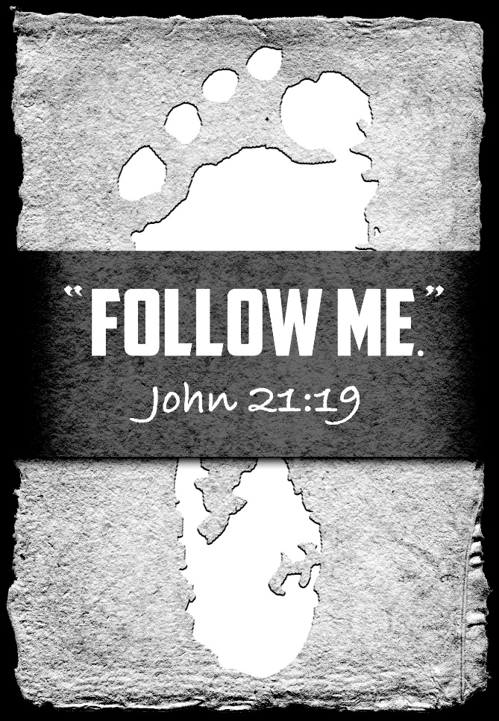

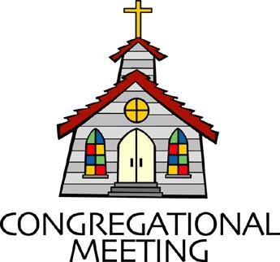
May 8, 2022 - 10:30 am

WELCOME VISITORS! We're glad you are here! Cards at the ends of each pew are for you to fill out and drop in the Offering Plate. Please let us know you are visiting, and join us for refreshments and fellowship following the service. The Sanctuary has an induction loop system to assist the hearing impaired. The system will also work on the telephone setting of hearing aids.

Springfield Presbyterian Church is rooted in the gospel of Jesus Christ, led by the Holy Spirit, and called to loving relationships through vibrant worship and service. Valuing all people, we are committed to developing disciples and fostering stewardship.
PREPARATION FOR THE WORD
(* those who are able are invited to stand)
PRELUDE

GATHERING OF THE PEOPLE

The Lord be with you! And also with you! (Greeting)

LIGHTING THE CHRIST CANDLE
Leader: Whenever we light this candle we proclaim:
People: Christ is the Light of the world and the center of our lives.

CALL TO WORSHIP
Leader: This Eastertide season, we focus upon the good news of salvation.
People: We come together to celebrate the power of the resurrection.
Leader: We join our alleluias to rise above the rafters.
People: In doing so, we also remember our call.
Leader: Our call to be the faithful people of God,
People: To care for one another,
Leader: To tend to those in need,
People: And to renew our commitment to discipleship once again.
Leader: May this act of worship be one that abundantly praises God,
People: For our mighty God has been and is faithful still.
ALL: Let us worship God!

* HYMN God of the Women
(to the tune of #450 "Be Thou My Vision")

God of the women who answered your call,
Trusting your promises, giving their all,
Women like Sarah and Hannah and Ruth —
Give us their courage to live in your truth.

God of the women who walked Jesus' Way,
Giving their resources, learning to pray,
Mary, Joanna, Susanna, and more —
May we give freely as they did before.

God of the women long put to the test,
Left out of stories, forgotten, oppressed,
Quietly asking: "Who smiled at my birth?" —
In Jesus' dying you show us our worth.

God of the women who ran from the tomb,
Prayed with the others in that upper room,
Then felt your Spirit on Pentecost Day —
May we so gladly proclaim you today.

O God of Phoebe and ministers all,
May we be joyful in answering your call.
Give us the strength of your Spirit so near
That we may share in your ministry here.

Tune: Traditional Irish melody ("Be Thou My Vision") (MIDI)
Text: Copyright © 1998 by Carolyn Winfrey Gillette. All rights reserved.

CALL TO CONFESSION
Leader: The Easter promise of new life is life giving. It is one that helps us to look at our lives and our commitment to God in new ways. It is a way in which we orient our lives, continuing to recall this glorious act. The world has become busy and so have we, so let us gather together and reset our hearts and minds to focus on the awe of that resurrection day once again…

PRAYER OF CONFESSION
Generous God, we hear the promise and the stories of your resurrection and we celebrate that sacred Easter morning. Yet time has passed and those alleluias have started to fade slowly. We forget, we let other matters take up space in our hearts and minds. We have forgotten your Word and acts and in doing so, we have not been living our life to your Glory. So we ask that you right us again, reignite the resurrection passion in our hearts, and enlighten us to fully commit to being your disciples.

SILENT PRAYERS OF CONFESSION

RESPONSE Restore in Us, O God Tune #434
Restore in us, O God, the splendor of your love;
Renew your image in our hearts, and all our sins remove.

WORDS OF ASSURANCE
Leader: We are promised that when we come before God, humbly admitting our sin and asking forgiveness, God forgives us.
People: We are grateful for the grace and mercy that God offers us. We are a forgiven people. Praise be to God!

* MUSICAL RESPONSE OF PRAISE Alleluia, Alleluia! Give Thanks
Alleluia, alleluia! Give thanks to the risen Lord.
Alleluia, alleluia! Give praise to his name.

* THE PEACE The peace of Christ be with you! And also with you!
(You may greet those around you.)

* RESPONSE Here I Am, Lord
Here I am, Lord, Is it I, Lord? I have heard you calling in the night.
I will go, Lord, if you lead me. I will hold your people in my heart.
THE PROCLAMATION OF THE WORD

PRAYER OF ILLUMINATION
Loving God, open our hearts and minds to hear your Word more fully and to lean into all that it commands us to do. Grant us the ability to release all that distracts us and turn our focus to you. Guide us in our listening that these words become more than words, but bear witness to your life, here and today. Amen.

FIRST SCRIPTURE LESSON Psalm 30
¹ I will extol you, O Lord, for you have drawn me up, and did not let my foes rejoice over me. ² O Lord my God, I cried to you for help, and you have healed me. ³ O Lord, you brought up my soul from Sheol, restored me to life from among those gone down to the Pit. ⁴ Sing praises to the Lord, O you his faithful ones, and give thanks to his holy name. ⁵ For his anger is but for a moment; his favor is for a lifetime. Weeping may linger for the night, but joy comes with the morning. ⁶ As for me, I said in my prosperity, ‘I shall never be moved.’ ⁷ By your favor, O Lord, you had established me as a strong mountain; you hid your face; I was dismayed. ⁸ To you, O Lord, I cried, and to the Lord I made supplication:
⁹ ‘What profit is there in my death, if I go down to the Pit? Will the dust praise you? Will it tell of your faithfulness? ¹⁰ Hear, O Lord, and be gracious to me! O Lord, be my helper!’ ¹¹ You have turned my mourning into dancing; you have taken off my sackcloth and clothed me with joy, ¹² so that my soul may praise you and not be silent. O Lord my God, I will give thanks to you for ever.

SECOND SCRIPTURE LESSON John 21:1-19
After these things Jesus showed himself again to the disciples by the Sea of Tiberias; and he showed himself in this way. ²Gathered there together were Simon Peter, Thomas called the Twin, Nathanael of Cana in Galilee, the sons of Zebedee, and two others of his disciples. ³Simon Peter said to them, ‘I am going fishing.’ They said to him, ‘We will go with you.’ They went out and got into the boat, but that night they caught nothing. ⁴Just after daybreak, Jesus stood on the beach; but the disciples did not know that it was Jesus. ⁵Jesus said to them, ‘Children, you have no fish, have you?’ They answered him, ‘No.’ ⁶He said to them, ‘Cast the net to the right side of the boat, and you will find some.’ So they cast it, and now they were not able to haul it in because there were so many fish. ⁷That disciple whom Jesus loved said to Peter, ‘It is the Lord!’ When Simon Peter heard that it was the Lord, he put on some clothes, for he was naked, and jumped into the lake. ⁸But the other disciples came in the boat, dragging the net full of fish, for they were not far from the land, only about a hundred yards off. ⁹When they had gone ashore, they saw a charcoal fire there, with fish on it, and bread. ¹⁰Jesus said to them, ‘Bring some of the fish that you have just caught.’ ¹¹So Simon Peter went aboard and hauled the net ashore, full of large fish, a hundred and fifty-three of them; and though there were so many, the net was not torn. ¹²Jesus said to them, ‘Come and have breakfast.’ Now none of the disciples dared to ask him, ‘Who are you?’ because they knew it was the Lord. ¹³Jesus came and took the bread and gave it to them, and did the same with the fish. ¹⁴This was now the third time that Jesus appeared to the disciples after he was raised from the dead. ¹⁵When they had finished breakfast, Jesus said to Simon Peter, ‘Simon son of John, do you love me more than these?’ He said to him, ‘Yes, Lord; you know that I love you.’ Jesus said to him, ‘Feed my lambs.’ ¹⁶A second time he said to him, ‘Simon son of John, do you love me?’ He said to him, ‘Yes, Lord; you know that I love you.’ Jesus said to him, ‘Tend my sheep.’ ¹⁷He said to him the third time, ‘Simon son of John, do you love me?’ Peter felt hurt because he said to him the third time, ‘Do you love me?’ And he said to him, ‘Lord, you know everything; you know that I love you.’ Jesus said to him, ‘Feed my sheep. ¹⁸Very truly, I tell you, when you were younger, you used to fasten your own belt and to go wherever you wished. But when you grow old, you will stretch out your hands, and someone else will fasten a belt around you and take you where you do not wish to go.’ ¹⁹(He said this to indicate the kind of death by which he would glorify God.) After this he said to him, ‘Follow me.’

Leader: Hear what the Spirit is saying to the Church.
All: Thanks be to God.

SERMON A Sacred Breakfast Shared Rev. Becca Crate-Price

THE RESPONSE TO THE WORD

* HYMN Christ, Whose Glory Fills the Skies

Christ, whose glory fills the skies; Christ, the true, the only light;
Sun of Righteousness, arise; triumph o'er the shades of night;
Dayspring from on high, be near; Daystar, in my heart appear.

Dark and cheerless is the morn unaccompanied by thee;
Joyless is the day's return till thy mercy's beams I see;
Till they inward light impart, cheer my eyes and warm my heart.

Visit then this soul of mine; pierce the gloom of sin and grief;
Fill me, radiancy divine; scatter all my unbelief;
More and more thyself display, shining to the perfect day.

PASTORAL PRAYER AND THE LORD’S PRAYER

OFFERTORY A Shepherd’s Psalm arr. Joseph M. Martin
SONG OF THANKS We Give Thee but Thine Own #708
We give thee but thine own, what e’er the gift may be;
All that we have is thine alone, a trust, O Lord, from thee.
PRAYER OF DEDICATION

* HYMN Jesus Calls Us

Jesus calls us: o'er the tumult of our life's wild, restless sea;
Day by day his sweet voice soundeth saying, "Christian, follow me."

Jesus calls us from the worship of the vain world's golden store,
From each idol that would keep us, saying, "Christian, love me more."

In our joys and in our sorrows, days of toil and hours of ease,
Still he calls, in cares and pleasures, "Christian, love me more than these."

Jesus calls us: by thy mercies, Savior, may we hear thy call,
Give our hearts to thy obedience, serve and love thee best of all.

* CHARGE AND BENEDICTION
Leader: Jesus said, “Feed my lambs.”
People: So we feed all in need.
Leader: Jesus said, “Tend to my sheep.”
People: So we care for all of God’s people.
Leader: Jesus said, “Feed my sheep and follow me.”
People: And so, from this moment onwards, let our lives reflect God’s call. Amen.

* UNISON AMEN

POSTLUDE

Sunday May 15, 2022 Lectionary
Acts 11:1-18; Psalm 148; Revelation 21:1-6; John 13:31-35
Assisting in Worship: We appreciate those who serve:

Today 5/8 Next Week 5/15
Sunday Opener Barbara Cornell Beth Oates
Ushers/Greeters Don Vasbinder & Steve & Donna
Bob Rogers Mazer
Lay Leader Kathy Russ Bob Steppling

Happy Birthday! May 10 – Kathy Russ

Announcements

Sunday School is back! On the 1st and 3rd Sundays of the month, we will be offering Sunday School! See Pastor Becca for details…

Spring Plant Sale: Between May 1 and May 31, buy your spring plants at Buppert’s Farm and they will donate 10% of your purchase price back to Springfield’s ongoing projects and mission! Pick up a flyer in the Narthex and share it with your family and friends!

Springfield Membership: Are you interested in finding out more about our faith community and becoming a member? We would love to answer any questions you have. Please contact Pastor Becca at springfieldpastor@gmail.com for more information.

Mask Update: By the agreement of Session, we are now making masks optional. We do want to encourage you, if you feel compelled or have any underlying conditions, to keep your mask on. If you do wish to take off your mask though, we are also happy to see your faces. More information about fellowship and other practices will be coming as we make our way back to normalcy.

Congregational Care / Mission & Outreach: Do you know of a member or friend of our church family who is ill, needs prayers, would like call, a visit or a card, or might benefit from meal train? If so, please contact the Church Office (410-795-6152), Cathy Marsh (410-549-6916) or Diana Steppling (862-266-2242).

Fellowship Help Needed: If you are interested in helping with Fellowship, please contact Barbara Cornell (401-549-9397). A sign-up sheet will also be available.

Today:
Sunday May 8 – Happy Mother’s Day!
10:30 am Worship
11:30 am Fellowship

This Week:
Wednesday May 11
6:00 pm Bell Choir Practice
No Adult Choir Practice
Thursday May 12
7:00 pm Session Meeting (Manse)

Looking Ahead:
Sunday May 15
10:30 am Worship
11:30 am Fellowship
12:00 noon Elder Training (Large Classroom)
Wednesday May 18
6:15 – 7:15 pm Bell Choir Practice
7:30 – 8:45 pm Adult Choir Practice

Office Hours: Tuesday, Wednesday & Friday
Springfield Presbyterian Church

10:30 am Worship
11:30 am Fellowship
Website: www.springfield-church.org Church Office: 410-795-6152
Like us on Facebook: www.facebook.com/SpringfieldPresbyterianChurch
Pastor: Rev. Becca Crate-Price
Email: springfieldpastor@gmail.com
Clerk of Session: Sharon Pappas
Minister of Music: Linda Caviglia
Accompanist/Organist: Aaron Thacker
Youth Group Coordinator: Dylan Vasbinder
Administrative Assistant: Donna Mazer e-mail: spc.office@verizon.net

