(Large Print)

Springfield Presbyterian Church (USA)
7300 Spout Hill Road, Sykesville, MD 21784 410-795-6152

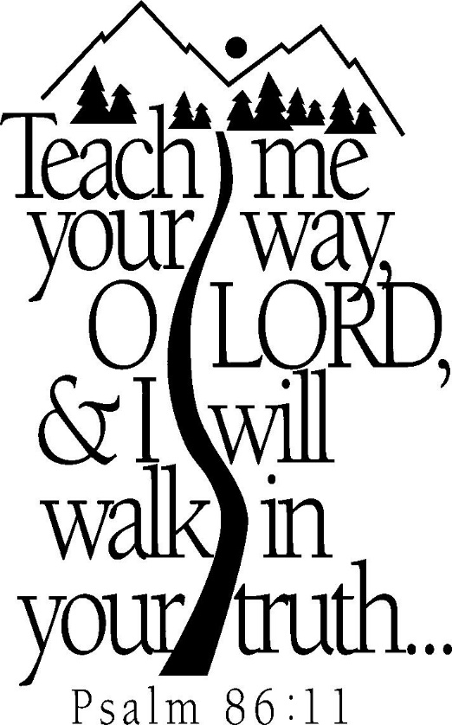

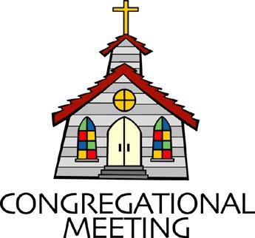
October 16, 2022 - 10:30 am

WELCOME VISITORS!
We're glad you are here! Cards at the ends of each pew are for you to fill out and drop in the Offering Plate. Please let us know you are visiting, and join us for refreshments and fellowship following the service. The Sanctuary has an induction loop system to assist the hearing impaired. The system will also work on the telephone setting of hearing aids.

Springfield Presbyterian Church is rooted in the gospel of Jesus Christ, led by the Holy Spirit, and called to loving relationships through vibrant worship and service. Valuing all people, we are committed to developing disciples and fostering stewardship.
PREPARATION FOR THE WORD
(* those who are able are invited to stand)

PRELUDE

GATHERING OF THE PEOPLE

The Lord be with you! And also with you! (Greeting)

LIGHTING THE CHRIST CANDLE
Leader: Whenever we light this candle we proclaim:
People: Christ is the Light of the world and the center of our lives.

CALL TO WORSHIP
Leader: This week, we continue to ask, “What do you need?”
People: What a privilege it is to be able to ask the question.
Leader: It allows us to hear the inner longings of our fellow siblings’ hearts.
People: For where one may struggle, another may provide.
Leader: What a gift it is to be able to answer the question.
People: To say what you need is a vulnerable act, but it can also provide a deep sense of peace.
Leader: So today we come together to worship God, to hear one another, and to be mindful of the community we are co-creating with God.
People: Let us do so as we pray, as we sing, and as we hear the Word proclaimed.
ALL: Let us worship God!

* HYMN Come Sing, O Church, in Joy! GTG #305

Come sing, O church, in joy! Come join, O church, in song!
For Christ the Lord has led us through the ages long!
In bold accord, come celebrate the journey now and praise the Lord!

Long years have come and gone, and still God reigns supreme,
Empowering us to catch the vision, dream the dream!
In bold accord, come celebrate the journey now and praise the Lord!

Let courage be our friend; let wisdom be our guide,
As we in mission magnify the Crucified!
In bold accord, come celebrate the journey now and praise the Lord!

Come sing, O church, in joy! Come join O church, in song!
For Christ the Lord has triumphed o’er the ages long!
In bold accord, come celebrate the journey now and praise the Lord!

CALL TO CONFESSION
Leader: Hear the heart of your pastor: This week, I’ve been asking myself the critical question, “What do I need?” At moments I felt selfish for wondering. This week, I also have been so busy that I have not asked anyone, “What do you need?” even though I long for that to be my practice. What I know though, and what is a great comfort, is that I am not alone. As a community, as humans, we find ourselves in this challenging space. Thank God we can come before God and ask to be set aright once again. Let us pray together:

PRAYER OF CONFESSION
Gracious God, it is a gift that you already know what we need before we sense it or can say it aloud. What a gift it is as well that you empower us to ask the needs of others around us. Yet we have been caught up in our own worlds, ones where it is so frantic that we haven’t stopped to ask the needs of others. We have also not taken the important time to be self-reflective. God, do not let us walk away from this gift of being in relationship with you and our siblings more deeply. Instill in us a desire to dig deeper, to wonder more, to walk more slowly, all in the hopes that as we give and receive, we are able to embody a better sense of what your Kingdom looks like in the world. Amen.

SILENT PRAYERS OF CONFESSION

RESPONSE Hear My Prayer, O God Tune #782
Hear my prayer, O God, and listen to my plea;
Faithful, righteous One, give ear and answer me.
Judge me not, I pray; no merit dare I claim;
Knowing my own faults, I trust in your just Name.

WORDS OF ASSURANCE
Leader: When we come before God with our confessions and seek renewal in authenticity, God is ready to receive us in forgiveness with open arms.
People: Thanks be to God who continues to forgive us and restores us again and again. Alleluia and amen!

* MUSICAL RESPONSE OF PRAISE O My Soul, Bless Your Redeemer
Bless your Maker, all you creatures, ever under God’s control,
All throughout God’s vast dominion; bless the Lord of all, my soul!

* THE PEACE The peace of Christ be with you! And also with you!
(You may greet those around you.)

* RESPONSE Here I Am, Lord
Here I am, Lord, Is it I, Lord? I have heard you calling in the night.
I will go, Lord, if you lead me. I will hold your people in my heart.

THE PROCLAMATION OF THE WORD

PRAYER OF ILLUMINATION
Guide us, O God, by your Word and Spirit, that in your light we may see light, in your truth find freedom, and in your will discover your peace; through Jesus Christ our Lord. Amen.
FIRST SCRIPTURE LESSON Psalm 86
¹ Incline your ear, O Lord, and answer me, for I am poor and needy.
² Preserve my life, for I am devoted to you; save your servant who trusts in you. You are my God; ³ be gracious to me, O Lord, for to you do I cry all day long. ⁴ Gladden the soul of your servant, for to you, O Lord, I lift up my soul. ⁵ For you, O Lord, are good and forgiving, abounding in steadfast love to all who call on you. ⁶ Give ear, O Lord, to my prayer; listen to my cry of supplication. ⁷ In the day of my trouble I call on you, for you will answer me. ⁸ There is none like you among the gods, O Lord, nor are there any works like yours. ⁹ All the nations you have made shall come and bow down before you, O Lord, and shall glorify your name. ¹⁰ For you are great and do wondrous things; you alone are God. ¹¹ Teach me your way, O Lord, that I may walk in your truth; give me an undivided heart to revere your name. ¹² I give thanks to you, O Lord my God, with my whole heart, and I will glorify your name for ever. ¹³ For great is your steadfast love towards me; you have delivered my soul from the depths of Sheol. ¹⁴ O God, the insolent rise up against me; a band of ruffians seeks my life, and they do not set you before them. ¹⁵ But you, O Lord, are a God merciful and gracious, slow to anger and abounding in steadfast love and faithfulness. ¹⁶ Turn to me and be gracious to me; give your strength to your servant; save the child of your serving-maid. ¹⁷ Show me a sign of your favor, so that those who hate me may see it and be put to shame, because you, Lord, have helped me and comforted me.

SECOND SCRIPTURE LESSON 2 Timothy 4:9-18
⁹Do your best to come to me soon, ¹⁰for Demas, in love with this present world, has deserted me and gone to Thessalonica; Crescens has gone to Galatia, Titus to Dalmatia. ¹¹Only Luke is with me. Get Mark and bring him with you, for he is useful in my ministry. ¹²I have sent Tychicus to Ephesus. ¹³When you come, bring the cloak that I left with

Carpus at Troas, also the books, and above all the parchments. ¹⁴Alexander the coppersmith did me great harm; the Lord will pay him back for his deeds. ¹⁵You also must beware of him, for he strongly opposed our message. ¹⁶At my first defense no one came to my support, but all deserted me. May it not be counted against them! ¹⁷But the Lord stood by me and gave me strength, so that through me the message might be fully proclaimed and all the Gentiles might hear it. So I was rescued from the lion’s mouth. ¹⁸The Lord will rescue me from every evil attack and save me for his heavenly kingdom. To him be the glory for ever and ever. Amen.

Leader: Hear what the Spirit is saying to the Church.
All: Thanks be to God.

SERMON Paul’s To Do List Rev. Becca Price

THE RESPONSE TO THE WORD

* HYMN A Covenant of Grace Tune #202

(SEE LAST PAGE OF BULLETIN)

PASTORAL PRAYER AND OUR LORD’S PRAYER

OFFERTORY
SONG OF THANKS Great God of Every Blessing Tune #694
Great God of every blessing, of faithful, loving care,
You are the fount of goodness, the daily bread we share.
How can we hope to thank you? Our praise is but a start:
Sincerely and completely I offer you my heart.
PRAYER OF DEDICATION

* HYMN We All Are One in Mission GTG #733

We all are one in mission; we all are one in call,
Our varied gifts united by Christ, the Lord of all.
A single, great commission compels us from above
To plan and work together that all may know Christ's love.

We all are called for service to witness in God's name.
Our ministries are different; our purpose is the same:
To touch the lives of others by God's surprising grace,
So every folk and nation may feel God's warm embrace.

Now let us be united and let our song be heard.
Now let us be a vessel for God's redeeming word.
We all are one in mission; we all are one in call,
Our varied gifts united by Christ, the Lord of all.

* CHARGE AND BENEDICTION
Leader: As you leave this place, may God grant us,
People: The curiosity to counter assumptions,
Leader: The vulnerability to befriend,
People: The bravery to speak your truth,
Leader: The wisdom to listen,
People: The strength to ask for help,
Leader: The resiliency to choose love, even when it’s hard,
People: And the awareness of the Holy Spirit always beside us.
Leader: In the name of our Great God, who is Love itself, may you go in peace.

* UNISON AMEN

POSTLUDE

Sunday, October 23, 2022 Lectionary
Ruth 1:1-22

Assisting in Worship: We appreciate those who serve:

Today 10/16 Next Week 10/23
Sunday Opener Bob Rogers Barbara Cornell
Ushers/Greeters Elizabeth Meirowitz Don Vasbinder
Brenda McClung Cynthia Smith
Lay Leader Sharon Pappas Barbara Cornell

Happy Birthday! October 17 – Beth Oates
October 19 – Martha Streaker
October 23 – Connie Robinson

Happy Anniversary! October 18 – Jim & Mary Rhodes

Announcements

Fall Fellowship Time: The weather is changing! Time to make our plans for Fellowship through the fall. We'd love to have your help providing and serving the goodies we share as we visit after worship. If you have not hosted Fellowship, we can pair you with someone who knows the routine (and where we hide the toothpicks!).
If you don't want to host, we would be happy to have you sign up to bring something in. We always have a supply of crackers and cookies in the kitchen, but our table often includes fruit, cheese and baked goods. Let us know on the sign-up sheet in the kitchen or email me what you'd like to bring. Thanks so much!
Barbaracornell4@gmail.com or 240-308-0035
Mask Update: Since COVID-19 is still with us, the Session has decided that masking and social distancing is encouraged but is optional. Though it is not a mandate, we seek to love one another by keeping each other as safe as possible. Thank you for your help in this endeavor.

Christian Education: Our Time and Talents survey shows folks are interested in an adult bible study program, and Alex McClung is interested in leading a study group. We imagine meeting 2x/month before church, but content, format, and timing are all TBD. Please contact Alex with your suggestions, interests, and best times: akmcclungiii@gmail.com.

Pastor-Parish Committee: The Pastor-Parish Committee invites you to share your concerns, suggestions, and gratitude. We have a form in the Narthex and a lock-box that we will open weekly and we ask that you share your name and be specific. We look forward to reading your comments so that we can continue to grow into the body of Christ.

Springfield Membership: Are you interested in finding out more about our faith community and becoming a member? We would love to answer any questions you have. Please contact Pastor Becca at springfieldpastor@gmail.com for more information.

Congregational Care / Mission & Outreach (CoCaMO): Do you know of a member or friend of our church family who is ill, needs prayers, would like call, a visit or a card, or might benefit from meal train? If so, please contact the Church Office (410-795-6152), Cathy Marsh (410-549-6916) or Diana Steppling (862-266-2242).

Prayers & Thanksgivings
~ Continued prayers for Sue Holmes’ mom, Betty Martlew, who fell and broke her hip and is recovering.
Today:
Sunday October 16
10:30 am Worship
11:30 am Fellowship

This Week:
Wednesday October 19
7:30 – 8:45 pm Adult Choir Practice
Saturday October 22
9:00 – 11:00 am Clean Up

Looking Ahead:
Sunday October 23
10:30 am Worship
11:30 am Fellowship
Wednesday October 26
6:15 – 7:15 pm Bell Choir Practice
7:30 – 8:45 pm Adult Choir Practice

Office Hours: Tuesday, Wednesday & Friday
Springfield Presbyterian Church

10:30 am Worship
11:30 am Fellowship
Website: www.springfield-church.org Church Office: 410-795-6152
Like us on Facebook: www.facebook.com/SpringfieldPresbyterianChurch
Pastor: Rev. Becca Price
Email: springfieldpastor@gmail.com
Clerk of Session: Sharon Pappas
Minister of Music: Linda Caviglia
Accompanist/Organist: Aaron Thacker
Youth Group Coordinator: Dylan Vasbinder
Administrative Assistant: Donna Mazer e-mail: spc.office@verizon.net

