(Large Print)

Springfield Presbyterian Church (USA)
7300 Spout Hill Road, Sykesville, MD 21784 410-795-6152

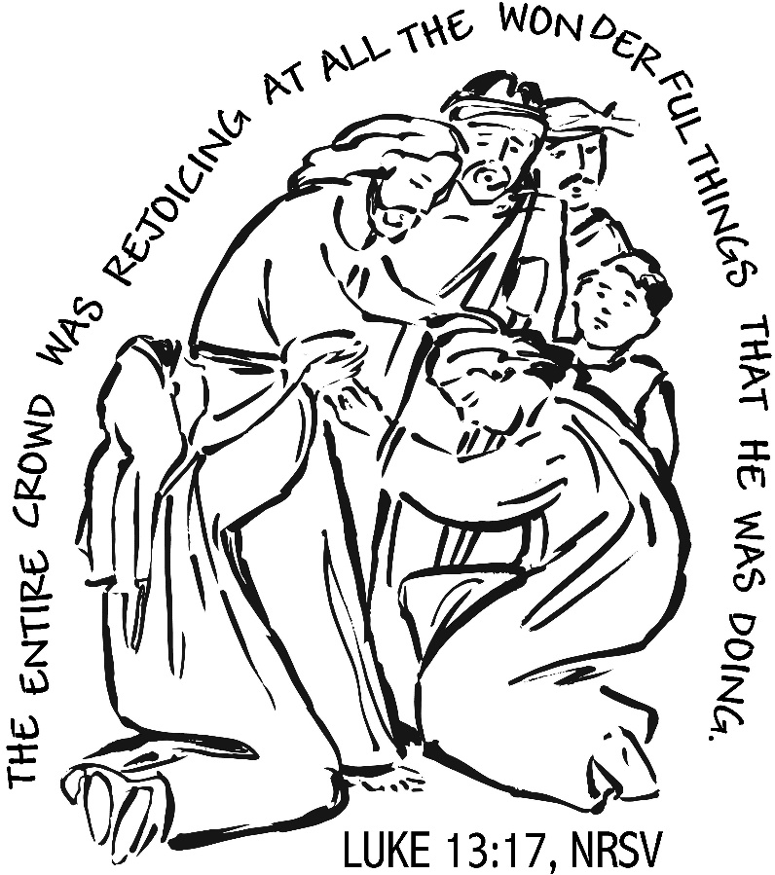

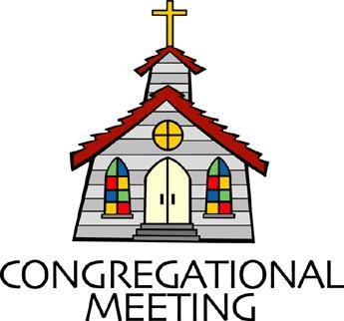
August 25, 2019 - 10:30 am

WELCOME VISITORS! We're glad you are here! Cards at the ends of each pew are for you to fill out and drop in the Offering Plate. Please let us know you are visiting, and join us for refreshments and fellowship following the service. The Sanctuary has an induction loop system to assist the hearing impaired. The system will also work on the telephone setting of hearing aids.

Springfield Presbyterian Church is rooted in the gospel of Jesus Christ, led by the Holy Spirit, and called to loving relationships through vibrant worship and service. Valuing all people, we are committed to developing disciples and fostering stewardship.

PREPARATION FOR THE WORD
(* those who are able are invited to stand)

PRELUDE

GATHERING OF THE PEOPLE

The Lord be with you! And also with you! (Greeting)

LIGHTING THE CHRIST CANDLE
Leader: Whenever we light this candle we proclaim:
People: Christ is the Light of the world and the center of our lives.

CALL TO WORSHIP [Psalm 71:1-6]
Leader: In you, O Lord, I take refuge; let me never be put to shame.
People: In your righteousness deliver me and rescue me; incline your ear to me and save me.
Leader: Be to me a rock of refuge, a strong fortress, to save me, for you are my rock and my fortress.
People: Rescue me, O my God, from the hand of the wicked, from the grasp of the unjust and cruel.
Leader: For you, O Lord, are my hope, my trust, O Lord, from my youth.
People: Upon you I have learned from my birth; it was you who took me from my mother’s womb. My praise is continually of you.
ALL: Let us gather together as the people of God to praise our divine and loving God! Alleluia, amen!

* HYMN There’s a Sweet, Sweet Spirit

There’s a sweet, sweet Spirit in this place, and I know that it’s the Spirit of the Lord;
There are sweet expressions on each face, and I know they feel the presence of the Lord.
Refrain:
Sweet Holy Spirit, sweet heavenly Dove, stay right here with us,
Filling us with your love; and for these blessings we lift our hearts in praise; without a doubt we’ll know that we have been revived when we shall leave this place.

There are blessings you cannot receive till you know him in his fullness and believe;
You’re the one to profit when you say, “I am going to walk with Jesus all the way.” [Refrain]

PRAYER OF CONFESSION (Unison)
Gracious God, you call us to proclaim the Gospel, but we remain silent in the presence of evil. You call us to be reconciled to you and one another, but we are content to live in separation. You call us to seek the good of all, but we fail to resist the powers of oppression. You call us to fight pretensions and injustice, but we sit idly by, endangering the lives of people far and near. Forgive us, O Lord, reconcile us to you by the power of your Spirit, and give us the courage and strength to be reconciled to others; through Jesus Christ, your Son, our Savior. Amen.

SILENT PRAYERS OF CONFESSION

RESPONSE Remember Not, O God
O Lord, our Savior, help, and glorify your name;
Deliver us from all our sins and take away our shame.

WORDS OF ASSURANCE
Leader: Our righteousness is found in Christ alone, a gift of God by faith.
People: Beloved people of God, believe the good news: through the grace of Jesus Christ we are forgiven! Alleluia, amen!

* MUSICAL RESPONSE OF PRAISE Great Is Thy Faithfulness
Great is thy faithfulness! Great is thy faithfulness! Morning by morning new mercies I see. All I have needed thy hand hath provided. Great is thy faithfulness Lord unto me.

* THE PEACE The peace of Christ be with you! And also with you!
(You may greet those around you.)

* RESPONSE Here I Am, Lord
Here I am, Lord, Is it I, Lord? I have heard you calling in the night.
I will go, Lord, if you lead me. I will hold your people in my heart.

THE PROCLAMATION OF THE WORD

PRAYER OF ILLUMINATION
Leader: God our helper, by your Holy Spirit, open our minds that as the scriptures are read and your word is proclaimed, we may be led into your truth and taught your will, for the sake of Jesus Christ our Lord. Amen.

FIRST SCRIPTURE LESSON Psalm 103:1-8
¹ Bless the Lord, O my soul, and all that is within me, bless his holy name. ² Bless the Lord, O my soul, and do not forget all his benefits—
³ who forgives all your iniquity, who heals all your diseases, ⁴ who redeems your life from the Pit, who crowns you with steadfast love and mercy, ⁵ who satisfies you with good as long as you live so that your youth is renewed like the eagle’s. ⁶ The Lord works vindication and justice for all who are oppressed. ⁷ He made known his ways to Moses, his acts to the people of Israel. ⁸ The Lord is merciful and gracious, slow to anger and abounding in steadfast love.

SECOND SCRIPTURE LESSON Luke 13:10-17
¹⁰Now he was teaching in one of the synagogues on the sabbath. ¹¹And just then there appeared a woman with a spirit that had crippled her for eighteen years. She was bent over and was quite unable to stand up straight. ¹²When Jesus saw her, he called her over and said, ‘Woman, you are set free from your ailment.’ ¹³When he laid his hands on her, immediately she stood up straight and began praising God. ¹⁴But the leader of the synagogue, indignant because Jesus had cured on the sabbath, kept saying to the crowd, ‘There are six days on which work ought to be done; come on those days and be cured, and not on the sabbath day.’ ¹⁵But the Lord answered him and said, ‘You hypocrites! Does not each of you on the sabbath untie his ox or his donkey from the manger, and lead it away to give it water? ¹⁶And ought not this woman, a daughter of Abraham whom Satan bound for eighteen long years, be set free from this bondage on the sabbath day?’ ¹⁷When he said this, all his opponents were put to shame; and the entire crowd was rejoicing at all the wonderful things that he was doing.

Leader: Hear what the Spirit is saying to the Church.
All: Thanks be to God.

TIME WITH YOUNG PEOPLE

SERMON Redefining Sabbath Rev. Becca Crate

THE RESPONSE TO THE WORD

* HYMN We Cannot Measure How You Heal
We cannot measure how you heal or answer every sufferer’s prayer,
Yet we believe your grace responds where faith and doubt unite to care. Your hands, though bloodied on the cross, survive to hold and heal and warn, to carry all through death to life and cradle children yet unborn.

The pain that will not go away, the guilt that clings from things long past,
The fear of what the future holds, are present as if meant to last.
But present too is love which tends the hurt we never hoped to find,
The private agonies inside, the memories that haunt the mind.

So some have come who need your help and some have come to make amends,
As hands which shaped and saved the world are present in the touch of friends.
Lord, let your Spirit meet us here to mend the body, mind and soul,
To disentangle peace from pain, and make your broken people whole.

PASTORAL PRAYER AND THE LORD’S PRAYER
“For this I pray to God.” / “For this I give thanks to God.”
Congregational Response: “Hear our prayer, O God.”

PRESENTATION OF TITHES AND OFFERINGS
OFFERTORY Signe by Eric Clapton
Henry Halvorson – Guitar, Aaron Thacker - Piano
* SONG OF THANKS As Those of Old Their Firstfruits Brought
In gratitude and humble trust we bring our best today,
To serve your cause and share your love with all along life’s way.
O God who gave yourself to us in Jesus Christ your Son,
Help us to give ourselves each day until life’s work is done.
* PRAYER OF DEDICATION

* HYMN Christ Be Beside Me

Christ be beside me; Christ be before me; Christ be behind me, King of my heart. Christ be within me; Christ be below me; Christ be above me, never to part.

Christ on my right hand, Christ on my left hand, Christ all around me, shield in the strife. Christ in my sleeping, Christ in my sitting, Christ in my rising, Light of my life.

Christ be in all hearts thinking about me; Christ be on all tongues telling of me. Christ be the vision in eyes that see me; in ears that hear me Christ ever be.

* CHARGE AND BENEDICTION
Leader: We are called to rest in you,
People: To live out the call of Sabbath.
Leader: Help us by your spirit to live out Sabbath,
People: So we may live the life you call us to,
Leader: By rest, reading, healing, listening, and learning,
People: May we renew our sense of Sabbath.

* UNISON AMEN

POSTLUDE

Assisting in Worship: We appreciate those who serve:
Today 8/25 Next Week 9/1
Sunday Opener Jennifer Wise Ron Holmes
Greeters & Ushers Kathy Russ & Steve & Donna
Barbara Nickell Mazer
Lay Leader Sharon Pappas Ron Holmes
Children’s Activity Connie Robinson Connie Robinson
Fellowship Brittany & Danny
Rachin
Sunday September 1 Lectionary
Jeremiah 2:4-13; Psalm 81:1, 10-16; Hebrews 13:1-8, 15-16;
Luke 14:1, 7-14

Church Attendance: August 11 – 43 Concert - 38

Church Cleaning: September 6, 7 or 8 – Martha & Davis Streaker

Happy Birthday! August 27 - Aaron Wise
August 27 – Connie Gibbons
August 28 – Bob Rogers
August 31 – Bridget Doyle

Happy Anniversary! September 1 – Charlie & Deb Sperling

Announcements

Choir and Bell Choir: If anyone is interested in joining us for choir, there are no auditions! If you'll let Linda Caviglia know before the first practice, she will make sure to have a folder with all the music for you.

Wednesday, August 28
Adult Choir Practice - 6:30 - 9:00 As usual, we will try to read through all the music up to the end of the calendar year... and have a 1/2 hour for snacks and fellowship from 7:30 - 8:00pm.

Wednesday, September 4
Presbytones Bell Choir Practice 6:30 - 7:30 pm
Adult Choir Practice 7:45 - 9:00 pm

Blessing Bags are in the Narthex. Please feel free to pick up a few. Handing one out to someone in need gives you a very real way to meet their immediate needs by providing them with some basic supplies.

Weekly Announcements: If you have an announcement to include with next week’s bulletin, please call the Office at 410-795-6152 or email to spc.office@verizon.net by Wednesday each week.

Prayers & Thanksgivings

~ Continued prayers of comfort and healing for Barbara Nickell who broke her wrist.
~ Prayers for First of Howard County from our Ministry Group.

The Congregational Care team wants to know what YOU or someone you know needs...a visit...a call...a meal. Please contact Diana Steppling or Connie Robinson. If you are in need of pastoral care, please contact Pastor Becca at 410-795-6152 or springfieldpastor@gmail.com.

Today:
Sunday August 25
10:30 am Worship
11:30 am Fellowship
12:00 noon Session Meeting (Library)

This Week:
Wednesday August 28
6:30 pm Adult Choir Practice

Looking Ahead:
Sunday September 1
10:30 am Worship
11:30 am Fellowship
Wednesday September 4
6:30 pm Bell Choir Practice
7:45 pm Adult Choir Practice

Office Hours: Tuesday, Wednesday, Friday 9:00 am - 3:00 pm

Springfield Presbyterian Church

10:30 am Worship
11:30 am Fellowship
Website: www.springfield-church.org Church Office: 410-795-6152
Like us on Facebook: www.facebook.com/SpringfieldPresbyterianChurch
Pastor: Rev. Becca Crate
Email: springfieldpastor@gmail.com
Clerk of Session: Sharon Pappas
Minister of Music: Linda Caviglia
Accompanist: Aaron Thacker Organist: Jennifer Wise
Youth Group Coordinators: Charles & Deb Sperling
Sunday School Coordinator: Connie Robinson
Administrative Assistant: Donna Mazer
e-mail: spc.office@verizon.net

