(Large Print)

Springfield Presbyterian Church (USA)
7300 Spout Hill Road, Sykesville, MD 21784 410-795-6152

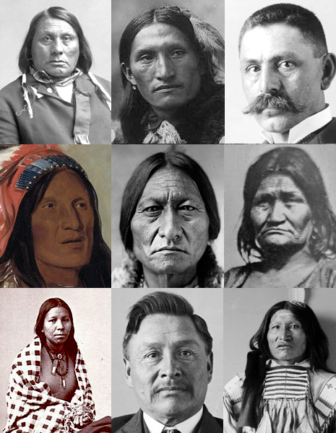

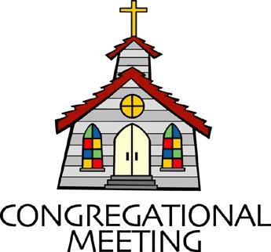
September 29, 2019 - 10:30 am

WELCOME VISITORS! We're glad you are here! Cards at the ends of each pew are for you to fill out and drop in the Offering Plate. Please let us know you are visiting, and join us for refreshments and fellowship following the service. The Sanctuary has an induction loop system to assist the hearing impaired. The system will also work on the telephone setting of hearing aids.

Springfield Presbyterian Church is rooted in the gospel of Jesus Christ, led by the Holy Spirit, and called to loving relationships through vibrant worship and service. Valuing all people, we are committed to developing disciples and fostering stewardship.

PREPARATION FOR THE WORD
(* those who are able are invited to stand)

PRELUDE

GATHERING OF THE PEOPLE

The Lord be with you! And also with you! (Greeting)

LIGHTING THE CHRIST CANDLE
Leader: Whenever we light this candle we proclaim:
People: Christ is the Light of the world and the center of our lives.

CALL TO WORSHIP [From UMC Discipleship]
Leader: Come, let us worship the Creator with hearts open to all peoples, where pride and prejudice once dwelt;
People: Let us worship the Creator with minds open to the wisdom of Native peoples, where listen and respect once had no place.
Leader: Let us honor the One who freely gives by showing honor to those who were once and still remain oppressed.
People: Let us worship the God of diversity, who made the world in colors, in seasons, in endless variety; who created the diversity of the earth’s people in God’s image.
ALL: We were created to honor one another, and in so doing, we honor the Creator. Let us honor God today by reflecting in our worship and in life His image – Love. Amen.

* HYMN Many and Great, O God, Are Thy Works (repeat 2x)

Many and great, O God, are thy works, Maker of earth and sky.
Thy hands have set the heavens with stars;
thy fingers spread the mountains and plains.
Lo, at thy word the waters were formed. Deep seas obey thy voice.

Grant unto us communion with thee, thou star-abiding One.
Come unto us and dwell with us.
With thee are found the gifts of life.
Bless us with life that has no end, eternal life with thee.

PRAYER OF CONFESSION
Leader: This is a prayer that has been translated from the Lakota Chief Yellow Lark. Let us pray together.
ALL: O Great Spirit, whose voice I hear in the wind, whose breath gives life to all the world, hear me: I need your strength and wisdom. Let me walk in beauty, and make my eyes ever behold the red and purple sunset. Make my hands respect the things you have made and my ears sharp to hear your voice. Make me wise so that I may understand the things you have taught my people. Amen.
SILENT PRAYERS OF CONFESSION

RESPONSE Lord Jesus, Think on Me
Lord Jesus, think on me, and purge away my sin.
From earth-born passions set me free, and make me pure within.

WORDS OF ASSURANCE
Leader: Black Elk, from the Lakota community shared phrases of wisdom. There is one in particular I would like to share with you, words that assure us of God’s continuing presence. Black Elk said, “All over the sky, a sacred voice is calling your name.”

People: May we know this sacred voice, the voice of God, redeems us, renews us, and restores us into forgiven people, called out into the world.

* MUSICAL RESPONSE OF PRAISE From All That Dwell Below the Skies
Eternal are thy mercies, Lord; eternal truth attends thy word: Alleluia! Alleluia!
Thy praise shall sound from shore to shore, till suns shall rise and set no more. Alleluia! Alleluia! Alleluia! Alleluia! Alleluia!

* THE PEACE The peace of Christ be with you! And also with you!
(You may greet those around you.)

* RESPONSE Here I Am, Lord
Here I am, Lord, Is it I, Lord? I have heard you calling in the night.
I will go, Lord, if you lead me. I will hold your people in my heart.

THE PROCLAMATION OF THE WORD

FIRST SCRIPTURE LESSON 1 Corinthians 12:12-26
¹²For just as the body is one and has many members, and all the members of the body, though many, are one body, so it is with Christ. ¹³For in the one Spirit we were all baptized into one body—Jews or Greeks, slaves or free—and we were all made to drink of one Spirit.
¹⁴Indeed, the body does not consist of one member but of many. ¹⁵If the foot were to say, ‘Because I am not a hand, I do not belong to the body’, that would not make it any less a part of the body. ¹⁶And if the ear were to say, ‘Because I am not an eye, I do not belong to the body’, that would not make it any less a part of the body. ¹⁷If the whole body were an eye, where would the hearing be? If the whole body were hearing, where would the sense of smell be? ¹⁸But as it is, God arranged the members in the body, each one of them, as he chose. ¹⁹If all were a single member, where would the body be? ²⁰As it is, there are many members, yet one body. ²¹The eye cannot say to the hand, ‘I have no need of you’, nor again the head to the feet, ‘I have no need of you.’ ²²On the contrary, the members of the body that seem to be weaker are indispensable, ²³and those members of the body that we think less honorable we clothe with greater honor, and our less respectable members are treated with greater respect; ²⁴whereas our more respectable members do not need this. But God has so arranged the body, giving the greater honor to the inferior member, ²⁵that there may be no dissension within the body, but the members may have the same care for one another. ²⁶If one member suffers, all suffer together with it; if one member is honored, all rejoice together with it.

SECOND SCRIPTURE LESSON Luke 4:18
‘The Spirit of the Lord is upon me, because he has anointed me to bring good news to the poor. He has sent me to proclaim release to the captives and recovery of sight to the blind, to let the oppressed go free.’

Leader: Hear what the Spirit is saying to the Church.
All: Thanks be to God.

TIME WITH YOUNG PEOPLE

SERMON Honoring the Indigenous People: Past, Present and Future

THE RESPONSE TO THE WORD

* HYMN Take the Saving Word of God (repeat 2x)

Take the saving word of God; put it first within your life.
Nothing comes before God’s holy word.

PASTORAL PRAYER AND THE LORD’S PRAYER
“For this I pray to God.” / “For this I give thanks to God.”
Congregational Response: “Hear our prayer, O God.”

PRESENTATION OF TITHES AND OFFERINGS
OFFERTORY On Eagle’s Wings Arr. Mark Hayes
* SONG OF THANKS Dakota Doxology Tune #606
Wakantanka yatan miye, Cinhintku kin makata hi,
Wicaceji yatanpi kte, Qa Woniya Wakan kici.
* PRAYER OF DEDICATION

* HYMN All Creatures of Our Spirit God
(sung to the tune of All Creatures of Our God and King)

All creatures of our Spirit God, lift up your voice and with us sing,
O praise ye! Alleluia!
O Brother Sun with golden beam, O Sister Moon with silver gleam!
O praise ye! O praise ye! Alleluia, Alleluia, Alleluia!

O Brother Wind, Air, Clouds, and Rain, by which all creatures you sustain, O praise ye! Alleluia!
Thou rising morn, in praise rejoice, Ye lights of evening, find a voice!
O praise ye! O praise ye! Alleluia, Alleluia, Alleluia!

O Sister Water, flowing clear, make music for thy God to hear,
O praise ye! Alleluia!
O Brother Fire who lights the night, providing warmth, enhancing sight.
O praise ye! O praise ye! Alleluia, Alleluia, Alleluia!

* CHARGE AND BENEDICTION Dakota Doxology Tune #606
Wakantanka yatan miye, Cinhintku kin makata hi,
Wicaceji yatanpi kte, Qa Woniya Wakan kici.

* UNISON AMEN

POSTLUDE

Assisting in Worship: We appreciate those who serve:

Today 9/29 Next Week 10/6
Sunday Opener Jennifer Wise Beth Oates
Greeters & Ushers Steve & Donna Bob Rogers &
Mazer Amy Vasbinder
Lay Leader Barbara Cornell Diana Steppling
Sunday School Connie Robinson Connie Robinson
Fellowship Diana Steppling Barbara Cornell

Church Attendance: September 15 – 39 September 22 - 39

Church Cleaning: October 4, 5 or 6 – The Anderson Family

Happy Birthday! October 1 – Evan Stinson
October 6 – Mary Rhodes

Happy Anniversary! October 5 – Connie Gibbons & Cathy Marsh

Sunday October 6 Lectionary
Lamentations 1:1-6; Lamentations 3:19-26 or Psalm 137;
2 Timothy 1:1-14; Luke 17:5-10
Announcements

Noisy Offering: This offering received TODAY is an opportunity to empty your loose change, making a Noisy Offering. This will be collected by our youth and will go to support a local school.

C.I.A. (Community in Action): Next meeting is October 7 from 4:30 to 6 pm in the Manse. Pizza is provided! Please plan on attending to support OUR community!

C.I.A. is a group open to all religious and non-religious people as a means of providing the community with acts of kindness. We will be doing different activities throughout the school year to help people in
our community who are in need.

ESCAPE Lunch Packing: ESCAPE lunch packing will be on Tuesday, October 8 at 7 pm at the Manse. There will be a sign up sheet at church.

Did You Know? SPC has a new website! If you haven’t seen it yet, go to www.springfield-church.org and check it out. Let us know what you think!

Children/Youth Activities: If your child/youth is participating in any activities this Fall, please let Connie Robinson know as we want to be part of the activity.

Blessing Bags are in the Narthex. Please feel free to pick up a few. Handing one out to someone in need gives you a very real way to meet their immediate needs by providing them with some basic supplies.

Weekly Announcements: If you have an announcement to include with next week’s bulletin, please call the Office at 410-795-6152 or email to spc.office@verizon.net by Wednesday each week.

Prayers & Thanksgivings

~ Continued prayers of comfort and healing for Barbara Nickell who broke her wrist. If you would like to provide a meal for the Nickells, please see Connie Robinson.
~ Prayers for Mt. Hebron Presbyterian Church from our Ministry Group.

The Congregational Care team wants to know what YOU or someone you know needs...a visit...a call...a meal. Please contact Diana Steppling or Connie Robinson. If you are in need of pastoral care, please contact Pastor Becca at 410-795-6152 or springfieldpastor@gmail.com.

Today:
Sunday September 29 – Noisy Offering
10:30 am Worship & Sunday School
11:30 am Fellowship

This Week:
Wednesday October 2
6:30 pm Bell Choir Practice
7:45 pm Adult Choir Practice

Looking Ahead:
Sunday October 6 – World Communion Sunday
9:00 am Red Sea Parting Practice
10:30 am Worship & Sunday School
11:30 am Fellowship
Monday October 7
4:30 pm C.I.A. Meeting (Manse)
Tuesday October 8
10:30 am Prayer Group (Manse)
7:00 pm ESCAPE Lunch Packing (Manse)
Wednesday October 9
6:30 pm Bell Choir Practice
7:45 pm Adult Choir Practice
Thursday October 10
7:00 pm Session Meeting (Manse)

Office Hours: Tuesday, Wednesday, Friday 9:00 am - 3:00 pm
Springfield Presbyterian Church

10:30 am Worship & Sunday School
11:30 am Fellowship
Website: www.springfield-church.org Church Office: 410-795-6152
Like us on Facebook: www.facebook.com/SpringfieldPresbyterianChurch
Pastor: Rev. Becca Crate
Email: springfieldpastor@gmail.com
Clerk of Session: Sharon Pappas
Minister of Music: Linda Caviglia
Accompanist: Aaron Thacker Organist: Jennifer Wise
Youth Group Coordinators: Charles & Deb Sperling
Sunday School Coordinator: Connie Robinson
Administrative Assistant: Donna Mazer
e-mail: spc.office@verizon.net

