(Large Print)

Springfield Presbyterian Church (USA)
7300 Spout Hill Road, Sykesville, MD 21784 410-795-6152

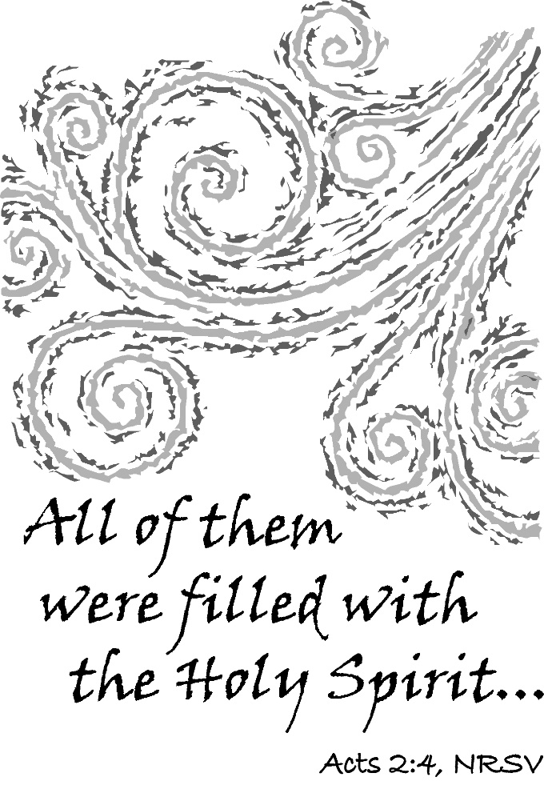

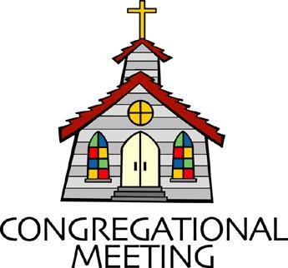
June 5, 2022 - 10:30 am

WELCOME VISITORS! We're glad you are here! Cards at the ends of each pew are for you to fill out and drop in the Offering Plate. Please let us know you are visiting, and join us for refreshments and fellowship following the service. The Sanctuary has an induction loop system to assist the hearing impaired. The system will also work on the telephone setting of hearing aids.

Springfield Presbyterian Church is rooted in the gospel of Jesus Christ, led by the Holy Spirit, and called to loving relationships through vibrant worship and service. Valuing all people, we are committed to developing disciples and fostering stewardship.
PREPARATION FOR THE WORD
(* those who are able are invited to stand)
PRELUDE

GATHERING OF THE PEOPLE

The Lord be with you! And also with you! (Greeting)

LIGHTING THE CHRIST CANDLE
Leader: Whenever we light this candle we proclaim:
People: Christ is the Light of the world and the center of our lives.

CALL TO WORSHIP [Psalm 104:31-35b]
Leader: May the glory of the Lord endure forever;
People: May the Lord rejoice in his works!
Leader: He who looks on the earth and it trembles,
People: He who touches the mountains and they smoke.
Leader: We will sing to the Lord as long as we live;
People: We will sing praise to our God while we are living.
Leader: May our meditations be pleasing unto him, for we rejoice in the Lord.
People: Bless the Lord, O my soul! Praise the Lord!

* HYMN Pentecost Had Come Tune #765
Pentecost had come and in that time of grace,
Jesus’ friends were gathered in a meeting place.
Suddenly the Spirit came in wind and flame,
Sending men and women out in Jesus’ name
Spirit, come upon us, too! Give us gifts to share for you.
We live in a world in need; send us where you daily lead!

All around the city joy was in the air;
People gathered in the streets from everywhere.
Soon they heard some preaching and the news was good!
There, in every language, they all understood.
Spirit, move through every land till all know and understand:
Jesus died and rose – it’s true! Now we have new life in you.

Peter told the crowd to turn and be baptized;
Thousands heard the words he spoke and changed their lives.
Daily they sold what they owned to help the poor;
Day by day the church was growing more and more.
Spirit, change the way we live. Teach us how to gladly give.
Guide us, as we seek to be faithful in our ministry.

Text Copyright 2010 by Carolyn Winfrey Gillette. All rights reserved.

CALL TO CONFESSION
Leader: We come before God not because we must, but because we can, through God’s gracious mercy. Today, as we celebrate communion together, as we witness to the power of the Holy Spirit, and as we confirm those called to the service of the church, we have much to bring before God. We see those places where we could have been in better fellowship, where we could have leaned into listening to the Spirit, and where we could have followed the call but chose not to. So today, we lean on God’s grace, confessing our fault and failure together as a community, seeking to grow in faithfulness:

PRAYER OF CONFESSION
Almighty God, you poured your Spirit upon gathered disciples creating bold tongues, open ears, and a new community of faith. We confess that we hold back the force of your Spirit among us. We do not listen for your word of grace, speak the good news of your love, or live as a people made one in Christ. Have mercy upon us, O God. Transform our timid lives by the power of your Spirit and fill us with a flaming desire to be your faithful people, doing your will for the sake of Jesus Christ our Lord. Amen.
SILENT PRAYERS OF CONFESSION

RESPONSE The Woman Hiding in the Crowd Tune #178
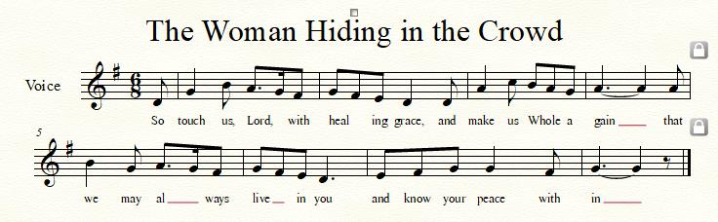

WORDS OF ASSURANCE
Leader: Through Christ, God has poured out the Holy Spirit upon us for the forgiveness of sins.
People: In the name of Jesus Christ, we are forgiven! Amen!

* MUSICAL RESPONSE OF PRAISE O My Soul, Bless Your Redeemer
Bless your Maker, all you creatures, ever under God’s control,
All throughout God’s vast dominion; bless the Lord of all, my soul!

* THE PEACE The peace of Christ be with you! And also with you!
(You may greet those around you.)

* RESPONSE Here I Am, Lord
Here I am, Lord, Is it I, Lord? I have heard you calling in the night.
I will go, Lord, if you lead me. I will hold your people in my heart.

THE PROCLAMATION OF THE WORD

PRAYER OF ILLUMINATION
God of Power and Grace, fill us with the wisdom of your Word and the understanding of your Holy Spirit so that we may be your church: a people with dreams and visions at work in all the world; through Jesus Christ our Lord. Amen.

FIRST SCRIPTURE LESSON Acts 2:1-13
When the day of Pentecost had come, they were all together in one place. ²And suddenly from heaven there came a sound like the rush of a violent wind, and it filled the entire house where they were sitting. ³Divided tongues, as of fire, appeared among them, and a tongue rested on each of them. ⁴All of them were filled with the Holy Spirit and began to speak in other languages, as the Spirit gave them ability.
⁵Now there were devout Jews from every nation under heaven living in Jerusalem. ⁶And at this sound the crowd gathered and was bewildered, because each one heard them speaking in the native language of each. ⁷Amazed and astonished, they asked, ‘Are not all these who are speaking Galileans? ⁸And how is it that we hear, each of us, in our own native language? ⁹Parthians, Medes, Elamites, and residents of Mesopotamia, Judea and Cappadocia, Pontus and Asia, ¹⁰Phrygia and Pamphylia, Egypt and the parts of Libya belonging to Cyrene, and visitors from Rome, both Jews and proselytes, ¹¹Cretans and Arabs—in our own languages we hear them speaking about God’s deeds of power.’ ¹²All were amazed and perplexed, saying to one another, ‘What does this mean?’ ¹³But others sneered and said, ‘They are filled with new wine.’

SECOND SCRIPTURE LESSON Acts 2:14-21
¹⁴ But Peter, standing with the eleven, raised his voice and addressed them: ‘Men of Judea and all who live in Jerusalem, let this be known to you, and listen to what I say. ¹⁵Indeed, these are not drunk, as you suppose, for it is only nine o’clock in the morning. ¹⁶No, this is what was spoken through the prophet Joel: ¹⁷ “In the last days it will be, God declares, that I will pour out my Spirit upon all flesh, and your sons and your daughters shall prophesy, and your young men shall see visions, and your old men shall dream dreams. ¹⁸ Even upon my slaves, both men and women, in those days I will pour out my Spirit; and they shall prophesy. ¹⁹ And I will show portents in the heaven above and signs on the earth below, blood, and fire, and smoky mist. ²⁰ The sun shall be turned to darkness and the moon to blood, before the coming of the Lord’s great and glorious day. ²¹ Then everyone who calls on the name of the Lord shall be saved.”

Leader: Hear what the Spirit is saying to the Church.
All: Thanks be to God.

SERMON Visions and Dreams Rev. Becca Crate-Price

THE RESPONSE TO THE WORD

* HYMN Come! Live in the Light! (We Are Called) #749
Come! Live in the light! Shine with the joy and the love of the Lord.
We are called to be light for the kingdom, to live in the freedom of the city of God.

Refrain:
We are called to act with justice; we are called to love tenderly;
We are called to serve one another, to walk humbly with God.

Come! Open your heart! Show your mercy to all those in fear!
We are called to be hope for the hopeless so hatred and violence will be no more. [Refrain]

Sing! Sing a new song! Sing of that great day when all will be one!
God will reign, and we’ll walk with each other as sisters and brothers united in love. [Refrain]

INSTALLATION OF ELDERS
Sentences of Scripture [Eph. 4:1-6]

Lead a life worthy of the calling to which you have been called, making every effort to maintain the unity of the Spirit in the bond of peace.

There is one body and one Spirit, just as we were called to the one hope of our calling:
One Lord, one faith, one baptism, one God and Father of all, who is above all and through all and in all.

Call to Discipleship [Book of Order F-1.0304]

We are called by God to be the church of Jesus Christ, a sign in the world today of what God intends for all humankind.

The great ends of the church are the proclamation of the gospel for the salvation of humankind; the shelter, nurture, and spiritual fellowship of the children of God; the maintenance of divine worship; the preservation of the truth; the promotion of social righteousness; and the exhibition of the Kingdom of Heaven to the world.

The call of Christ is to willing and dedicated discipleship. Our discipleship is a manifestation of the new life we enter through baptism. Discipleship is both a gift and a commitment, an offering, and a responsibility.

We now give thanks for the disciples who heard the call and answered affirmatively. In the renewal of ordination vows, we now ask our elders taking active service these constitutional questions:

W-4.0404: Constitutional Questions

The moderator of the council of those to be ordained, installed, or commissioned shall ask them to face the body of membership and to answer the following questions:
a. Do you trust in Jesus Christ your Savior, acknowledge him Lord of all and Head of the Church, and through him believe in one God, Father, Son, and Holy Spirit?

b. Do you accept the Scriptures of the Old and New Testaments to be, by the Holy Spirit, the unique and authoritative witness to Jesus Christ in the Church universal, and God’s Word to you?

c. Do you sincerely receive and adopt the essential tenets of the Reformed faith as expressed in the confessions of our church as authentic and reliable expositions of what Scripture leads us to believe and do, and will you be instructed and led by those confessions as you lead the people of God?

d. Will you fulfill your ministry in obedience to Jesus Christ, under the authority of Scripture, and be continually guided by our confessions?

e. Will you be governed by our church’s polity, and will you abide by its discipline? Will you be a friend among your colleagues in ministry, working with them, subject to the ordering of God’s Word and Spirit?

f. Will you in your own life seek to follow the Lord Jesus Christ, love your neighbors, and work for the reconciliation of the world?

g. Do you promise to further the peace, unity, and purity of the church?

h. Will you pray for and seek to serve the people with energy, intelligence, imagination, and love?

i. (1) (For ruling elder) Will you be a faithful ruling elder, watching over the people, providing for their worship, nurture, and service? Will you share in government and discipline, serving in councils of the church, and in your ministry will you try to show the love and justice of Jesus Christ?

Congregational Questions:
a. Do we, the members of the church, accept [names] as ruling elders or deacons, chosen by God through the voice of this congregation to lead us in the way of Jesus Christ?
b. Do we agree to pray for them, to encourage them, to respect their decisions, and to follow as they guide us, serving Jesus Christ, who alone is Head of the Church?

Installation Prayer

Faithful God, in baptism you claimed us; and by your Holy Spirit you are working in our lives, empowering us to live a life worthy of our calling. We thank you for leading Leah, Alex, and Ron to this time and place. Establish them in your truth, and guide them by your Holy Spirit, that in your service they may grow in faith, hope, and love, and be faithful disciples of Jesus Christ, to whom, with you and the Holy Spirit, but honor and glory, now and forever.

Blessing and Charge to the Installed [1 Thess. 5:23]
Ron, Leah, and Alex, you are installed to service as ruling elders at Springfield Presbyterian.

May the God of peace make you holy in every way, and keep your whole being, spirit, soul, and body, free from every fault at the coming of our Lord Jesus Christ. Alleluia and Amen.

THE COMMUNION OF THE PEOPLE

INVITATION

THE GREAT PRAYER OF THANKSGIVING
Leader: The Lord be with you.
People: And also with you.
Leader: Lift up your hearts.
People: We lift them up to the Lord.
Leader: Let us give thanks to the Lord our God.
People: It is right to give our thanks and praise.
[The Pastor continues… “…who forever sing to the glory of your name.”]

IN PRAISE OF GOD Tune #552
Holy, holy, holy, Lord, God of Power and might.
Heaven and earth are full of your glory, Hosanna in the highest!
Blessed is He who comes in the name of the Lord.
Hosanna in the highest, hosanna in the highest.
[The Pastor continues… “…proclaim the one crucified and risen.”]

IN PRAISE OF CHRIST Tune #553
Christ has died; Christ is risen; Christ will come again.
Christ has died; Christ is risen; Christ will come again.

PASTORAL PRAYER AND THE LORD’S PRAYER

WORDS OF INSTITUTION

SHARING OF THE MEAL

PRAYER OF DEDICATION (Unison)
Dear God, take us out to live as changed people because we have shared the living bread and cannot remain the same. Ask much of us, expect much from us, enable much by us, encourage many through us. So, Lord, may we live to your glory, both as inhabitants of the earth, and citizens of the commonwealth of Heaven. Through Christ, with Christ, in Christ, in the unity of the Holy Spirit, all glory and honor are yours, almighty God, now and forever. Amen.
OFFERTORY Fill Us With Your Spirit by J. P. Williams/D. Lantz III
SONG OF THANKS As Those of Old Their Firstfruits Brought #712
In gratitude and humble trust we bring our best today, to serve your cause and share your love with all along life’s way. O God who gave yourself to us in Jesus Christ your Son, help us to give ourselves each day until life’s work is done.
PRAYER OF DEDICATION

* HYMN Though I May Speak GTG #693
Though I may speak with bravest fire,
And have the gift to all inspire,
And have not love, my words are vain,
As sounding brass, and hopeless gain.

Though I may give all I possess,
And striving so my love profess,
But not be given by love within,
The profit soon turns strangely thin.

Come, Spirit, come, our hearts control;
Our spirits long to be made whole.
Let inward love guide every deed;
By this we worship, and are freed.

* CHARGE AND BENEDICTION
Leader: By the power of the Holy Spirit,
People: Our lives are made anew!
Leader: And as we discern our next steps forward,
People: We lean upon the power of God to direct us.
Leader: We will be people who look to the future,
People: To dream dreams and to envision new life!
* UNISON AMEN POSTLUDE
Sunday June 12, 2022 Lectionary
Proverbs 8:1-4, 22-31; Psalm 8; Romans 5:1-5; John 16:12-15

Assisting in Worship: We appreciate those who serve:

Today 6/5 Next Week 6/12
Sunday Opener Barbara Cornell Beth Oates
Ushers/Greeters Tim & Beth Oates Leah & Henry
Halvorson
Lay Leader Ron Holmes Christy Yeager

Communion Servers Today:
1. Ron Holmes 4. Diana Steppling
2. Sue Holmes 5. Beth Oates
3. Sharon Pappas

Happy Anniversary! June 12 – Belle & Don Vasbinder

Announcements

Pentecost Offering: Pentecost offering will be received TODAY. Please see insert for all the information. A portion will be sent to Mission of Mercy in support of healthcare for at-risk youth.

Mask Update: Due to the uptick in COVID-19 cases, the Session has decided to strongly encourage masking and social distancing. Though it is not a mandate, we seek to love one another by keeping each other as safe as possible. Thank you for your help in this endeavor.

Pastor-Parish Committee: The Pastor-Parish Committee invites you to share your concerns, suggestions, and gratitude. We have a form in the Narthex and a lock-box that we will open weekly and we ask that you share your name and be specific. We look forward to reading your comments so that we can continue to grow into the body of Christ.

Sunday School is back! On the 1st and 3rd Sundays of the month, we will be offering Sunday School! See Pastor Becca for details…

Springfield Membership: Are you interested in finding out more about our faith community and becoming a member? We would love to answer any questions you have. Please contact Pastor Becca at springfieldpastor@gmail.com for more information.

Congregational Care / Mission & Outreach: Do you know of a member or friend of our church family who is ill, needs prayers, would like call, a visit or a card, or might benefit from meal train? If so, please contact the Church Office (410-795-6152), Cathy Marsh (410-549-6916) or Diana Steppling (862-266-2242).

Fellowship Help Needed: If you are interested in helping with Fellowship, please contact Barbara Cornell (240-308-0035). A sign-up sheet will also be available.

Today:
Sunday June 5 – Installation of Elders
9:30 am Adult Choir Practice
10:30 am Worship
11:30 am Fellowship

This Week:
Tuesday June 7
7:00 pm Session Meeting (Manse)
Wednesday June 8
6:45 pm Last rehearsal for Bells and Choir
(Linda Caviglia’s house)

Looking Ahead:
Sunday June 12
10:30 am Worship
11:30 am Fellowship
3:00 pm Concert (Sanctuary)

Office Hours: Tuesday, Wednesday & Friday
Springfield Presbyterian Church

10:30 am Worship
11:30 am Fellowship
Website: www.springfield-church.org Church Office: 410-795-6152
Like us on Facebook: www.facebook.com/SpringfieldPresbyterianChurch
Pastor: Rev. Becca Crate-Price
Email: springfieldpastor@gmail.com
Clerk of Session: Sharon Pappas
Minister of Music: Linda Caviglia
Accompanist/Organist: Aaron Thacker
Youth Group Coordinator: Dylan Vasbinder
Administrative Assistant: Donna Mazer e-mail: spc.office@verizon.net

