(Large Print)

Springfield Presbyterian Church (USA)
7300 Spout Hill Road, Sykesville, MD 21784 410-795-6152

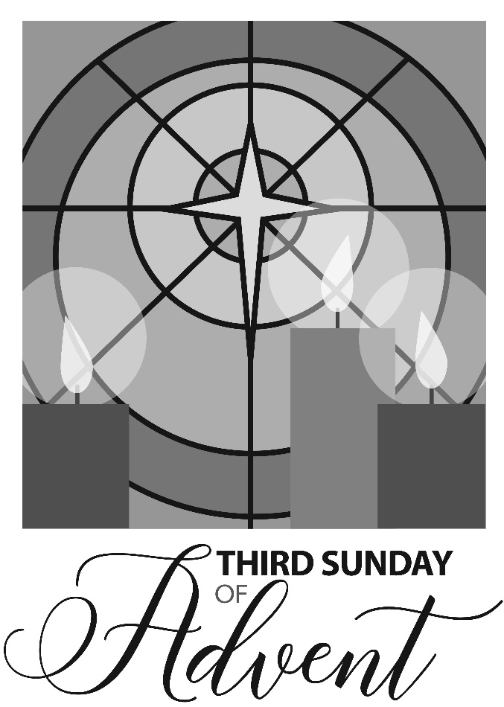

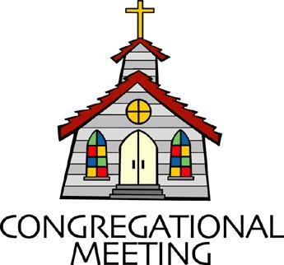
December 15, 2019 - 10:30 am

WELCOME VISITORS! We're glad you are here! Cards at the ends of each pew are for you to fill out and drop in the Offering Plate. Please let us know you are visiting, and join us for refreshments and fellowship following the service. The Sanctuary has an induction loop system to assist the hearing impaired. The system will also work on the telephone setting of hearing aids.

Springfield Presbyterian Church is rooted in the gospel of Jesus Christ, led by the Holy Spirit, and called to loving relationships through vibrant worship and service. Valuing all people, we are committed to developing disciples and fostering stewardship.
PREPARATION FOR THE WORD
(* those who are able are invited to stand)

PRELUDE

GATHERING OF THE PEOPLE

The Lord be with you! And also with you! (Greeting)

LIGHTING THE CHRIST CANDLE
Leader: Whenever we light this candle we proclaim:
People: Christ is the Light of the world and the center of our lives.

ADVENT CANDLE LIGHTING
Advent Reading – Joy
“The wilderness and the dry land shall be glad, the desert shall rejoice and blossom; like the crocus it shall blossom abundantly, and rejoice with joy and singing. The glory of Lebanon shall be given to it, the majesty of Carmel and Sharon. They shall see the glory of the LORD, the majesty of our God.” Isaiah 35:1-2

Joy to the world, the Lord is come! Christmas is a time of joy, and of good will to all people. But for some people it is a very lonely time. Loved ones have died, illness among family and friends all dampen the joy and happiness of this season. This morning, as we light this candle of joy, let us remember that the child whose birth we await grew up to become the one who healed the sick, gave sight to the blind, and conquered grief and pain. Even in the midst of our sorrow, Christ comes again to bring joy.

Sung Response (to the tune of Let All Mortal Flesh Keep Silence):
As we light the Advent candle with the light of Joy so bright,
Faithfully we wait His coming; faithfully it shines through the night. In our humble hearts, a fire burns as well;
Hear the prayer these flames would tell.
CALL TO WORSHIP [Alterations on Psalm 146:1-5]
Leader: Praise the Lord!
People: Praise the Lord, all our souls!
Leader: We will praise the Lord all our lives.
People: We will sing praise to God as long as we live.
Leader: We do not put our trust in princes,
People: We do not put our trust in human beings who cannot save.
Leader: When their spirit departs, they return to the ground; on that very day their plans come to nothing.
People: We are a people who are blessed; blessed as our help is the God of Jacob, whose hope is in the Lord their God.
ALL: Come all ye people, come praise your Maker. Let us worship God!

* HYMN My Soul Cries Out with a Joyful Shout
My soul cries out with a joyful shout that the God of my heart is great, and my spirit sings of the wondrous things that you bring to the ones who wait. You fixed your sight on your servant’s plight, and my weakness you did not spurn, so from east to west shall my name be blest. Could the world be about to turn?

Refrain:
My heart shall sing of the day you bring. Let the fires of your justice burn. Wipe away all tears, for the dawns draws near, and the world is about to turn.

Though I am small, my God, my all, you work great things in me, and your mercy will last from the depths of the past to the end of the age to be. Your very name puts the proud to shame, and to those who would for you yearn, you will show your might, put the strong to flight, for the world is about to turn. [Refrain]

From the halls of power to the fortress tower, not a stone will be left on stone. Let the king beware for your justice tears every tyrant from his throne. The hungry poor shall weep no more, for the food they can never earn; there are tables spread; every mouth be fed, for the world is about to turn. [Refrain]

Though the nations rage from age to age, we remember who hold us fast: God’s mercy must deliver us from the conqueror’s crushing grasp. This saving word that our forebears heard is the promise which holds us bound, till the spear and rod can be crushed by God, who is turning the world around. [Refrain]

PRAYER OF CONFESSION
Generous God, you have taught us to be patient and promised to supply our needs, O God. Yet we grow weary of waiting and restless with our wants. We blame our troubles on brothers and sisters, withholding from them the tolerance, acceptance, and care you have shown to us. O God, forgive our indulgence and help us to stand firm. In Christ you showed patience with the world in spite of the cross. Teach us to be patient, that in Christ we may have endurance in spite of our need. Amen.

SILENT PRAYERS OF CONFESSION

RESPONSE On Jordan’s Bank the Baptist’s Cry
Then cleansed be every life from sin; make straight the way for God within, and let us all our hearts prepare for Christ to come and enter there.

WORDS OF ASSURANCE
Leader: The good news of this Advent season is forgiveness of sin and new life. Let us commit our lives to Christ’s way of hope and peace.
People: Thanks be to the Advent God, who comes among us, setting us free to love and serve. Alleluia, amen!

* MUSICAL RESPONSE OF PRAISE Now Thank We All Our God
All praise and thanks to God, who reigns in highest heaven,
To Father and to Son and Spirit now be given:
The one eternal God, whom heaven and earth adore,
The God who was, and is, and shall be ever-more.

* THE PEACE The peace of Christ be with you! And also with you!
(You may greet those around you.)

* RESPONSE Here I Am, Lord
Here I am, Lord, Is it I, Lord? I have heard you calling in the night.
I will go, Lord, if you lead me. I will hold your people in my heart.

THE PROCLAMATION OF THE WORD

PRAYER OF ILLUMINATION
Leader: God of love and power, you are revealed to us in your Word, in accounts of prophecy and fulfillment that direct our attention to Jesus Christ. Illumine us now as we hear your Word proclaimed, that we may open our hearts to Him, yearn for His coming in glory, and serve Him with joy. Amen.

FIRST SCRIPTURE LESSON Psalm 146:5-10
⁵ Happy are those whose help is the God of Jacob, whose hope is in the Lord their God, ⁶ who made heaven and earth, the sea, and all that is in them; who keeps faith for ever; ⁷ who executes justice for the oppressed; who gives food to the hungry. The Lord sets the prisoners free; ⁸ the Lord opens the eyes of the blind. The Lord lifts up those who are bowed down; the Lord loves the righteous. ⁹ The Lord watches over the strangers; he upholds the orphan and the widow, but the way of the wicked he brings to ruin. ¹⁰ The Lord will reign for ever, your God, O Zion, for all generations. Praise the Lord!

SECOND SCRIPTURE LESSON James 5:7-10
⁷Be patient, therefore, beloved, until the coming of the Lord. The farmer waits for the precious crop from the earth, being patient with it until it receives the early and the late rains. ⁸You also must be patient. Strengthen your hearts, for the coming of the Lord is near. ⁹Beloved, do not grumble against one another, so that you may not be judged. See, the Judge is standing at the doors! ¹⁰As an example of suffering and patience, beloved, take the prophets who spoke in the name of the Lord.

Leader: Hear what the Spirit is saying to the Church.
All: Thanks be to God.

TIME WITH YOUNG PEOPLE Jesse Tree – Week 3

SERMON Patience is a Virtue Rev. Becca Crate

THE RESPONSE TO THE WORD

* HYMN O Lord, How Shall I Meet You
O Lord, how shall I meet you, how welcome you aright?
Your people long to greet you, my hope, my heart’s delight!
O kindle, Lord most holy, a lamp within my breast,
To do in spirit lowly all that may please you best.

Love caused your incarnation; love brought you down to me;
Your thirst for my salvation procured my liberty.
O love beyond all telling, that led you to embrace
In love, all loves excelling, our lost and fallen race.

You come, O Lord, with gladness, in mercy and goodwill,
To bring an end to sadness and bid our fears be still.
In patient expectation we live for that great day
When your renewed creation your glory shall display.

PASTORAL PRAYER AND THE LORD’S PRAYER
“For this I pray to God.” / “For this I give thanks to God.”
Congregational Response: “Hear our prayer, O God.”

PRESENTATION OF TITHES AND OFFERINGS
OFFERTORY
* SONG OF THANKS As with Gladness Men of Old
As they offered gifts most rare at thy manger, rude and bare,
So may we with holy joy, pure and free from sin’s alloy,
All our costliest treasures bring, Christ, to thee, our heavenly king.
* PRAYER OF DEDICATION

* HYMN In the Bleak Midwinter
In the bleak midwinter, frosty wind made moan;
Earth stood hard as iron, water like a stone;
Snow had fallen, snow on snow, snow on snow,
In the bleak midwinter, long ago.

Our God, heaven cannot hold him, nor earth sustain;
Heaven and earth shall flee away when he comes to reign:
In the bleak midwinter a stable place sufficed
The Lord God incarnate, Jesus Christ.

Angels and archangels may have gathered there;
Cherubim and seraphim thronged the air;
But his mother only, in her maiden bliss,
Worshiped the beloved with a kiss.

What can I give him, poor as I am?
If I were a shepherd, I would bring a lamb;
If I were a wise man, I would do my part;
Yet what I can I give him: give my heart.

* CHARGE AND BENEDICTION
Leader: Called to patience, we await your arrival.
People: We prepare our hearts.
Leader: In hope and excitement,
People: We await a King a cradle.
Leader: Inspire us now and in the coming days,
People: As Christ us, let us be a people of hope and of waiting, sharing the light of renewal with all. Amen.

* UNISON AMEN

POSTLUDE

Assisting in Worship: We appreciate those who serve:

Today 12/15 Next Week 12/22
Sunday Opener Bob Rogers Ron Holmes
Greeters & Ushers Cynthia Smith & Jim & Mary
Don Vasbinder Rhodes
Lay Leader Diana Steppling Sharon Pappas
Sunday School Connie Robinson Connie Robinson
Fellowship Linda Caviglia Belle Vasbinder

Sunday December 22 Lectionary
Isaiah 7:10-16; Psalm 80:1-7, 17-19; Romans 1:1-7; Matthew 1:18-25
Church Attendance: December 1 – 51 December 8 - 58

Church Cleaning: December 27, 28 or 29 – Sandy & Ed Newsome

Happy Birthday! December 19 – Becky Spicer
December 20 – Stephanie Bunting
December 20 – Chad Stewart

Announcements

SERRV Sale: TODAY during Fellowship, come and shop for unique, handcrafted fair trade items from around the world. Items sold through SERRV will help to fight poverty and build up the communities of impoverished artisans and farmers. Last sale date is December 22.

Christmas Joy Offering: The Christmas Joy gift supports our past, present and future church workers. Half the offering goes to provide financial assistance to present or retired church workers. The other half is sent as financial support to Presbyterian-related colleges, equipping their students to learn and grow in faith. This offering will be received TODAY and December 22.

Christmas Caroling: TODAY immediately following our service and fellowship, we are gathering a group to go to Copper Ridge and Birch Manor (formerly Transitions) to sing and visit with the patients in those locations. We'd love to have any and all who would like to join us!

C.I.A. (Community In Action): This year the children of C.I.A. will be making limited edition Craft Christmas Ornaments to be proudly displayed on the Church Christmas tree. These limited edition Christmas Ornaments are being made to support the Sykesville Food Bank. Your generous donation for each Christmas Ornament will help raise desperately needed money to support the food bank. After your Christmas Ornament is returned to you, you can proudly display it for years to come on your own Christmas tree. Each and every ornament will come with a letter of authenticity to verify that it was created by the children at C.I.A.

Christmas Pageant: This year for the Christmas Pageant we are making a slide show to play during the pageant. We would like the slide show to be of Christmas pictures that have significance to you - any picture from anytime in your life or a picture of you or your family now. Please email your pictures to spc.office@verizon.net.

Happy-Thon: This year more children than ever are attending the 2019 Happy-Thon where they will receive refreshments, entertainment and Christmas gifts. The event is coordinated by Downtown Sykesville Connection, and they are so very, very grateful for your generous donation of $322!

Offering Envelopes: Be sure to pick up your 2020 offering envelopes in the Narthex. If you do not currently receive envelopes and would like a set for 2020, please let Donna in the Church Office know.

Blessing Bags are in the Narthex. Please feel free to pick up a few. Handing one out to someone in need gives you a very real way to meet their immediate needs by providing them with some basic supplies.

Prayers & Thanksgivings

~ Dear Church Family, we want to thank you all for the amazing (and quick) outpouring of love you showed Josh and his USS Abraham Lincoln shipmates. Seven large boxes of snacks, toiletries, reading materials, treat-bags, and cards were collected and mailed to the Persian Gulf. All of these “Hugs from Home” will bring happiness and comfort to our military men and women who are unexpectedly

away from their loved ones this holiday season. As parents, we too appreciate the love shown to us throughout this difficult time.
With love and gratitude, Ed & Sandy Newsome
~ Prayers for Hope Presbyterian Church from our Ministry Group.

The Congregational Care team wants to know what YOU or someone you know needs...a visit...a call...a meal. Please contact Diana Steppling or Connie Robinson. If you are in need of pastoral care, please contact Pastor Becca at 410-795-6152 or springfieldpastor@gmail.com.

Today:
Sunday December 15
9:00 am Red Sea Parting Practice
10:30 am Worship
11:30 am Fellowship
12:00 noon Caroling

This Week:
Monday December 16
9:30 am Feed My Sheep (Wesley Freedom)
4:30 pm C.I.A. Meeting (Manse)
Wednesday December 18
6:30 pm Bell Choir Practice
7:45 pm Adult Choir Practice
Friday December 20
7:00 pm Blue Christmas Service

Looking Ahead:
Sunday December 22
10:30 am Christmas Pageant
11:30 am Fellowship
Tuesday December 24
5:30 pm Family Christmas Eve Service
8:00 pm Traditional Christmas Eve Service

Office Hours: Tuesday, Wednesday, Friday 9:00 am - 3:00 pm

Springfield Presbyterian Church

10:30 am Worship & Sunday School
11:30 am Fellowship
Website: www.springfield-church.org Church Office: 410-795-6152
Like us on Facebook: www.facebook.com/SpringfieldPresbyterianChurch
Pastor: Rev. Becca Crate
Email: springfieldpastor@gmail.com
Clerk of Session: Sharon Pappas
Minister of Music: Linda Caviglia
Accompanist: Aaron Thacker Organist: Jennifer Wise
Youth Group Coordinators: Charles & Deb Sperling
Sunday School Coordinator: Connie Robinson
Administrative Assistant: Donna Mazer
e-mail: spc.office@verizon.net

