(Large Print)

Springfield Presbyterian Church (USA)
7300 Spout Hill Road, Sykesville, MD 21784 410-795-6152

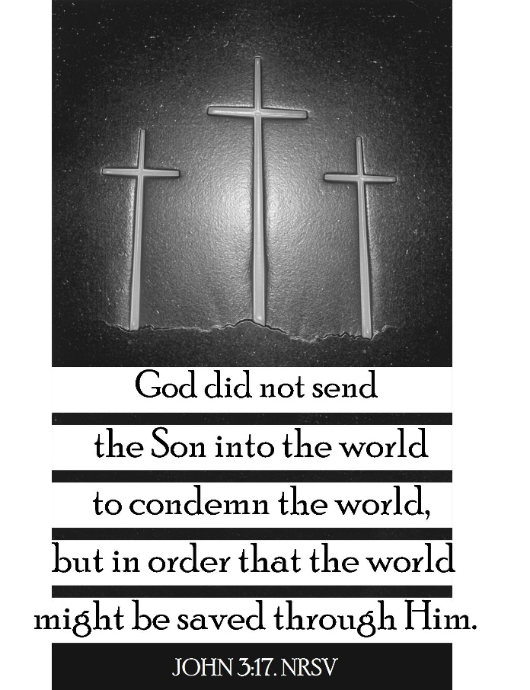

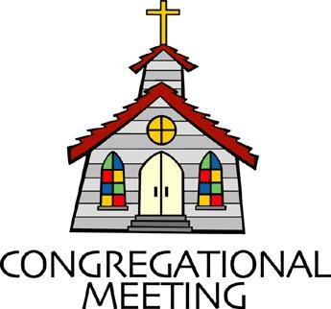
March 8, 2020 - 10:30 am

WELCOME VISITORS!

We're glad you are here! Cards at the ends of each pew are for you to fill out and drop in the Offering Plate. Please let us know you are visiting, and join us for refreshments and fellowship following the service. The Sanctuary has an induction loop system to assist the hearing impaired. The system will also work on the telephone setting of hearing aids.

Springfield Presbyterian Church is rooted in the gospel of Jesus Christ, led by the Holy Spirit, and called to loving relationships through vibrant worship and service. Valuing all people, we are committed to developing disciples and fostering stewardship.

PREPARATION FOR THE WORD
(* those who are able are invited to stand)

PRELUDE

GATHERING OF THE PEOPLE

The Lord be with you! And also with you! (Greeting)

LIGHTING THE CHRIST CANDLE
Leader: Whenever we light this candle we proclaim:
People: Christ is the Light of the world and the center of our lives.

CALL TO WORSHIP [Psalm 116 – Iona Responses]
Leader: I love the Lord who listens to us; our prayers are heard in heaven.
People: Death and hell laid hold of us; we were desperate, distressed, and in anguish.
Leader: Then I called on the name of our God: Save us! Save our lives!
People: God is gracious and merciful; we were rescued from all that oppressed us.
Leader: Our lives were delivered from death, our eyes from tears, our feet from stumbling.
People: What shall we offer to God in return for all the grace we received?
Leader: We will lift up the cup of salvation and call on God by name.
People: We will offer our gift of gratitude in the place beloved by God.
Leader: We will make our vows to our Maker, in the presence of all God’s people.
People: We will come and worship our God.

* HYMN God Is Calling through the Whisper

God is calling through the whisper of the Spirit’s deepest sighs,
Through the thrill of sudden beauties that can catch us by surprise.
Flash of lightning, crash of thunder; hush the stillness, rush of wonder:
God is calling – can you hear? God is calling – can you hear?

God is calling through the voices of our neighbors’ urgent prayers,
Through their longing for redemption and for rescue from despair.
Place of hurt or face of needing; strident cry or silent pleading:
God is calling – can you hear? God is calling – can you hear?

God is calling through the music of sublime and human arts,
Through the hymns of earth and angels, and the carols of our hearts.
Lift of joy and gift of singing; days and nights our praises bringing:
God is calling – and we hear! God is calling – and we hear!

PRAYER OF CONFESSION
God of Grace, we confess that we can want to hide our faith, in fears of being shamed, stereotyped, or our reputation changed. We offer our worship in quiet, in the safety of the sanctuary, in the quietness of our rooms, and in the security of those we know share our same faith. Yet you call us to embody the Kingdom, to live a faith that speaks the truth and calls for love, and it requires us to get out of our comfort zones; to move from the dark to the light. Forgive us, restore us, and renew us as we learn and grow into the people you call us to be. Amen.

SILENT PRAYERS OF CONFESSION

RESPONSE O Lord, Hear My Prayer (sing two times)
O Lord, hear my prayer. O Lord, hear my prayer. When I call, answer me.
O Lord, hear my prayer. O Lord, hear my prayer. Come and listen to me.

WORDS OF ASSURANCE
Leader: Listen, so that you may live: the steadfast love of the Lord never fails.
People: In the name of Jesus Christ, we are forgiven. Thanks be to God! Amen!

* MUSICAL RESPONSE OF PRAISE Magnificat (sung as a round) Magnificat. Magnificat. Magnificat anima mea Dominum.
Magnificat. Magnificat. Magnificat anima mea!

* THE PEACE The peace of Christ be with you! And also with you!
(You may greet those around you.)

* RESPONSE Here I Am, Lord
Here I am, Lord, Is it I, Lord? I have heard you calling in the night.
I will go, Lord, if you lead me. I will hold your people in my heart.

THE PROCLAMATION OF THE WORD

PRAYER OF ILLUMINATION
Leader: Gracious God, our way in the wilderness, guide us, by your Word, through these forty days, and minister to us with your Holy Spirit, so that we may reformed, restored, and renewed; through Jesus Christ our Lord. Amen.

FIRST SCRIPTURE LESSON Psalm 121
¹ I lift up my eyes to the hills—from where will my help come? ² My help comes from the Lord, who made heaven and earth. ³ He will not let your foot be moved; he who keeps you will not slumber. ⁴ He who keeps Israel will neither slumber nor sleep. ⁵ The Lord is your keeper; the Lord is your shade at your right hand. ⁶ The sun shall not strike you by day, nor the moon by night. ⁷ The Lord will keep you from all evil; he

will keep your life. ⁸ The Lord will keep your going out and your coming in from this time on and for evermore.

SECOND SCRIPTURE LESSON John 3:1-17
Now there was a Pharisee named Nicodemus, a leader of the Jews. ²He came to Jesus by night and said to him, ‘Rabbi, we know that you are a teacher who has come from God; for no one can do these signs that you do apart from the presence of God.’ ³Jesus answered him, ‘Very truly, I tell you, no one can see the kingdom of God without being born from above.’ ⁴Nicodemus said to him, ‘How can anyone be born after having grown old? Can one enter a second time into the mother’s womb and be born?’ ⁵Jesus answered, ‘Very truly, I tell you, no one can enter the kingdom of God without being born of water and Spirit. ⁶What is born of the flesh is flesh, and what is born of the Spirit is spirit. ⁷Do not be astonished that I said to you, “You must be born from above.” ⁸The wind blows where it chooses, and you hear the sound of it, but you do not know where it comes from or where it goes. So it is with everyone who is born of the Spirit.’ ⁹Nicodemus said to him, ‘How can these things be?’ ¹⁰Jesus answered him, ‘Are you a teacher of Israel, and yet you do not understand these things? ¹¹ ‘Very truly, I tell you, we speak of what we know and testify to what we have seen; yet you do not receive our testimony. ¹²If I have told you about earthly things and you do not believe, how can you believe if I tell you about heavenly things? ¹³No one has ascended into heaven except the one who descended from heaven, the Son of Man. ¹⁴And just as Moses lifted up the serpent in the wilderness, so must the Son of Man be lifted up, ¹⁵that whoever believes in him may have eternal life. ¹⁶ ‘For God so loved the world that he gave his only Son, so that everyone who believes in him may not perish but may have eternal life. ¹⁷ ‘Indeed, God did not send the Son into the world to condemn the world, but in order that the world might be saved through him.

Leader: Hear what the Spirit is saying to the Church.
All: Thanks be to God.

TIME WITH YOUNG PEOPLE

SERMON Undercover Discipleship Rev. Becca Crate

THE RESPONSE TO THE WORD

* HYMN To God Be the Glory
To God be the glory; great things he has done!
So loved he the world that he gave us his Son,
who yielded his life an atonement for sin,
and opened the life-gate that all may go in.

Refrain:
Praise the Lord, praise the Lord; let the earth hear his voice!
Praise the Lord, praise the Lord; let the people rejoice!
O come to the Father through Jesus the Son,
and give him the glory: great things he has done!

Great things he has taught us; great things he has done,
and great our rejoicing through Jesus the Son;
but purer and higher and greater will be
our wonder, our transport, when Jesus we see. [Refrain]

* AFFIRMATION OF FAITH [From the Iona Community]

Leader: We believe in God,
People: Who is older than eternity and younger than our next breath; who is beyond describing yet knows us all by name; who inspires faith yet cannot be contained by religion.

Leader: We believe in Jesus Christ, flesh of our flesh, bone of our bone;
People: He came in the body to give worth to every human life. He touched the untouchable, loved the unlovable and endured slander, persecution, and death.
Leader: We believe that God’s Kingdom comes on earth through Christ’s suffering love.
People: He rose from the grave as living proof that what is laid down in faith will be raised in glory. He ascended to heaven to be present at all times to all people.
Leader: We believe in the Holy Spirit,
People: Who leads us into truth and freedom, who gives good gifts to all God’s children, who works through prayer and politics, through justice, care of creation and the healing of the nations.
Leader: We celebrate the potential God has given:
People: The life in our bodies, the yearning in our souls, the promise of good things in store for those who love and serve their maker.

PASTORAL PRAYER AND THE LORD’S PRAYER
“For this I pray to God.” / “For this I give thanks to God.”
Congregational Response: “Hear our prayer, O God.”

PRESENTATION OF TITHES AND OFFERINGS
OFFERTORY For God So Loved the World By: Allen Pote
* SONG OF THANKS In the Lord I’ll Be Ever Thankful Tune #654
In the Lord I’ll be ever thankful; in the Lord I will rejoice!
Look to God; do not be afraid. Lift up your voices; the Lord is near.
Lift up your voices; the Lord is near.
* PRAYER OF DEDICATION

* HYMN How Great Thou Art

O Lord my God, when I in awesome wonder
consider all the worlds thy hands have made,
I see the stars, I hear the rolling thunder,
thy power throughout the universe displayed:

Refrain:
Then sings my soul, my Savior God, to thee:
How great thou art! How great thou art!
Then sings my soul, my Savior God, to thee:
How great thou art! How great thou art!

When through the woods and forest glades I wander
and hear the birds sing sweetly in the trees,
when I look down from lofty mountain grandeur
and hear the brook and feel the gentle breeze: [Refrain]

And when I think that God, his Son not sparing,
sent him to die, I scarce can take it in,
that on the cross, my burden gladly bearing,
he bled and died to take away my sin: [Refrain]

When Christ shall come with shout of acclamation
and take me home, what joy shall fill my heart!
Then I shall bow in humble adoration,
and there proclaim, "My God, how great thou art!" [Refrain]

* CHARGE AND BENEDICTION
Leader: May we go from this place,
People: Not in secret,
Leader: But as a people who are led into the light,
People: To proclaim your love to all people.
Leader: Through the guidance and grace of your Spirit,
People: So we may be active and live witnesses to your work in the world. Amen.

* UNISON AMEN

POSTLUDE

Assisting in Worship: We appreciate those who serve:

Today 3/8 Next Week 3/15
Sunday Opener Ron Holmes Barbara Cornell
Greeters & Ushers Cynthia Smith & Elizabeth Meirowitz &
Beth Oates Bob Rogers
Lay Leader Don Vasbinder Tony Caviglia
Sunday School Connie Robinson Connie Robinson
Fellowship Christy Yeager Barbara Nickell

Church Attendance: Feb. 23 – 51 Feb. 26 – 28 March 1 - 33

Church Cleaning: March 20, 21 or 22 – Mark Kearney

Happy Birthday! March 14 – Shannon Stewart

Sunday March 15, 2020 Lectionary
Exodus 17:1-7; Psalm 95; Romans 5:1-11; John 4:5-42
Announcements

2020 Lenten Devotionals: Becoming A Beloved Community, A Matthew 25 Journey to the Cross, published by Presbyterian Mission, are available in the Narthex. Know that they are there for you to take home, read the daily portion, and pause with the artwork.

Mission & Outreach Fair: After Worship on March 15, the Mission Team will present the first in a series of opportunities for everyone to learn about the many ways in which the congregation is engaged within the church family and also out in the community.

Pysanky (Ukrainian) Egg Workshop: On Sunday, March 29 after Worship, come and learn about the ancient Ukrainian art form of Pysanky and try your hand at creating your own egg. All materials will be provided. I will be taking the eggs home, varnishing them and hanging them up to be part of our Easter morning decorations. Cost is $5 ($10 if you would like to keep your kistka). Please email or text Brittany Rachin at dannybrittany0628@gmail.com or 410-562-4995 by March 28 so I have enough materials.

Help Wanted: Nursery Attendant, 10am – 12pm on Sundays as well as other “special” services throughout the year, $15/hour, must be 18 years of age and have experience working with and caring for children, complete a criminal background check, and be certified in Infant First Aid/CPR. If interested, please contact the office at 410-795-6152 to schedule an interview.

We are also in need of some amazing volunteers to assist our “soon to be hired” Nursery Attendant during worship. Sue Holmes will have a sign-up sheet for those who are interested. It is our hope to create a rotating schedule similar to the one we use for church cleaning and Sunday openers. We thank you in advance for your willingness to serve.

Inclement Weather: If we feel the need to cancel Worship and Sunday School, there will be a message on the Church answering machine, as well as on Facebook. You may also receive an email with that information.

Coat Drive: Shepherd’s Staff is collecting new or gently used coats, hats, mittens, gloves and socks. Bring them (clean) to church and Julie Ballard will deliver them to Shepherd’s Staff throughout the winter.

Blessing Bags are in the Narthex. Please feel free to pick up a few. Handing one out to someone in need gives you a very real way to meet their immediate needs by providing them with some basic supplies.

Prayers & Thanksgivings

~ Prayers of healing for Davis Streaker, in rehab for a broken hip.
~ Prayers for swift recovery for Steve Mazer’s father, Bernie, who had knee replacement surgery.
~ Continued prayers of healing for Elaine Cleland for health concerns.
~ Prayers for Granite Presbyterian Church from our Ministry Group.

The Congregational Care team wants to know what YOU or someone you know needs...a visit...a call...a meal. Please contact Diana Steppling or Connie Robinson. If you are in need of pastoral care, please contact Pastor Becca at 410-795-6152 or springfieldpastor@gmail.com.

Today:
Sunday March 8 – 2nd Sunday in Lent
10:30 am Worship
11:30 am Fellowship

This Week:
Monday March 9
7:00 pm Head Huggers (Manse)
Tuesday March 10
10:30 am Prayer Group (Manse)
7:00 pm ESCAPE Lunch Packing (Manse)
Wednesday March 11
6:30 pm Bell Choir Practice
7:45 pm Adult Choir Practice
Thursday March 12
7:00 pm Session Meeting (Manse)

Looking Ahead:
Sunday March 15 – 3rd Sunday in Lent
9:00 am Red Sea Parting Practice
10:30 am Worship
11:30 am Fellowship
12:00 noon Mission & Outreach Fair
Monday March 16
9:30 am Feed My Sheep (Wesley Freedom)
4:30 pm C.I.A. Meeting (Manse)
Wednesday March 18
6:30 pm Bell Choir Practice
7:45 pm Adult Choir Practice
Friday March 20
7:00 pm Family Game Night (Fellowship Room)

Office Hours: Tuesday, Wednesday, Friday 9:00 am - 3:00 pm

Springfield Presbyterian Church

10:30 am Worship & Sunday School
11:30 am Fellowship
Website: www.springfield-church.org Church Office: 410-795-6152
Like us on Facebook: www.facebook.com/SpringfieldPresbyterianChurch
Pastor: Rev. Becca Crate
Email: springfieldpastor@gmail.com
Clerk of Session: Sharon Pappas
Minister of Music: Linda Caviglia
Accompanist: Aaron Thacker Organist: Jennifer Wise
Youth Group Coordinators: Charles & Deb Sperling
Sunday School Coordinator: Connie Robinson
Administrative Assistant: Donna Mazer
e-mail: spc.office@verizon.net

